**DreamHack Winter festival LIVE on Viagame**

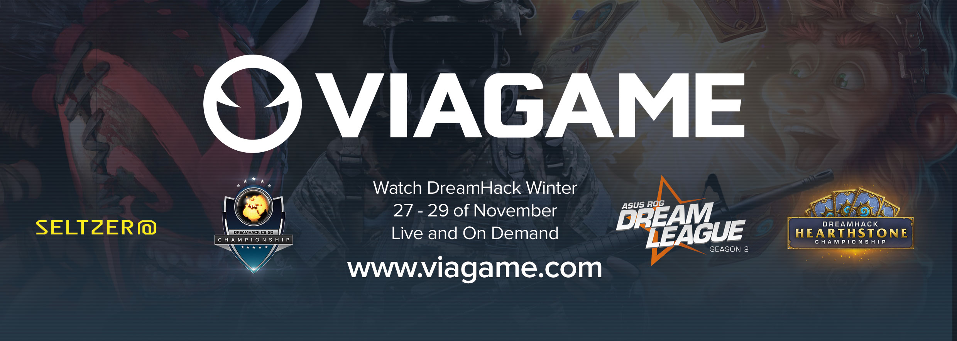

​**STOCKHOLM 18 November 2014. Viagame will be broadcasting several tournaments from the DreamHack Winter festival, which takes place in Jönköping, Sweden on 27–29 of November. This time e-Sport enthusiasts around the world will be able to follow tournaments covering Hearthstone, Dota 2 and CS:GO, Live and on demand on Viagame.com.**

The fast growing Blizzard title Hearthstone will be available in English, Russian, French and Spanish, both Live and on demand. The best of the best will be accompanying the viewers across the path of the battles and there are some very famous names among the casters. [​Frodan](https://twitter.com/Frodan), [​ThatsAdmirable](https://twitter.com/ThatsAdmirable) and [​Gnimsh](https://twitter.com/GnimshTV) will take the lead on the English broadcast, [​Olesami](https://twitter.com/Olesami) will be heading the Russian stream, [​Torlk](https://twitter.com/MillTorlk) and [​BestMarmotte](https://twitter.com/Bestmarmotte) will catch-up on French and [​AliaDeschain](https://twitter.com/AliaDeschain) will introduce the Spanish version of the event.

In line with tradition the final outcome of DreamLeague season will be determined in Jönköping during the DreamHack Winter festival. For Dota2 fans, Dreamleague will be available in both English and Swedish on viagame.com and [​TV6](http://www.tv6.se/) Sweden. In addition, the Swedish production of the DreamLeague finals will be broadcasted on the Swedish TV channel TV6.

In cooperation with the [​Polsat Viasat Explore](http://viasatexplore.pl/), Viagame will be producing and broadcasting the DreamHack CS:GO Championship in Polish. CS:GO attracted a lot of attention during ESL One Cologne earlier this year and is expected to be a very popular title at DreamHack Winter. Teams will compete for a prize pool of $250,000, with casting performed by Piotr 'izak' Skowyrski and Patryk Dzięcioł.

For those who are not able to make it to Jönköping this November, Viagame has prepared the backstage interview show Seltzer@, where Rachel “Seltzer” Quirico will be interviewing some very interesting people at the event.

Viagame will be organizing numerous social activities and competitions during the 3 days of the events, so make sure to follow [@Viagame](https://twitter.com/viagame) on Twitter to stay up to date with all the news and latest announcements and visit our [Facebook page](https://www.facebook.com/Viagame) for competitions and updates.

Viagame is a global streaming service for premium eSports and casual gaming content. Viagame is a part of MTGx, the digital accelerator of international media company Modern Times Group (MTG). MTG’s operations span four continents and include online, free-TV, pay-TV, radio and content production businesses. MTG is a growth company and is listed on the Nasdaq OMX Stockholm stock exchange.