Digitalisation of Portsmouth International Port

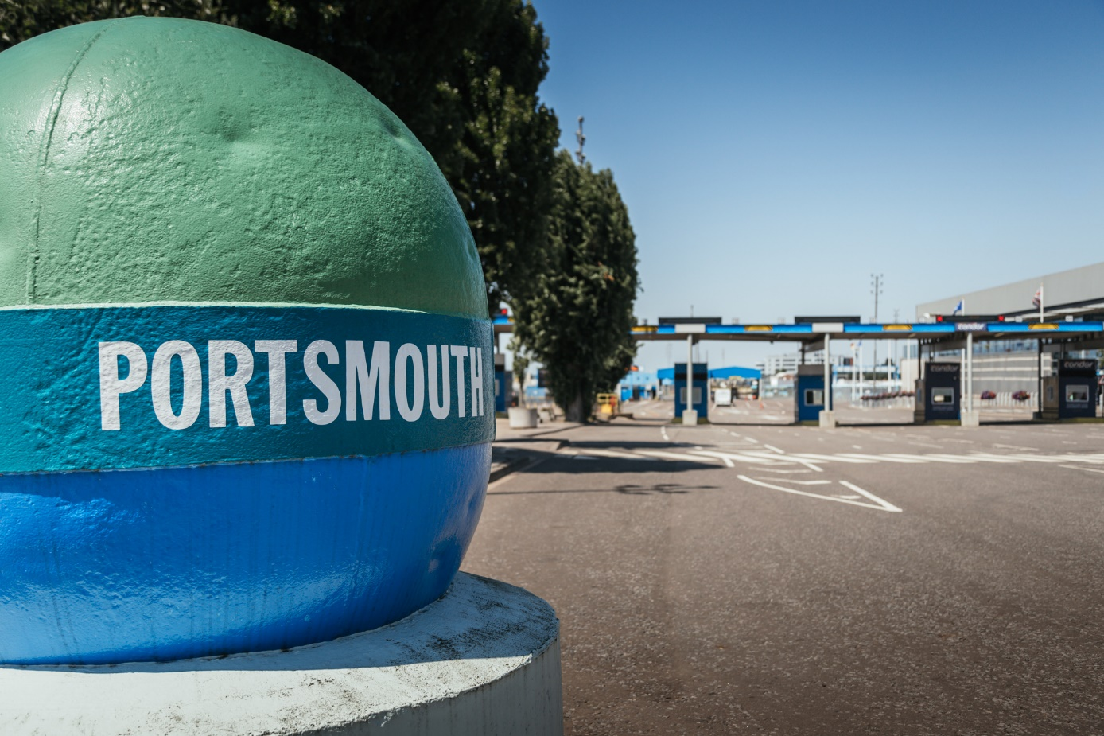

**Portsmouth International Port is the second-largest cross-channel port in the UK, and offers more ferry routes than any other UK ferry port, serving popular destinations in France, Spain, and the Channel Islands. Two ferry companies transport 250,000 freight units through the terminal each year. Portsmouth International Port awarded to Hogia the contract to supply a terminal operating system to digitalise the management of freight transport through the terminal thereby increasing the terminal’s efficiency.**

Mike Sellers, Portsmouth International Port’s director said: “Using Hogia's terminal operating system (TOS) is the first step towards digitalisation for our terminal operations. It will make terminal operations more efficient, enable us to provide a higher quality of service for our customers, and provide a more competitive edge. Importantly it gives us more flexibility, paving the way for the future and securing the capacity we need to meet the growing demand for freight transport.”

Hogia's TOS is a standard system that provides a shared platform for port staff and ferry operators, enabling the terminal operations to be managed digitally. TOS has an open interface and is easily integrated with third-party applications, such as the shipping companies' own booking systems. The information held in TOS makes it easy to identify freight units arriving at the terminal gate and to assign the units to a known location on the terminal, the information being available, if desired, to both port operations staff as well as to the ferry operators.

Terminal Managers also benefit through the ability to generate detailed operational and management reports and statistics regarding many aspects of the terminal’s operation.

“This is the start of a long-term partnership and we are looking forward to helping Portsmouth International Port to further expand the digitalisation of its port operations through creating automatic workflows, thereby increasing efficiency and throughput, enabling the Port to develop and grow its business”, says Ulf Hille-Dahl, Sales Executive International Market at Hogia Logistics Systems AB.

More information:

Portsmouth International Port is a port and ferry terminal located in the city of Portsmouth on the south coast of England. It operates departures and arrivals for cruise ships, cargo ships and passenger ferries. It is widely known as Britain’s Best Connected Port with more ferry routes than any other UK ferry port, serving popular destinations in France, Spain and the Channel Islands. The port handles more than 250,000 freight units each year. For more information visit [www.portsmouth-port.co.uk](https://eur02.safelinks.protection.outlook.com/?url=http%3A%2F%2Fwww.portsmouth-port.co.uk%2F&data=02%7C01%7C%7C4b498678f74646a2da8d08d705e87a0a%7C98de831b417d449aa3649018328d77e6%7C0%7C0%7C636984368404002577&sdata=6OaJUCfyakcQxtvRMuRgcBIldJzzb%2BH1Z2Qiq2hKMVY%3D&reserved=0)

July 2019

Contacts:   
Emma Soovik, Communication Manager, Mobile: +46 (0)70 817 96 51, email: [emma.soovik@hogia.se](mailto:emma.soovik@hogia.se)

[Gary Umpleby](https://www.mynewsdesk.com/hogia/contact_people/53087), Senior Business Advisor,  Mobile +44 (0)20 7795 8156, email: [gary.umpleby@hogia.com](mailto:gary.umpleby@hogia.com)

*Hogia has over 25 years of experience in developing and supplying software and IT systems for the transport sector and is the only system supplier in Europe to offer integrated solutions for ferries, port terminals, road transport and public transport. For more information, visit www.hogia.com*