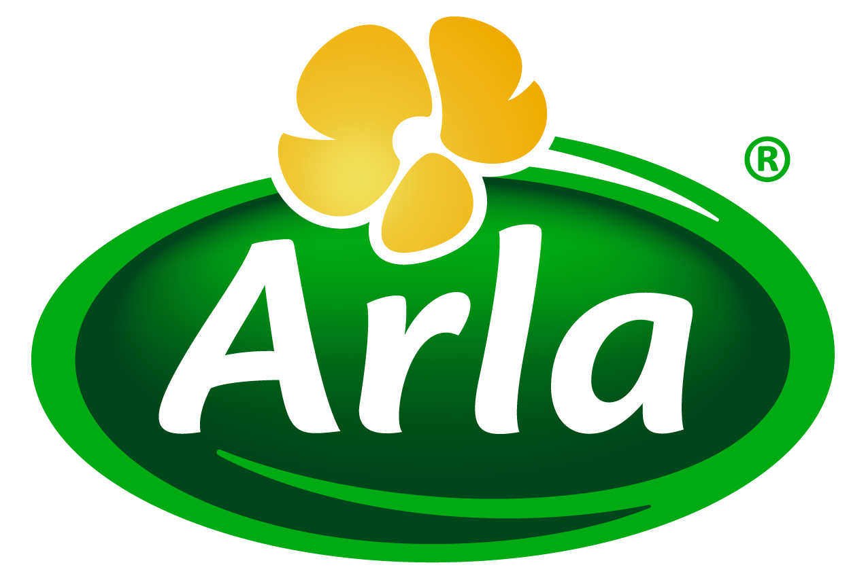
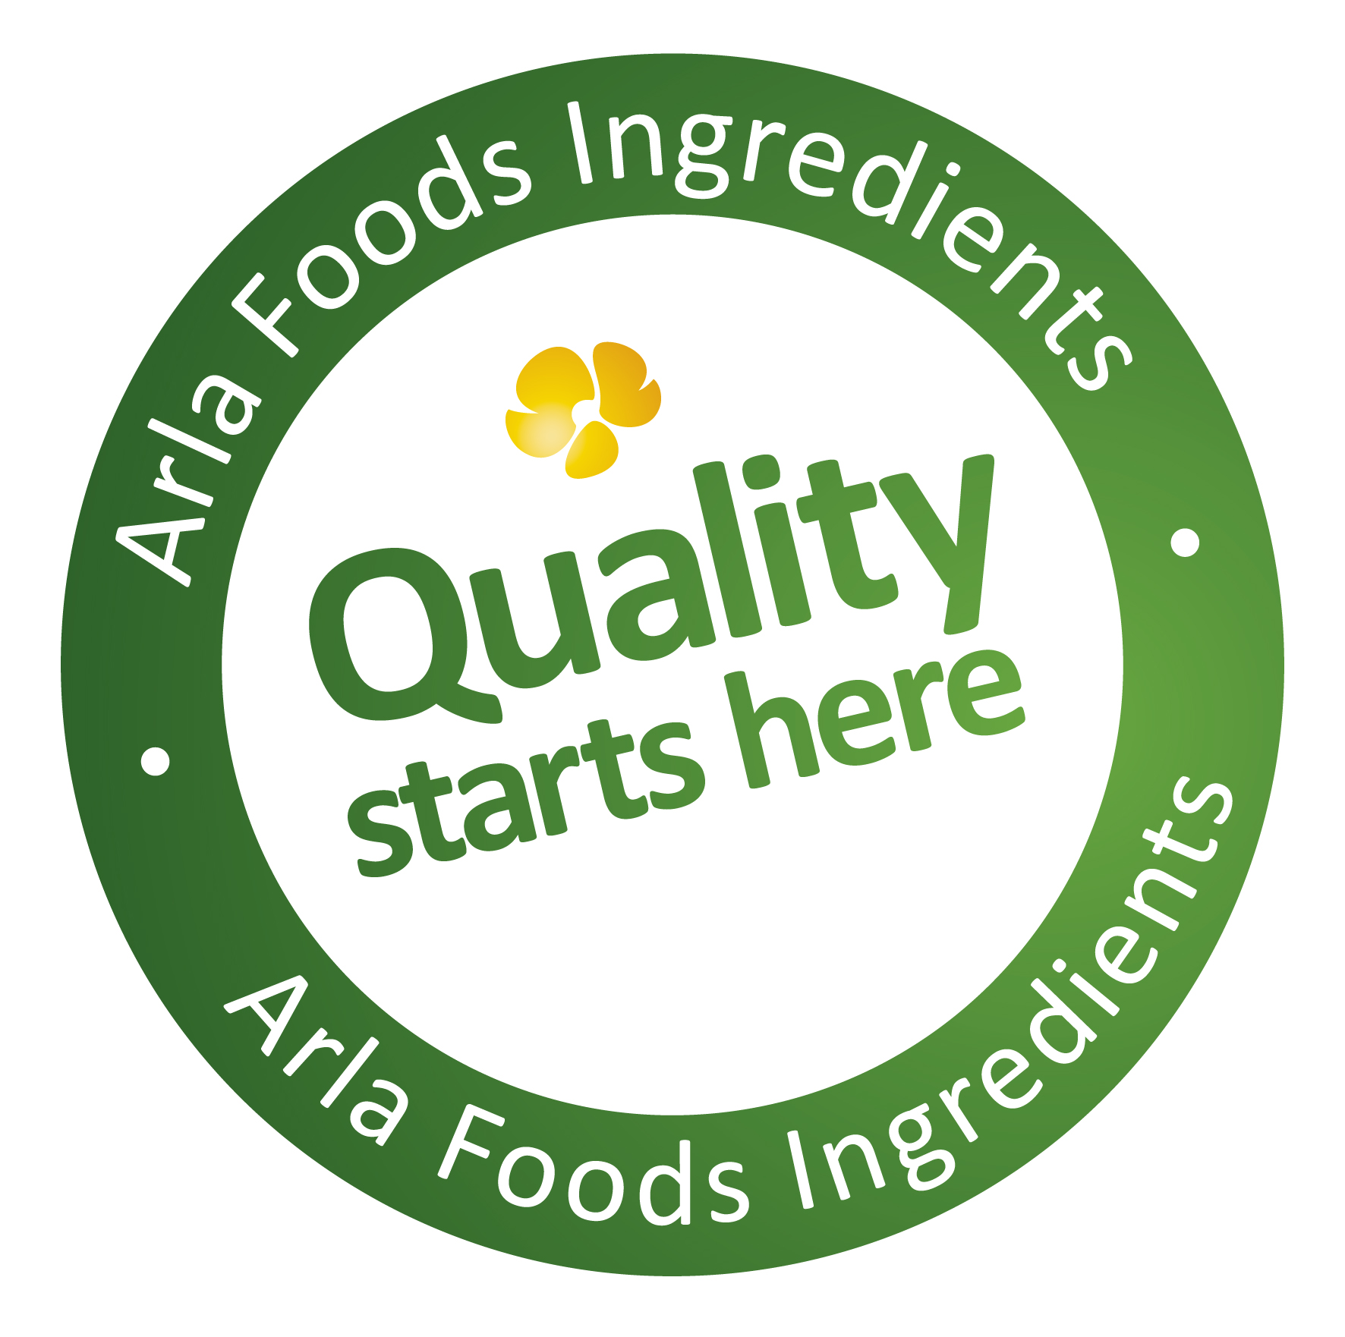

12 August 2014
PRESS RELEASE

Whey and lactose production gets underway
at new ArNoCo joint-venture factory

Production has begun at a new whey and lactose production facility that is a joint venture between Denmark’s Arla Foods Ingredients and German dairy co-operative Deutsches Milchkontor (DMK).

The factory, which cost more than €50 million to build, is operated by ArNoCo, an organisation created by the two companies specifically to produce high quality ingredients for the food and beverage industry. Located in Nordhackstedt in Germany, just 22km south of the Danish border, the new facility is adjacent to an existing 60,000 tonnes-a-year cheese factory owned by DMK. This site produces Mozzarella and semi-hard cheeses such as Gouda.

ArNoCo will use the whey by-product from DMK’s cheese-making operations to produce whey protein concentrate ready to be converted into value-added ingredients for the bakery, dairy and nutrition sectors.

The new site will also produce 25,000 tonnes of lactose annually, which will be processed and sold as Arla Foods Ingredients’ premium quality Dry Blend lactose for infant formula.

Hans Jørgen Lauridsen, ArNoCo’s Project Director, said: “This new joint venture will enhance Arla Foods Ingredients’ position as one of the world’s leading suppliers of the highest quality whey protein and lactose ingredients. The market for these products is growing faster than the ingredients industry can supply them, so the establishment of ArNoCo in co-operation with DMK is a significant development.”

Following a test production phase in July, the ArNoCo factory is now running at 80% capacity and is on track to be at full capacity in September.

Hans Jørgen Lauridsen added: “The construction of the new ArNoCo factory in Nordhackstedt is part of our quest to fulfill the pledges we make under our ‘Quality starts here’ brand platform, which promises to offer our customers security of supply backed by adequate capacity, logistics and documentation, along with uniform high product quality, supported by strong traceability.”

ENDS

For more information, please contact:

Miranda Mills, Ingredient Communications
Tel: +44 207 193 4167
Email: Miranda.mills@ingredientcommunications.com

About Arla Foods Ingredients
Quality starts here: Arla Foods Ingredients is a global leader in natural whey ingredients for products in a range of categories – from bakery, beverages, dairy and ice cream to clinical, infant and sports nutrition.
The cornerstones of our business are innovative ingredients, world-class facilities and a staff of dedicated experts. Drawing on our portfolio of functional and nutritional whey proteins, milk minerals, lactose and permeate, our expert team delivers solutions that bring new food products quickly and efficiently to market. Our application centres run hundreds of customer product trials every week. All ingredients are produced using state-of-the-art processing technology at our plant in Denmark, or by one of our joint ventures in Argentina, Germany and the UK.
Arla Foods Ingredients Group P/S is a 100% owned subsidiary of Arla Foods, a global dairy company and cooperative owned by dairy farmers in Denmark, Sweden, the UK, Germany, Belgium and Luxemburg.

RSS Feed
Visit our website at www.arlafoodsingredients.com/news and sign up to our News RSS feed for all the latest developments – updated regularly.

Twitter
Follow us on twitter for all the latest updates @ArlaIngredients

