**HAGLÖFS’ KHIONE & NENGAL – BUILT TO HANDLE THE NORDIC WINTER**

*(Stockholm, October 2019)*

**Haglöfs continue to evolve its popular Khione and Nengal Freeride Collection, with an addition of the new Nengal 3L PROOF™ Bib Pant to the range, as well as a limited-edition heritage design colorway. The products in this range have been made using Haglöfs' own high-performance, fluorocarbon-free PROOF™ ECO material. They're built to handle the Nordic winter and keeps you comfortable when the weather changes – and they're perfect for harsh, rugged conditions out in the backcountry.**

**The collection still contains the core items from last season, which were created** for maximum functionality and high performance**.** They're smartly designed, easy to adjust, ventilated, reinforced and built for action and motion. They also contain built-in trackable RECCO® reflectors for extra safety. They're equipped with handy features like three-way adjustable hoods, adjustable suspenders and two-way zippers - small touches that come in really handy whenever you find yourself out of bounds.

NENGAL 3L PROOF™ BIB PANT

This season's major update is the addition of the Bib Pant: designed and tested with help from Haglöfs’ ambassador Antti Autti. The water- and windproof Nengal 3L PROOF™ Bib Pant is built for epic, deep powder days. Designed to help protect you from even the harshest elements, the item includes an embedded RECCO® reflector, reinforced areas where it counts and adjustable suspenders. The Bib Pants are also constructed to keep you cool when your pulse and temperature rise, thanks to long ventilation zippers. Like the rest of the collection, they have fluorocarbon free DWR-treated surfaces to help repel water & dirt.

HAGLÖFS’ INTERPRETATION OF ‘KURBITS’

Haglöfs has also introduced a new colorway, inspired by the region where the company was originally founded. The Khione & Nengal 3-layer PROOF™ jackets will be available in a limited edition Kurbits-inspired pattern. Kurbits is a traditional floral pattern from the Dalarna region in Sweden, and – as always – Haglöfs stayed true to their way of doing things and came up with a new take on it, rather than simply copying and pasting an existing design. This way, Haglöfs have made an already-impressive line of freeride wear even more visually intriguing.

Haglöfs’ Khione and Nengal collection will be available from Fall 2019, in Haglöfs’ own stores and online, as well as through selected retailers worldwide.

**For more information, please contact:**

Lisa Grübb  
*Publishing Coordinator*  
[lisa.grubb@haglofs.se](mailto:lisa.grubb@haglofs.se)  
+46 8 121 362 61

PRODUCT SHEET

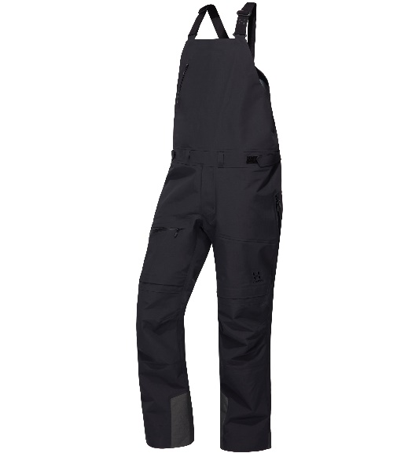**Nengal 3L PROOF™ Bib Pant**

Fabrics: PROOF™ ECO 3-layer 100% recycled Polyamide, rugged, dull, big-square ripstop weave face, laminated to a microporous Polyurethane membrane and a tricot backer, 187 g/m², bluesign® approved, Hydrostatic head: >15,000 mm; Moisture Permeability (inverted cup): >15,000 g/m²/24h Reinforcement: Schoeller® Keprotec® 73% Polyamide Cordura®, 14% Polyurethane, 13% Kevlar, reinforcement weave , 240 g/m², bluesign® approved.

Weight: 785g (Size L)

Available in size range:

Men: S-XXL

Recommended retail price: 400€

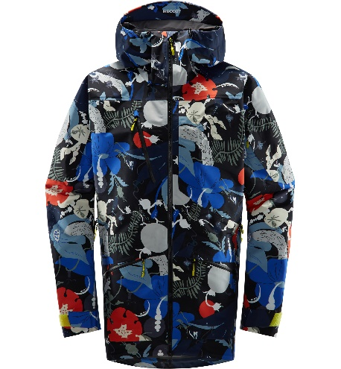

**Nengal 3L PROOF™ Kurbits Parka**

Fabrics: PROOF™ ECO 3-layer 100% recycled Polyamide, rugged, dull, big-square ripstop weave face, laminated to a microporous Polyurethane membrane and a tricot backer, 187 g/m² Hydrostatic head: >15,000 mm; Moisture Permeability (inverted cup): >15,000 g/m²/24h

Weight: 880 G (SIZE L)

Available in size range:

Men: S-XXL

Recommended retail price: 500€

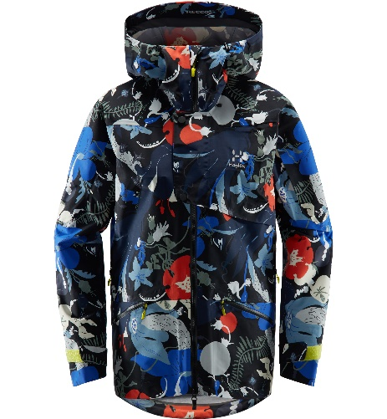**Khione 3L PROOF™ Kurbits Jacket**

PROOF™ ECO 3-layer 100% recycled Polyamide, rugged, dull, big-square ripstop weave face, laminated to a microporous Polyurethane membrane and a tricot backer, 187 g/m² Hydrostatic head: >15,000 mm; Moisture Permeability (inverted cup): >15,000 g/m²/24h

750 G (SIZE M)

Available in size range:

Men: XS-XXL

Recommended price: 500€