LOST RELICS OF THE KNIGHTS TEMPLAR

NEW AND EXCLUSIVE SERIES ON HISTORY®

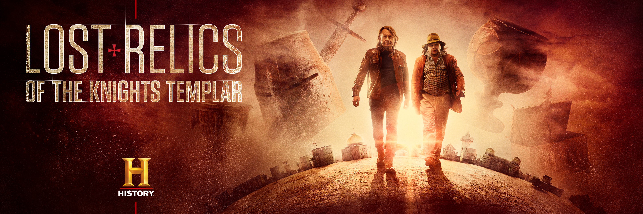

WEDNESDAYS FROM 22nd APRIL AT 22.00 (5x1)

INTERVIEWS AVAILABLE ON REQUEST
Web: https://www.historytv.eu/
Facebook: https://www.facebook.com/HISTORYnorge/
https://www.facebook.com/HISTORYdanmark/

CONTENTS

Series Press Release P.2

The Collection P.4

Series and Episode Synopses P.9

Cast Biographies P.13

Q&A with Hamilton White and Carl Cookson P.17
LOST RELICS OF THE KNIGHTS TEMPLAR

NEW AND EXCLUSIVE SERIES ON HISTORY®

WEDNESDAYS FROM 22nd APRIL AT 22.00 (5x1)

INTERVIEWS AVAILABLE ON REQUEST
Web: https://www.historytv.eu/
Facebook: https://www.facebook.com/HISTORYnorge/
https://www.facebook.com/HISTORYdanmark/

Join HISTORY® in uncovering potentially one of the most incredible treasure hauls of all time.

Lost Relics of the Knights Templar follows one of the world’s most prolific yet unknown treasure hunters, Hamilton White, and his long-time friend, Carl Cookson, as they trace the origin of an amazing hoard of relics – believed to have belonged to the legendary Knights Templar.

Until today, no major items belonging to the Knights Templar – the medieval Special Forces of Christendom, made famous by The Crusades – have ever been recovered. However, Hamilton and Carl believe they have at last discovered what everyone else has been looking for – a treasure trove of artefacts which reveal who the Templars were, how they worshipped, and why they were targeted, imprisoned and wiped out by Papal decree in 1307.

With possible key Templar relics in their possession – a black obsidian chalice, a Templar sword, an alabaster libation vessel, and an iron reliquary box – the duo travel all over Europe and the Middle East to trace the origins of their treasure.

Hamilton has operated in virtual anonymity for more than 30 years but is now breaking cover for the first time with property tycoon, Carl, to reveal the secrets of his multimillion-pound treasure hunting business.

Alongside Hamilton and Carl’s journey, the story of the Templars will be told by historians, including presenter and best-selling author of ‘The Templars: The Rise and Spectacular Fall of God’s Holy Warriors’, Dan Jones.

The series will follow Hamilton and Carl as they seek to establish the provenance of each relic from one of the most secretive organisations in history before they reveal the hoard to the world.

Historian Dan Jones said: “The Templars were one of the most famous, and notorious, organisations in western history. They emerged from the crusades and amassed huge wealth and property across Europe.”
“When they were wiped out between 1307 and 1312 most of their riches were either stolen or destroyed. People have been searching for Templar ‘treasure’ – real and imaginary – for generations, generally without finding very much. Hamilton and Carl have some intriguing finds and it's going to be exciting to see what they discover.”

Lost Relics of the Knights Templar (5x1) premieres on HISTORY® Wednesday 22nd April at 22.00.

ENDS

Episode 1 available here | Password – TEMPLAR | All episodes available on request

Additional imagery and episodes available upon request
Editor’s Notes
• Clips, viewing materials, biographies to be provided on request
• Images here: https://we.tl/t-YTNFjzDNi3
• Key art available here https://www.dropbox.com/sh/1qr0cxtzszcg6ne/AACCCcdVfq-8172mrHd2VBgBa?dl=0
• Interviews with cast and production team available
• HISTORY social pages @HISTORYdanmark @HISTORYnorge
• Website: https://www.historytv.eu/
• All information correct at time of writing

About A+E Networks UK
A+E Networks® UK is a joint venture between A+E Networks® and Sky. Its portfolio of quality factual and entertainment channels includes HISTORY®, Lifetime®, Crime + Investigation®, H2® and free-to-air channel BLAZE™. A+E Networks UK launched in November 1995 and now operates 18 channels, broadcasting into 56 million homes across 102 countries in the UK, Scandinavia, Benelux, Central & Eastern Europe, Africa and the Middle East. The venture has offices in London, Warsaw and Johannesburg. www.aenetworks.tv @AENetworksUK

For more information please contact:
Jo Fellows at A+E Networks UK / Joanna.Fellows@aenetworks.co.uk / +44 7583 022 665

The Collection
THE OBSIDIAN CHALICE

This spectacular chalice is made from one of the world’s rarest materials – obsidian, known as volcanic glass.
It stands at 21cm high, has a diameter of 14.5cm at the lip and measures 16.5cm across the most bulbous part of the bowl. Possibly of Byzantine manufacture, it could have been made in the 12th Century.

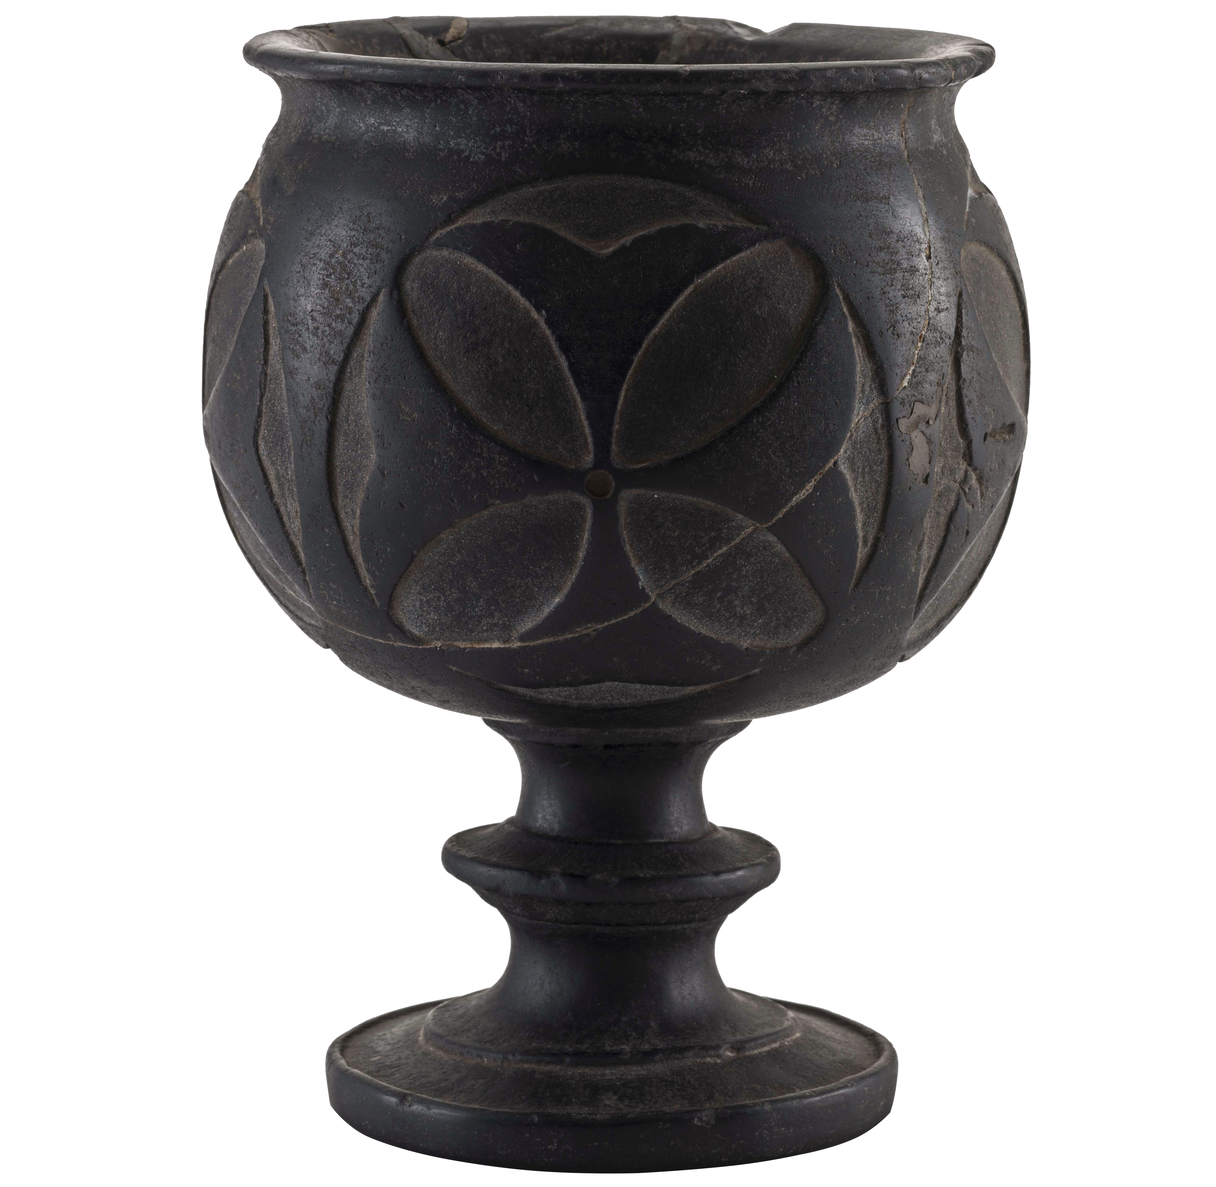

THE HELMET

This helmet is suspected to have been made in the 13th Century and is in the style of ‘Great Helms’ favoured by medieval knights. Heinrich Himmler may have once owned this helmet, and it is almost identical to one on display at the Altes Zeughaus museum in Berlin, named ‘The Dargen Helmet’.
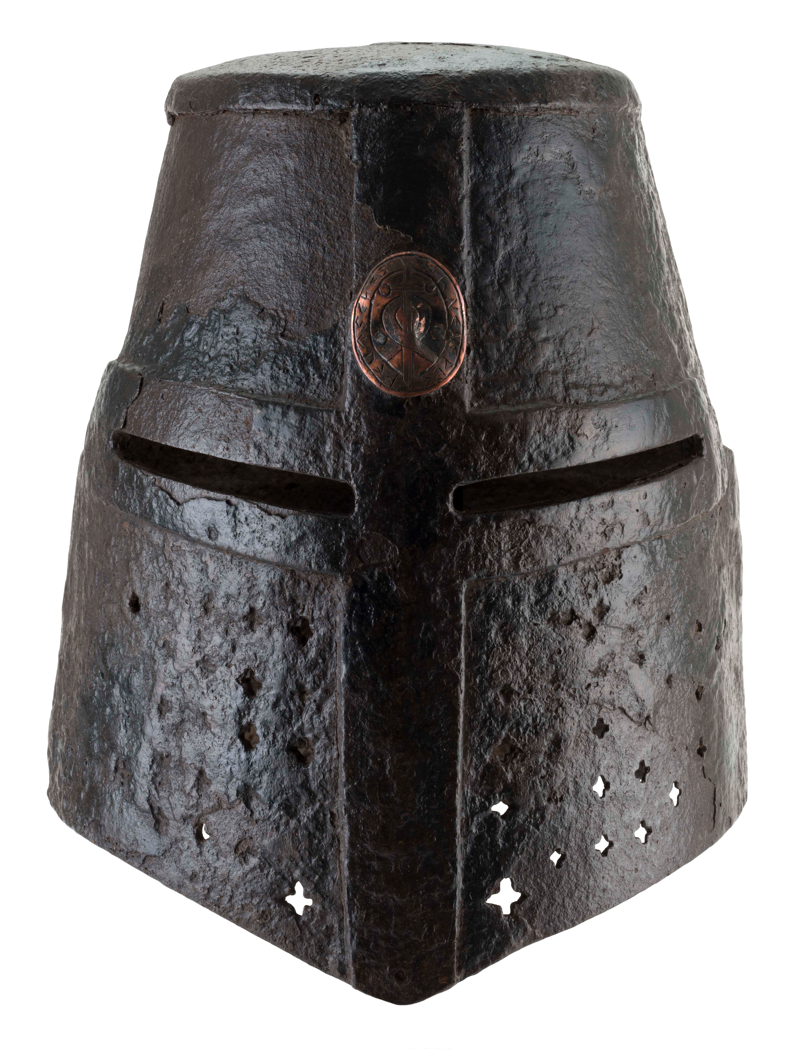

THE LIBATION CUP

This stunning piece of marble art could have been made in the 12th Century, with carved heads acting as handles.

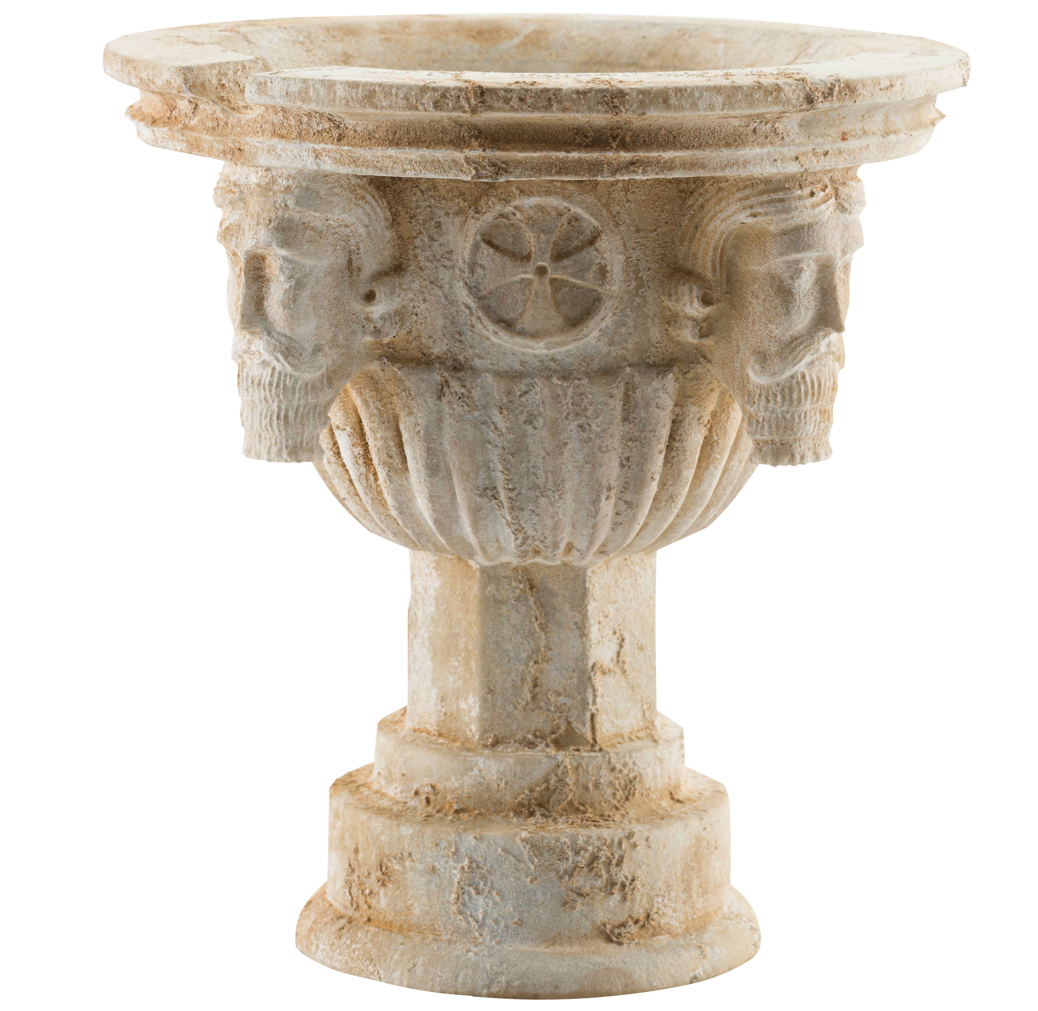

THE SWORD

This blade is 95.5cm long with several crosses visible and is a simple but elegant piece.

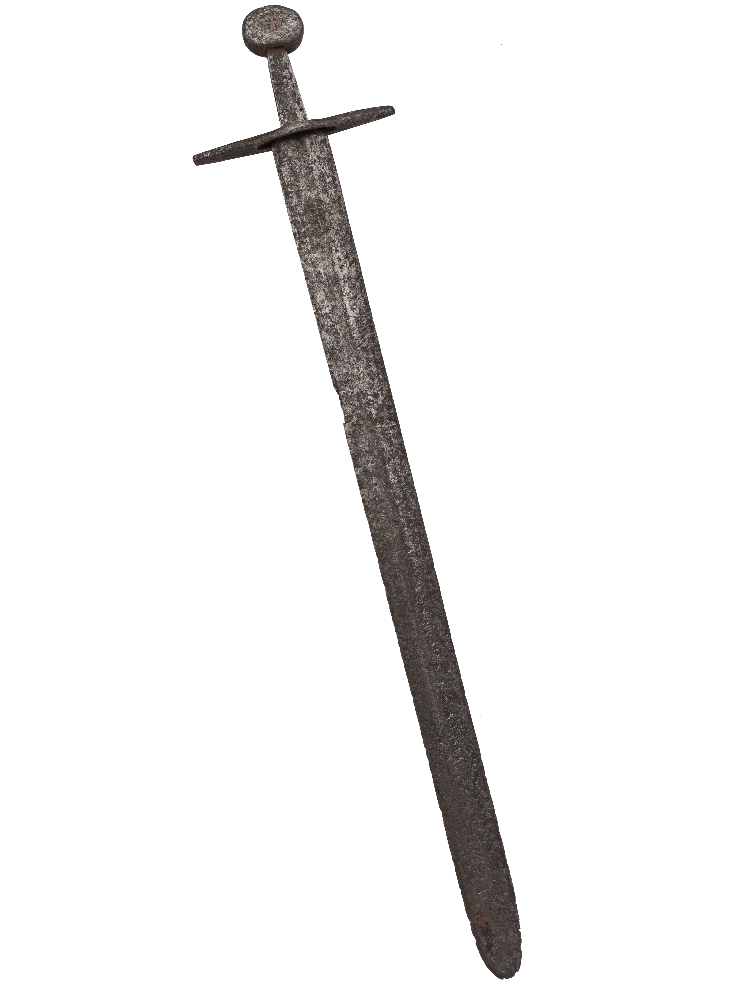

THE RELIQUARY BOX

This ornate item could have been made in the early 13th Century and is 29cm tall. Several characters are depicted on the box, possibly St George and Jesus Christ, but in Monk Robes.

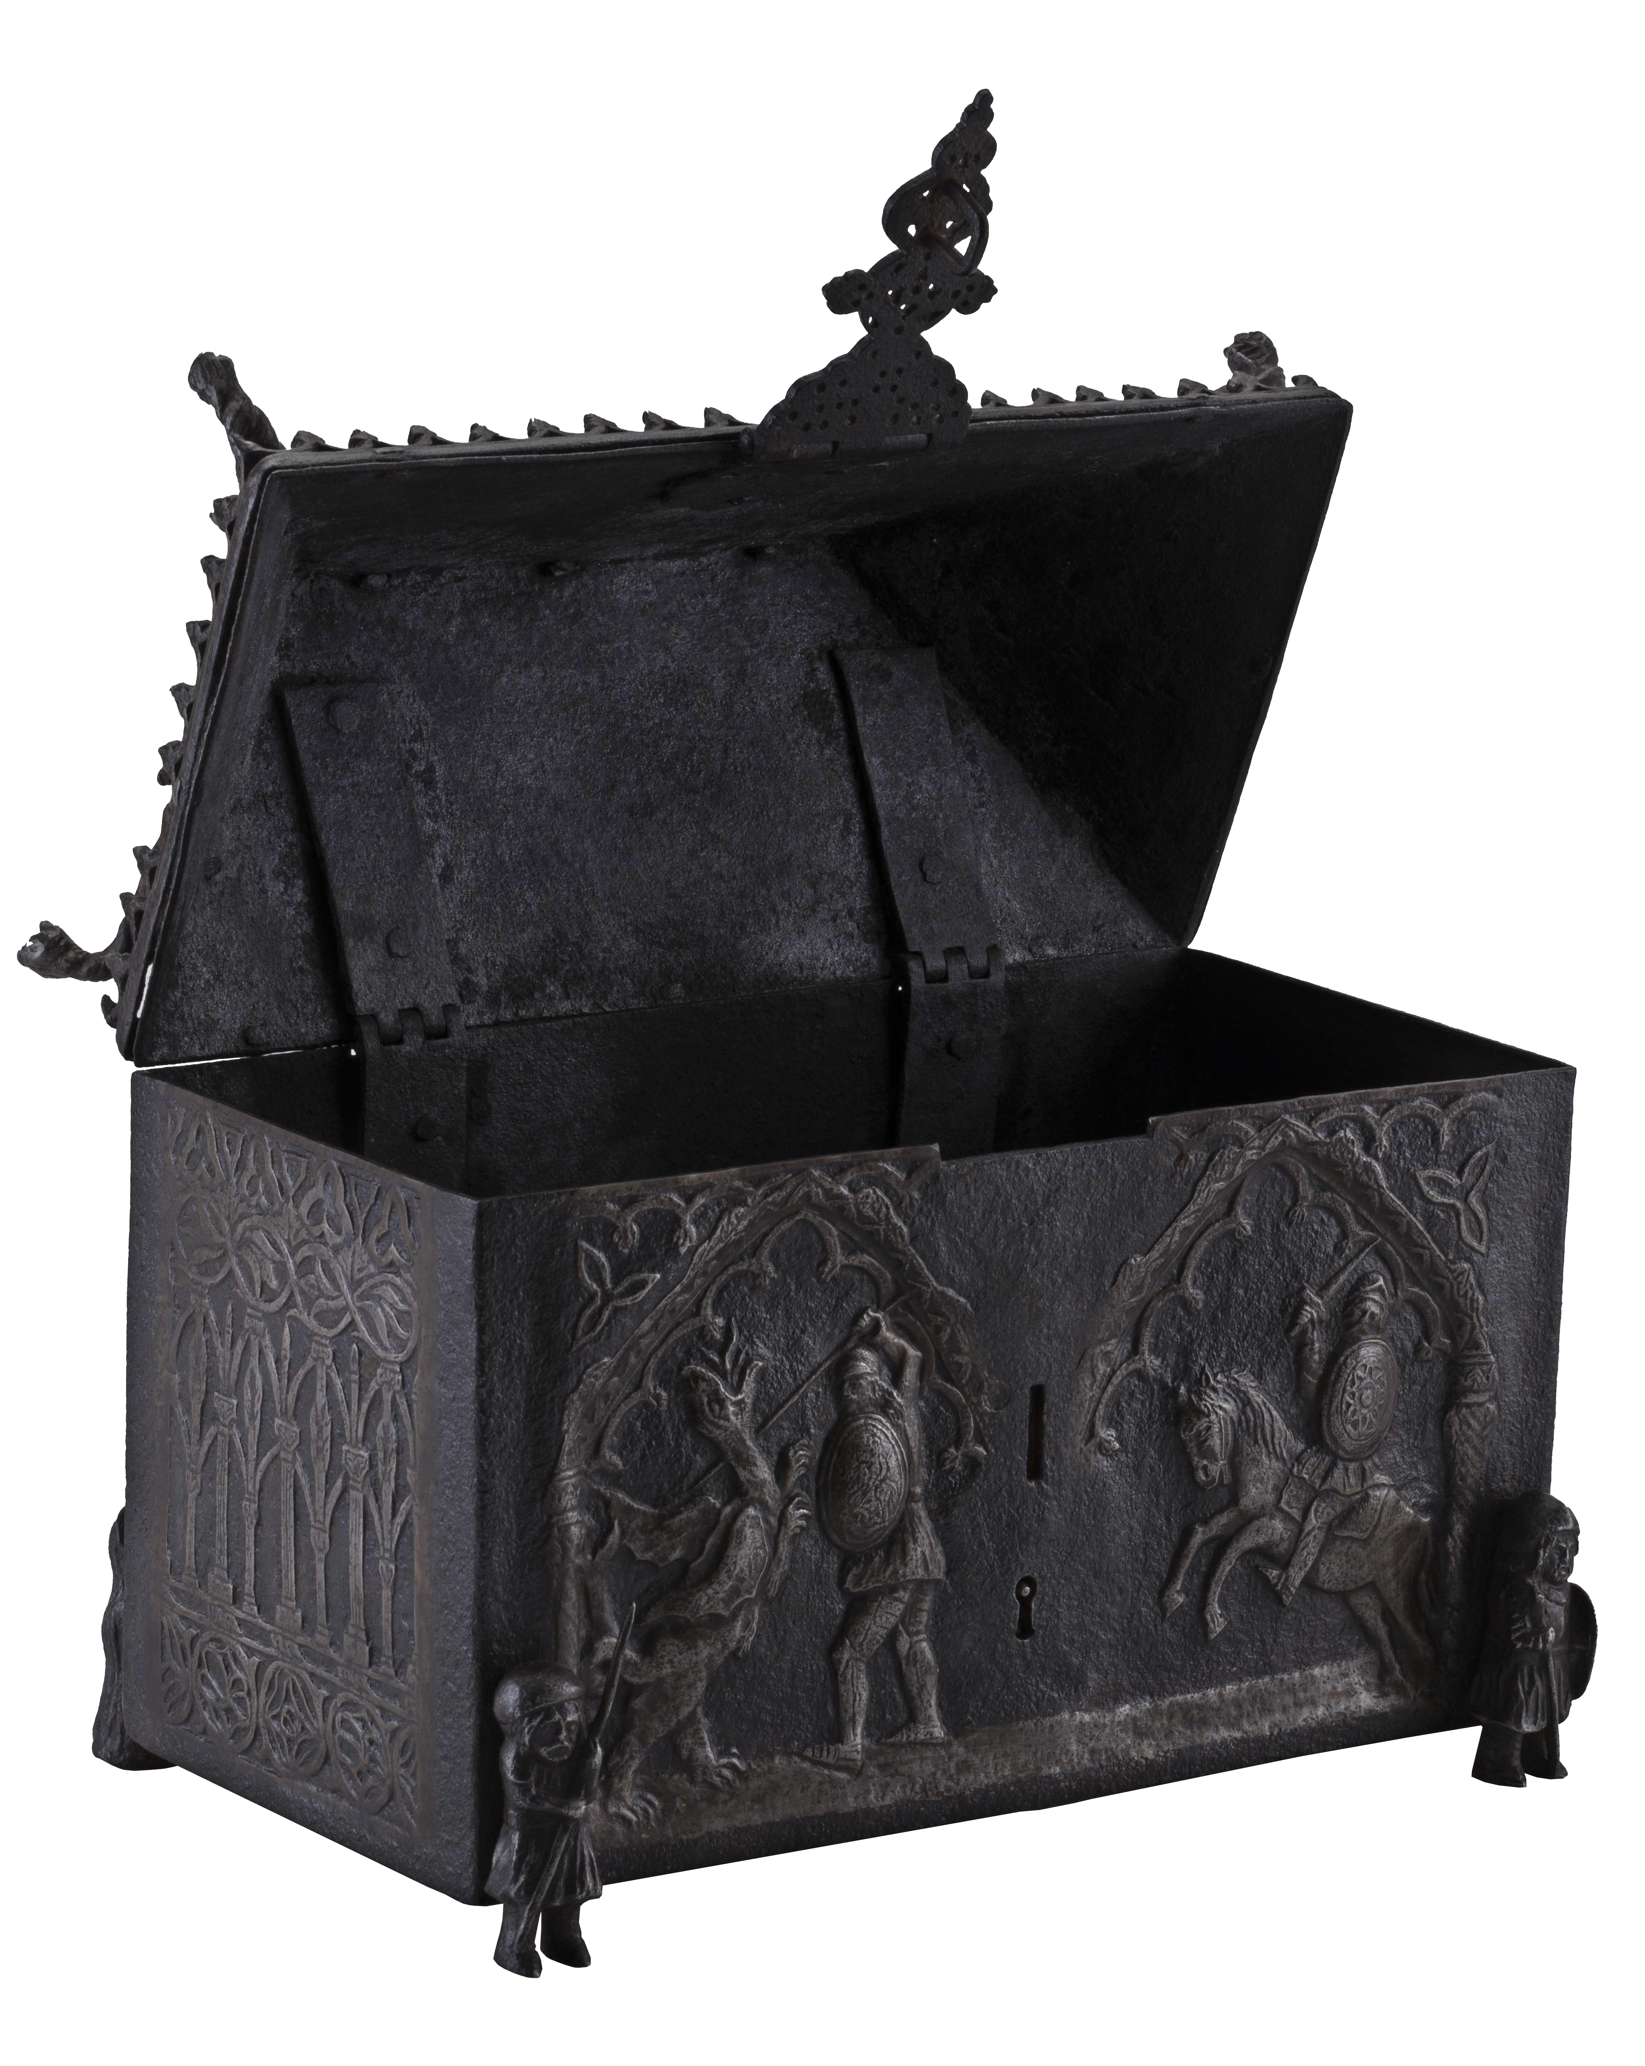

LOST RELICS OF THE KNIGHTS TEMPLAR

NEW AND EXCLUSIVE SERIES ON HISTORY®

WEDNESDAYS FROM 22nd APRIL AT 22.00 (5x1)

INTERVIEWS AVAILABLE ON REQUEST

SERIES SYNOPSIS
Lost Relics of the Knights Templar follows one of the world’s most prolific yet unknown treasure hunters, Hamilton White, and his long-time friend, Carl Cookson, as they trace the origin of an amazing hoard of relics – believed to have belonged to the legendary Knights Templar.

Until today, no major items belonging to the Knights Templar – the medieval Special Forces of Christendom, made famous by The Crusades – have ever been recovered. However, Hamilton and Carl believe they have at last discovered what everyone else has been looking for – a treasure trove of artefacts which reveal who the Templars were, how they worshipped, and why they were targeted, imprisoned and wiped out by Papal decree in 1307.

With potentially key Templar relics in their possession – a black obsidian chalice, a Templar sword, an alabaster libation vessel, and an iron reliquary box – the duo travel all over Europe and the Middle East to trace the origins of their treasure.

With the help of historians and authors, including Dan Jones, Carl and Hamilton learn more about Templar ceremonies and history, as well as what significant part each item in their extraordinary treasure hoard might have played. The guys also need to establish the provenance of each relic before they can reveal their hoard to the world.

EPISODIC SYNOPSIS
EPISODE ONE | WEDNESDAY 22ND APRIL AT 22.00

Meet Carl and Hamilton and marvel at their collections of classic cars, Viking treasure, Celtic gold and Nazi memorabilia, establishing them as obsessive collectors of rare and extremely valuable items. The duo invite historian and best-selling author of ‘The Templars: The Rise and the Spectacular Fall of God’s Holy Warriors’, Dan Jones, into their inner sanctum to reveal the hoard to him for the first time. Excited but cautious, Dan challenges Carl and Hamilton to prove each item’s provenance before they reveal their discovery to the world.

This will involve tracing the relics back to their country of origin, unpacking the history of each item and figuring out how they were used. Most important of all, they want to work out whether the existence of the relics sheds new light on our understanding of the mysterious Order of Knights Templar. Figuring out answers to these questions takes Carl and Hamilton to Wewelsburg in Germany, to Aubeterre in France, Tomar in Portugal, and Jerusalem, the heart and soul of the Templar story. Meanwhile, Dan Jones visits archives in London, Paris and Portugal to look at rare documents and books that shed more light on how the Templars were able to accumulate vast wealth and priceless treasure.

But first they explore the Nazi obsession with the Holy Grail and Templar treasure. Tracing the history of a crusader helmet in Hamilton’s collection of Nazi memorabilia that once belonged to Heinrich Himmler leads them to Wewelsburg Castle where Himmler planned to install the Grail if he ever found it. Along the way they unpack the story of Otto Rahn, the Nazi Grail hunter whose story would be the basis for the first Indiana Jones movie, The Last Crusade.

EPISODE TWO | WEDNESDAY 29TH APRIL AT 22.00

This episode focuses on the most stunning relic in Hamilton and Carl’s collection; the black obsidian chalice. They take it to Devon to be examined by Jonathan “Jonty” Tokeley-Parry, one of the most respected antiquities restorers in the business. He will attempt to trace the likely provenance of the piece and explain the nature of the crude repairs. With only half a dozen sources of black obsidian in the world, as well as it being one of the hardest substances in nature, how on earth did they create the chalice in the Middle Ages?

Carl and Hamilton leave Jonty to work on the chalice as they head back to Portugal to hunt for clues that could explain what the chalice would have been used for. They are met by local historian and tour guide, Joao Fiandiero at the Convento de Cristo, an extraordinarily well-preserved 12th century Knights Templar castle and convent complex. Joao explains some of the secret ceremonies of the Order of the Knights Templar that would have been carried out in the Charola, a spectacular private chapel modelled on the Church of the Holy Sepulchre in Jerusalem.
Back in the UK, Carl and Hamilton meet Roger Box in the Cotswolds. Roger, a former police detective and forensic archaeologist, has offered to help them decode the symbolic crosses that decorate the chalice. In Devon, Jonty’s got a big surprise in store for the guys as well. In his opinion not only is the chalice genuine but it would have been inlaid with gold and he has restored it to its former glory. Finally, historian and Knights Templar expert Dr Tim Wallace Murphy reveals the true significance of obsidian and the nature of the Gnostic rituals it would probably have been used in.

EPISODE THREE | WEDNESDAY 6TH MAY AT 22.00
This episode features the most dramatic object in the collection – the stunning Knights Templar Sword that Carl and Hamilton believe might have been used at the infamous battle of Acre – the last stand of the Knights Templar in the Holy Land.

Could it have belonged to fabled Grand Master Guillaume De Beaujeu, who was mortally wounded defending the city from Muslim marauders, and can they prove it? Carl and Hamilton decide to travel to the Temple Mount in Jerusalem where the Templars originally had their headquarters. They explore rumours that the Templars dug a network of tunnels beneath the Mount searching for the legendary sacred relics of King Solomon – including the Ark of the Covenant, a chest containing the stone tablets with the ten commandments that were handed down to Moses by God.
Roger Box flies out to Israel to meet the guys to introduce them to his contact, Lenny, a Jewish Glaswegian, who has been dealing in ancient artefacts from the area for 40 years. Lenny announces his opinion that the Templar relics are genuine – it’s an unexpected but welcome endorsement of the hoard. From Jerusalem they proceed to Acre, site of the infamous battle where they believe their sword was last used in anger. While the guys investigate the infamous siege of 1291 on the ground, in Paris Dan Jones digs out a medieval chronicle – the only first-hand account of the battle ever recorded.

Together the team learn of the horrific massacre in which Grand Master De Beaujeu went down fighting, but his sword and shield were saved by his comrades. All the civilians who were not able to flee the city by boat were either slaughtered or enslaved - only the Templar fortress held out. But ten days later that was torched and razed to the ground, killing everyone inside. So how then could De Beaujeu’s sword and the Templar’s treasure have got out of the doomed city? The guys meet up with Israeli archaeologist Edna Stern who tells them about a remarkable discovery – a secret network of underground tunnels that led from the Templar fortress to the port. For years historians knew that the entire Templar treasury had been smuggled out of the city seven days into the siege of the Templar fortress, but until the tunnels were accidentally discovered and Edna and her colleagues were able to excavate them, they never knew how. Finally, the riddle is solved.

EPISODE FOUR | WEDNESDAY 13TH MAY AT 22.00

Episode four centres on the Libation vessel. Exquisitely shaped from marble, it’s Carl’s favourite piece from the hoard and in pristine condition; adorned with four carved heads. Could these be a depiction of John the Baptist? And if so, why was John so important to the Knights Templar? In this episode Carl and Hamilton look into the beliefs of the Templars, investigate their downfall and look for clues of what might have happened to their relics following the collapse of the order. But first, Jonty’s Russian wife Zhanna Kovalchuk visits Hamilton to go through his collection of Nazi memorabilia, looking for pieces to be used in an upcoming international exhibition on the Holocaust.

Carl travels to France to the stunning medieval village of La Couvertoirade, he is looking for clues the Templars worshipped knowledge above all else and therefore might have venerated Jesus’ teacher John the Baptist, explaining the heads on their libation vessel. Carl and Hamilton consult author Dr. Tim Wallace Murphy for his take on Templar heresy.

Dan Jones travels to Paris to the Hotel de Soubise, part of the French Archives Nationale, to examine the interrogation roll of the Templars which contains confessions made under torture following the arrest of the members of the order in 1307. There were rumours the Templar treasure was smuggled out of Paris to a waiting fleet in La Rochelle in light of their persecution in France.

Carl and Hamilton also retrace the steps of Otto Rahn, the famous grail hunter employed by Heinrich Himmler, the head of the Nazi SS, with the help of eccentric film director Richard Stanley, now a leading expert on Rahn and his quest for the grail. They head on to explore a network of caves nearby with the help of guide Jeanne D’Aout, and they question whether sacred relics could have been deposited in these secretive initiatory cave systems.

Finally, the duo retrace the journey of the mysterious Templar fleet. They head to Tomar in Portugal to the Convent of Christ, where King Denis was sympathetic to the Templars. Hamilton provides a scrap of evidence that even suggests the Nazis came here looking for relics in the 1930s but were unsuccessful some thirty years before their hoard was dug up.

EPISODE FIVE | WEDNESDAY 20TH MAY AT 22.00

The series finale focuses on perhaps the most intriguing piece in the Templar treasure hoard – the reliquary casket. Carl and Hamilton know the casket dates to a later period – probably early 15th century, more than 100 years after the Templars were disbanded. Yet a series of engravings on it – the “box code” – appears to make veiled references to Templar beliefs including those deemed heretical by the Catholic church that would contribute to their downfall.

Carl and Hamilton must attempt to decipher the box code and to finally try to work out how and why the Templar treasure hoard was buried. To do that they must return to the Convento De Christo in Tomar, which is littered with clues about the meaning of relics in the hoard. There they discover that in 1307 the King of Portugal, Denis I, refused to comply with the Pope’s decree to disband the Templars. He allowed them to simply change their name to the Order of Christ and continue as before. But with their beliefs and rituals branded as heresy, they would have had to practice them in secret. This explains the cryptic nature of the box code that Carl and Hamilton can now unravel.

But why was their treasure buried and when? Dan Jones travels to Coimbra, 50 miles north of Tomar, home to the oldest university in Portugal and later to the Spanish Inquisition when it arrived in Portugal in the 16th century. At the university Dan examines some 16th century manuscripts that reveal the true horror of the Inquisition. Meanwhile, Carl and Hamilton discover that the Templars and their successors, the Order of Christ, would not be untouched by the inquisition. During this period all the tombs of the Templar Grand Masters in Tomar, bar one, were destroyed and members of the Order of Christ faced trial and even being burnt at the stake. This finally explains both why and when the Templar treasure hoard would have been buried.

Only one piece of the puzzle now remains. Returning home to the UK, Carl and Hamilton consult Dr Tim Wallace Murphy one last time. Could the reliquary box, which points to the way the Templars passed on secret knowledge to the Order of Christ, be the Rosetta Stone that points to the true meaning of the Holy Grail? Wallace Murphy explains that the Grail is not an object but a metaphor for a process of spiritual and intellectual enlightenment. One of the first Grand Masters of the Order of Christ was Prince Henry the Navigator. He was succeeded by King Manuel I who sponsored Vasco Da Gama’s voyages of exploration which would ultimately lead to the discovery of a maritime route to India and open up the spice trade. Could the knowledge handed down by the Templars have led to this European Age of Discovery that would transform the world forever? If so, the hoard itself and the clues therein could be said to be the Holy Grail.

LOST RELICS OF THE KNIGHTS TEMPLAR

NEW AND EXCLUSIVE SERIES ON HISTORY®

WEDNESDAYS FROM 22nd APRIL AT 22.00 (5x1)

Biographies
Dan Jones
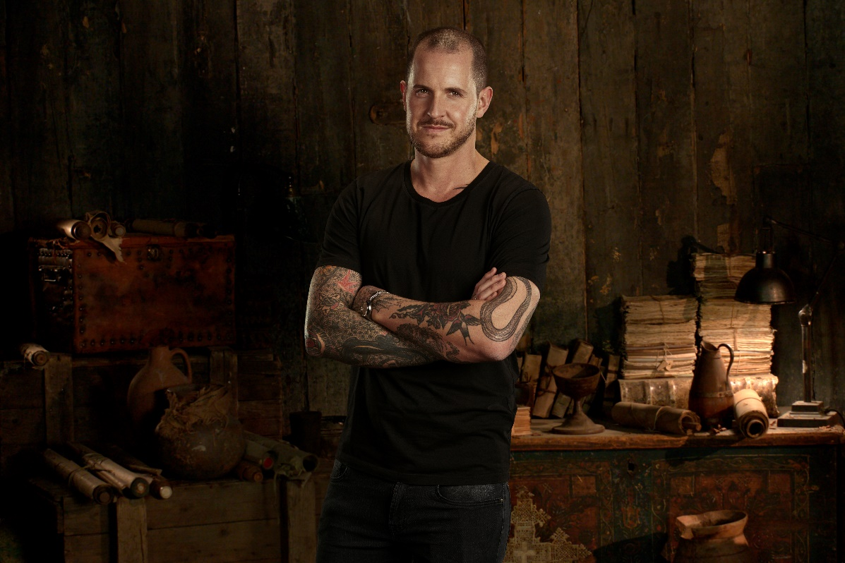

Dan Jones is the historic advisor on the brand-new HISTORY series: Lost Relics of the Knights Templar. Dan Jones is a bestselling historian, TV presenter and award-winning journalist. His books, which have sold more than a million copies worldwide and have featured on The New York Times and Sunday Times bestseller lists, include The Plantagenets, The Templars, and The Hollow Crown. He has also written books about the Peasants’ Revolt and Magna Carta, and co- authored The Colour of Time, with Marina Amaral. His latest book, published in autumn 2019, is Crusaders.

Dan has written and presented numerous TV series including Secrets of Great British Castles (Netflix, Channel 5), Britain’s Bloodiest Dynasty: The Plantagenets and London: 2000 Years of History. His shows have been sold to more than 40 countries. He has also appeared in programmes for BBC1, BBC2, BBC3, BBC4, Channel 4, Sky Atlantic and HISTORY® as well as dozens of radio stations in the UK and USA. He worked as a consultant on the A&E series Knightfall, wrote and hosted the official Knightfall podcast, and appeared in HBO’s official film charting the real history behind Game of Thrones.

Dan’s journalism appears on both sides of the Atlantic. For a decade he was a weekly columnist for the London Evening Standard, and he has also contributed to The Times, Sunday Times, Wall Street Journal, Washington Post, Daily Mail, Mail on Sunday, Daily Telegraph, Guardian, Smithsonian, CNN, GQ, Spectator, New Statesman, American Interest, BBC History Magazine, History Today, Tatler and Literary Review. He lives in Surrey, UK.

Hamilton White

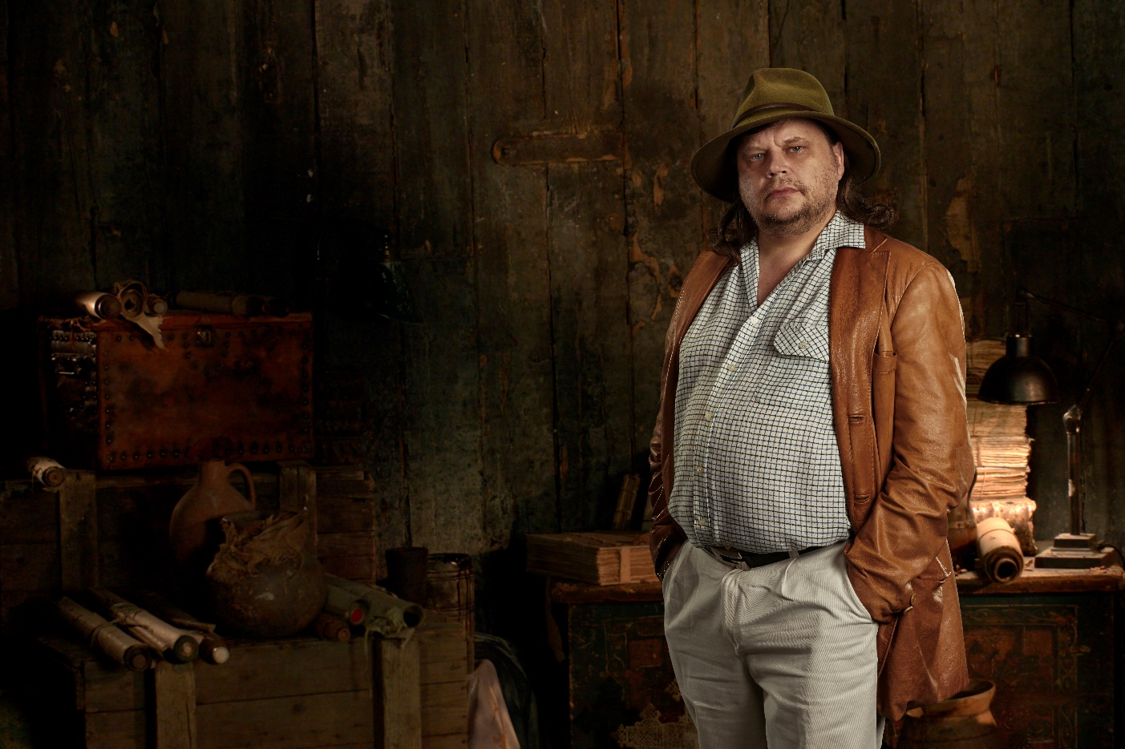

Hamilton’s large and eclectic collection started to come together when he began trading as a child using his pocket money – the collection covers a wide range of subjects from the prehistoric period to 1960s art. A long-term fascination has been the study of weapons and associated items from the Celtic, Viking and early medieval period. He has at his workshop a selection of cars and motorcycles undergoing restoration and numerous other projects under development.

After an intense last few years with “The Tomar Hoard”, Hamilton is dividing his time between his property on the Iberian Peninsula where he is developing a nature reserve and the Caribbean where he is diving on some previously unrecorded wreck sites. Whilst in the Caribbean he will divert to Nassau, location of “The Heritage Museum of the Bahamas”, the museum he founded to display his collection of historical artefacts relating to the region. Here visitors can see a wide-ranging selection of items from the colonial era, slavery, piracy and other unusual artefacts.

Later in 2020, Hamilton will be turning his attention to the next project, the setting up of an exhibition in Russia to loan out his collection of holocaust and WW2 items. This will be the first exhibition of its type ever held in Russia and he is working in collaboration with the Ministry of Culture. As part of this, there will be an unveiling of a unique and important WW2 relic last seen in Berlin in 1945. Hamilton does not shy away from controversial subjects and this exhibition is likely to attract global interest.

Carl Cookson

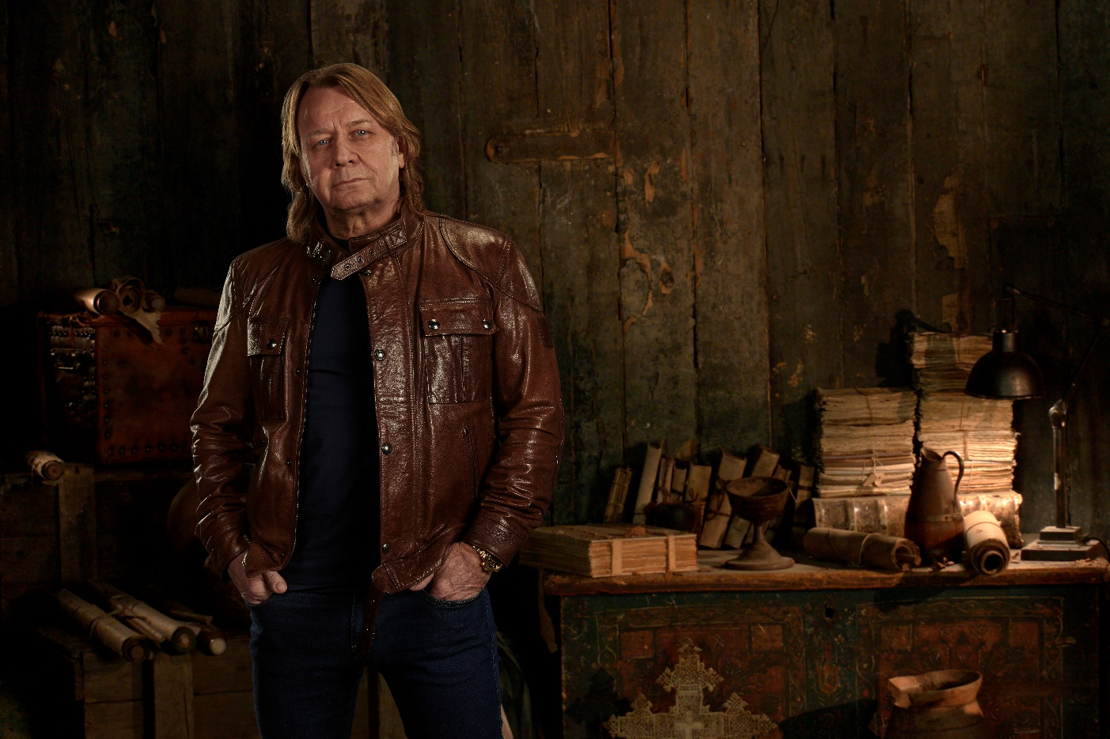

After starting and developing several successful business enterprises spanning back to the late 1970s, in August 2005 Carl and his brother Lawrence agreed the sale of their “Swift Rent A Car Limited” business to a FTSE 350 PLC for over £25 million Following the disposal of the business, Carl and Lawrence decided to invest their capital in commercial property. They have since achieved strong capital appreciation and upwardly growing yields and are continuing to invest and expand their position within this sector.

Carl has recently invested time and funds into charitable work such as the demining of Cambodia charity “Find A Better Way” started by Sir Bobby Charlton, where Carl joined as the treasurer. Under his stewardship, the charity received donations and pledges in excess of £15 million and has invested in seven landmine detection and characterisation projects at various universities, as well as funding humanitarian and educational activities and establishing an £8 million Centre for International Research for the Clearance of Landmines and Explosives at Manchester University.

Carl said: “My dad played a big part in my interest of the medieval era. He would tell me stories about how the people in the medieval age would have lived, both the good and the bad things that people had to experience. He was a captivating storyteller and he always painted a very vivid and real picture in my mind. In particular he would explain how difficult, dangerous and tough it would have been if you were born into peasantry. When I was a young boy all my mates and I loved the stories of King Arthur and the knights of the round table, Robin Hood and the Three Musketeers. We watched them all on our black and white TVs. We just couldn’t get enough of it. I was always interested in art and paintings. The Pre-Raphaelite painters held a special attraction to me, this was due to the fact that their focus was concerned with venerating the great romantic medieval age, its folklore, and the importance of chivalry, honesty and duty. Their paintings encapsulated perfectly how I romantically imagined life would be living in that era.

“It wasn’t until I was in my mid-forties that I was to be reacquainted with my childhood interest and my dreams of the medieval period. I was on holiday in France and found an amazing village where I made the unexpected decision to buy a property there. There was one building in the village that I had walked past and felt a very curious attraction to. It was this particular building that I eventually bought and became the very proud owner of. It then transpired that it was originally built by the Knights Templar in the 11th century to be used as their Commanderie.

“Anyway, I was so happy once I moved in. I couldn’t believe how amazing this house was and how incredible that it was actually a genuine part of the legacy of the Templars. By now I was completely hooked and thrown right back into my childhood interest of the medieval era and very focussed on the lives and the history of the Knights Templar. A year later, I met Hamilton in Monaco and told him about my house. He was equally fascinated and was eager to come and see the house. It was from this point of our friendship that my curiosity and intrigue became more and more engaged in the history of the Templars. A number of years later Hamilton took me to the Royal Armoury in Leeds, it was here that my initiation into the amazing world of medieval artefacts began. Naturally when Hamilton acquired the amazing Tomar Hoard, my learning curve to discover more about the Templars has become more intense and more exciting and of course more relevant.

“So far it has been an unreal journey. I feel honoured and very fortunate to be involved in this amazing story. From the beginning I have known exactly what the purpose of my role is in the story of the Tomar Hoard. It is a massive responsibility and something that is always in the forefront of my mind. I am committed to protect and feel dutybound to ensure that the Tomar Hoard finds its next rightful custodian.”

LOST RELICS OF THE KNIGHTS TEMPLAR

NEW AND EXCLUSIVE SERIES ON HISTORY®
WEDNESDAYS FROM 22nd APRIL AT 22.00 (5x1)

INTERVIEWS AVAILABLE ON REQUEST
Web: https://www.historytv.eu/
Facebook: https://www.facebook.com/HISTORYnorge/
https://www.facebook.com/HISTORYdanmark/

Find out more about Templar history here:
Q&A with Hamilton and Carl

- What is the Tomar Hoard and is it part of a larger collection of Templar related artefacts?

It is the name given to a group of items discovered in 1960 in the town of Tomar, former HQ of the Knights Templars in Portugal and subsequent to their dissolution, to the newly formed Order of Christ. The initial discovery – made quite by accident, contained approximately 30 items, the exact number unearthed is unknown, but the initial find contained all the important ritual vessels and chalices. The condition of the pieces in the hoard vary; there were two caches, one in a stone box structure, the second was buried in a wooden box which decomposed in the ground. It is believed that these items were hidden during the first part of the 16th Century when officers from the Spanish Inquisition came to Portugal investigating possible heretical activities.

- What are the items that feature in the HISTORY Series?

- The larger obsidian chalices
- A white ritual chalice
- Libation vessel with four faces
- Sword
- Iron reliquary casket
- Carved stone which features a knight kneeling before a chalice
- Carved stone – two monks, black and white kneeling beside a chalice
- Crusader era Great Helm – believed to have belonged to Heinrich Himmler

- What is the background to each item, how did they come into the collection and why are they important?

By the late 1960s many of the pieces were in Switzerland and remained there until the owners’ death when his collection of antiquities was sold. Hamilton White has reassembled the find and in doing so has located and secured many more Templar items, including unique stonework, Templar architectural pieces, carvings and other items of ritual significance.

They are a unique group of items which we believe to be from the Knights Templar. Potentially, the only surviving pieces of ritualistic and ceremonial Templar regalia. A number, of the agate and gold items match vessels known to have been taken from Constantinople in 1204 during the third crusade. In all probability many of the items left Acre in 1291 on the last Templar vessel that departed bound for Cyprus. This is recorded in period documents written by those at the siege, the fall of Acre effectively ended the crusader era and handed the Holy Land back into Arab hands. The end of the crusades rendered the Templars virtually obsolete and their downfall came in 1307.

- How long has it taken to put the collection together?

We have been working on this for over six years since acquiring the first piece. The interest in items from the crusader period dates back over 30 years as Hamilton has been collecting swords and armour of this era. Carl owned for many years a 12th Century Templar Commandery in the village of Aubeterre sur Dronne in France and has had a fascination for the subject before and since buying the property.

Further pieces are still coming to light, all Templar related, including some items from Israel which corroborate with the items found in Portugal. The collection is by far the largest group of Knights Templar pieces ever assembled. Jonathan Tokeley Parry, recognised as one of, if not the finest antiquities restorers in the world, has slowly been working through the group and producing lab reports on each piece.

- What is the estimated value of this collection?

A fixed value would be purely conjecture at this stage - as there has never been anything like this found before or come onto the art market. The value is hard to be specific about, clearly it is of enormous value both financially and in term of importance to history. As the collection is not for sale the owner isn’t keen to focus on this discussion; In some people’s eyes it will be seen as one of the greatest medieval discoveries every made, of the utmost importance and as such the only way to measure a realistic valuation is comparing it to equally important artefacts that have entered the art market in the “investment” price range. Art as an “investment” vehicle is a huge and booming market with more buyers than sellers. At the top end of the art world £100 million plus is not considered a big price amongst those investor/collectors who operate at this level. Items of this importance have no cap to their value and could easily reach the sale prices that important paintings regularly attain.

- Are there any plans for what happens next?

The research into the objects and the scientific study of the pieces by Jonathan Tokeley Parry is ongoing and will take many years to complete. A number of the items need careful conservation which requires time and money. There is likely to be a book produced that tells the story of the hoard and the journey it has taken since leaving the Holy Land in 1291. The time is now right for the items to be shown to the public and various options are being discussed to bring the collection out, either on loan to a suitable institution or a stand-alone exhibition. There has been interest from several countries, all want the kudos of being able to be the first to display the entire hoard together, possibly alongside Hamilton’s collection of weapons and armour.

- Who do I contact with further questions?

For all enquiries please contact Jo Fellows at A+E Networks UK. - Joanna.Fellows@aenetworks.co.uk / +44 7583 022 665.

ENDS

For more information please contact:

Jo Fellows at A+E Networks UK / Joanna.Fellows@aenetworks.co.uk / +44 7583 022 665

Editor’s Notes
• Clips, viewing materials, biographies to be provided on request
• Images here: https://we.tl/t-YTNFjzDNi3
• Key art available here https://www.dropbox.com/sh/1qr0cxtzszcg6ne/AACCCcdVfq-8172mrHd2VBgBa?dl=0
• Interviews with cast and production team available
• HISTORY social pages @HISTORYdanmark @HISTORYnorge
• Website: https://www.historytv.eu/
• All information correct at time of writing

About A+E Networks UK
A+E Networks® UK is a joint venture between A+E Networks® and Sky. Its portfolio of quality factual and entertainment channels includes HISTORY®, Lifetime®, Crime + Investigation®, H2® and free-to-air channel BLAZE™. A+E Networks UK launched in November 1995 and now operates 18 channels, broadcasting into 56 million homes across 102 countries in the UK, Scandinavia, Benelux, Central & Eastern Europe, Africa and the Middle East. The venture has offices in London, Warsaw and Johannesburg. www.aenetworks.tv @AENetworksUK

For more information please contact:
Jo Fellows at A+E Networks UK / Joanna.Fellows@aenetworks.co.uk / +44 7583 022 665

