**Spain next for the Bäckman’s**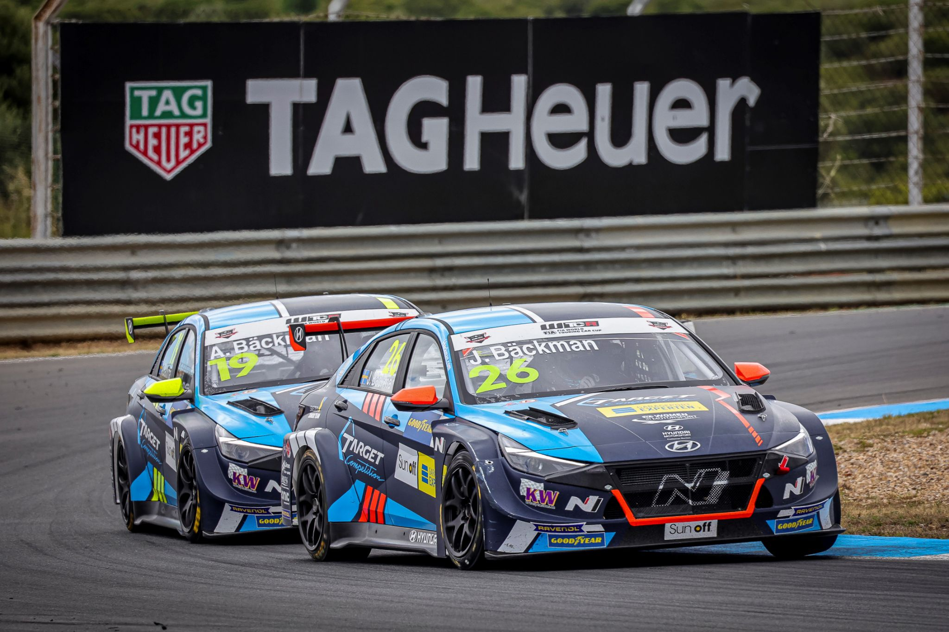Andreas and Jessica Bäckman are ready for the third round of WTCR this weekend in Spain.  
Photo: FIA WTCR (Free rights to use the image)

**The siblings Andreas and Jessica Bäckman competes this weekend in the third round of WTCR - FIA World Touring Car Cup in Aragón, Spain. After a tough weekend in Portugal, the Sweden National Team drivers are looking forward to a new weekend with new opportunities.  
- I feel prepared and ready. I hope we can find some speed in the cars so we can fight higher up in the field, Jessica Bäckman says.**

This weekend, July 10th-11th, the third round of the FIA WTCR series will be held at the classic Aragón track in Spain. It will be the siblings Andreas and Jessica Bäckman's third race weekend in WTCR, and they will compete for the Italian team Target Competition in their Hyundai Elantra N TCR cars.

- This is a track that I look forward to driving on, it is a fairly complete track that has basically all types of corners and also some quite large elevation changes. Hopefully we can find more speed in the cars this race weekend. This weekend will also be tough in other ways as it looks like it will be very hot. So it becomes important to prepare for this as well, **Andreas Bäckman** says.

**WTCR Race of Spain - Motorland Aragón**MotorLand Aragón, also known as the Circuito de Alcañiz, is a racing track located just outside Alcañiz in Spain. The track was built in 2007 and designed by the track designer Hermann Tilke together with the British architectural firm Foster and Partners and Formula 1 driver Pedro de la Rosa. 2010 announced that Aragón was awarded a contract to host MotoGP, which has been competing there ever since. 2020 was the first time that WTCR arranged a competition on the famous track.

This weekend, July 10-11th, it is time for WTCR to run on the track in the WTCR Race of Spain 2021 and it will also be WTCR's third visit to the track.

- New race weekend, new opportunities. It will be fun to compete again, I feel prepared and ready. I really hope we can find some speed in the cars so we can race and fight higher up in the field, looking forward to the weekend, **Jessica Bäckman** says**.**

**WTCR is broadcasted LIVE on Eurosport**Throughout this season, all competitions will be broadcasted LIVE on both Eurosport on TV and can also be streamed via Eurosport Player. The two free practice sessions are also broadcasted LIVE on WTCR's [Facebook](https://www.facebook.com/WorldTouringCarCup)- and [YouTube](https://www.youtube.com/FIAWTCR) pages.

**Timetable for this weekend (WTCR Round 3):**(all times are in CEST/Swedish time)

**Saturday July 10th:**09:45 Free Practice 1 (Broadcasted LIVE on Eurosport Player & on FIA WTCR on [Facebook](https://www.facebook.com/WorldTouringCarCup) and [YouTube](https://www.youtube.com/FIAWTCR))  
12:45 Free Practice 2 (Broadcasted LIVE on Eurosport Player & on FIA WTCR on [Facebook](https://www.facebook.com/WorldTouringCarCup) and [YouTube](https://www.youtube.com/FIAWTCR))  
16:30 Qualifying (Broadcasted LIVE on Eurosport Player)

**Sunday July 11th:**11:15 Race 1 (Broadcasted LIVE on Eurosport 2 & Eurosport Player)  
13:15 Race 2 (Broadcasted LIVE on Eurosport 2 & Eurosport Player)

**The FIA WTCR app**In the FIA WTCR app, you can follow the competitions with live timing, and there is also more information such as results and the championship standings. Here you will also find the latest news and photos. The FIA WTCR app is available on both [App Store](https://apps.apple.com/se/app/fia-wtcr/id358795125) and [Google Play](https://play.google.com/store/apps/details?id=com.eurosport.events.wtcc&hl=sv&gl=US).

**About the track (MotorLand Aragón):**

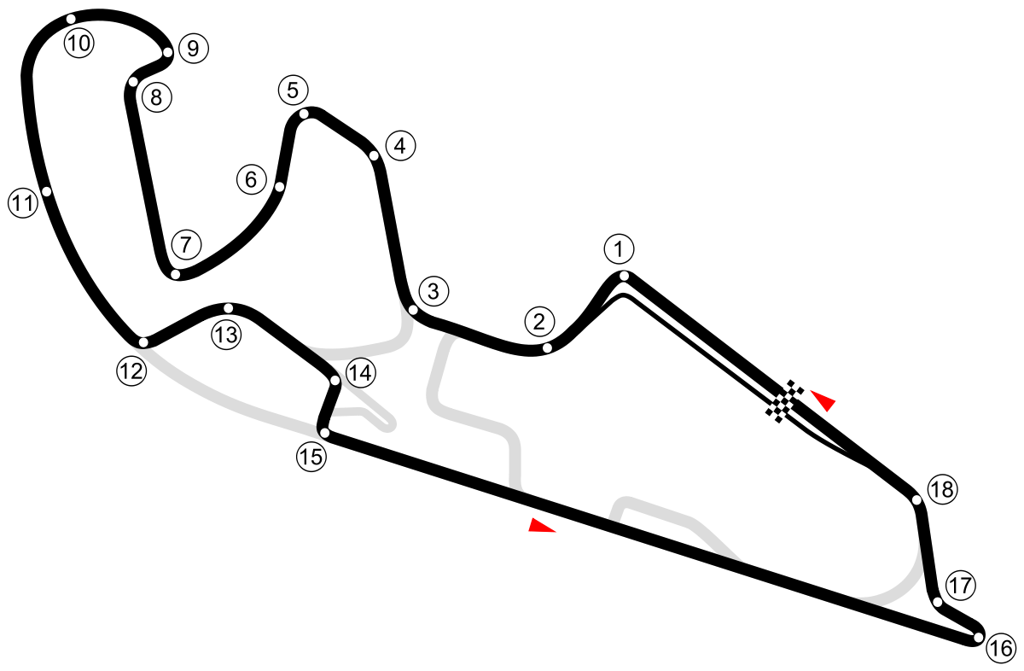

**Location:** Aragón, Spain

**Length:** 5,345 km

**Corners:** 18

**Race length:** Race 1: 10 laps (53,306 km) and Race 2: 12 laps (63,996 km)

**Track record (TCR):** 2:05.838 / average speed 152.9 kph, Norbert Michelisz (Hyundai i30 N TCR) 2020

**WTCR Series Standings**

**FIA World Touring Car Cup for Drivers WTCR – Overall (Top 3)**FIA WTCR 2021 (After 2 of 8 race weekends)

1: Jean-Karl Vernay (FRA), 61 p.

2: Attila Tassi (HUN), 56 p.

3: Yvan Muller (FRA), 56 p.

–

**21: Jessica Bäckman (SWE), 2 p.**

**22: Andreas Bäckman (SWE), 1 p.**

[See the full standings here](https://www.fiawtcr.com/standings/)

**WTCR Trophy – Overall (Top 3)**FIA WTCR 2021 (After 2 of 8 race weekends)

1: Gilles Magnus (BEL), 42 p.

2: Tom Coronel (NLD), 22 p.

**3: Andreas Bäckman (SWE), 17 p.**-

**4: Jessica Bäckman (SWE), 17 p.**

[See the full standings here](https://www.fiawtcr.com/standings/)

**FIA World Touring Car Cup for Junior Drivers – Overall (Top 3)**FIA WTCR 2021 (After 2 of 8 race weekends)

1: Gilles Magnus (BEL), 107 p.

2: Luca Engstler (DEU), 80 p.

**3: Jessica Bäckman (SWE), 71 p.**

[See the full standings here](https://www.fiawtcr.com/standings/)

**WTCR – FIA World Touring Car Cup for Teams – Overall (Top 3)**FIA WTCR 2021 (After 2 of 8 race weekends)

1: ALL-INKL.DE Muennich Motorsport, 108 p.

2: Cyan Racing Lynk & Co, 105 p.

3: ALL-INKL.COM Muennich Motorsport, 94 p.

–

**11: Target Competition, 3 p.**

[See the full standings here](https://www.fiawtcr.com/standings/)

​ ***Free rights to use the images.***

***Download press-photos here:***[***http://bit.ly/jabaeckman-photos***](http://bit.ly/jabaeckman-photos)[***https://www.mynewsdesk.com/se/ja-backman/images***](https://www.mynewsdesk.com/se/ja-backman/images)

