Prisdryss til Huawei i Barcelona
Huawei vant hele 47 priser på Mobile World Congress 2019. Den brettbare smartmobilen Huawei Mate X og de nye pc’ene MateBook 13, 14 og X Pro fikk størst oppmerksomhet.

Barcelona – 25. februar, 2019 – Etter lanseringen av Huawei Mate X og Huawei MateBook-serien, vant Huawei hele 47 “Beste fra MWC”-priser og topplister fra konferansen.

Media pekte på Huawei Mate X for sin innovative kombinasjon av 5G, en brettbar skjerm, AI og en banebrytende ny brukeropplevelse. Huawei MateBook X Pro imponerte media med sin 13,9-tommer 3K Ultra FullView-skjerm, kraftige ytelse og Huawei Share 3.0 som løser vanskeligheter med dataoverføring mellom Windows-PC-er og Android-telefoner. I tillegg lot de seg begeistre over Huawei MateBook 14 sin FullView-skjerm, høye ytelse, lette mobilitet og solide byggekvalitet.

Her er de 31 prisene Huawei Mate X har mottatt:

GSMA awarded the HUAWEI Mate X “Best New Connected Mobile Device at Mobile World Congress 2019” thanks to its Falcon Wing Mechanical Hinge, leading 5G capabilities, innovative interactions with consumers and HUAWEI SuperCharge. This highly coveted, special award is given by the organizer GSMA for newly released or soon-to-be-listed mobile products, signifying the highest recognition for pioneering the future of mobile technology. The GSMA represents the interests of mobile operators worldwide, uniting more than 750 operators with over 350 companies in the broader mobile ecosystem.

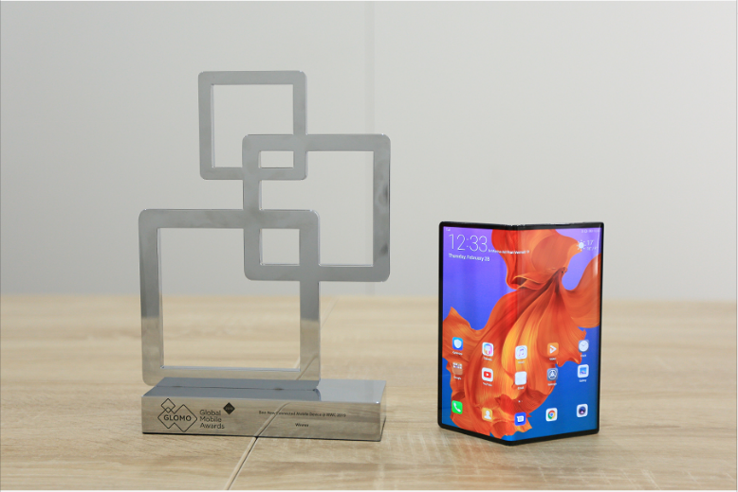

TechRadar gave the HUAWEI Mate X the “Best of MWC 2019” award, calling it as a smartphone that has brought “sci-fi imaginations” to life. Its Falcon Wing hinge mechanism was highlighted as a standout aspect of its beautiful design while its impressive performance was also acknowledged. TechRadar is an online publication focused on technology, with news and reviews of tech products, especially gadgets. It attracts 47.3 million unique monthly readers.

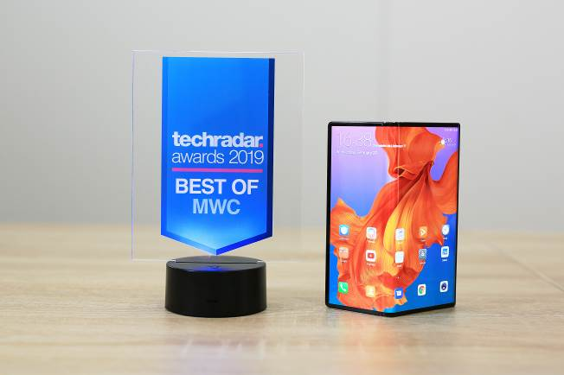

Tom's Guide chose the HUAWEI Mate X as “Best in Show,” saying its “packed with innovation” including 5G connectivity and a fast-charging dual battery. Tom’s Guide is a website offering unbiased reviews, buyer’s guides, tutorials and more. It has 46.11 million readers.

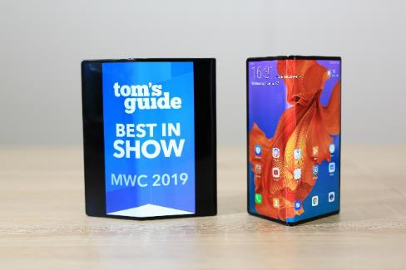

Android Central awarded the HUAWEI Mate X as “Best of MWC 2019” noting its Falcon Wing hinge and “super-thin” form factor. Huawei was also praised for the intuitive and easy-to-use approach to the overall design of the device. Android Central is a leading Android community that attracts 27.2 million monthly visitors.

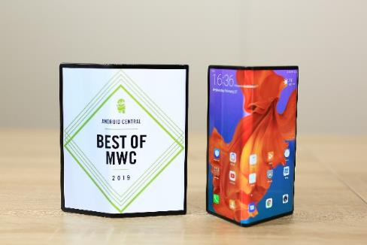

Digital Trends awarded the HUAWEI Mate X “Best Emerging Technology” of MWC, because it brings innovative technology to so many aspects of the device. They were impressed with the device’s design and the unique form factor – and said it is one of the most sensational new mobile technologies they have used in years. Digital Trends is a premier source for technology news and product reviews. It attracts 25 million readers monthly.

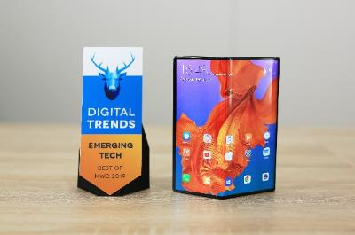

Trusted Reviews awarded the HUAWEI Mate X with “Best of MWC 2019” recognition. It said the HUAWEI Mate X “is without a doubt one of the most interesting things to arrive at MWC 2019” thanks to its super-fast 5G connectivity, all-new Leica camera array and a flexible OLED display. Trusted Reviews offers reviews of the latest consumer electronics, IT and computing products, technology industry news, analysis and product launches. It attracts 23.3 million readers.

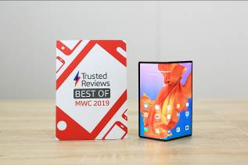

TechAdvisor named the HUAWEI Mate X a “Best in Show” award, saying Huawei “made a technological marvel” for its svelte design and powerful 5G chipset. TechAdvisor is a global IDG publication offering expert help and advice including news, hardware reviews, forums and more. It reaches 21.45 million readers.

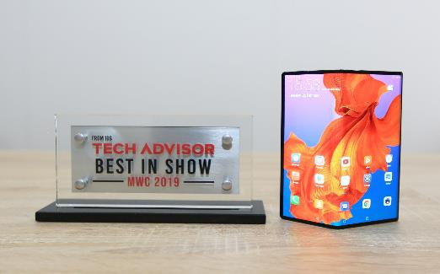

Android Authority recognized the HUAWEI Mate X as “Best of MWC 2019,” saying it’s an innovative “powerhouse” with impressive fast charging and a beautiful display. Android Authority provides news, tips and reviews on all things Android, and has 20.2 million readers a month.

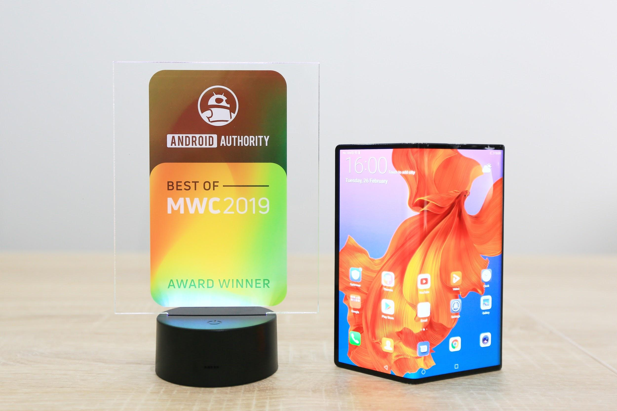

Pocket-lint recognized the “stunning” HUAWEI Mate X as “Best of MWC 2019,” thanks to its “elegant hardware” and stand-out, “intelligent” design. Pocket-lint is the largest independent gadget news and reviews site in the UK and has 17.7 million readers a month.

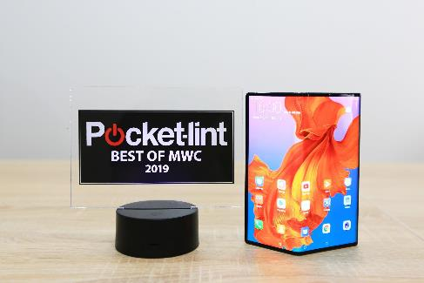

BGR recognized the HUAWEI Mate X with its “Best of MWC” award, commending the smartphone for an almost bezel-less display, which “looks amazing.” The ultra-thin device was called out for particular praise as well as the “incredibly fast” SuperCharge technology. BGR is a technology-influenced website covering topics such as consumer gadgets, entertainment, gaming and science. It has 17.5 million readers.

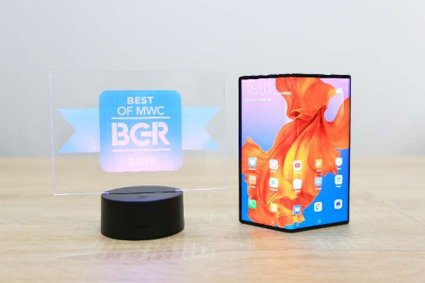

Android Police gave the HUAWEI Mate X its “Best of MWC 2019” award. The “crazy fast” charging technology was singled out for praise while the easy to hold form factor was also highlighted as a stand out feature. Android Police focuses on Android-based news, reviews and deals, and receives 13.7 million monthly visitors.

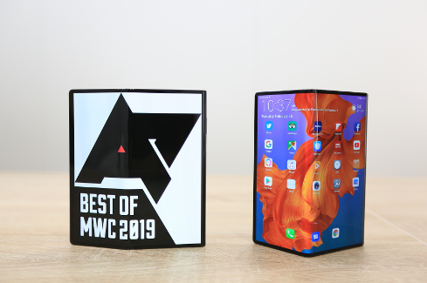

Expert Reviews gave the HUAWEI Mate X “Best of MWC 2019” award, citing its “impressive” display, highlighting that the foldable device “represents a significant development in terms of smartphone design.” Expert Reviews provides authoritative and independent technology reviews based on in-depth testing to help consumers find the perfect products to buy. It attracts 7 million unique monthly visitors.

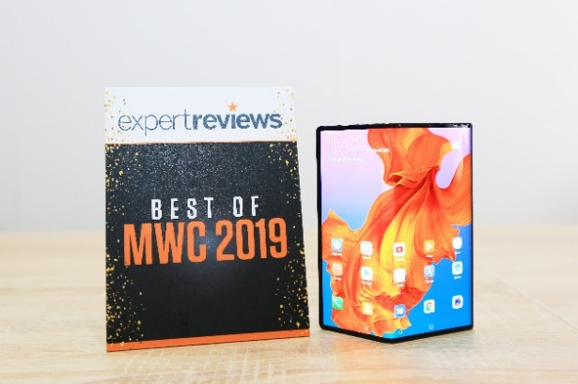

Android Headlines gave the HUAWEI Mate X “Best of MWC 2019” award for its unique “Falcon Wing Design” and stunning outward fold. Android Headlines is a global website dedicated to Android news and reviews about technology, as well as business topics. It reaches 3.83 million readers.

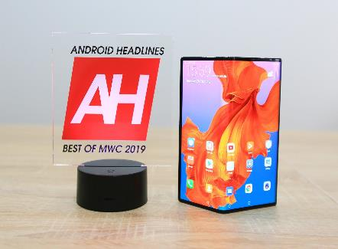

SlashGear awarded the HUAWEI X the “Editor’s Choice” for its “astonishingly slender” design, mentioning that “even out of 5G coverage, though, the phone should still wow.” SlashGear covers technology, science, automotive, gaming and entertainment, and has 3.2 million monthly visitors.

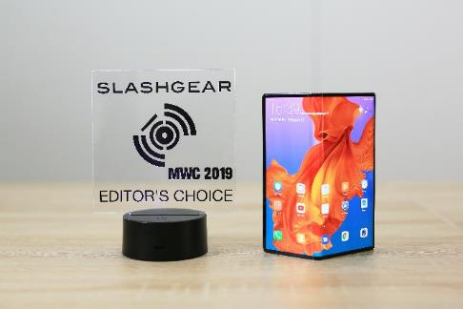

Ubergizmo presented the HUAWEI Mate X with the “Best of MWC 2019” award. The smartphone was congratulated for an intelligent design which enables an extremely thin form factor without compromising performance. Ubergizmo is a US-based technology reviews and news outlet with 2.9 million monthly visitors.

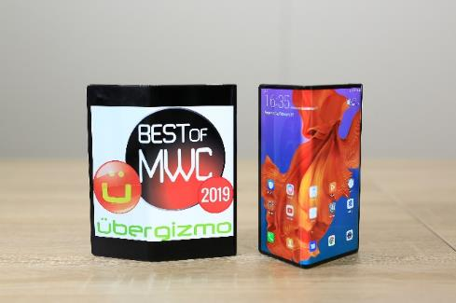

FoneArena awarded the HUAWEI Mate X the “Best of MWC 2019” for its stunning design and powerful charging capabilities. FoneArena is the leading independent mobile portal in India with 2.77 million unique visitors monthly.

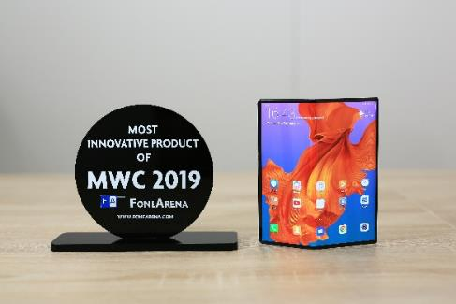

T3 awarded the HUAWEI Mate X an “Innovation Award,” calling Huawei a “5G folding phone pioneer” and applauded the device’s accessibility, quality and convenience, saying the handset, “definitely will appeal to far more than tech enthusiasts and, in partnership with the power that 5G networks will have in transforming how we use our personal mobile devices.” T3 covers the latest gadget and technology news, reviews, buyer's guides and features for smartphones, laptops, audio, gaming, fitness and more. T3 attracts 1.78 million unique monthly visitors.

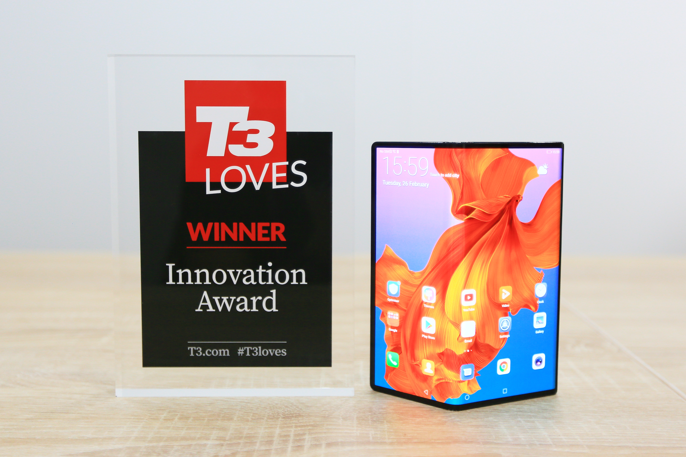

TechnoBuffalo honored the HUAWEI Mate X with its “Best of MWC 2019” award. The innovative camera system that allows users to see themselves on-screen when taking selfies was praised in addition to the “unique” display. TechnoBuffalo is a leading technology publication with a focus on consumer devices and reviews boasting 1.1 million monthly visitors.

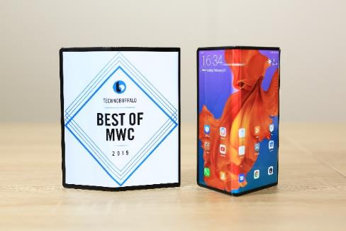

Mr. Mobile awarded the HUAWEI Mate X “Best of MWC 2019” for its stunning design and exciting innovation. Mr. Mobile only gives out one award during MWC for the very best product – so this is a highly prestigious award recognizing Huawei and the HUAWEI Mate X above everything showcased at MWC. Mr. Mobile is an influential mobile technology reviewer that has over 747K subscribers on his YouTube channel.

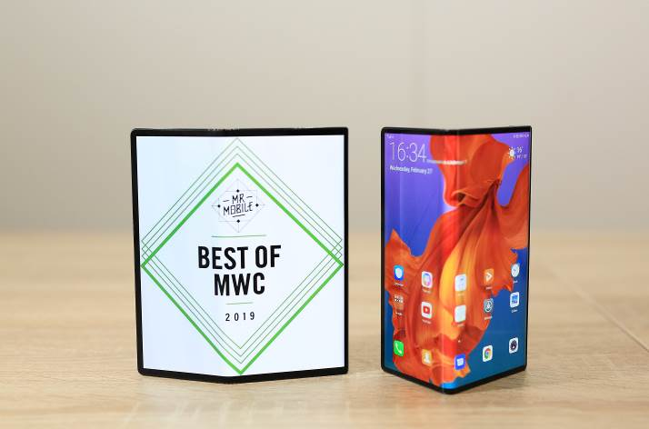

Gearbrain gave the HUAWEI Mate X its “Best of MWC 2019” award for its stunning display and unique form factor, stating that “smartphone industry has had some real energy injected into it this week.” Gearbrain is a US-based publication that provides advice and recommendations on new devices. It receives 437K monthly visitors.

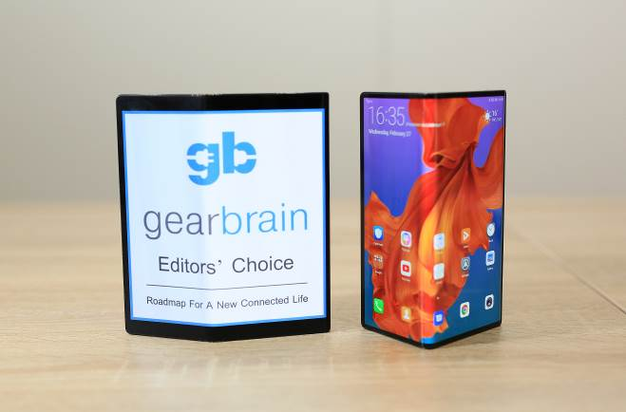

Talk Android awarded the HUAWEI Mate X “Best of MWC 2019,” thanks to its “best-in-class” cameras, 5G capabilities and long-lasting battery, concluding that the handset certainly has the “X factor.” Talk Android covers everything Android and Google related, and has more than 406,000 readers a month.

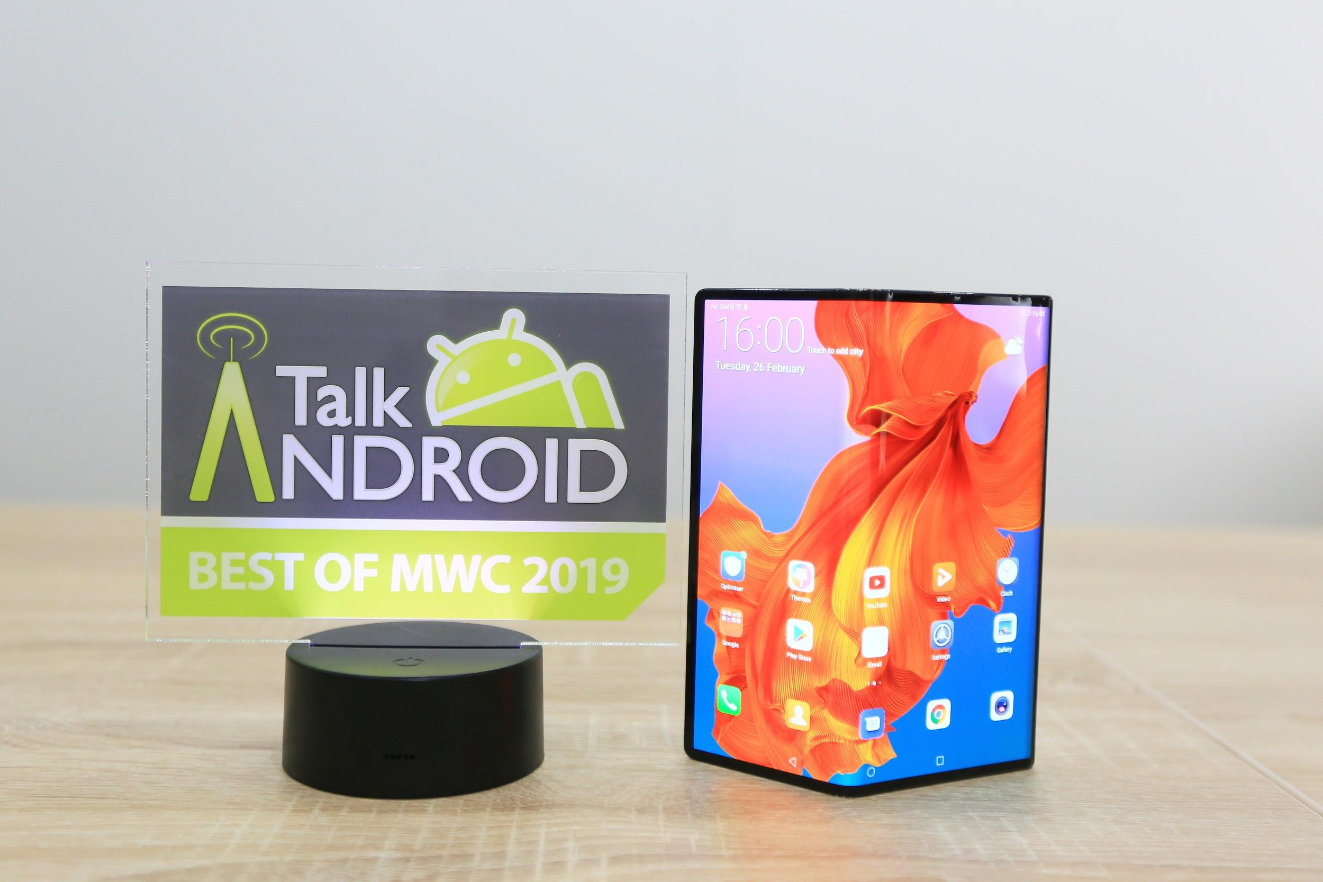

GadgetMatch gave the HUAWEI Mate X “Best of MWC 2019” award for its ergonomic curvature, unique design, powerful battery and charging capabilities. GadgetMatch is a leading multi-platform media company providing technology news, reviews and video content to help consumers find the right devices to suit their needs. It has 309,673 monthly readers.

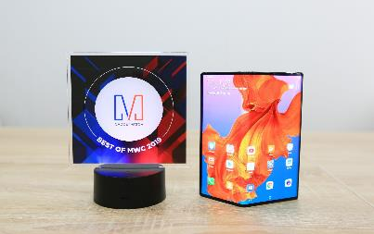

Techaeris gave the world’s first foldable 5G handset, the HUAWEI Mate X “Best of MWC” award at MWC 2019, thanks to its “high-capacity” 4500mAh cell, 5G capabilities and stunning design. Techaeris provides the latest consumer tech news and reviews to an audience of 307,000 readers a month.

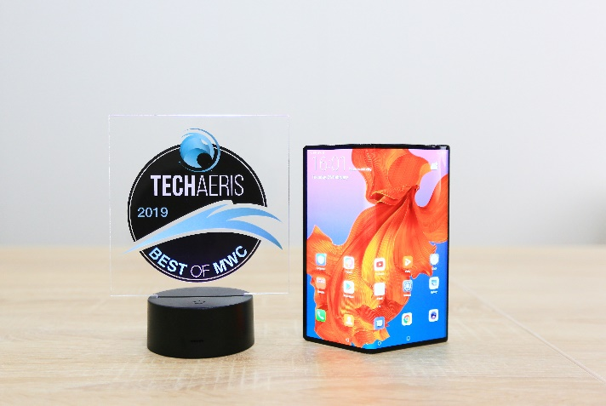

Gear Diary recognized the HUAWEI Mate X as “Best of MWC 2019,” noting that its “glorious” FullView display, long-lasting battery and 5G capabilities make it a “spectacular example of a folding phone done right.” Gear Diary is U.S.-based website that provides its users with easy-to-understand information about technology. It reaches 149,840 readers.

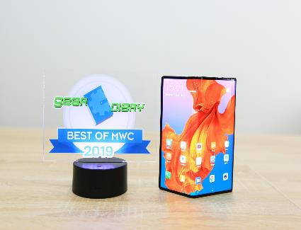

Big Tech Question (BTQ) awarded the HUAWEI Mate X the “Best of MWC 2019” award, calling it a “staggering piece of engineering” and “a cutting-edge phone.” Big Tech Question is a forum for all technology, and receives 105K monthly visitors.

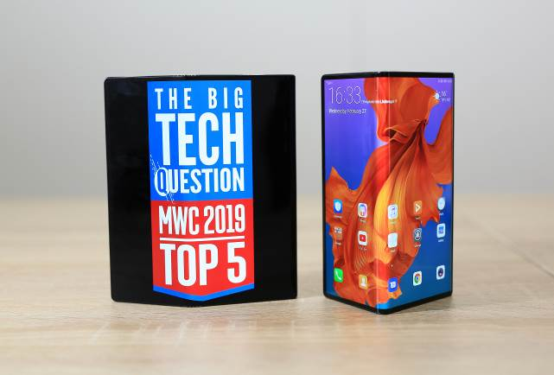

GeekSpin named the HUAWEI Mate X “Best of MWC 2019,” highlighting the foldable device’s “sophisticated” design, “brilliant” cameras and long-lasting battery. GeekSpin shares the latest on what’s trending in tech and lifestyle to an audience of more than 54,600 readers a month.

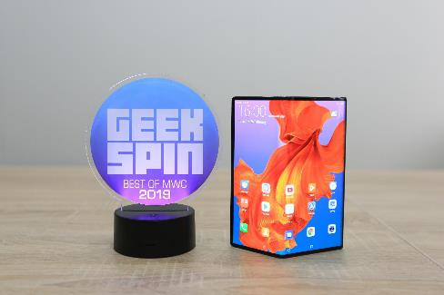

TechBox gave the HUAWEI Mate X a “Top Innovation” award for its stunning design, unique display and powerful performance. TechBox is a Slovakian publication that features the latest source of the newest tech and gadgets news, and detailed reviews.

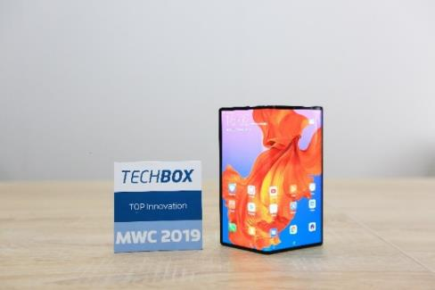

MyPhone honored the HUAWEI Mate X with the “Most Innovative Product MWC 2019” award. MyPhone is a Greek publication that is a mobile telecommunications portal, with an active forum, reviews of the latest mobile phones and technical documents and articles.

IT World Canada included the HUAWEI Mate X in its list of “Best Foldable Smartphones at MWC 2019” calling the device “the current champ in slimness” and “a gorgeous-looking phone.” IT World Canada covers the latest technology news for the region, and receives 216K monthly visitors.

Mashable featured the HUAWEI Mate X in its list of “Best Tech at Mobile World Congress 2019” saying the device was “hands-down the best foldable phone at MWC.” Mashable is an influential tech publication that receives 28 million monthly visitors.

Stuff included the HUAWEI Mate X in its list of “MWC 2019 Awards” calling the device “a game-changing smartphone.” Stuff covers breaking news and videos of the latest news stories and receives 2.8 million monthly visitors.

Her er de 12 prisene Huawei MateBook X Pro mottok:

TechRadar gave the HUAWEI MateBook X Pro the “Best of MWC 2019” award for “merging performance with panache.” The 91 percent screen-to-body ratio and “super-sharp” display were called out as particular high points of a “winning design.” TechRadar is an online publication focused on technology, with news and reviews of tech products, especially gadgets. It attracts 47.3 million unique monthly readers.

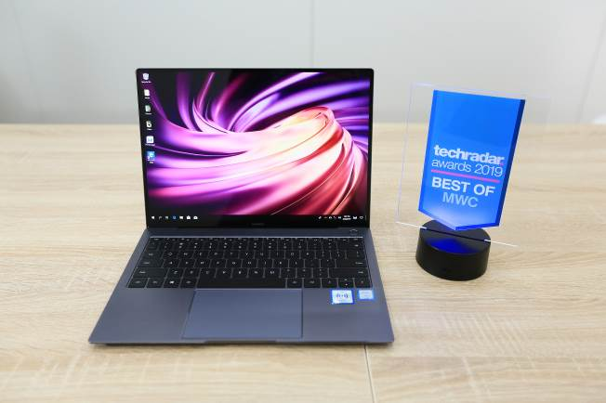

Windows Central gave the HUAWEI MateBook X Pro its “Best of MWC 2019” award. The “extremely thin” design as well as the powerful CPU and GPU were praised in particular. Windows Central is considered the leading source for Windows news, featuring reviews, help & tips, buyer guides, forums and accessories. The publication attracts 27.2 unique monthly visitors.

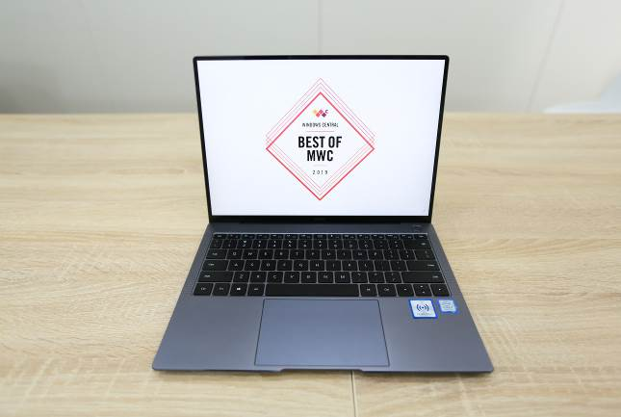

Trusted Reviews awarded the HUAWEI MateBook X Pro with the “Best of MWC” recognition. The publication said it is “a strong addition to the series” with a great screen, slick design and a lot of clever touches. Trusted reviews offers reviews of the latest consumer electronics, IT and computing products, technology industry news, analysis and product launches. It attracts 23.3 million readers.

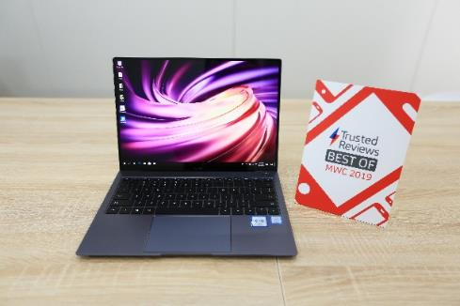

Android Authority awarded the HUAWEI MateBook X Pro the “Best of MWC 2019,” praising the laptop’s high-end specs, display and hardware. Android Authority provides news, tips and reviews on all things Android, and has 20.2 million readers a month.

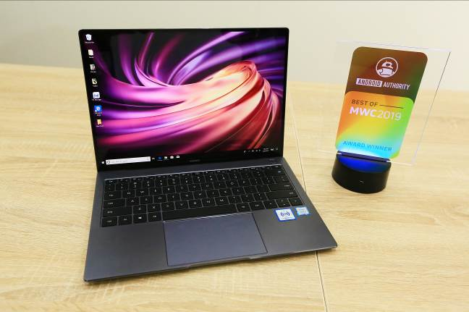

Pocket-lint named the MateBook X Pro as the “Best of MWC 2019” winner. The device was praised for its “stunning” design and high-end specifications that make it “great for work and play on the move.” Pocket-lint is the largest independent gadget news and reviews site in the UK and has 17.7 million readers a month.

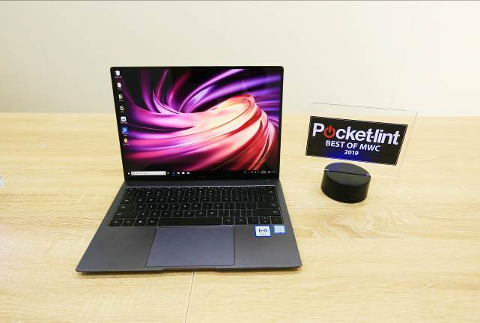

BGR included the HUAWEI MateBook X Pro in its “Best of MWC 2019” list, telling readers it was “the star of Huawei’s event on Sunday when it comes to laptops,” praising its several key improvements over its predecessors, including a seamless, NFC-based high-speed wireless bridge between Windows and Android for fast, bi-directional data transfer. BGR is a technology-influenced website covering topics such as consumer gadgets, entertainment, gaming and science. It has 17.5 million readers.

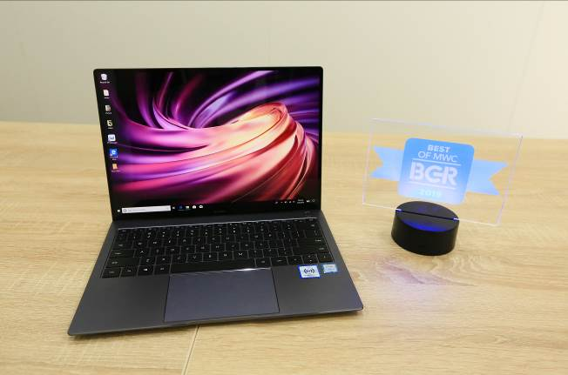

BestProducts.com awarded the HUAWEI MateBook X Pro its “Best of MWC 2019” for its looks, power, and practicality that the publications says will “surprise its competitors.” BestProducts.com features the latest product reviews and roundups for consumers and receives 4 million daily users.

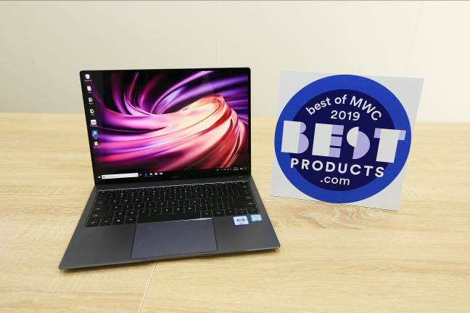

SlashGear honored the HUAWEI MateBook X Pro with its “Editor’s Choice” award, stating that, “Huawei is looking to crank up its competitiveness with the new MateBook X Pro 2019,” with the same style, but faster tech. SlashGear covers technology, science, automotive, gaming and entertainment, and has 3.2 million monthly visitors.

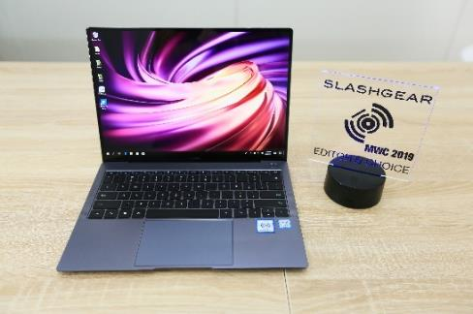

Ubergizmo awarded the HUAWEI MateBook X Pro the “Best of MWC 2019” award, remarking on its updated connectivity features including Huawei Share. The impressive sound performance and display were also called out as highlights. Ubergizmo is a US-based technology reviews and news outlet with 2.9 million monthly visitors.

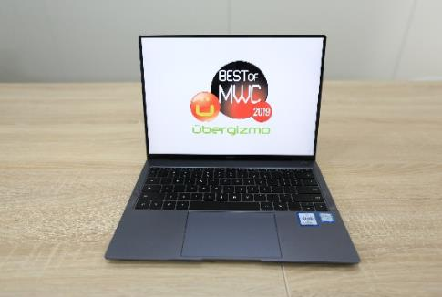

GadgetMatch gave the HUAWEI MateBook X Pro the “Best of MWC 2019” for its impressive specs and a “bunch of new ‘magic’ features.” GadgetMatch is a leading multi-platform media company providing technology news, reviews and video content to help consumers find the right devices to suit their needs. It has 309,673 monthly readers.

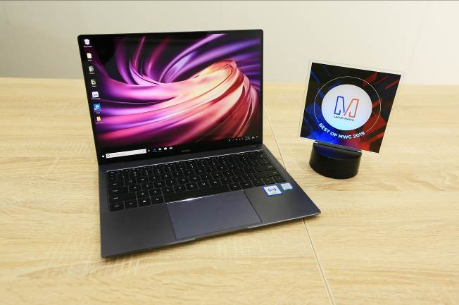

Mashable featured the HUAWEI MateBook X Pro in its list of “Best Tech at Mobile World Congress 2019” saying that “one of the best laptops of 2018 is even better this year.” Mashable is an influential tech publication that receives 28 million monthly visitors.

Stuff included the HUAWEI MateBook X Pro in its list of “MWC 2019 Awards,” stating, “What really matters here is the power boost, and the addition of OneHop functionality that lets you instantly transfer words, photos and documents.” Stuff covers breaking news and videos of the latest news stories and receives 2.8 million monthly visitors.

Her er de tre prisene Huawei MateBook 14 mottok:

TechAdvisor named the HUAWEI MateBook 14 “Best of MWC 2019,” for its “considerably stronger connectivity,” quad-microphone arrangement, which makes it better suited for making video calls where there are multiple people in a room. TechAdvisor is a global IDG publication offering expert help and advice including news, hardware reviews, forums and more. It reaches 21.45 million readers.

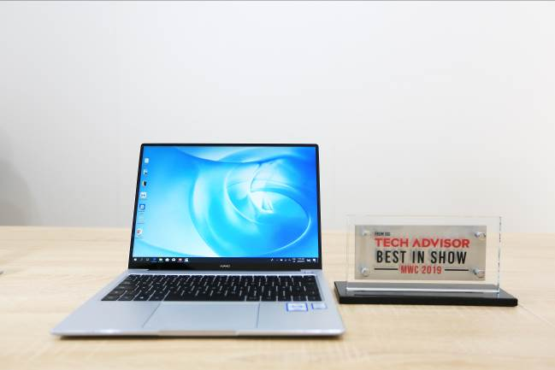

Expert Reviews gave the HUAWEI MateBook 14 the “Best of MWC 2019” award, citing its “impressive” display, highlighting that the foldable device “represents a significant development in terms of smartphone design.” Expert Reviews provides authoritative and independent technology reviews based on in-depth testing to help consumers find the perfect products to buy. It attracts 7 million unique monthly visitors.

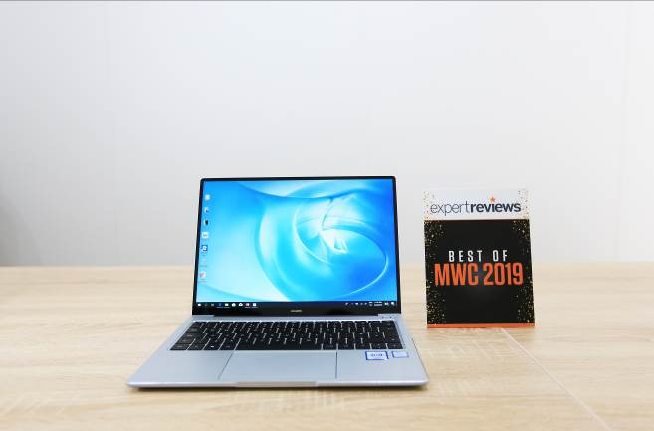

Big Tech Question (BTQ) awarded the HUAWEI MateBook 14 the “Best of MWC 2019,” for its slim design and powerful performance. Big Tech Question is a forum for all technology, and receives 105K monthly visitors.

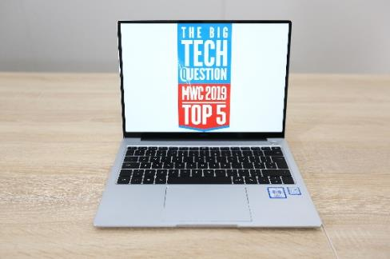

In addition, The HUAWEI Mate 20 Pro won the “Best Smartphone – Judges’ Choice” at the Glomo Awards, in recognition of its powerful performance, outstanding camera system, long battery life, innovative charging solutions and striking design. The Glomo Awards is the official awards program of Mobile World Congress, celebrating the best in innovation over the past year.

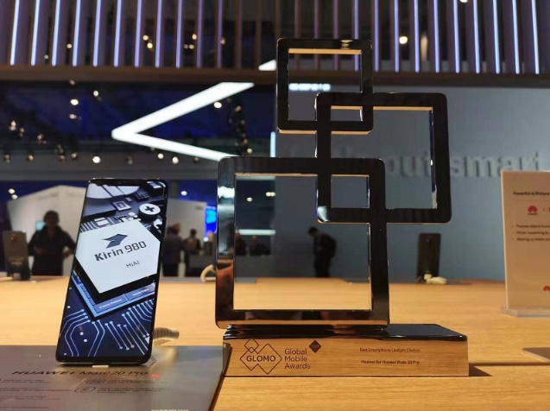

# # #

Om Huawei
Huawei er et globalt konsern med hovedsete i Shenzhen, Kinas Silicon Valley. Konsernet er forskningsdrevet, har 180.000 ansatte og virksomhet i 170 land. Huawei er verken statseid eller børsnotert, men eies av ansatte som brenner for at teknologi skal bidra til en enklere og bedre hverdag.

Huawei leverer kunnskap, teknologi, tjenester, utstyr og produkter til teleselskaper, offentlig og privat næringsliv og konsumenter. Vi er en av få aktører som utvikler standarder og utstyr til 5G, neste generasjons mobilnett.

Huawei klatrer årlig på de mest anerkjente indeksene over verdens mest verdifulle merkevarer.

