Press Release

For immediate release

# Making Energy Engaging for Belgian Households

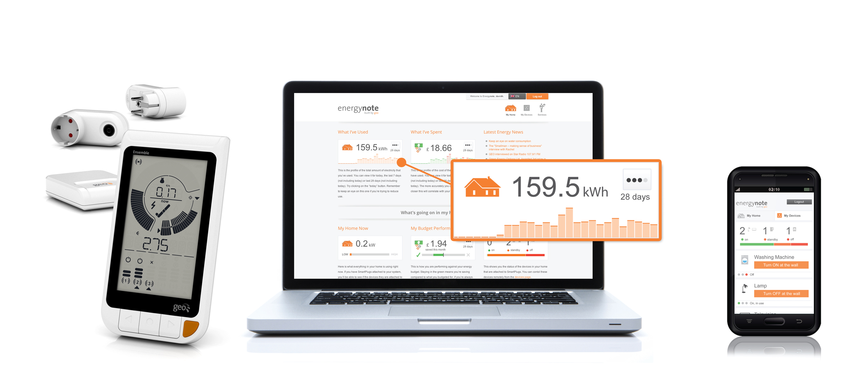**October 19, 2012 (Cambridge, UK). Green Energy Options (GEO) has appointed Elecom SA to distribute their Home Energy Management Systems within Belgium. These include a range of In-Home Displays (IHDs) which are easy for consumers to install, provide real-time information on energy usage and put them in control of their energy consumption.**

As shown in a recent report by VaasaETT (a Global Energy Think Tank based in Finland), GEO and Elecom could **reduce household electricity consumption in Belgium by up to 9% a year.** By using a Home Energy Management System, householders are able to manage energy consumption more effectively.

Belgians pay more for their electricity than many other European nations which makes any type of energy efficiency extremely valuable. And with the average Belgian household utility bill increasing year on year, a 9% saving can make a huge difference to the household budget each month.

Elecom will be offering three of GEO’s Home Energy Management Systems, which incorporate in-home energy displays, online energy services and accessories such as Smart Plugs and Temperature Sensors.

* **Ensemble** Home Energy Management System, which comes with an In-Home Display, three Smart Plugs to monitor and control domestic appliances and an Internet Bridge to connect to online energy services.
* **Solo PV In-Home Display,** which provides real-time information, in colour, on the electricity generated by a domestic solar photovoltaic system.
* **Solo** In-Home Display, which provides real-time information on energy consumption for those households that want a simple and engaging way to monitor their energy usage.

Patrick Caiger-Smith, Chief Executive Officer of GEO comments; “*Given the rising costs of energy, Belgian consumers can really benefit from access to real-time energy information, so we’re delighted to be appointing SAD as a distributor for the Belgian market*”.

Christophe Deligne, Managing Director of Elecom continues: “*We are delighted to be the first in the Belgian market to sell global energy monitors and smart plugs to the domestic market. We strongly believe that the benefit of an energy monitoring system is a quick return on investment, but also that other players in the energy market will love the concept. It is our goal to make the job of the grid managers easier. They have to cope with increased demand during peak hours, while private solar micro-generation often saturates the network at times where the demand is low.*

*“GEO’s monitoring solutions result in a more efficient use of energy, which will benefit both the end-users and energy distributors. Today, GEO makes it possible for consumers to view their energy consumption at a glance – it’s as simple as looking at the time on a clock*.”

**Notes for Editors**

* Interviews can be arranged with Patrick Caiger-Smith and Christophe Deligne
* More information on Elecom’s energy information services are available at: <http://www.sadinter.com>
* More information on GEO including product information, images and a company profile, is available at [www.greenenergyoptions.co.uk](http://www.greenenergyoptions.co.uk)

**About Green Energy Options**

GEO designs and produces in-home energy displays, online energy services and mobile applications that make energy engaging. They enable energy suppliers, meter manufacturers and installers to strengthen the relationship with their customers by putting end-users in control of their energy consumption, home appliances and energy budget in a visual, informative and engaging way. GEO’s products and services work together with pre-smart and smart meters and micro-generation to enable the energy-efficient home.

**Media contact:** Christine Rush, GEO, +44 1223 851 390,[christine@greenenergyoptions.co.uk](mailto:christine@greenenergyoptions.co.uk)

**About Elecom SA**

ELECOM SA is the specialist of Energy Management System within the SAD Group Companies, a family business which started in 1962 and has 35 dedicated staff.

SAD Group built its reputation as leaders in distributing products and services related to:

* Production and distribution of electricity (generation, transport, distribution grids)
* Public transport
* High and low voltage protection equipment
* EPI (protection and safety of people)
* HV, MV and LV installation equipment
* Maintenance of grids

We also provide theoretical and practical education and training with our officially recognised training center.

For more information about our Products and Services: [www.sadinter.com](http://www.sadinter.com)

**About VaasaETT Global Energy Think Tank**

The VaasaETT Global Energy Think Tank is widely recognised as one of the world’s top centres for expertise in the fields of Utility Customer Psychology, Customer Behaviour and Demand Response in energy markets. It is also a leading international expert in related issues including Utilities Marketing and Competition, Smart Energy, Smart Home, Smart Grid and Market Structures, and is a founding member of the Smart Energy Demand Coalition (SEDC). VaasETT brings together global expertise for building value into the current and future electricity, gas, water and related markets.