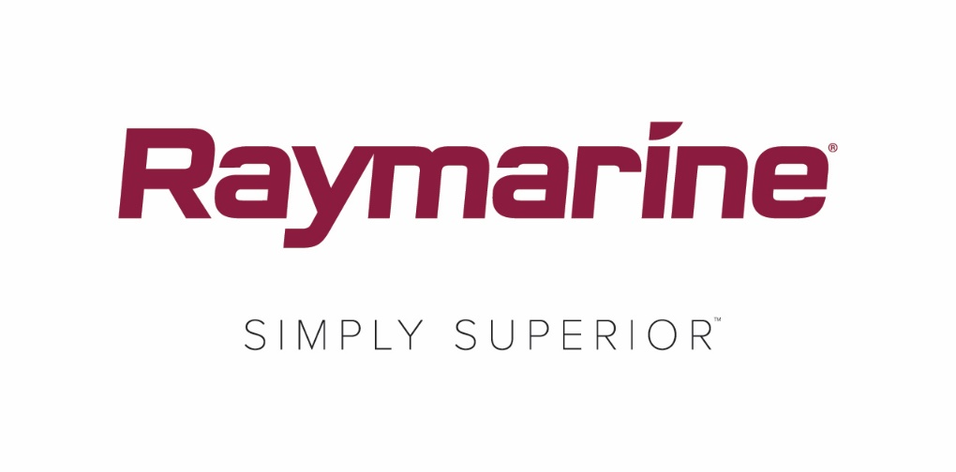

**FLIR Releases Major Raymarine LightHouse OS Upgrade**

***Free LightHouse 3.4 Brings Entertainment, New Features and Connectivity***

**WILSONVILLE, OR (April 4, 2018) – What turns a chartplotter into a multifunction display (MFD)? Performance, technology and connectivity. FLIR is pleased to announce LightHouse version 3.4, the latest free update to Raymarine’s LightHouse 3 OS software system.**

**Laden with upgrades and enhancements, LightHouse version 3.4 brings to your helm functions and digital services previously reserved for mobile phones and your living room.**

**Key enhancements provided by LightHouse version 3.4:**

**Lighthouse Apps for Entertainment, Communications and Integration**

**LightHouse Apps are an exciting new way to expand the power and capabilities of LightHouse OS and Raymarine will continue to expand LightHouse Apps with future support for Seakeeper gyro stabilizer control, Mazu satellite communications and more. LightHouse Apps are only available on Axiom and Axiom Pro.**

**Bluetooth™ Audio Output**

**LightHouse 3.4 also adds Bluetooth audio output from Axiom and Axiom Pro MFD’s. Connect Axiom’s Bluetooth to your marine stereo or Bluetooth enabled speakers and enjoy digital audio from your streamed movies and music. Bluetooth audio is only available on Axiom and Axiom Pro.**

**Other LightHouse version 3.4 features:**

* Vessel Alarm History and Management. LightHouse 3.4 now offers easy access to alarm settings and history right from the home screen.
* Chartplotter “Find Nearest” Hot-Spotting. Use a simple long-press anywhere on the chart and trigger the “Find Nearest” menu to instantly see a listing of common chart-related Point-Of-Interest data points including wrecks, marinas, fueling stations and many more.
* Chart Tide Mode for Tides and Currents. Enable tide mode on your chart display and instantly see all the nearby tidal height and tidal current stations.
* Fuel Management Tools. Fuel management interacts with your NMEA2000 engine data and tank level senders. See real-time fuel burn, range and economy, and receive low fuel alerts.
* Network Dimming for MFDs and Instruments. LightHouse 3.4 is now compatible with Raymarine’s network dimming system, also employed by our i50, i60 and i70 instruments and autopilot controllers. Dim or brighten your entire helm with a single command.
* Custom Splash Screens. Add a personal touch to your Axiom by selecting a favorite photo or graphic to display onscreen at startup. Remember a favorite moment, celebrate your boat or team, or just change it up for fun and variety.

**Upgrade Today and Keep Your System Up-To-Date**

LightHouse 3.4 is available free now at Raymarine.com. You can also update your MFD using its built-in Wi-Fi networking if you are in range of a wireless or mobile internet hotspot. Full details on Raymarine software updates are always available [online](http://click.icptrack.com/icp/rclick.php?d=jjiXoF3Cf8NfV-NNtAkNpQC-pI7iox1K&w=4&destination=http%3A%2F%2Fwww.raymarine.com%2Fmultifunction-displays%2Flighthouse3%2Fv3-4%2F).

####

**About FLIR Systems**

*Founded in 1978 and headquartered in Wilsonville, Oregon, FLIR Systems is a world-leading maker of sensor systems that enhance perception and heighten awareness, helping to save lives, improve productivity, and protect the environment. Through its nearly 3,500 employees, FLIR's vision is to be "The World's Sixth Sense" by leveraging thermal imaging and adjacent technologies to provide innovative, intelligent solutions for security and surveillance, environmental and condition monitoring, outdoor recreation, machine vision, navigation, and advanced threat detection. For more information, please visit* [*www.flir.com*](http://www.flir.com/) *and follow* [*@flir*](http://www.twitter.com/flir)*.*

**About Raymarine:**

*Raymarine, a world leader in marine electronics, develops and manufactures the most comprehensive range of electronic equipment for the recreational boating and light commercial marine markets. Designed for high performance and ease of use, the award-winning products are available through a global network of dealers and distributors. The Raymarine-branded product lines include radar, autopilots, GPS, instruments, fishfinders, communications, and integrated systems. Raymarine is a brand of FLIR Systems, a world leader in thermal imaging. For more information about Raymarine please go to* [*www.raymarine.com*](http://www.raymarine.com)*.*

**Media contact:**

**Karen Bartlett**

**Saltwater Stone**

+44 (0) 1202 669 244

k.bartlett@saltwater-stone.com