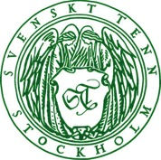

Press Release

Stockholm, September 06, 2016

**New Svenskt Tenn website designed to mirror the Stockholm store**

**Five years ago, the Svenskt Tenn store at Strandvägen in Stockholm underwent a major renovation, and now the online store has made a corresponding journey. The intention is to offer customers from all over the world an experience that mirrors the physical store, when they visit the updated svenskttenn.se.**

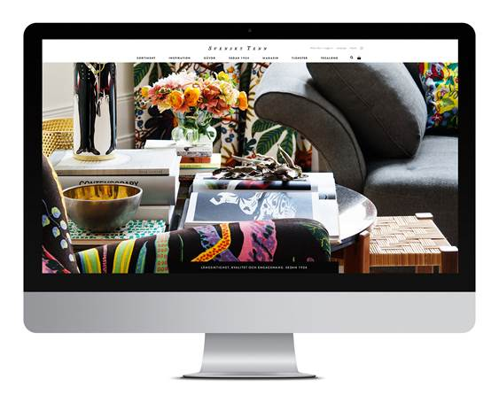Svenskt Tenn’s history dates back to 1924, when the company was founded by Estrid Ericson. She later connected with the established architect and designer Josef Frank, and the distinctive Svenskt Tenn style was defined by their longtime collaboration. Today, Svenskt Tenn is owned by a charitable foundation with the objective that the company should live forever. The business is based on the legacy of Estrid Ericson and Josef Frank, maintained in a contemporary form. This gives the fortuity to operate with a pledge to quality and persistence allowed to but a few companies.

The new website is a central element for upholding Svenskt Tenn’s brand and vision. It reflects an equally strong dedication to text and image content and to company’s rapidly growing e-commerce, with customers in 85 countries as of today. A new feature is an online magazine, where visitors can read news and feature stories about Svenskt Tenn’s exhibitions, contributing designers, and decoration projects where the company’s interior design studio is engaged.

“For a retailer with a single physical store, digital channels are really important as they make our offering much more reachable,” says Thommy Bindefeld, Marketing Director at Svenskt Tenn. “This is why we invested in a new website to make online shopping easier and more enjoyable. Our intention is to erase the line between the physical and virtual stores to deliver a similarly great customer experience regardless of which store you are visiting.”

The new website was developed by NetRelations and Planeta Design.

**For further information, please contact:**

Vicky Nordh, Marketing Assistant: +46 8-670 16 23 or vicky.nordh@svenskttenn.se

Thommy Bindefeld, Marketing Director: +46 8 670 16 02 or thommy.bindefeld@svenskttenn.se

Images can be downloaded from [svenskttennpress.se](http://www.svenskttennpress.se). Username: *Press*. Password: *Tenn*

Svenskt Tenn is an interior design company with retail stores at Strandvägen in Stockholm and online. Since 1975, Svenskt Tenn is owned by the Kjell and Märta Beijer Foundation, which provides research grants within ecology, medicine and the preservation of Swedish interior design tradition.