Press Release 20th of May 2015

INCON Recognizes Melbourne as the 2015 Winner of the Digital Infrastructure Award
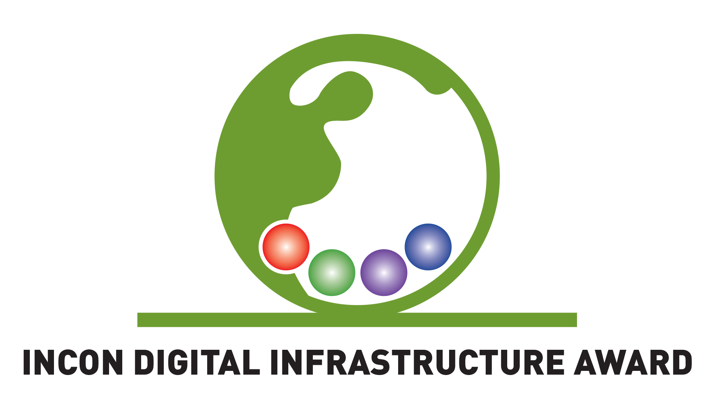
Today, at the annual IMEX Tradeshow in Frankfurt, INCON announced the Melbourne Exhibition and Convention Centre as the overall winner of the 2015 INCON Digital Infrastructure Award. The judges also distinguished Stockholmsmassen for an honourable mention.
Now in its second year, the INCON Digital Infrastructure Award rests on a simple principle that meetings are better when a first class digital infrastructure is made available along with applications and tools that enhance the delegate productivity and experience. Presenting the award today, Roslyn McLeod, INCON Co Chair said: "We are delighted that Melbourne has won this year’s award they were by far our strongest entry. We hope that other venues will follow suit and lift the quality of digital infrastructure across the whole industry”.
“In today’s world, the quality of the digital infrastructure and support tools a venue provides can make or break an event, not to mention just providing a positive experience for the delegates who just want to stay connected.” said Bob Heile, the award judge. “Effectively managing large numbers of connected devices greatly improves the effectiveness of an event and delegate satisfaction. It is hard work but results in huge dividends. By recognising Melbourne as industry leaders we hope to inspire others to make similar investments in their digital infrastructure.”

Daniel Branik, Arinex General Manager who also sits on the INCON Judging panel remarked “the cloud is pushing many services from onsite to online, putting additional pressure on venues and their digital infrastructure. It is important for venues to keep up with these trends providing sufficient bandwidth and infrastructure. INCON Digital Infrastructure Award recognises those that do that the best.”

Convention Centres and Hotel Venues interested in nominating their venue for the 2016 award will be able to do so from 1 September 2015. More information about the award is available on www.incon-pco.com/award.

About INCON
INCON is a partnership of the world’s leading conference organisers and event management companies. Currently, there are 10 Partners operating in 170 destinations employing 3,000 staff. INCON has substantial purchasing power and organises annually 10,000 projects, serves 3 million delegates, and manages budgets in excess of €1 billion.

Contact Person
Angela Guillemet
Executive Director
INCON Group
Tel: +353 86 311 40 67
angela@incon-pco.com
www.incon-pco.com

