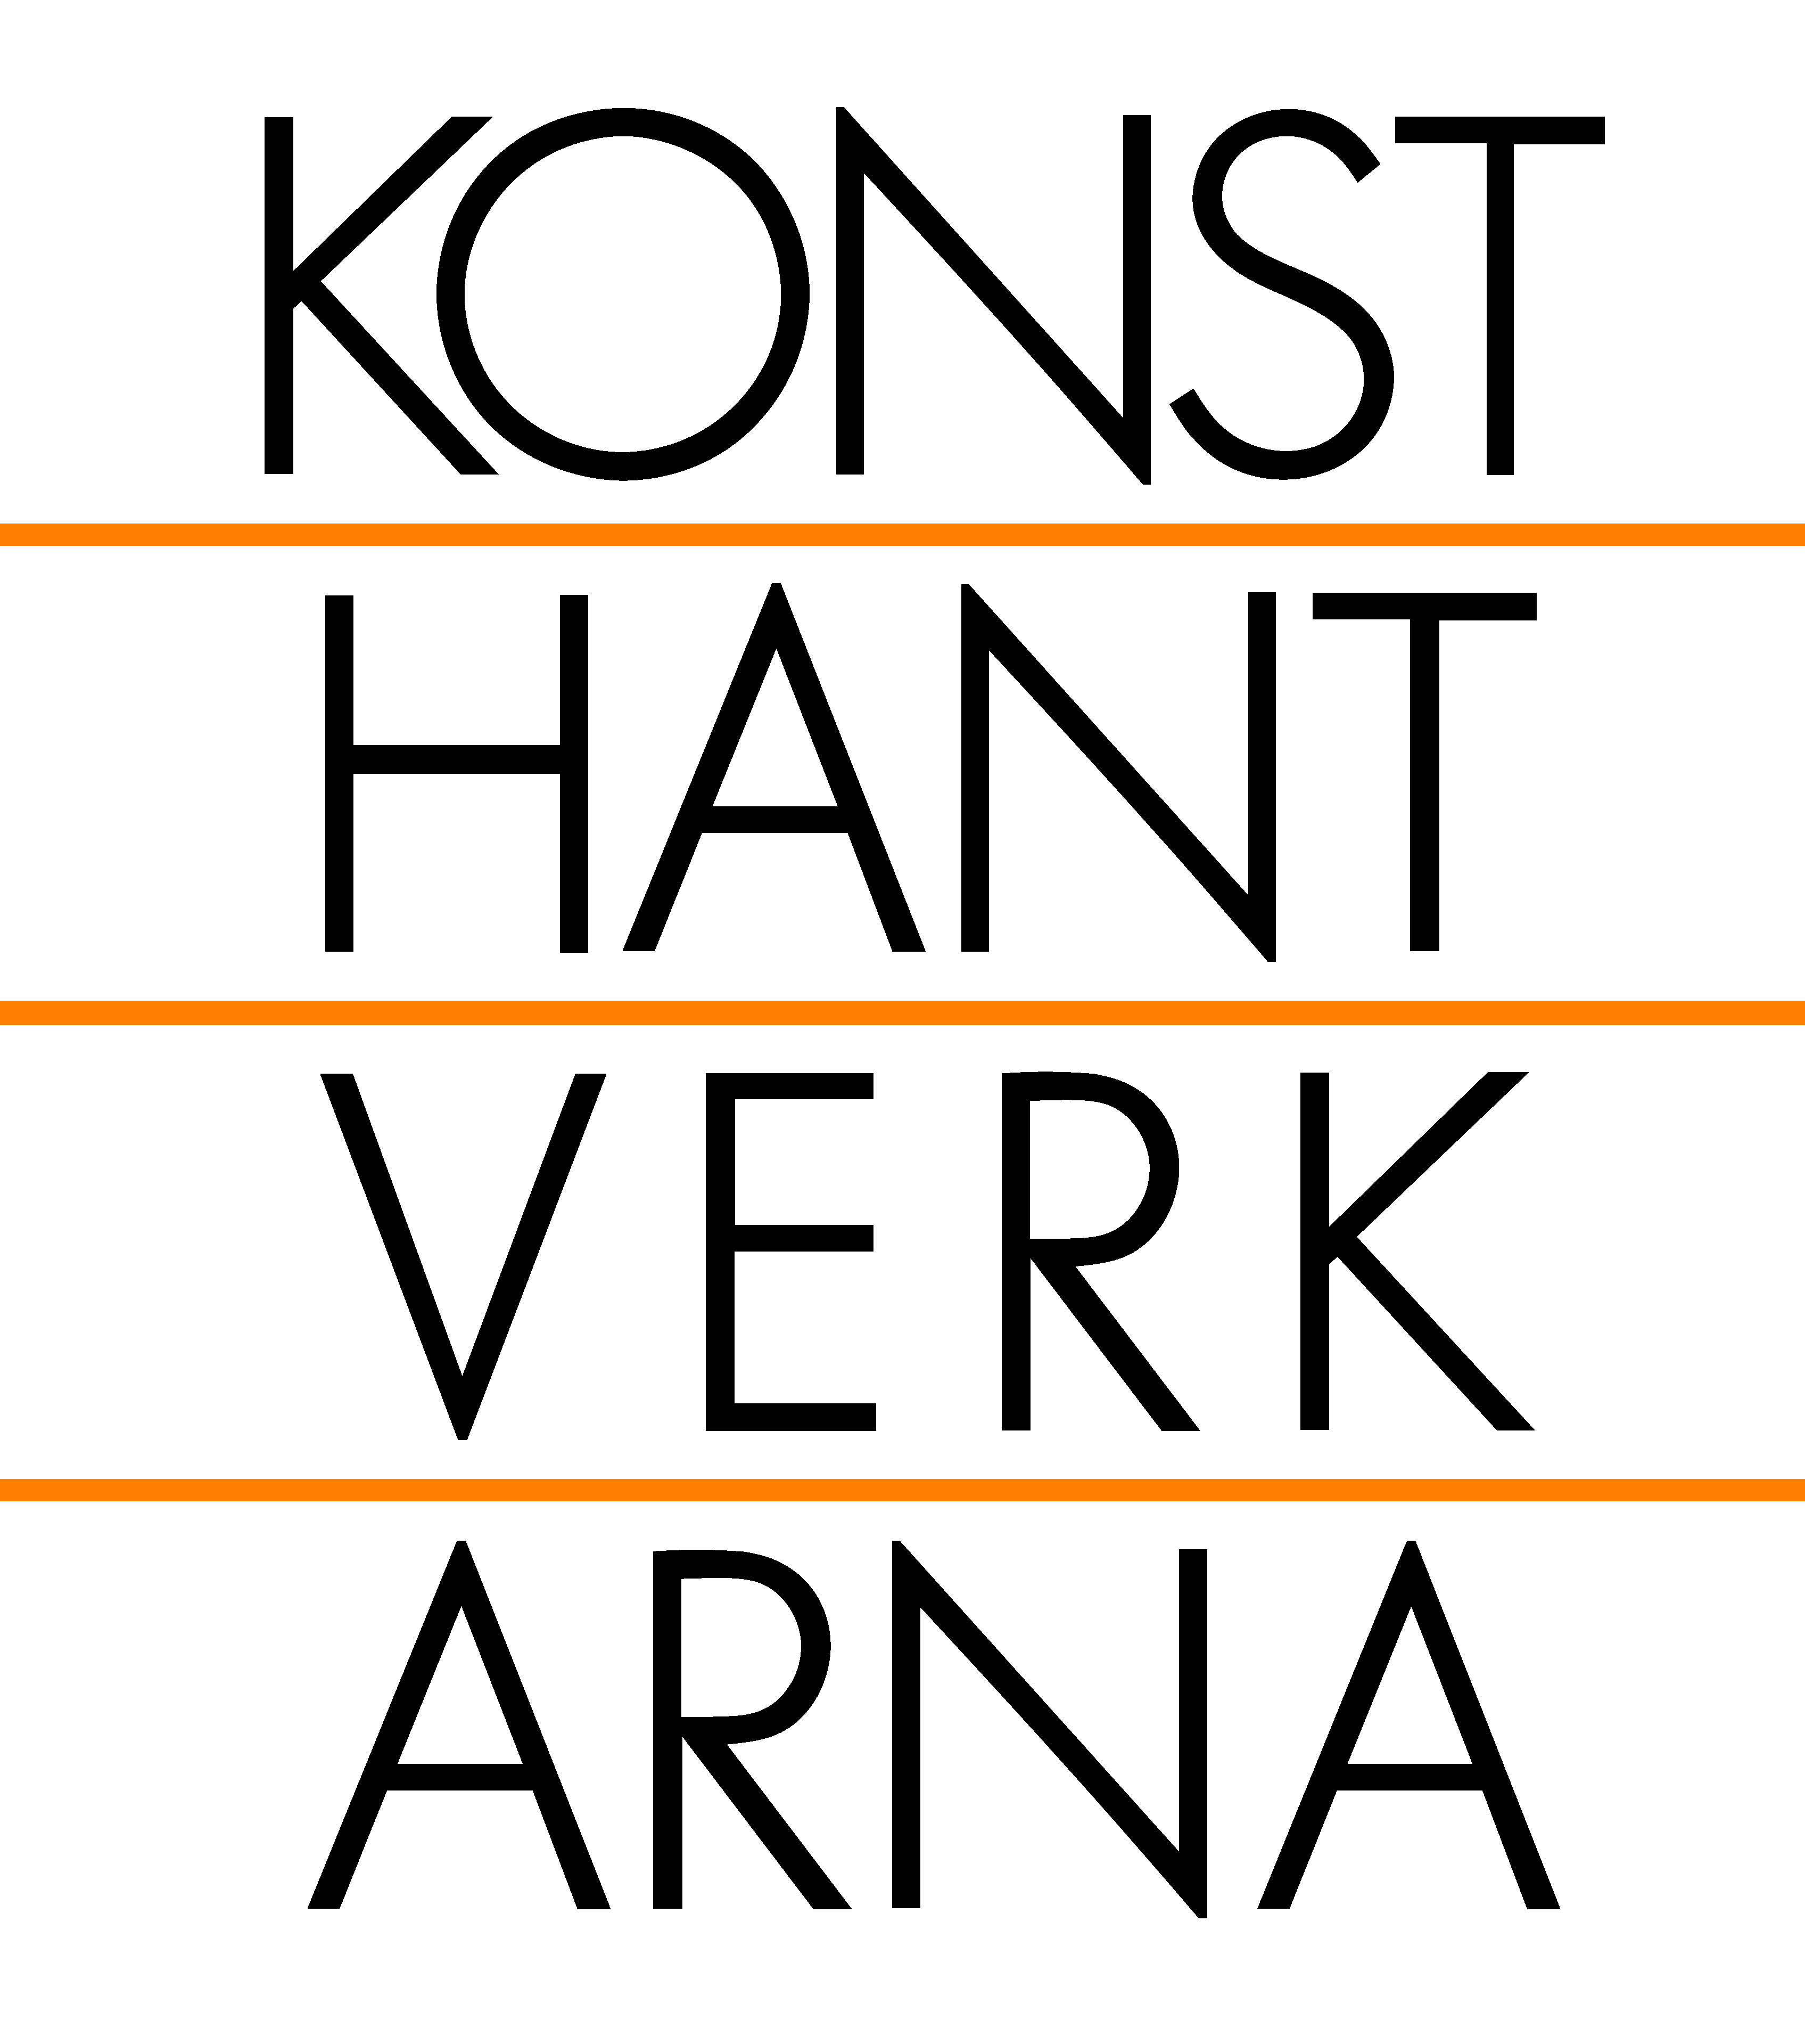
‘The mind can go in a thousand directions, but on this beautiful path, I walk in peace.’
-Thich Nhat Hanh

Weaving Indigo

An installation arranged in Morse Code by Aor Sutthiprahpa 13-29 of June 2013
“This is the fruit obtained from observing self practice whilst immersed in one’s internal dialogue. In the duration taken on this journey, concentration is key. It is a ‘repetition’ of constant and consistent willful actions in time that weaves a pathway arriving to cognizance.” Aor Sutthiprahpa
Konsthantverkarna has invited Aor Sutthiprahpa to exhibit for the reason that her work stike us as very contemporary and it is commenting on today’s world. We were immediately taken by Sutthiprahpa’s sensitive approach to the ceramic material and how she is putting it in a context where repetition and movement becomes vibrant and harmonic. The work is harmonious but at the same time very forceful, says Åsa Lockner, curator at Konsthantverkarna.
“Movement and motion may at times create indistinct shapes, just like singer Corinne Bailey Rae once sang: ‘The more you stay the same, the more they seem to change’. But with repetition in motion it does seem almost as if one is still, with clarity, and as such, shapes become more distinct. Saturated with serenity, my mind is focused yet lost in contemplation when I work with clay. In this fluid state, I learn, as clay reveals its character, what it needs and what I can contrive.
Weaving Indigo arranged in Morse Code is attained from being able to truly accept and comprehend clay. And as the project carried forth, awareness was acknowledged: an awareness of ‘Clay and humans are very similar’. Both are ever changing, so uncontrollable and ever requiring constant attention. With this said, it is still a journey to define attachment, since both in time are always in a state of flux.
As I witnessed it, I have come to realize the only certainty of life is that ‘What Exists Will Decay’. Nothing remains, nothing is permanent. And only if this truth is accepted, then I shall walk in peace.” Aor Sutthiprahpa April 2013
Aor Sutthiprahpa studied at HDK, Högskolan för Design och Konsthantverk, in Gothenburg and graduated with a Master degree in 2011. Since then Sutthiprahpa has worked in Thailand but the Swedish audience have seen quite a lot of Sutthiprahpa during her time here since she exhibited regularly and also received the Anna Wall design reward in 2011.

