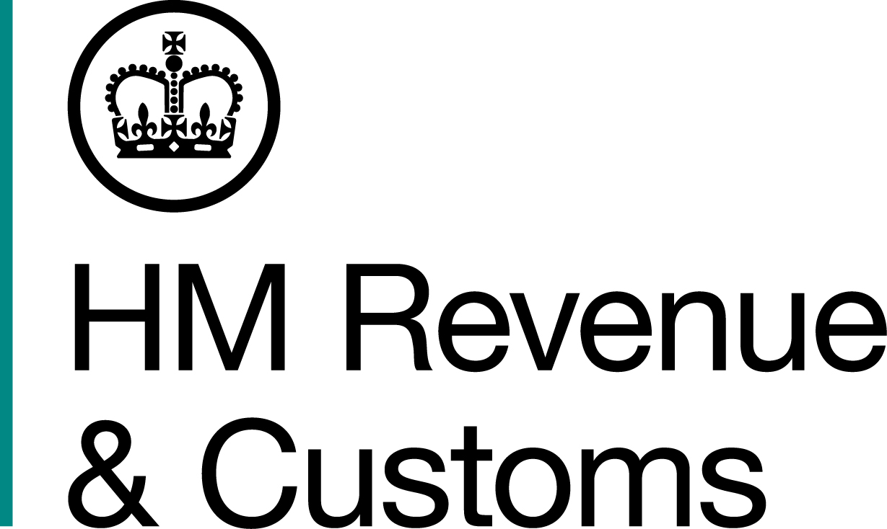
News Release

 | For the attention of News Desks |  | No of pages: 3
 | Date: | 27 January 2016 | Ref: | NTH 03 16

Déjà vu for Newcastle tobacco smugglers

Two men, who were caught with a van containing half a million illicit cigarettes just a week before going on trial for an almost identical fraud, have been jailed for 30 months each after they were investigated by HM Revenue and Customs (HMRC).

Haulage firm owner Stephen McDonough, 58, and accomplice David Collinson, 28, both of Newcastle, were first snared on 26 November 2014 when their Mercedes vans were pulled over by North Yorkshire Police on the northbound A1 near Boroughbridge in North Yorkshire.

Inside the vehicles, officers discovered 1000kg of hand-rolling tobacco – worth £180,460 in unpaid duty. After telling HMRC investigators they were unaware the vans contained tobacco, Collinson and McDonough were ordered to stand trial.

But on 24 November 2015, almost exactly a year after their arrest, and just seven days before appearing in the dock, the pair were again stopped on the northbound A1, 30 miles further north at Scotch Corner. Their van – the same model used in their first ill-fated journey – was laden with 500,000 non-duty paid cigarettes, worth £126,334.25 in unpaid duty.

Cheryl Burr, Assistant Director, Fraud Investigation Service, HMRC, said:

“The similarities between the two seizures were uncanny, and I’m sure Collinson and McDonough will never look at that stretch of the A1 in the same way again. They showed total contempt for the law by embarking on yet another tobacco run, days before they were due to face a jury.

“Disrupting criminal trade is at the heart of our strategy to clamp down on the illicit tobacco market, which costs the UK around £2.1 billion a year. This is theft from the taxpayer and undermines legitimate traders.”

Following their first arrest, the pair were taken to Harrogate police station and interviewed by HMRC investigators. McDonough said he had been paid £100 to transport the shipment, but claimed he didn’t know it was tobacco. Collinson refused to answer any questions.

However, after being arrested for a second time, the men admitted to being fully aware of the vehicles’ contents, on both occasions.

Collinson and McDonough were remanded in custody, spending Christmas in prison, after pleading guilty to two counts of the fraudulent evasion of excise duty at York Crown Court on 1 December 2015. At the same court today, 27 January 2016, they were sentenced to 30 months imprisonment.

Notes to Editors

- Stephen Shaun McDonough, DOB: 30/06/1957 of Benwell Village Mews, Newcastle upon Tyne was sentenced to 30 months imprisonment.
- David Andrew Collinson, DOB: 01/12/1987 of Moorvale Lane, Newcastle upon Tyne was sentenced to 30 months imprisonment.
- Remand time will be taken into account.
- Follow HMRC Press Office on Twitter @HMRCpressoffice;
- HMRC's Flickr channel: www.flickr.com/hmrcgovuk.

Issued by HM Revenue & Customs Press Office

Press enquiries only please contact:

Joshua Shrimpton Dean
Tel: 03000 554556 / 07469 023445
Email: joshua.shrimpton-dean@hmrc.gsi.gov.uk
Or
Greg Black
Tel: 03000 546 374 / 07469 023 118
Email: greg.black@hmrc.gsi.gov.uk

Out of hours
Tel: 07860 359544

Website www.gov.uk/hmrc

