2024-05-29

**PRESS RELEASE**

**New research on one of the Universe’s most efficient particle accelerators - collisionless shocks**

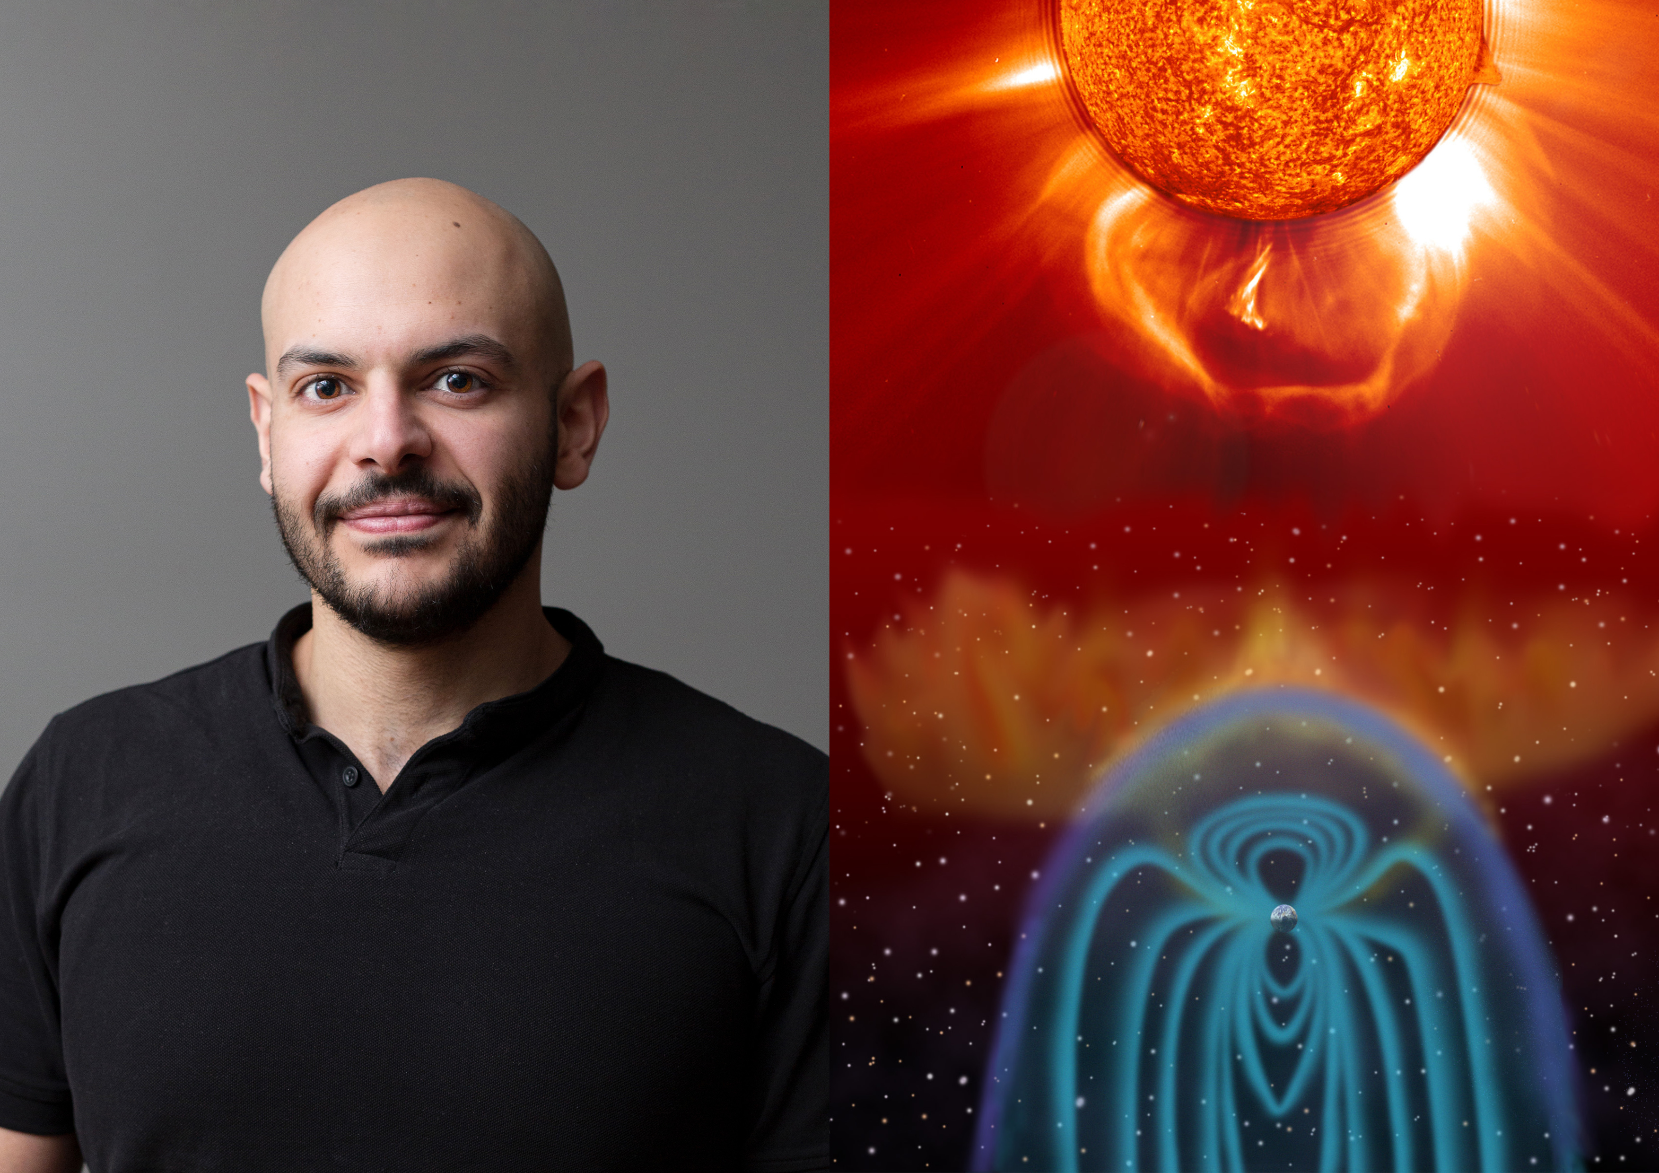

*Ahmad Lalti has analyzed data from the Magnetospheric Multiscale (MMS) satellites in his research on collisionless shocks. Photo: IRF. Illustration: ESA/NASA – SOHO/LASCO/EIT*

**In a doctoral thesis from the Swedish Institute of Space Physics (IRF) and Uppsala University, new insights into the interaction between charged particles and plasma waves at the Earth's collisionless bow shock are presented. Ahmad Lalti, who has analyzed data from NASA's Magnetospheric Multiscale (MMS) satellites, defends his thesis on May 31.**

The Earth's bow shock is a shock wave created when the stream of charged particles from the Sun, the solar wind, blows against the Earth's magnetic field.

A shock wave in air is a thin disruption that occurs when an object, such as a bullet or a fighter jet, travels at speeds greater than the speed of sound. Beyond the shock, the flow slows to subsonic speeds and the air heats up. In outer space, shock waves occur at the interface between the solar wind and Earth's magnetic field, supernova remnants, active galactic nuclei, or the interface between the heliosphere and the interstellar medium.

Ahmad's research explains the development of the different types of oscillations in the electric and magnetic fields, called plasma waves, and their effect on electron heating over the bow shock.

*“Collisionless shocks are believed to be some of the most efficient particle accelerators in the universe. They are believed to be the source of cosmic rays reaching Earth. I used existing methods and developed new ones that allowed me to reliably explore the excitation and evolution of the different types of plasma waves around Earth’s bow shock and their effects on electron heating. My results play an important role in pushing our understanding of how particles are accelerated at collisionless shocks*", says Ahmad.

In air, heating across shocks is usually mediated by collisions between the particles. In space, however, the density of the medium is so low that collisions are almost absent on the scale of the shock. They are collisionless shocks and their exact dynamics is still one of the remaining open questions in physics.

It is established that the interplay between charged particles and plasma waves can play the role of collisions and generate irreversible energy loss, i.e., heating, over collisionless shocks. Scientists are still searching for answers to the exact pathways of such energy loss.

Ahmad Lalti, born and raised in Lebanon, presents and defends his doctoral thesis "*Electrostatic turbulence and electron heating in collisionless shocks*" at 09.15 on Friday 31 May in the Heinz-Otto Kreiss lecture hall at the Ångström laboratory in Uppsala.

The faculty examiner is Dr Christian Mazelle from the Institut de Recherche en Astrophysique et Planétologie: Toulouse, Midi-Pyrénées, (FR).  
  
**The thesis:** <https://uu.diva-portal.org/smash/record.jsf?pid=diva2%3A1848882&dswid=-8778>

**Contact:** Ahmad Lalti, PhD student, Swedish Institute of Space Physics (IRF) and Uppsala University.  
[ahmad.lalti@irfu.se](mailto:ahmad.lalti@irfu.se)