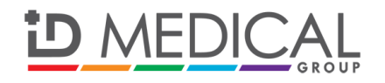
PRESS RELEASE
For immediate release: Friday 30 May 2014

ID Medical supports new GMC language requirements with Medical English courses

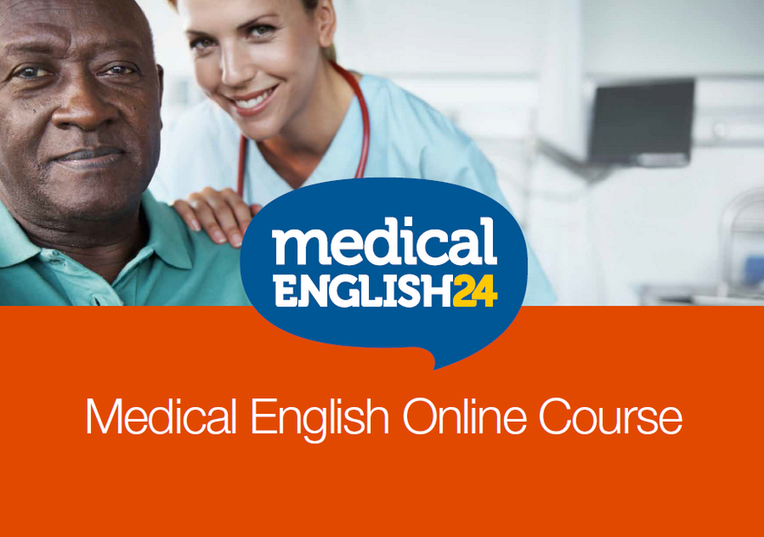

As the General Medical Council (GMC) confirms the dates for the new language requirements for doctors, leading multi-discipline healthcare recruiter ID Medical launches its Medical English course offering through its overarching medical education brand, ID Medical School, at this opportune moment.

Through its affiliation with Medical English 24, ID Medical offers its candidates (doctors, nurses and allied health professionals) exclusively discounted English Language e-learning courses, supporting them in becoming medical English fluent whilst saving them €209. The recommended course takes up to 12 months to complete the 48 lessons and final exam, enabling medical professionals to learn at their own pace, from the comfort of their own home.

The course ensures medical professionals are fully grounded with medical vocabulary and includes case histories, sample medical documentations in addition to guidelines and procedures to understand foreign healthcare systems.

From 18 June onwards, a new minimum score of 7.5 for the International English Testing System test applies and new rules and regulations will come into effect, allowing the GMC to refuse a licence to practise for those who do not meet the minimum English language requirements. As a result, foreign doctors and nurses need to prove they can meet the standards that patients expect.

Turning to the nursing profession, a recent study by the National Nursing Research Unit found that nurses feel that being generally competent in English did not mean they had the ‘right’ language skills to work effectively in the health service. The study revealed that some overseas nurses struggled to get their qualifications recognised and require ongoing support in this area.

ID Medical School’s Medical English course will help its medical candidates study towards the recognised English language examinations of IELTS (International English Language Testing System), sTANDEM (Standardised Language System for Medical Purposes) and PLAB (Professional and Linguistic Assessments Board).

Deenu Patel, managing director at ID Medical comments, “We see International recruitment becoming more and more prevalent within the NHS as a result of the persistent staffing shortages, and the recognition that foreign doctors and nurses make a valuable contribution to our healthcare system. Yet the concern around poor communication skills continues to rise.

We know that it is our duty to supply doctors and nurses who can communicate effectively in English to ensure the safety of their patients. Through ID Medical School and our Medical English 24 course offering, we provide our International candidates with the additional professional development and support they need whilst helping NHS Trusts to strengthen protection for patients, alleviating English language competency concerns.”
ENDS

About ID Medical
Award-winning, multi-discipline healthcare recruiter ID Medical was formed in 2002 and is a superior quality supplier of locum doctors, nurses, allied health professionals and clerical staff, holding preferred supplier contracts with over 90% of NHS hospitals and private medical sector organisations.

From its headquarters in Milton Keynes as well as its Central London office, ID Medical provides practical, cost-effective and innovative workforce solutions, supplying over 3 million hours to the NHS per annum. Within each of its professional divisions, ID Medical has dedicated client and candidate teams covering the multitude of medical specialties and roles to ensure every valued customer receives its premier level service, ultimately ensuring patients are always put first.

ID Medical wholly embraces the 6 key values and behaviours of the NHS - Care, Compassion, Courage, Communication, Commitment and Competence which represent care at its very best, and promotes these across its multi-discipline candidate staffing groups.

Since its foundation, the company has earned itself industry-wide accreditation and success with an amounting collection of accolades. These include the Recruiter FAST 50, Investec Hot 100, Recruitment International Top 250 and The Sunday Times Virgin Fast Track 100. Most notably, through an abiding focus on employee satisfaction, ID Medical was crowned Recruitment International’s ‘Best Recruitment Company to Work for 2013’ and made its debut in The Sunday Times Best Companies to Work for 2014 at list position 33.

For more information please visit our website at www.id-medical.com, view our Facebook page or follow us on Twitter @IDMedical.

About Medical English 24

Medical English 24 is a market leading e-learning platform created in co-operation with doctors working in the UK, medical institutes and academic language teachers, provides specialist language training for anyone working in the medical field. https://www.medpharmjobs.com/medical-english/.

You can also contact ID Medical’s head of marketing Caryn Cooper direct on:

Caryn Cooper
head of marketing

ID MEDICAL - ID House - 1 Mill Square - Wolverton Mill South - Milton Keynes - MK12 5ZD
t: +44 (0) 1908 555 498 f: +44 (0)1908 552 825
w: id-medical.com e: caryn.cooper@id-medical.com

