
Press release
EFA Honours Susanne Bier
European Achievement in World Cinema Award for Danish Director

In recognition of a rich and extensive international career, Susanne Bier will receive the honorary EUROPEAN ACHIEVEMENT IN WORLD CINEMA AWARD.


After studies in Israel, UK and Denmark, Danish director, screenwriter and producer Susanne Bier started her career with FREUD LEAVING HOME, the story of a Jewish woman who still lives with her parents in Stockholm at the age of 25, which received the 1991 Dragon Award in Gothenburg and a nomination for the Swedish Guldbagge Awards, and won Danish actress Ghita Nørby the supporting actress award at the 1992 European Film Awards.

In 1993, her short film LETTER TO JONAS won her the first of a series of Danish Robert awards, among them Best Film for the Danish comedy hit THE ONE AND ONLY in the year 2000.

She directed the Dogma movie OPEN HEARTS with Sonja Richter, Nikolaj Lie Kaas and Mads Mikkelsen about the consequences of a bad car accident that leaves the husband paralyzed from the neck down. The film received the 2002 FIPRESCI Award in Toronto and the Robert Audience Award. Her next movie, BROTHERS, about two unequal siblings and the psychological effects of war, got the 2005 Audience Award in Sundance and no less than eight nominations for the European Film Awards. AFTER THE WEDDING, with Mads Mikkelsen as the manager of an Indian orphanage, received nominations for two European Film Awards in 2006, for an Academy Award and for ten Robert awards.

IN A BETTER WORLD, with Mikael Persbrandt, Trine Dyrholm, and Ulrich Thomsen about the lives of two smalltown Danish families intertwining, won Bier the Director Award at the 2011 European Film Awards as well as an Academy Award, a Golden Globe Award and a Robert Award for actress Trine Dyrholm.

The romantic comedy LOVE IS ALL YOU NEED, with Trine Dyrholm and Pierce Brosnan as two bruised souls falling in love under extraordinary circumstances in Southern Italy, premiered in Venice in 2012 and won European Comedy at the European Film Awards in 2013.

In 2014, Susanne Bier directed SERENA, an American–French drama starring Bradley Cooper and Jennifer Lawrence, followed by the Danish drama A SECOND CHANCE starring Nikolaj Coster-Waldau.

In 2016, Susanne Bier directed her first TV-series, the internationally acclaimed John le Carré miniseries THE NIGHT MANAGER starring Tom Hiddleston, Hugh Laurie and Olivia Colman, which earned her a Primetime Emmy Award for Best Directing of a Limited Series. Her next outing was the Netflix horror movie BIRD BOX, starring Sandra Bullock, which is the 2nd most viewed Netflix original movie of all time.
Last year, she helmed HBO’s successful miniseries THE UNDOING with Nicole Kidman and Hugh Grant, and in 2022, she directs the entire first season of THE FIRST LADY for Showtime, a drama series chronicling the lives of American first ladies, starring Viola Davis, Michelle Pfeiffer, Gillian Anderson and Kiefer Sutherland.

Susanne Bier is the first female director to win an Oscar, a Golden Globe Award, a Primetime Emmy Award, and a European Film Award.

It is a great pleasure for the European Film Academy to present the European Achievement in World Cinema Award to Susanne Bier for her impressive dedication to cinema.

Susanne Bier will be an honorary guest at the 34th European Film Awards Ceremony on 11 December in Berlin.

Berlin, 30 September 2021
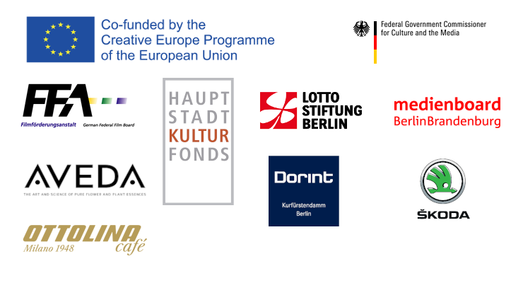
Patrons: Catalan Institute for Cultural Companies from the Ministry of Culture of Catalonia * Centre du Cinéma of the Federation Wallonia Brussels * Centre national du cinéma et de l'image animée (CNC) * Danish Film Institute * Eurimages * Film Centre of Montenegro * Film Fund Luxembourg * Film i Väst * Finnish Film Foundation * Flanders Audiovisual Fund (VAF) * Icelandic Film Centre * Instituto do Cinema e do Audiovisual (ICA) * International Sámi Film Institute * Istituto Luce-Cinecittà * Kosovo Cinematography Center * Lithuanian Film Centre * Ministry for the National Heritage, the Arts and Local Government of Malta * Ministry of Education, Culture, Sports and Youth of the Republic of Cyprus * Netherlands Film Fund * North Macedonia Film Agency * Norwegian Film Institute * Polish Film Institute * Screen Ireland/Fís Éireann * Seville European Film Festival, a project of ICAS, organised by Seville City Council * SF Studios * Swedish Film Institute * Swiss Films

