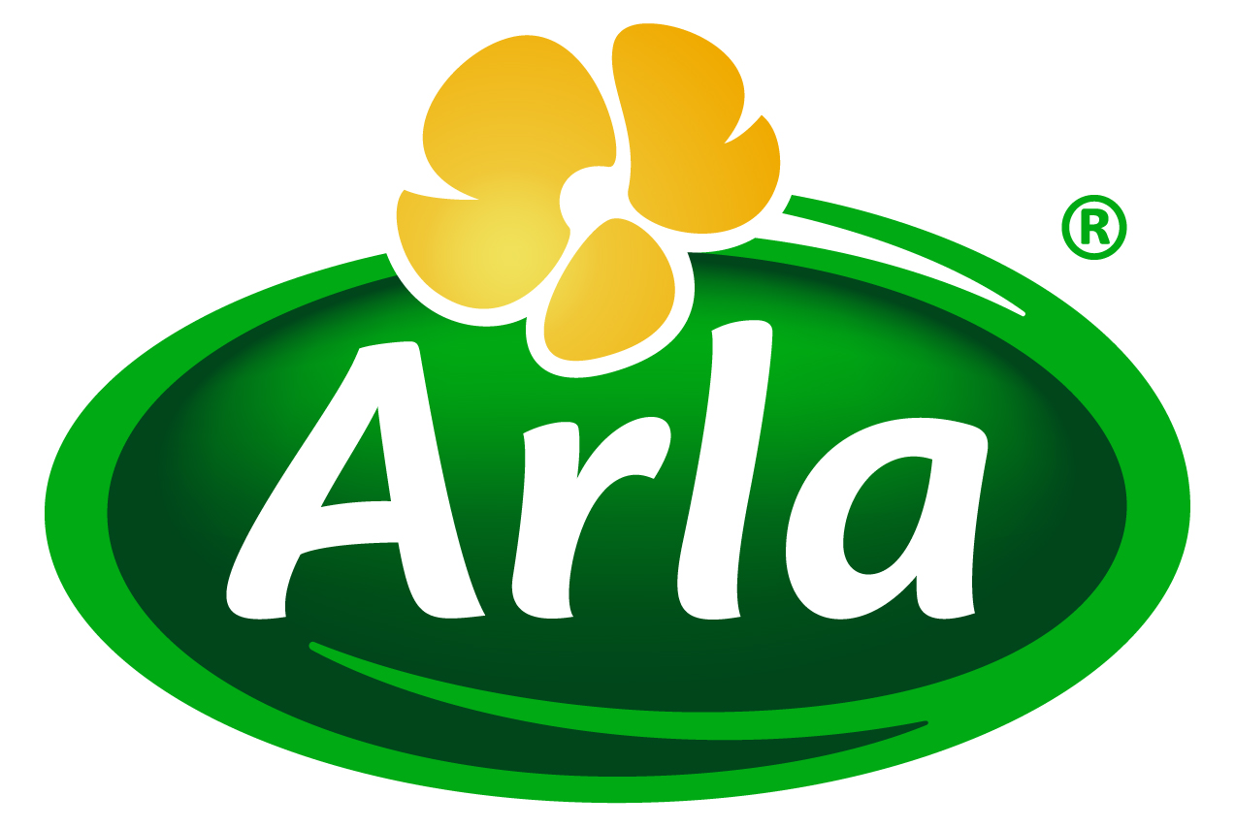
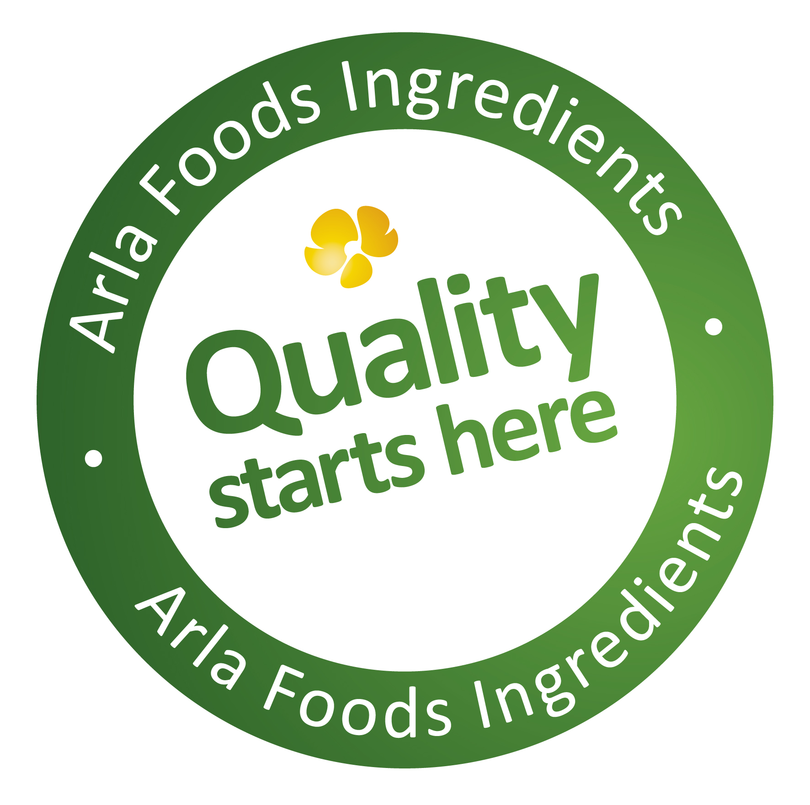

23 April 2015
PRESS RELEASE
Arla Foods Ingredients doubles
production of Alpha-lactalbumin

Arla Foods Ingredients has doubled its capacity for producing Alpha-lactalbumin in a bid to meet growing demand from the global infant formula market.

Alpha-lactalbumin is the dominant protein in human milk, but is also found naturally in cows’ milk. Incorporating it into infant formula enables manufacturers to create products that more closely resemble breast milk.

Anne Staudt Kvistgaard, Head of Pediatric at Arla Foods Ingredients, said: “Alpha-lactalbumin is very rich in essential amino acids. This means that protein levels in infant formulas can be optimized in regards to protein concentration and composition while maintaining compliance with the amino acid levels set by regulations.”

Arla Foods Ingredients produces Alpha-lactalbumin at its Denmark Protein facility in Jutland, which adheres to the strictest quality and safety standards anywhere in the infant formula industry today. It has added a second production line at the factory, which will increase output of the protein by 100%.

Anne added: “Human milk will always be the gold-standard for infants but commercial production of Alpha-lactalbumin means babies fed with formula can benefit from similar levels of protein composition. In recognition of this, worldwide demand for Alpha-lactalbumin is growing fast – especially in China – and we’re delighted that this increase in our production capacity will help to secure further supplies for our customers in line with our ‘Quality starts here’ commitments.”

The Alpha-lactalbumin produced by Arla Foods Ingredients is marketed under the Lacprodan® Alpha-10 brand. Besides infant formula, Alpha-lactalbumin’s rich protein content means that it is also suitable for use as a high quality ingredient in health foods and in sports and clinical nutrition products.

ENDS

For more information, please contact:
Kine Bjoralt, Ingredient Communications
Tel: +44 141 280 4141
Email: kine@ingredientcommunications.com
@ingredientcomms

About Arla Foods Ingredients
Quality starts here: Arla Foods Ingredients is a global leader in natural whey ingredients for products in a range of categories – from sports nutrition, beverages, bakery, dairy and ice cream to clinical and infant nutrition.
The cornerstones of our business are innovative ingredients, world-class facilities and a staff of dedicated experts. Drawing on our portfolio of functional and nutritional whey proteins, milk minerals, lactose and permeate, our expert team delivers solutions that bring new food products quickly and efficiently to market. Our application centres run hundreds of customer product trials every week. All ingredients are produced using state-of-the-art processing technology at our plant in Denmark, or by one of our joint ventures in Argentina, Germany and the UK.
Arla Foods Ingredients Group P/S is a 100% owned subsidiary of Arla Foods, a global dairy company and cooperative owned by dairy farmers in Denmark, Sweden, the UK, Germany, the Netherlands, Belgium and Luxemburg.

RSS Feed
Visit our website at http://www.mynewsdesk.com/arla-foods-ingredients and sign up to our News RSS feed for all the latest developments – updated regularly.

Twitter
Follow us on twitter for all the latest updates @ArlaIngredients

LinkedIn
http://www.linkedin.com/company/arla-foods-ingredients

