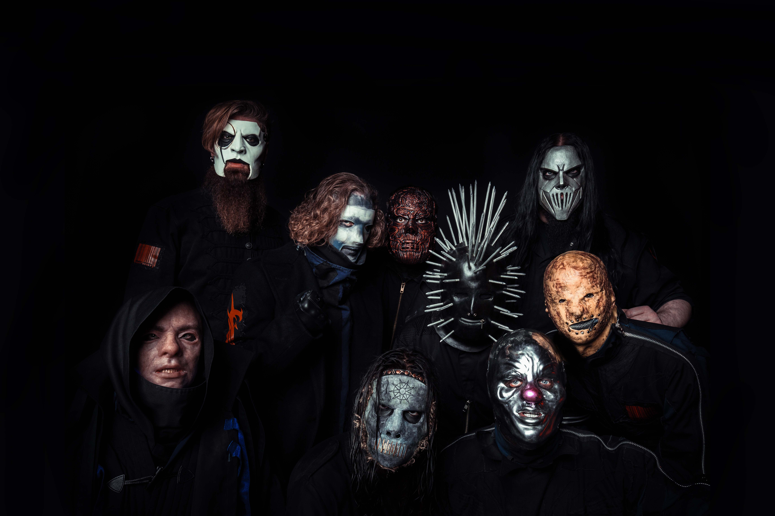

SLIPKNOT SHARE NEW SONG “SOLWAY FIRTH”

OFFICIAL VIDEO STREAMING NOW

KNOTFEST ROADSHOW NORTH AMERICA 2019 BEGINS JULY 26TH

NEW ALBUM WE ARE NOT YOUR KIND ARRIVES WORLDWIDE AUGUST 9TH

SLIPKNOT – “SOLWAY FIRTH” [OFFICIAL VIDEO]
YOUTUBE: https://youtu.be/V3ADK6gsDGg
EMBED: <iframe width="560" height="315" src="https://www.youtube.com/embed/V3ADK6gsDGg" frameborder="0" allow="accelerometer; autoplay; encrypted-media; gyroscope; picture-in-picture" allowfullscreen></iframe>

JULY 22, 2019 – SLIPKNOT has shared “Solway Firth,” the second new song to be released off their widely anticipated sixth LP, WE ARE NOT YOUR KIND, which will arrive August 9th on Roadrunner Records (album art / track listing below). “Solway Firth” is available now at all DSPs along with an official music video streaming on Slipknot’s YouTube channel. Directed by the band’s own M. Shawn Crahan, and created with UPROXX and Amazon Prime Video, the “Solway Firth” video features exclusive footage from the new Amazon Original, “The Boys” (premiering July 26th) alongside exclusive live performance footage from Slipknot’s recent headline festival run in Europe.

“Solway Firth” follows WE ARE NOT YOUR KIND’s lead single “Unsainted,” which made a massive impact upon release with the song’s official music video, directed by Crahan, trending at #1 worldwide on YouTube for 24 hours (all videos, not just music), amassing 35 million views to date. SLIPKNOT shook the world once again following their album announcement with the worldwide live debuts of “Unsainted” and their 2018 single “All Out Life” on Jimmy Kimmel Live!, both of which have become the show’s most viewed music performances of 2019 on YouTube.

Named by Vulture as on one of “36 Albums We Can’t Wait to Hear in 2019,” SLIPKNOT’s WE ARE NOT YOUR KIND is available for pre-order with exclusive bundles available at www.slipknot1.com. Produced by SLIPKNOT and Greg Fidelman, WE ARE NOT YOUR KIND follows the band’s blistering 2014 LP, .5: THE GRAY CHAPTER, which debuted Top 5 in the official album charts of 19 countries around the world, including the U.S. (#1), Japan (#1), Australia (#1), Russia (#1), U.K. (#2) & Germany (#2).

This summer SLIPKNOT will embark on their Knotfest Roadshow headline tour set to traverse across North America with Volbeat, Gojira, and Behemoth joining as special guests on all dates. Produced by Live Nation, the 29-city outing will kick off July 26th in Mountain View, CA at Shoreline Amphitheater and continue through September 8th where it will conclude with a performance at Cynthia Woods Mitchell Pavilion in The Woodlands, TX (see itinerary below). For tickets and more information on SLIPKNOT’s Knotfest Roadshow, visit www.slipknot1.com.

SLIPKNOT shocked fans around the globe last fall with the release of the standalone single, “All Out Life.” Reaction to the track was staggering, with the official music video – also directed by Crahan racking up over 42 Million YouTube views on the band’s official YouTube channel.

Last month SLIPKNOT unveiled details of their very own craft spirit, No. 9 Iowa Whiskey, which will be available August 10th at select retailers in all 50 states and at the band’s headline Knotfest Roadshow North America tour. No. 9 Iowa Whiskey can also be obtained at select markets on the North American tour ahead of the August 10th official launch. A collaboration with the Iowa-based Cedar Ridge Distillery, No. 9 Iowa Whiskey (90 proof) will retail for $39.99 and No. 9 Reserve Iowa Whiskey (99 proof) will retail for $69.99, both which are made with corn from the award-winning distillery’s family farm in Winthrop, Iowa.

(Album Art / Track Listing / Tour Itinerary Below)

SLIPKNOT
WE ARE NOT YOUR KIND
RELEASE DATE: AUGUST 9TH

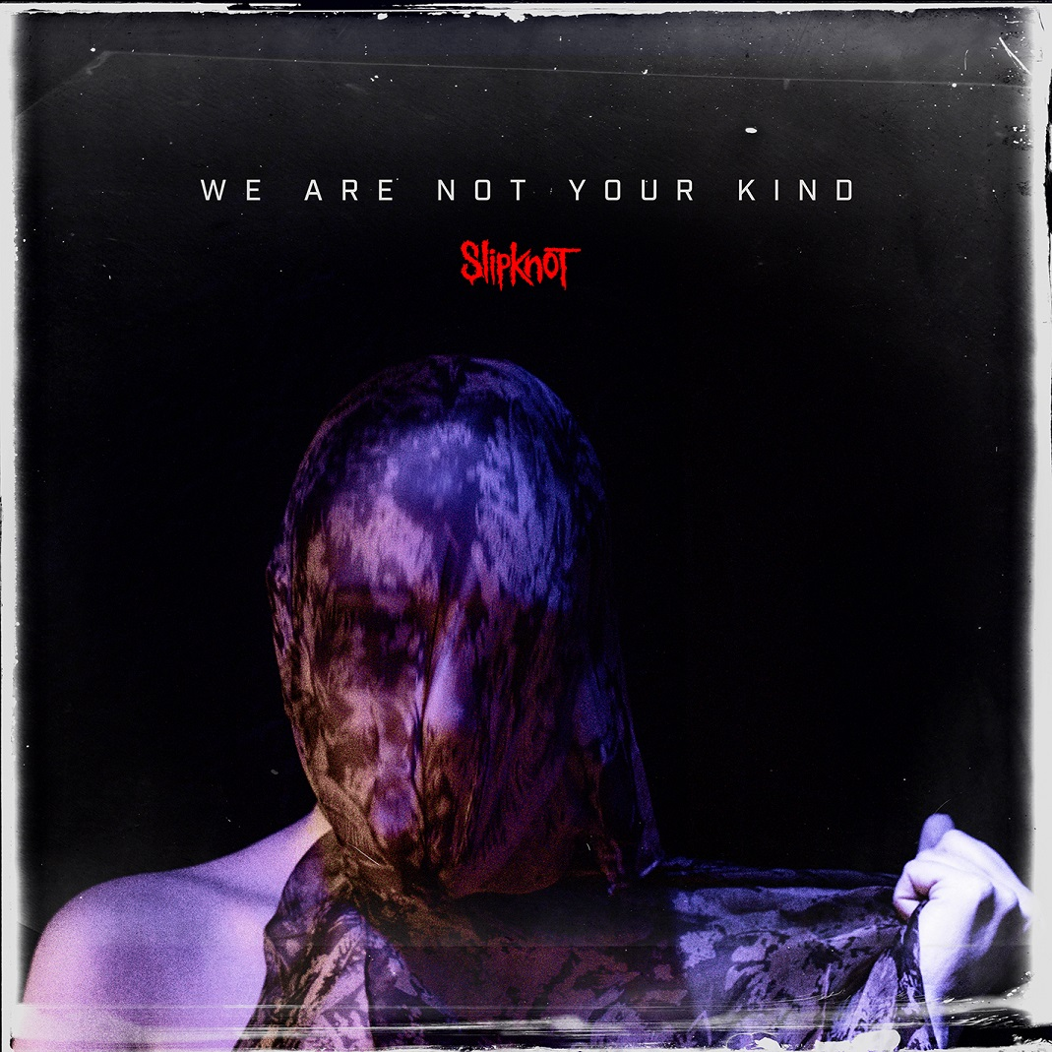

1. Insert Coin
2. Unsainted
3. Birth Of The Cruel
4. Death Because Of Death
5. Nero Forte
6. Critical Darling
7. A Liar’s Funeral
8. Red Flag
9. What’s Next
10. Spiders
11. Orphan
12. My Pain
13. Not Long For This World
14. Solway Firth

SLIPKNOT
ON TOUR 2019
7/26 – 9/8: Knotfest Roadshow with Volbeat, Gojira, and Behemoth
10/17 – 11/2: Australian Tour with Metallica

Jul 26 - Mountain View, CA - Shoreline Amphitheatre
Jul 27 - San Bernardino, CA - San Manuel Amphitheater
Jul 30 - Auburn, WA - White River Amphitheatre
Aug 1 - Salt Lake City, UT - USANA Amphitheatre
Aug 3 - Albuquerque, NM - Isleta Amphitheater
Aug 4 - Phoenix, AZ - Ak-Chin Pavilion
Aug 6 - Denver, CO - Pepsi Center
Aug 8 - Lincoln, NE - Pinnacle Bank Arena
Aug 10 - Des Moines, IA - Iowa State Fairgrounds* (SOLD OUT)
Aug 11 - Tinley Park, IL - Hollywood Casino Amphitheatre
Aug 12 - Clarkston, MI - DTE Energy Music Theatre
Aug 14 - Virginia Beach, VA - Veterans United Home Loans Amphitheater
Aug 16 - Noblesville, IN - Ruoff Home Mortgage Music Center
Aug 17 - Bonner Springs, KS - Providence Medical Center Amphitheater
Aug 18 - Maryland Heights, MO - Hollywood Casino Amphitheatre
Aug 20 - Toronto, ON - Budweiser Stage
Aug 21 - Saratoga Springs, NY - Saratoga Performing Arts Center
Aug 23 - Burgettstown, PA - KeyBank Pavilion
Aug 24 - Scranton, PA - The Pavilion at Montage Mountain
Aug 25 - Darien Center, NY - Darien Lake Amphitheater
Aug 27 - Mansfield, MA – The Xfinity Center
Aug 28 - Wantagh, NY - Northwell Health at Jones Beach Theater
Aug 30 - Holmdel, NJ - PNC Bank Arts Center
Aug 31 - Camden, NJ - BB&T Pavilion
Sep 1 - Bristow, VA - Jiffy Lube Live
Sep 3 - Alpharetta, GA - Ameris Bank Amphitheatre
Sep 4 - Tampa, FL - MIDFLORIDA Credit Union Amphitheatre
Sep 6 - Austin, TX - Austin360 Amphitheater at Circuit of The Americas
Sep 7 - Dallas, TX - Dos Equis Pavilion
Sep 8 - The Woodlands, TX - The Cynthia Woods Mitchell Pavilion presented by Huntsman
Sep 27 - Louisville, KY - Louder Than Life
Oct 11 - Sacramento, CA - Aftershock Festival
Oct 17 - Perth, AU - Optus Stadium
Oct 20 - Adelaide, AU - Adelaide Oval
Oct 22 - Melbourne, AU - Marvel Stadium (SOLD OUT)
Oct 24 - Melbourne, AU - Marvel Stadium
Oct 26 - Sydney, AU - ANZ Stadium
Oct 29 - Brisbane City, AU - QSAC
Oct 31 - Auckland, NZ - Mt. Smart Stadium (SOLD OUT)
Nov 2 - Auckland, NZ - Mt. Smart Stadium

For more information on SLIPKNOT, visit:
Official Website | Facebook | Twitter | Instagram | YouTube
Apple Music | Spotify | Amazon Music | Roadrunner Records

