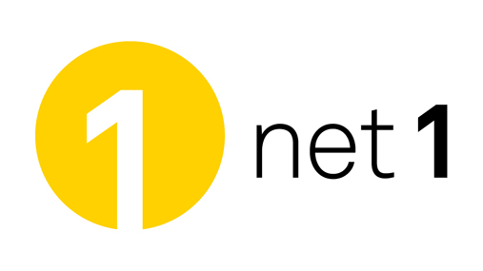Net1 chooses to upgrade to ComAround Zero™

Net1, a customer of ours for many years, is one of the first to have signed an agreement and thereby upgrade to ComAround Zero™. Net1 has a total of about 80 employees – in Sweden, Norway and Denmark – who are now using ComAround’s self-help service as a customer database for more reliable and secure support.

“*We’re really pleased to see the new functions which come with Zero and the possibilities they open up for us,”* says Stephan Johansson, Head of Customer Service at Net1.

**In 2010 Net1 won the Self Service Awards in the category** “**the Year’s Strategic Support” with the justification:**

“*Statistics show a very good outcome in terms of Return on Investment (ROI) and a high resolution rate in respect of the content in the information database. The content is updated continuously with the help of good processes and routines which has led to a total control over all the processes at the collaboration partners. The database has also been copied to the company’s sister companies in Norway and Denmark; this means that the work can be streamlined and the company can work with equivalent processes in all countries. In this way resources are managed more efficiently and the company acquires a very satisfactory knowledge transfer.”*

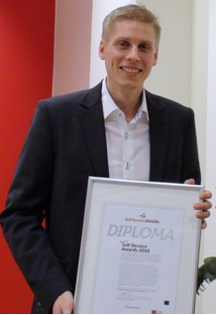

Stephan Johansson, Head of Customer Service Sweden. Net1

Net1 is a company that sells broadband and telephony services in Sweden, Norway and Denmark. Net1 has more than 150 000 customers in Scandinavia and covers 95 % of Sweden’s area with a nationwide Turbo 3G network.

**For more information, contact:**

Magnus Holmqvist

ComAround Scandinavia AB

E-mail: [magnush@comaround.se](mailto:magnush@comaround.se)

Tel: + 46 8 580 886 20

Stephan Johansson

Net1

E-mail: [stephan.johansson@net1.se](mailto:stephan.johansson@net1.se)