Press Update
June 2021
June 2021 - Prime Gaming Monthly Update

Welcome to the June Prime Gaming monthly content update! Kick off summer with Prime Gaming’s diverse games and content for popular titles, including:
- Exclusive content for Fall Guys, FIFA 21, VALORANT and Assassin’s Creed Valhalla
- The June Games with Prime lineup, featuring Batman - The Telltale Series, Newfound Courage, Lost in Harmony, BFF or Die, Spitkiss and Mugsters

Prime members can claim these offers at gaming.amazon.com. As a reminder, Prime Gaming offers are available for a limited time, so be sure to act fast before they disappear!

Read on below for a look at all of the great content and games coming in June, including a brand new Prime Gaming sizzle showcasing this month’s biggest offers.

Information on this month’s lineup, as well as the latest and greatest Prime Gaming news, can be found on the Prime Gaming blog. Download assets here.

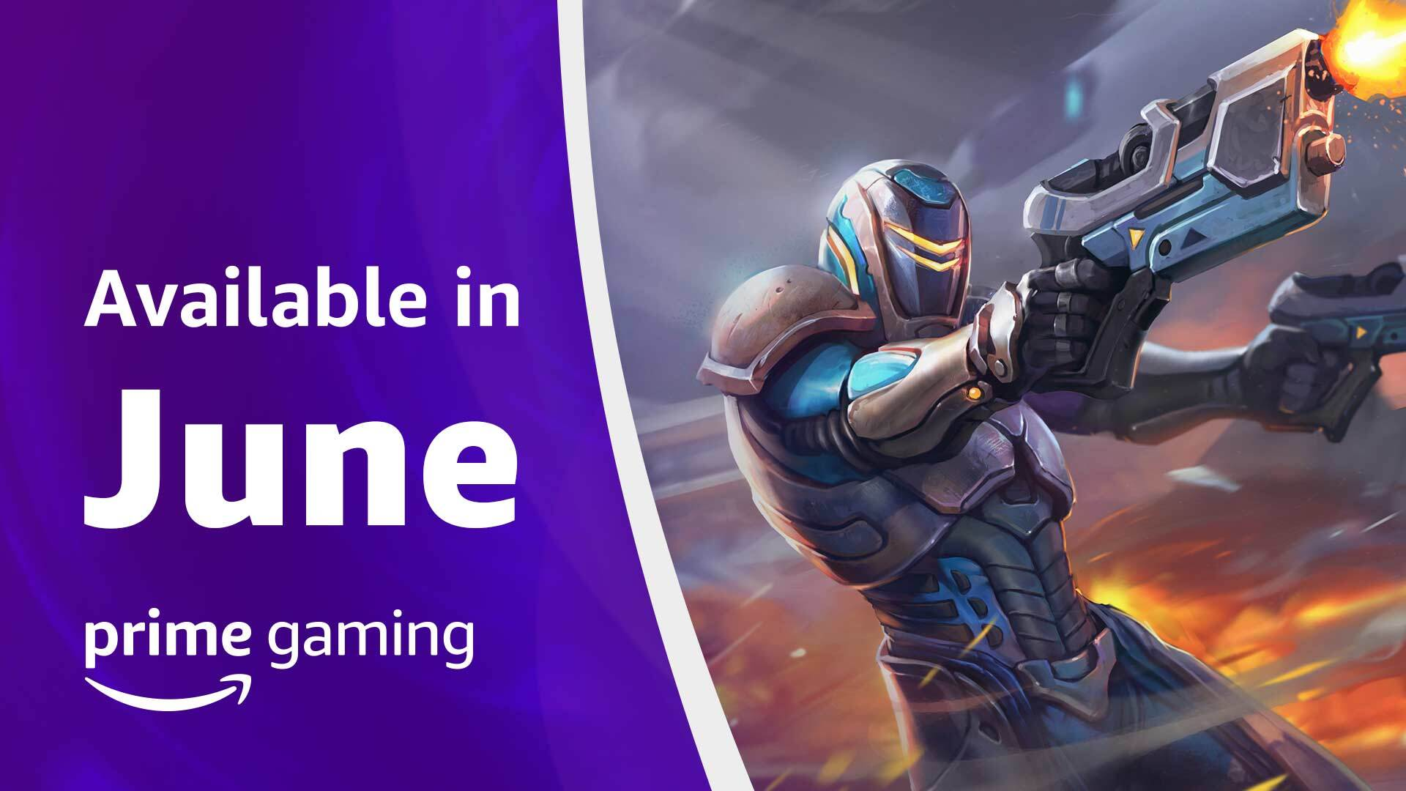
A Look at Prime Gaming’s June 2021 Offers
For an overview of this month’s biggest offers for Prime members, be sure to watch the latest sizzle reel! June brings a fresh, new selection of Games with Prime, in-game content for Fall Guys, FIFA 21, VALORANT and much more. Check out the latest video he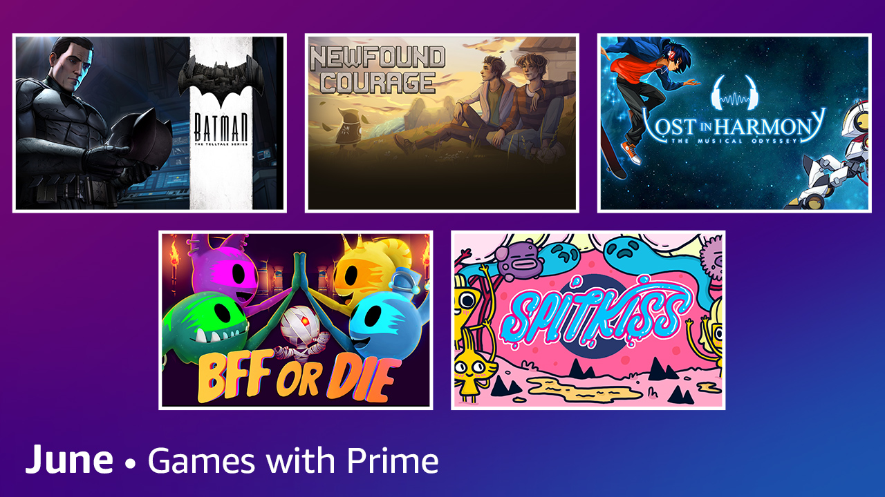re.
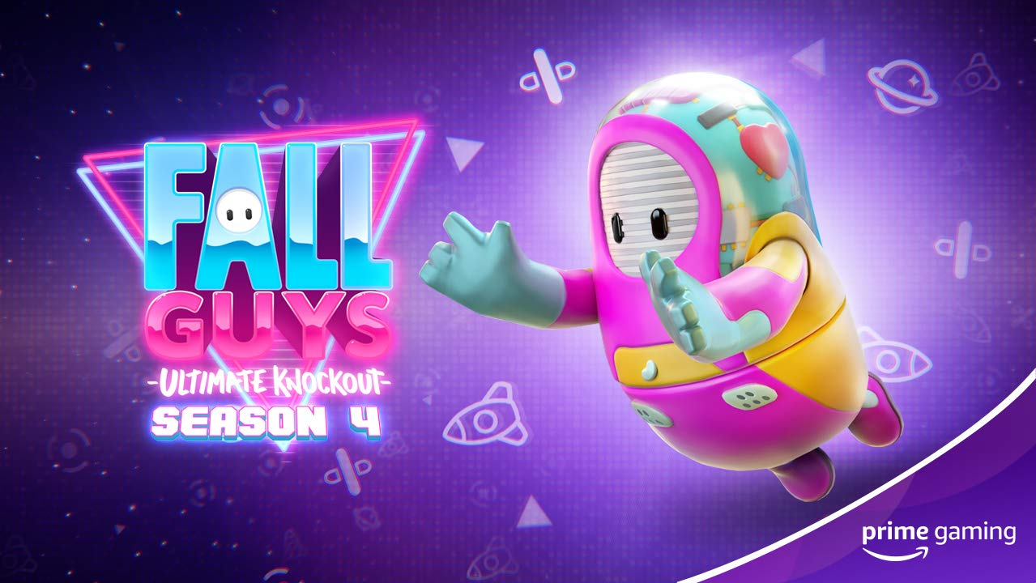
Dash Through the Dizzying Array of Fall Guys Obstacles with the New Bundle
Now Available To help celebrate the kickoff of Season 5, Amazon is gifting members with the Prime Gaming exclusive Burning Circuits Bundle for the battle royale game Fall Guys: Ultimate Knockout. The new bundle includes:
- A Burning Circuits Costume
- 6500 Kudos, to help players fast-track their way to the next in-game goodie.
Drop 6 of 6
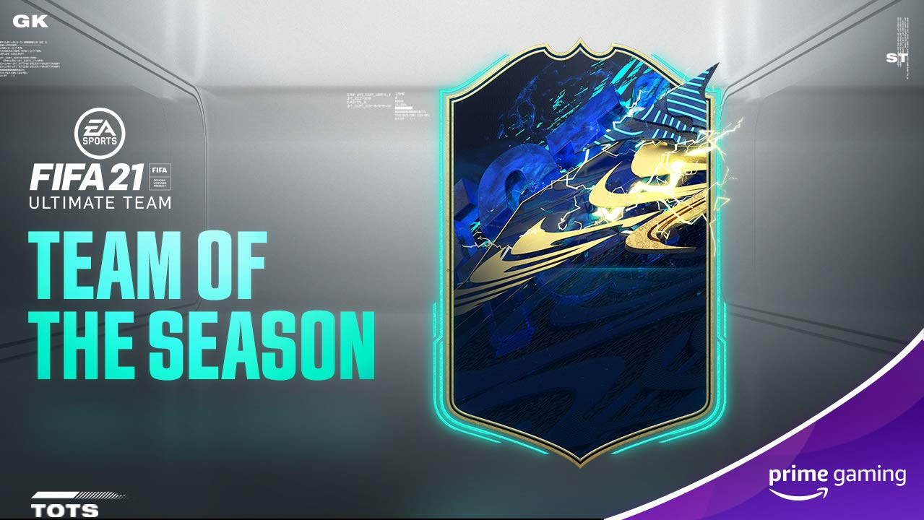
Feel Next Level with FIFA 21 Loot
Now Available While suiting up for your next match be sure to claim the latest Prime Gaming loot for FIFA 21 gameplay. Grab the Exclusive Prime Gaming 81+ OVR Player Pack including: 1 Player Pick of 4 OVR 83+ Players and 5 Gold Rare Players
Drop 5 of 9
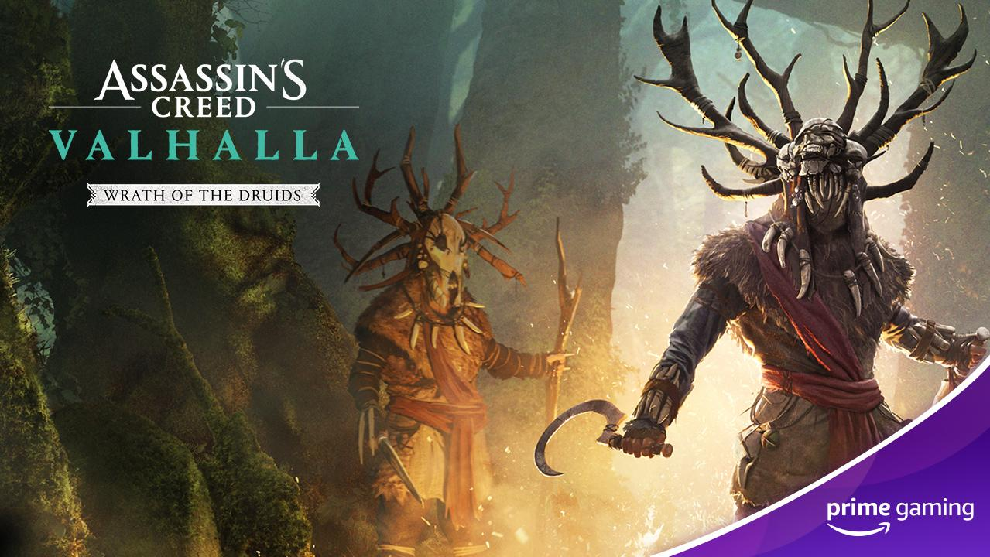
Become Legendary in Assassin’s Creed Valhalla with the Druidic Settlement Bundle!
Now Available Prime Members can lead their clan in the action role-playing game and claim the Druidic Settlement Bundle, which includes a Black Raven Settlement Pack, Mystical Settlement Pack and 5x One Hour XP Boosters.
Drop 2
Kick off the Summer with Six New Games!
Available June 1 Prime Gaming is adding SIX titles to our library starting June 1! This month’s lineup offers a variety of games to choose from, from Batman - The Telltale Series, the popular episodic point-and-click graphic adventure game to Newfound Courage, a story-driven adventure game.
- Batman - The Telltale Series - Indulge in this episodic point-and-click graphic adventure video game developed and published by Telltale Games.
- Newfound Courage - Explore the story-driven adventure game about a gay hero who falls in love with his best friend while the world unravels around them.
- Lost in Harmony - Jump into the musical runner that blends a deep and emotional story into a rhythm game.
- BFF or Die - Cozy up with this crazy cooperative puzzle game where you can play with up to four players! Become a time traveling alien sent to Earth on a risky rescue mission.
- Spitkiss - Enter this colorful and true one finger platformer that lets players enter into the lovely world of the Spitkissers, where tiny creatures that communicate through body fluids and emojis.
- Mugsters - Test your knowledge in this physics-based, supercharged, action-packed puzzler with sandbox levels where players must outrun, out-maneuver and outsmart their enemies by experimenting with different vehicles, environmental traps and explosives.
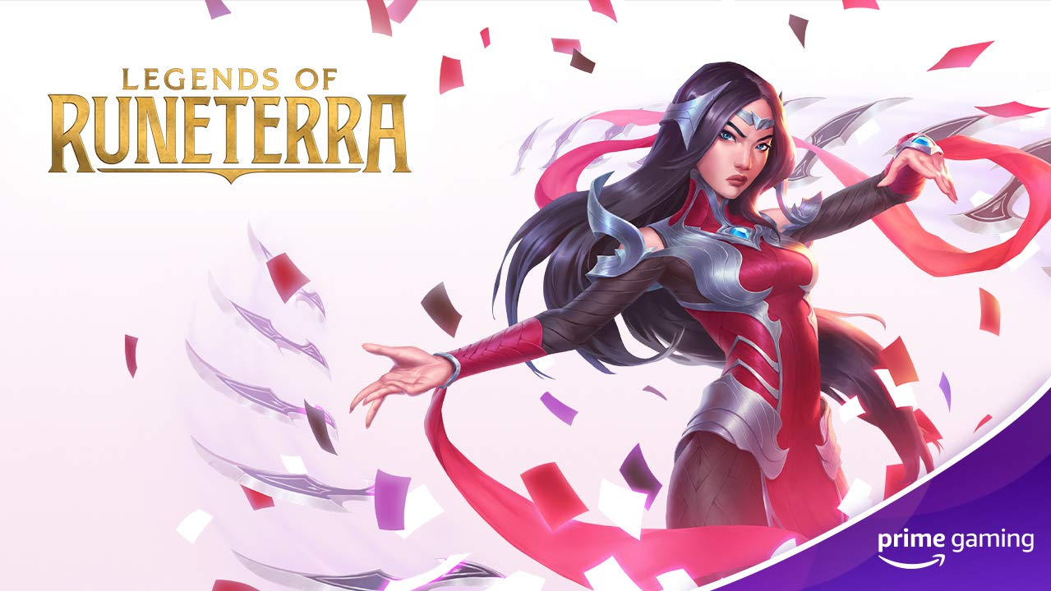 | 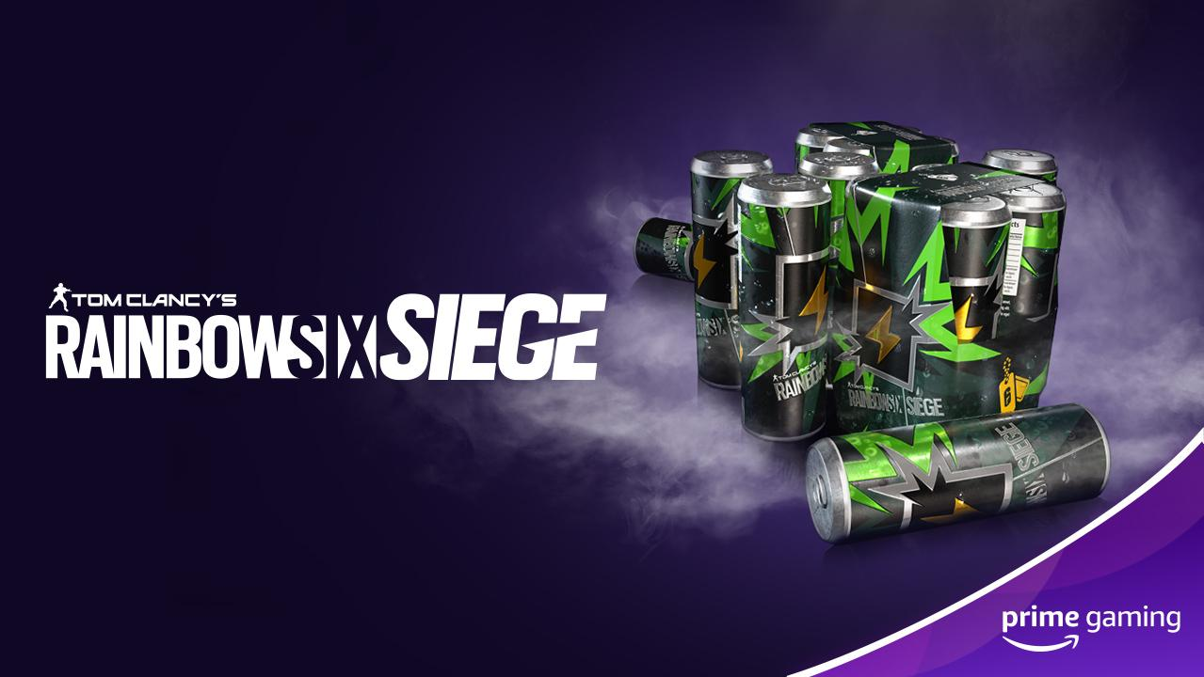 | 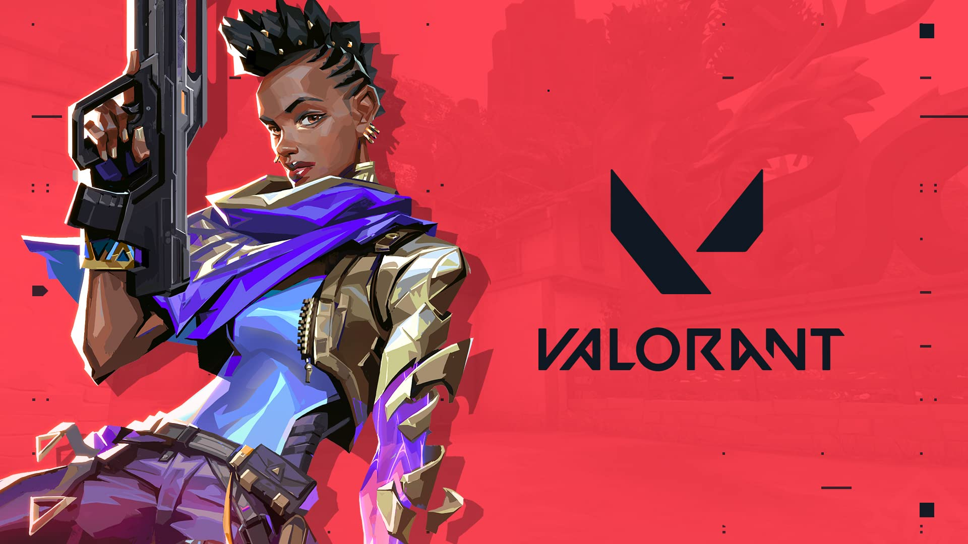
Legends of Runeterra  Drop 5: Now Available  Drop 6: June 10  Players can look forward to redeeming an Epic Wild Card each month!  Drop 5 - 6 of 12 | Rainbow Six Siege  Available Now Available  This month, grab up to a week’s worth of Renown Boosters for Rainbow Six Siege gameplay before it expires on June 21.  Drop 6 of 11 | VALORANT  Drop 2: Now Available  Drop 3: May 28  Prime members can claim the 200 IQ spray until May 28. Stay tuned for Drop 3 details.  Drop 2 - 3 of 10
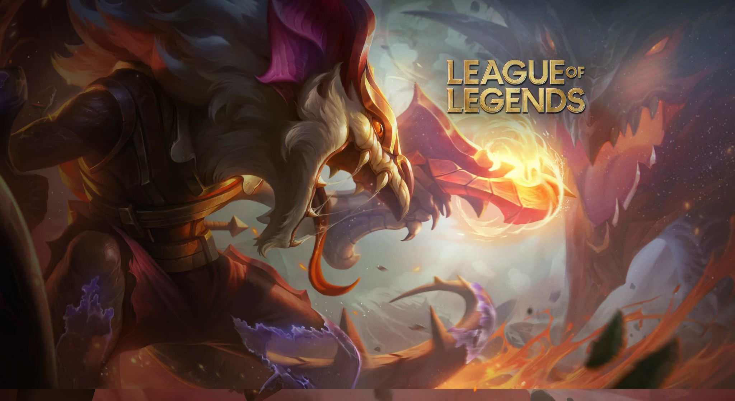 | 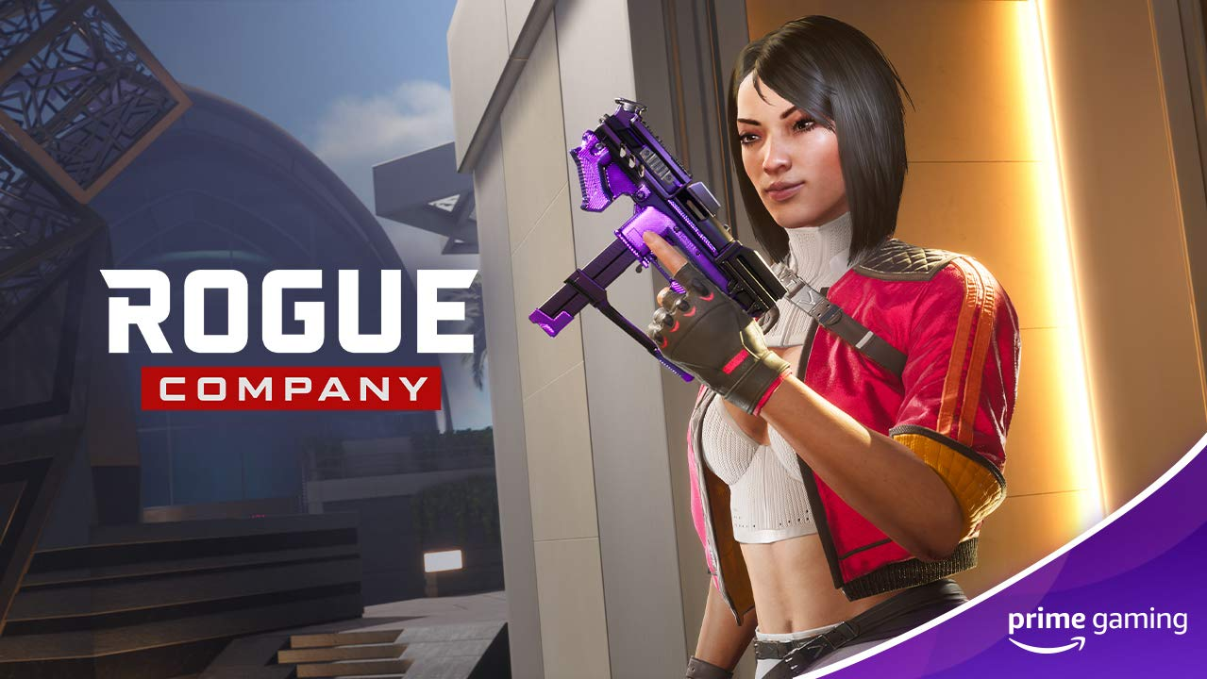 | 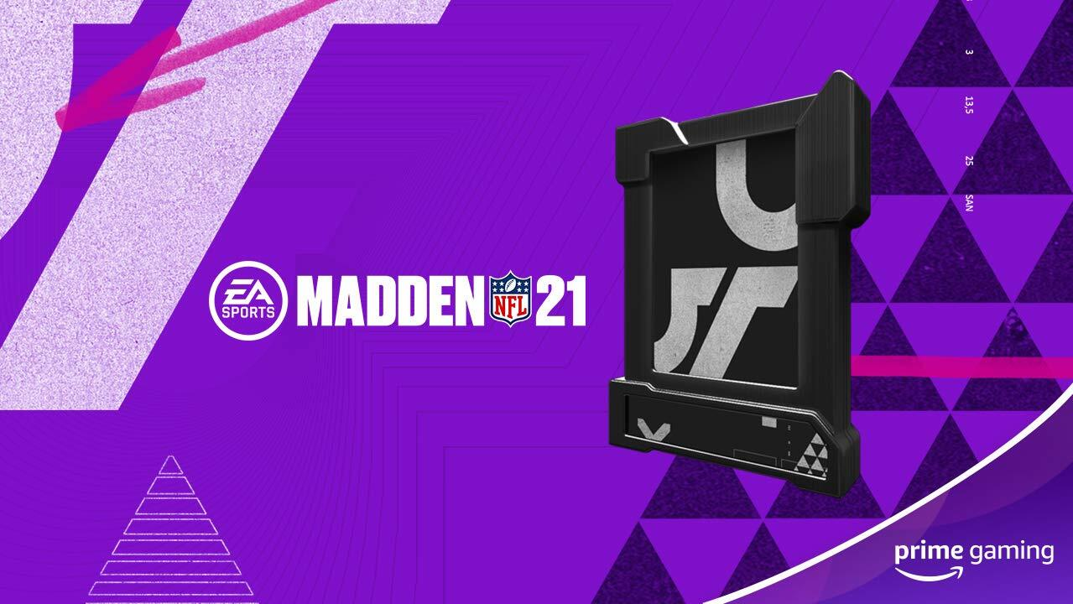
League of Legends  Drop 14: Now Available - June 11  Drop 15: June 1 - June 11  Drop 16: June 11 - July 12  Drop 17: June 21 - July 12  Members can claim up to four mystery skin shards for the wildly popular team-based strategy game  Drop 15 - 17 of 36 | Rogue Company  Now Available  Claim the Primordial Violet Weapon Wrap to assist in the 4v4 team-based multiplayer shooter gameplay.  Drop 8 of 11 | Madden 21  Available June 2  During the offseason, brush up on your skills with the following items:  - 1x Elite Player 80+ OVR  - 2x Gold or better players 70+ OVR  - 3x Silver players 62+ OVR  Drop 10 of 12
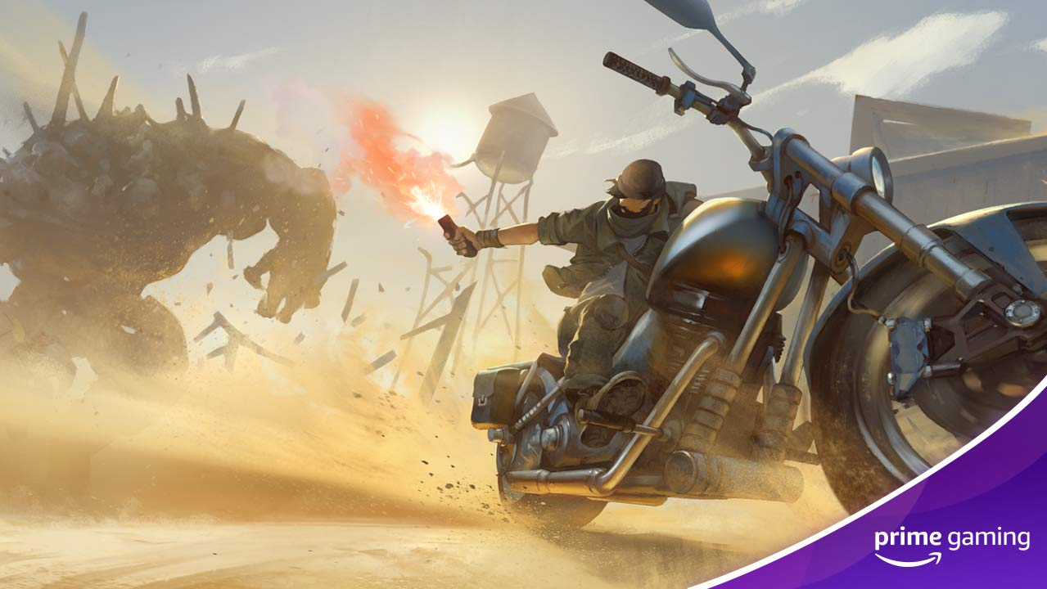 | 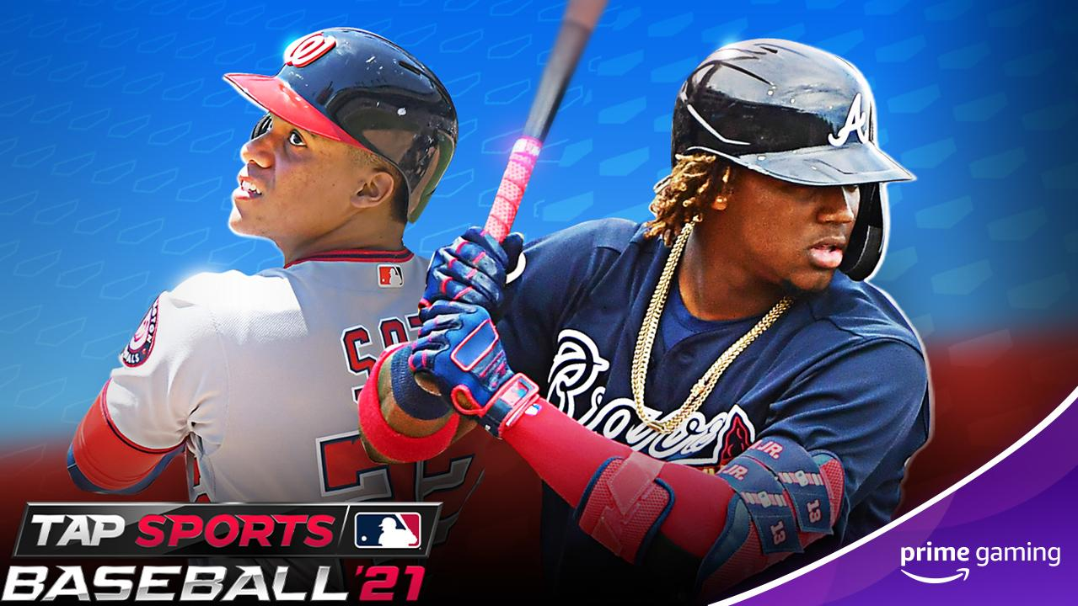 | 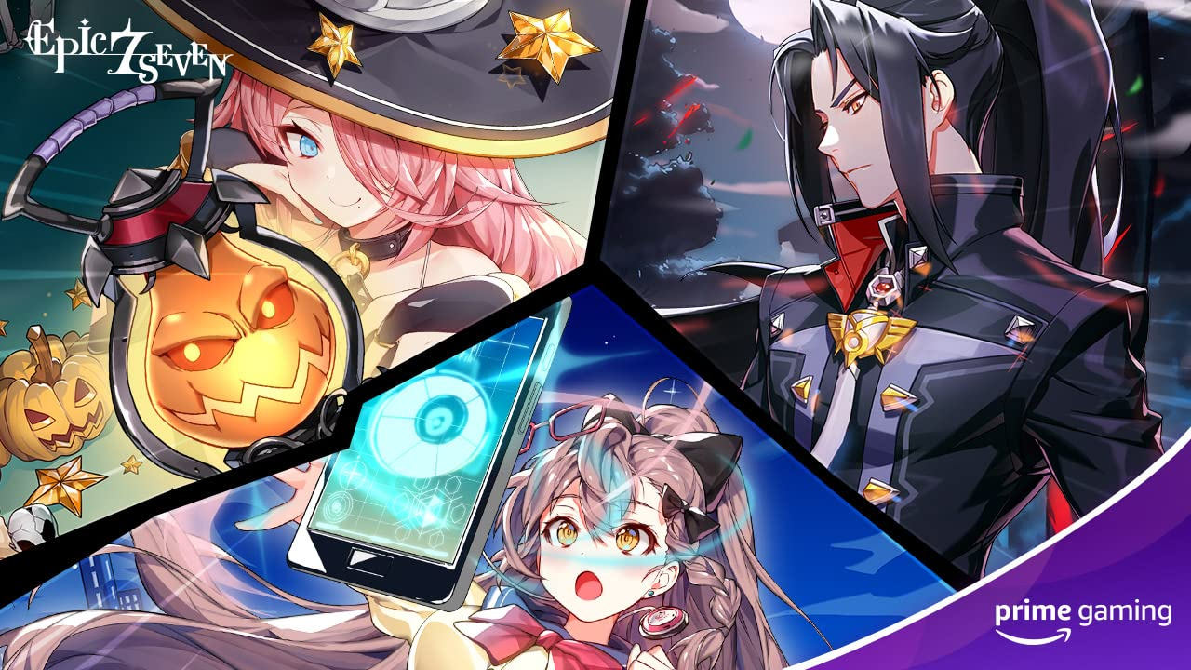
Last Day on Earth  Drop 4: Now Available  Drop 5: June 3  Drop 6: June 17  June brings tons of Last Day on Earth content! Be sure to claim a ‘Punk’ Backpack skin, special forces armor set + M16 and x1000/Caps!  Drop 4-6 of 16 | MLB Tap Sports Baseball ‘21  Drop 5: Now Available  Drop 6: June 9  Drop 7: June 23  Batter up! Prime Members can enjoy a daily box and in-game currency throughout the month of June.  Drop 5-7 of 16 | Epic Seven  Drop 8: Now Available  Drop 9: June 2  Drop 10: June 16  The epic RPG brings various offerings this month, including:  - Drop 8: 20x Leif  - Drop 9: 5x Greater Equipment Charms, 500,000 Golds  - Drop 10: 1x Tera-Phantasma, 6x Giga-Phantasma, 300,000 Golds"  Drop 8-10 of 18
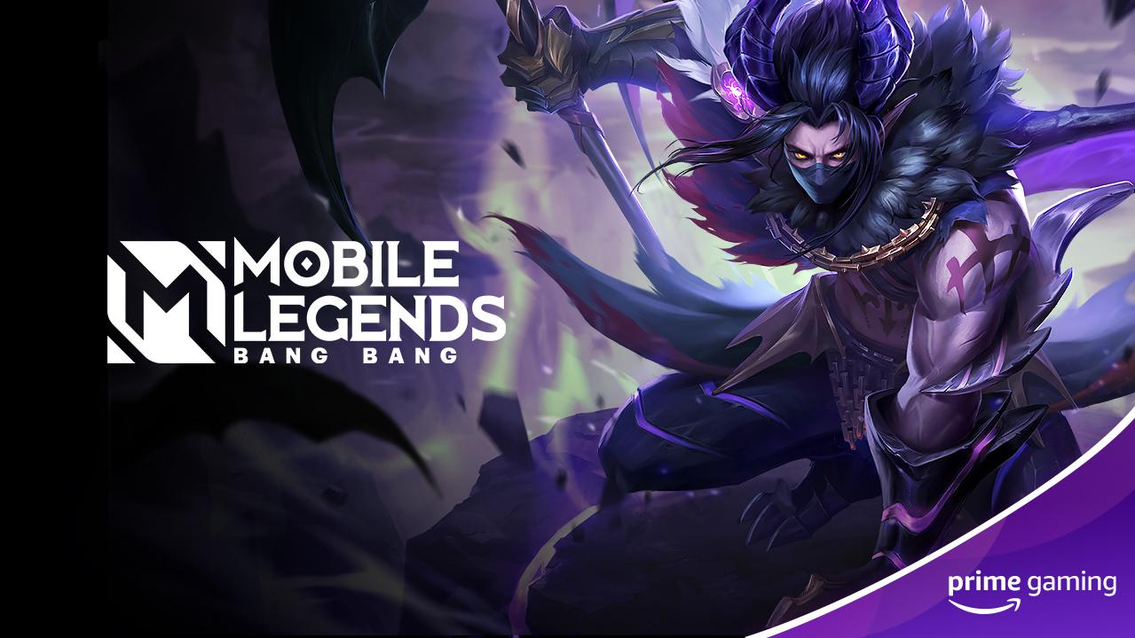 | 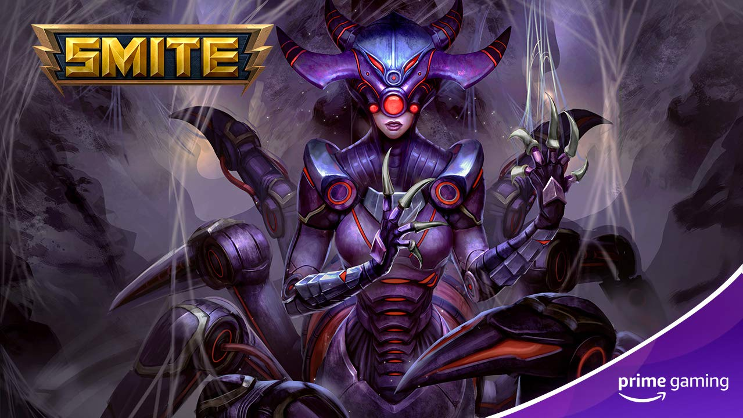 | 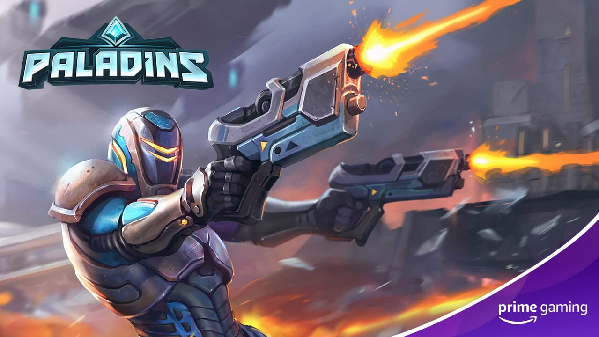
Mobile Legends Bang Bang  Drop 2: Now Available  Drop 3: June 8  Drop 4: June 22  Players can look forward to the following drops in the classic MOBA game:  - Drop 2: Amazon Prime Chest including "Hero Trial Cards of Natalia, Skin Trial Cards of Natalia-Phantom Dancer, Hero Trial Cards of Moskov and Skin Trial Cards of Moskov-Twilight Dragon  - Drop 3-4: Amazon Prime Chest  Drop 2-4 of 25 | SMITE  Now Available  Be sure to claim an exclusive Grim Weaver Arachne skin in the free-to-play, third-person multiplayer online battle arena game today!  Drop 9 of 9 | Paladins  Now Available  Prime Members can now snag a Exclusive LEX-O Suit Lex Skin in the popular free to play, first person shooter!  Drop 9 of 9
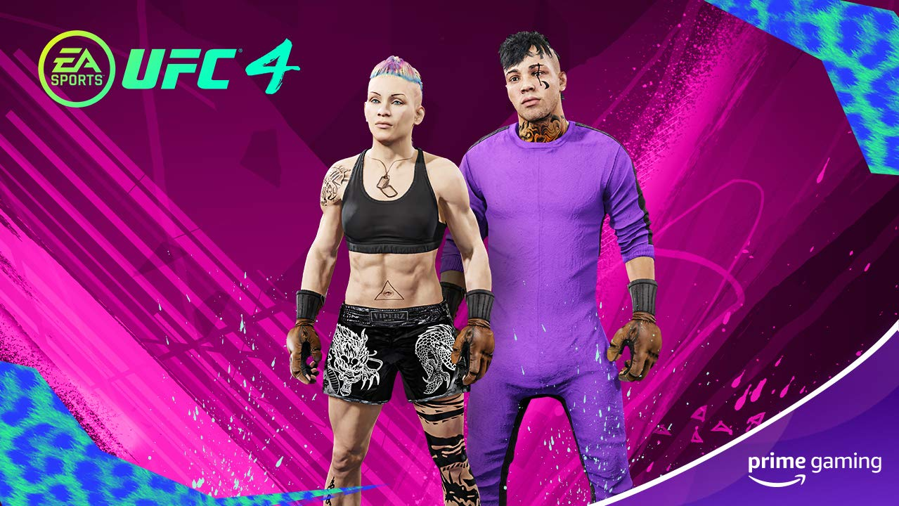 | 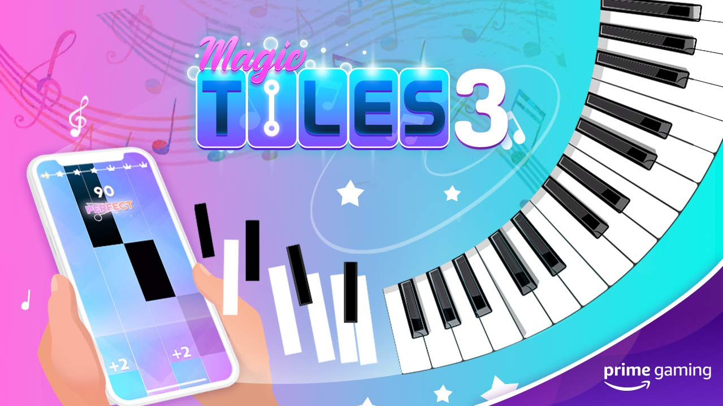 | 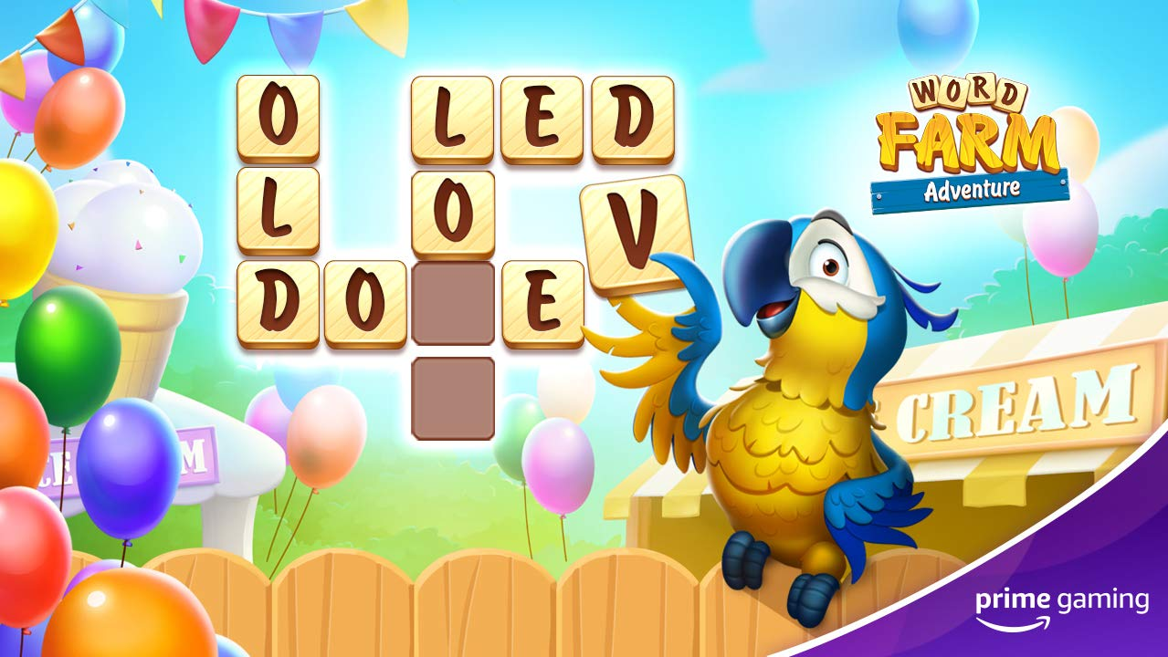
UFC 4  Now Available  Claim the latest threads with the Kenpo outfit, which includes Kenpo gloves, a purple jumpsuit, black Muay Thai dragon shorts and a unique playercard background.  Drop 5 of 6 | Magic Tiles 3  Now Available  Unlock One-Day VIP pass and five additional songs, every week!  Drop 25 & 26 | World Farm Adventure  Drop 2: June 1  Drop 3: June 15  Save the farm animals in this Free word scrabble puzzle game, with two drops this month:  - Drop 2: Super Spin (3 spins of the wheel of fortune)  - Drop 3: Piggy Bank Smash (One smash of the piggy bank to get coins + boosters)"  Drop 2 - 3 of 7
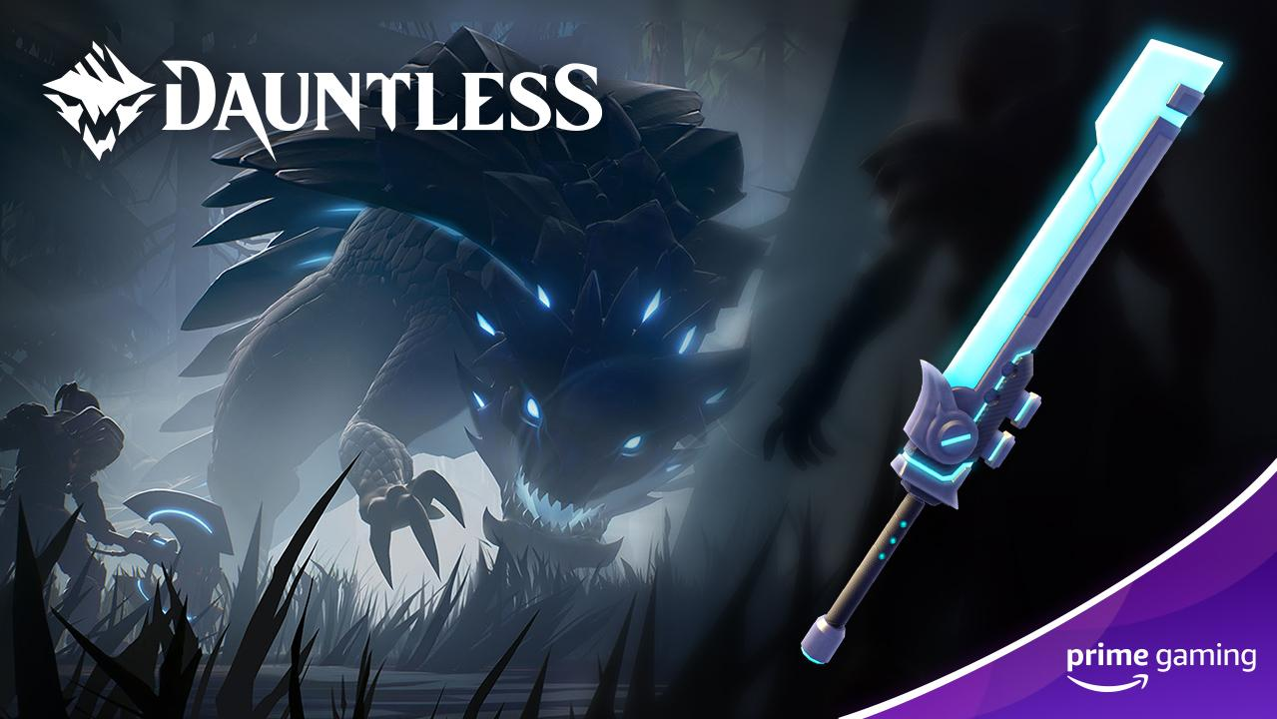 | 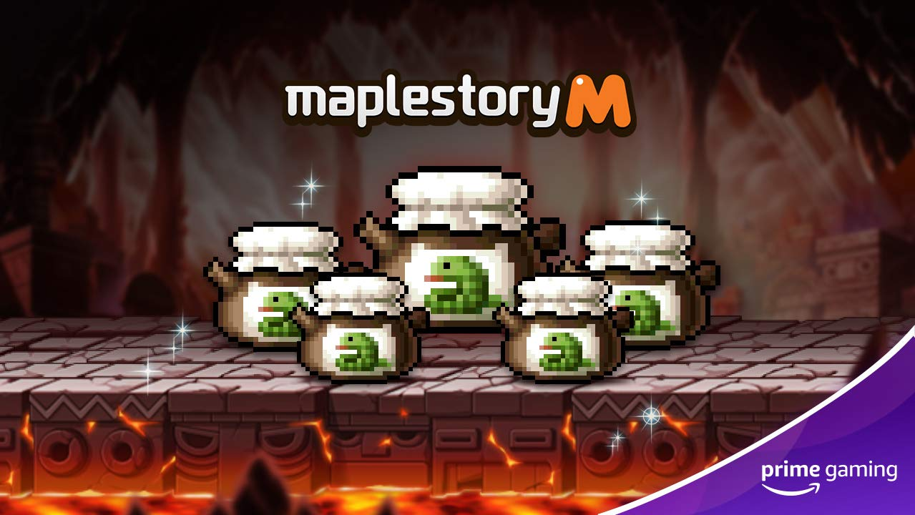 | 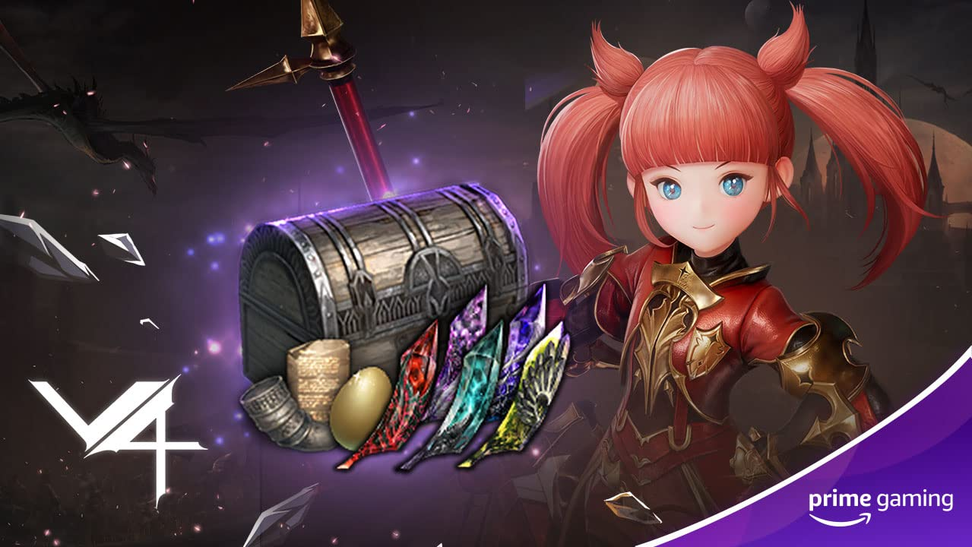
Dauntless  Drop 1: Now Available  Drop 2: June 8  This month, Prime Members can look forward to claiming 1 Arcslayer E-blade Sword Skin, 1 supply pack and 1 Primus Purple Armour Dye through June 17.  Come back for more Dauntless drops this calendar year.  Drop 1-2 of 7 | MapleStory M  Drop 9: June 2  Drop 11: June 19  Players can look forward to redeeming the following offers:  - Drop 9: Maple Beauty Box (Royal Hair Coupon x2, Royal Face Coupon x2, Hair Dye Coupon x1, Color Lens Coupon x1) until June 16  - Drop 10: Snake Soup Exp Booster x10 until June 30  Drop 9 - 10 of 12 | V4  Drop 7: June 10  Drop 8: June 24  Prime Members can look forward to special support packages and various skill choice chests, including:  - Drop 7: Special Support Package + Epic Demon Stone Choice Chest (Baktar – Artuman)  - Drop 8: Special Support Package + Rare Active Skill Choice Chest  Drop 7 - 8 of 12
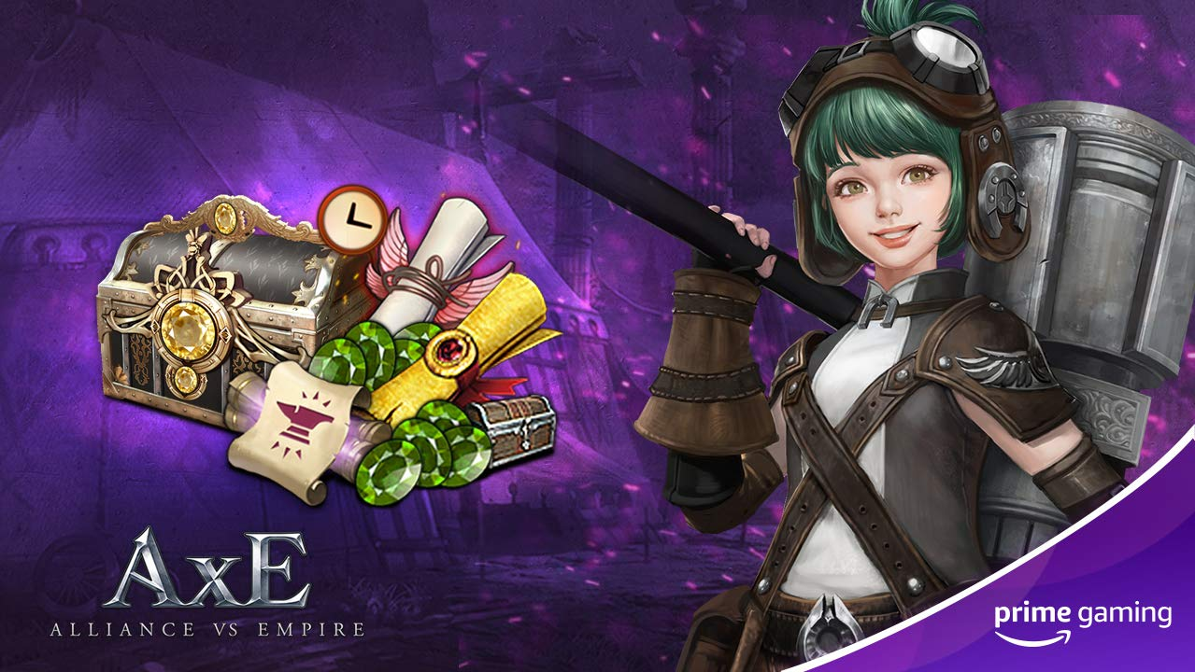 | 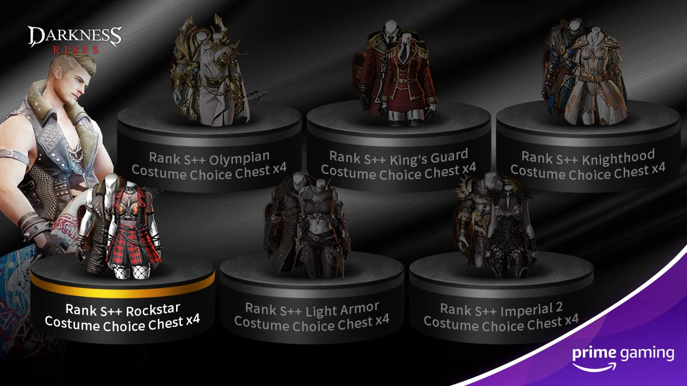 | 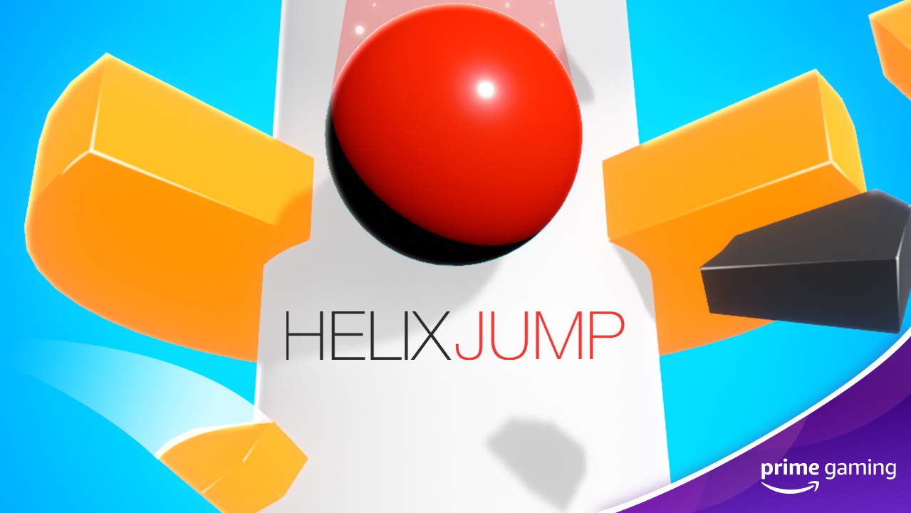
Alliance vs. Empire  Drop 8: June 9  Drop 9: June 23  Be sure to claim the following loot:  - Drop 8: White Diamond x500, Emerald x50, Enhancement Guard Ticket x50, King's Blessing x1, Benuv's Blessing x1 until June 23  - Drop 9: White Diamond x500, Enhancement Guard Ticket x50, Hero's Blessing x1, Treasure's Blessing x1 through July 7  Drop 8 - 9 of 12 | Darkness Rises  Drop 10: June 3  Drop 11: June 17  To assist in the revolutionary Action RPG:  - Drop 10: Rank S++ Rockstar Costumes Choice Box x4 through June 17  - Drop 11: Rank S++ Imperial 2 Costumes Choice Box x4 until June 1  Drop 10 - 11 of 12 | Helix Jump  Available June 10  Enjoy two weeks of ad-free play in the fun and addicting mobile game starting June 10.  Drop 6 of 6
Calendar June 2021
Now Available Apex Legends Drop 4
Now Available Assassin’s Creed Valhalla Drop 2
Now Available Dauntless Drop 1
Now Available Destiny 2 Drop 7
Now Available Epic Seven Drop 8
Now Available Fall Guys Drop 6
Now Available FIFA Drop 5
Now Available Last Day on Earth Drop 4
Now Available League of Legends Drop 14
Now Available Legends of Runeterra Drop 5
Now Available Magic Tiles 3 Drop 25 & 26
Now Available MLB Tap Sports Baseball ‘21 Drop 5
Now Available Mobile Legends Bang Bang Drop 2
Now Available Paladins Drop 9
Now Available Rainbow Six Siege Drop 6
Now Available Rogue Company Drop 8
Now Available Smite Drop 9
Now Available UFC 4 Drop 5
Now Available World of Tanks Drop 4
May 28 Valorant Drop 3
June 1 Games With Prime - Batman - The Telltale Series, Newfound Courage, Lost in Harmony, BFF or Die, Spitkiss and Mugsters
June 1 Last Chance to Claim Yoku’s Island Express, Healer’s Quest, Beholder, The Blind Prophet and A Blind Legend
June 1 League of Legends Drop 15
June 1 Word Farm Adventure Drop 2
June 1 Word Farm Adventure Drop 2
June 2 Epic Seven Drop 9
June 2 Madden 21 Drop 10
June 2 Maplestory M Drop 9
June 3 Darkness Rises Drop 10
June 3 Last Day on Earth Drop 5
June 8 Mobile Legends Bang Bang Drop 3
June 9 Alliance vs Empire Drop 8
June 9 MLB Tap Sports Baseball ‘21 Drop 6
June 10 Legends of Runeterra Drop 6
June 10 Helix Jump Drop 6
June 10 V4 Drop 7
June 11 League of Legends Drop 16
June 15 Word Farm Adventure Drop 3
June 16 Epic Seven Drop 10
June 16 Maplestory M Drop 10
June 17 Darkness Rises Drop 11
June 17 Last Day on Earth Drop 6
June 18 Dauntless Drop 2
June 21 League of Legends Drop 17
June 22 Mobile Legends Bang Bang Drop 4
June 23 Alliance vs Empire Drop 9
June 23 MLB Tap Sports Baseball ‘21 Drop 7
June 24 V4 Drop 8
For the latest on content, offers and sweepstakes, follow Prime Gaming on the official Prime Gaming blog, Twitter, Facebook and Instagram.

About Prime Gaming

With Prime Gaming, Amazon Prime members enjoy tons of exclusive content for their favorite PC, console, and mobile games. Plus, they can claim a collection of PC games for every month that are theirs to keep forever, and a monthly Twitch channel subscription. Prime Gaming’s selection of in-game content and PC games is always growing and rotating to stay fresh, with new items and games added every month.

This is in addition to the many other benefits available with Prime, including the best of shopping and entertainment from Amazon, including fast, free delivery, along with exclusive savings, early access to deals, Prime Day, and so much more. Members enjoy unlimited streaming access to a vast collection of TV shows, movies, sports and more with Prime Video, ad-free listening of 2 million songs plus thousands of stations and playlists with Amazon Music, unlimited access to a rotating selection of more than 1,000 books and magazines with Prime Reading, and unlimited photo storage with Amazon Photos.

