
Pressrelease Karlsborg 2012-05-31

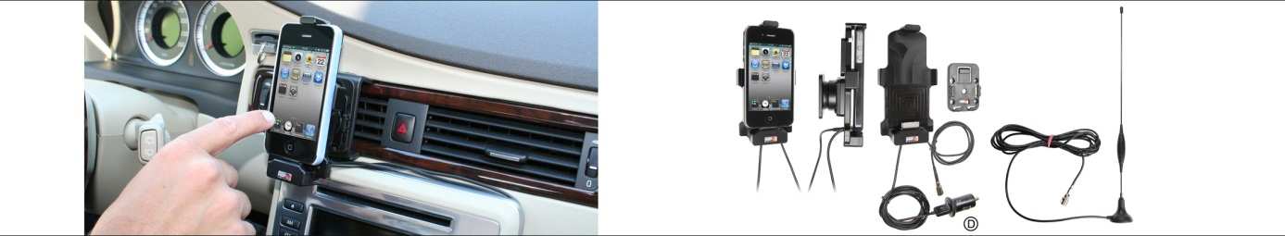

Holder for external antenna provides improved reception for iPhone and iPad
The Swedish company Brodit has developed a new holder with external antenna connection which provides a considerably better and more reliable mobile coverage for iPhone and iPad in the car. The enhanced antenna signal is transmitted wirelessly from the holder, which also charges the device.
Despite an extensive mobile network, there still are areas with weaker coverage. In rural areas the cell towers are more sparsely placed and in urban areas the signal can be blocked by high buildings.
Brodit’s solution to the problem is a new holder with external antenna connection which makes it possible to talk on the phone on most roads, use mobile surf with a decent speed also in places without broadband and listen to Spotify without annoying interruptions.
The holder is attached onto a mount on the dashboard and connected to an external antenna in the windshield or on the roof. The external antenna picks up even weaker signals that the antenna in the device does not detect and transfers them wirelessly to the device via the built-in inductive antenna. The external antenna provides a considerably better and more reliable mobile coverage than the device’s antenna.
In addition to a better reception the holder also charges the device. The holder is easy to install and use. In most cases the user can do the installation himself. A tilt swivel makes it easy to adjust the device into desired position within comfortable sight and reach.
Initially the holders will be launched for the newest iPhone and iPad models, and they will be available for devices both with and without skin. As Brodit develops and manufactures the holder, the company can also develop it for other phones and tablets if there is a demand. Brodit has almost 30 years of experience in products for installation of communication devices in vehicles.

– We strongly believe in our new holder with external antenna connection. It offers a solution to a major problem that has existed as long as mobile phones have been used. We are also thrilled to be first with such an advanced product that is fully developed in Sweden, says Ebbe Johansson, Brodit founder and CEO.
– Today many people are dependent of their mobile phones and now all who are struggeling with poor mobile coverage will get entirely new opportunities to use mobile phones. Most people will use the holder in the car, but it is also perfect for use in boats, or – in combination with a table stand and a bluetooth handsfree – at home, in the summer house or in the office.
The holder is design registered, it will be launched in June 2012 and available via Brodit’s distributors. Prices starting from €90.
------
Images and more pressreleases about Brodit products are available at www.mynewsdesk.com/se/pressroom/brodit

For more information, please contact:
Heidi Eskonniemi, marketing assistant, +46 (0)505 177 78, heidi@brodit.se

About Brodit AB:
Brodit develops and manufactures products for installation of communication devices in vehicles. Brodit was founded in 1983 and is located in Karlsborg, Sweden. The company has 80 employees, is market leading in mounting solutions in vehicles and exports to 30 countries. More information at www.brodit.com

