Ramboll shows resilient financial performance in the first half year despite global economic downturn

Ramboll Group delivered a resilient financial performance in the first half year reflecting that the company has successfully adapted to the prevailing market conditions. By the end of June 2009, the order book remained on the same high level as the previous year. In addition, the Group is almost net debt free and has a committed credit facility of DKK 1 billion. Thus, Ramboll is prepared to meet the global market conditions and pursue its strategy for growth.

At constant exchange rates the company's revenue increased by 4 percent to DKK 2,830 million. Organic growth represented 2 percent whereas 2 percent derived from acquisitions. Organic growth was primarily accomplished in Denmark, Norway, Sweden and Finland and within telecom in India. Growth from acquisitions was due to last year's acquisition of Ramboll IMI in India and smaller acquisitions in Norway and Sweden. The increase of the reporting currency DKK against GBP, SEK, and NOK in particular has affected the revenue adversely with 5 percent. Operating profit before amortization (EBITA) was DKK 176 million and EBITA margin was 6,2 percent. Profit before tax was DKK 122 million.

New opportunities within infrastructure, telecom, wind energy and climate
Since 2004, Ramboll Group has more than doubled its number of employees. By the end of first half year 2009 the total number of employees was 8,763 – an increase of 400 employees compared to last year's numbers. Since the end of 2008, the number of employees has declined by 85 as a consequence of the necessary, organisational adjustments to the changed market conditions within the area of Buildings & Design.

"After several years of record-breaking growth we experience low, and for some of our segments, negative growth rates. We see the downturn in the building market, particularly in the UK and Middle East but also in the Nordic countries. This causes a negative effect on parts of our business and we therefore take the necessary initiatives enabling us to relocate affected employees to other areas of our business. For the remainder of 2009, our full attention will be paid to the flexibility of our organisation and the adaption to the changing market conditions," says Group CEO Flemming Bligaard Pedersen.

On the other hand, Ramboll experiences high activity and many new opportunities within the areas of infrastructure, telecom, wind energy and climate. The total order book remains high despite the very competitive market due to a number of large projects won in the first half year of 2009. Including the tunnel project of Fehmarnbelt linking Germany and Denmark, the Nordhavn project in Copenhagen and a contact on maintenance and further development of core administrative systems in the educational sector for UNI-C, an agency under the Danish Ministry of Education.

Strong economic platform
Tough market conditions within a few market sectors do not change the goal to engage in new growth markets.

"The market situation in the rest of 2009 remains challenging but we show resilience due to the extensive diversity in our competencies, services and geographical presence. Simultaneously, our economic foundation provides us with a reasonable basis for the future. By the end of 2009 we are almost net debt free. Moreover, we have a committed credit facility of DKK 1 billion which we can make use of when following our strategy for growth focusing on strengthening our position in existing and new growth markets," concludes Group CEO Flemming Bligaard Pedersen.

Key statistics

Key figures and financial ratios |  |  |  | H1 2009 |  | H1 2009 | H1 2008 | 2008
Income statement, DKK million |  |  |  | EUR m
Revenue |  |  |  | 379.9 |  | 2,830.1 | 2,865.4 | 5,639.8
Operating profit before goodwill amort. (EBITA) |  |  |  | 23.7 |  | 176.2 | 229.4 | 435.9
Operating profit |  |  |  | 18.4 |  | 136.8 | 191.8 | 357.3
Profit before tax |  |  |  | 16.4 |  | 122.2 | 185.8 | 357.7
Profit for the period |  |  |  | 9.7 |  | 71.9 | 116.8 | 231.7
Balance sheet, DKK million
Total assets |  |  |  | 421.3 |  | 3,138.9 | 3,230.2 | 3,115.3
Shareholders' equity |  |  |  | 134.9 |  | 1,005.3 | 1,011.4 | 918.6
Net interest bearing debts/(cash) |  |  |  | 3.1 |  | 23.4 | 173.5 | 9.5
Cash flow, DKK million
Cash flow from operating activities |  |  |  | 7.2 |  | 53.3 | 20.4 | 348.8
Investment in tangible assets |  |  |  | -3.2 |  | -23.9 | -32.8 | -88.3
Free cash flow |  |  |  | 3.9 |  | 29.4 | -12.4 | 260.5
Employees
Number of employees, end of period |  |  |  |  |  | 8.763 | 8.372 | 8.848
Financial ratios in %
Revenue growth |  |  |  |  |  | -1.2 | 27.1 | 19.0
Organic growth |  |  |  |  |  | 1.9 | 11.4 | 10.0
EBITA margin |  |  |  |  |  | 6.2 | 8.0 | 7.7
Cash conversion ratio * |  |  |  |  |  | 45.3 | 26.8 | 96.4
Return on invested capital (ROIC) ** |  |  |  |  |  | 27.1 | 32.6 | 34.7
Return on equity (ROE) ** |  |  |  |  |  | 14.9 | 24.2 | 25.1
Equity ratio |  |  |  |  |  | 32.0 | 31.3 | 29.5
 |  |  |  |  |  | förutom
The figures in EUR have been translated from DKK using an average exchange rate of 7.45.

* Defined as (EBITA + changes in working capital) / EBITA * 100
** Calculated on annual basis

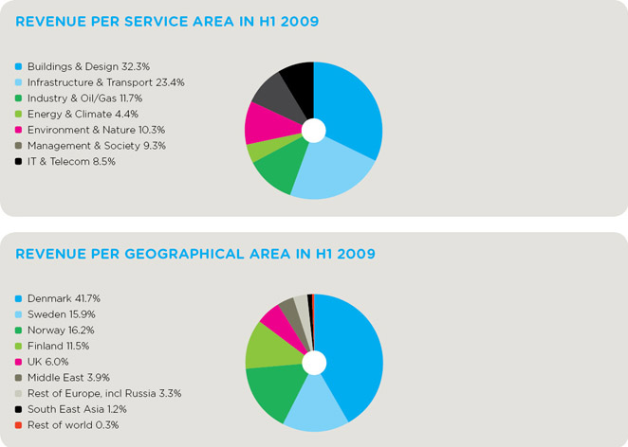

Contacts
For further information please contact Group CEO Flemming Bligaard Pedersen, +45 4598 6100 or Group CFO Michael Rosenvold, +45 4598 6068

Pictures and illustrations
1) Group CEO Flemming Bligaard Pedersen

2) Ramboll logo

3) Nordhavnen, Copenhagen: With an area covering the size of 625 football fields, Nordhavnen in Copenhagen is Scandinavia’s largest and most ambitious city development project these years.

4) Fehmarnbelt Tunnel: Ramboll designs the world's longest combined road and railway tunnel to link the Danish and German sides of Fehmarnbelt.

5) Offshore wind farms: Ramboll has designed more than 60 percent of all offshore wind turbine foundations in the world.

Ramboll in brief
Ramboll is a leading engineering, design and consultancy company founded in Denmark in 1945. Today, we employ more than 8,000 ambitious experts and have a significant presence in Northern Europe, India, Russia and the Middle East. With our close to 200 offices in 20 countries we emphasise local expertise combined with a global knowledge-base.

We constantly strive to achieve inspiring and exacting solutions that make a genuine difference to our customers, the end-users and society as a whole. Ramboll operates within the areas of: Buildings & Design, Infrastructure & Transport, Energy & Climate, Environment & Nature, Industry & Oil/Gas, IT & Telecom and Management & Society.

Ownership
The Ramboll Foundation is the main owner of Ramboll Group A/S and has as its main objective to promote the company's continuance alongside the long-term development of the company and its employees. All shares in Ramboll Group A/S are owned either by the Ramboll Foundation (95%) or by employees in Ramboll (5%).

