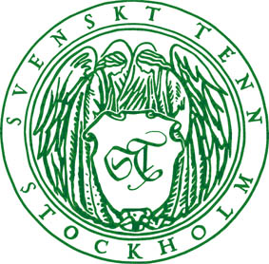

Press Release

Stockholm, November 14, 2014

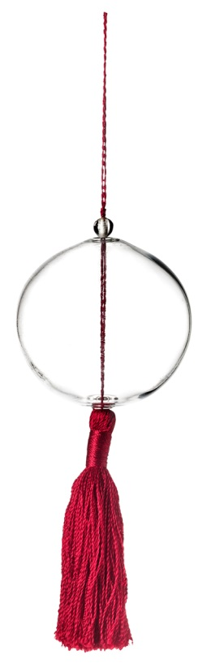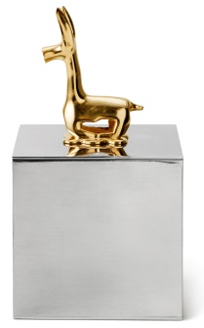**The Christmas market at Svenskt Tenn has opened**  
**The Christmas spirit has taken over the Svenskt Tenn store in Stockholm. There are many new Christmas tree decorations, and those looking for something to put *underneath* the tree might find suitable gifts among ten new pewter objects from the archives.**  
Designer Carina Seth Andersson has created a series of Christmas decorations, including glass balls with tassels in various colors, paper gourd and a brass star for the tree top. Prices SEK 40-350.  
  
Furthermore, no less than 10 objects from Svenskt Tenn’s archives are introduced, including several Estrid Ericson designs, inspired by items found during her many journeys. For example, two Chinese Ming era (1368-1644) figurines inspired her to create her own version in pewter. They are also available gold-plated. Price SEK 18,000 and 24,500.  
   
Estrid Ericson often decorated her objects by adding another design to it. The pewter box, for example, that she made for her husband Sigfrid Ericson, a captain with the Swedish American Line, has a gold-plated anchor chain for a knob. The box’s braided pattern comes from the captain’s Panama summer hat. Another box has a gold-plated Lama crowning the lid – probably inspired by the collections at a Far East Museum that she visited frequently. Price SEK 18,400 and 5,200.  
  
The snake biting its own tail was first displayed alongside many other Estrid Ericson pewter jewelry in 1943. Some were inspired by Bronze Age jewelry from the Museum of History collections, while others emerged in the Svenskt Tenn workshop. Earrings, price SEK 1,200.

**For further information, please contact:**

Vicky Nordh, Marketing Assistant: +46 8-670 16 23 or vicky.nordh@svenskttenn.se

Thommy Bindefeld, Marketing Director: +46 8 670 16 02 or thommy.bindefeld@svenskttenn.se

Image bank: [*www.svenskttennpress.se*](http://www.svenskttennpress.se) User name: *Press* Password: *Tenn*

**Svenskt Tenn** wasfounded in 1924 by designer and drawing teacher Estrid Ericson (1894-1981). In 1934, she began her lifelong collaboration with Josef Frank, already an internationally well-known architect, urban planner and designer, who had recently left Austria to take up residence in Sweden. Together, the two laid the foundations for the interior design philosophy that Svenskt Tenn has since come to represent, combining Estrid Ericson's artistic talent and entrepreneurial spirit with Josef Frank's inspired and timeless designs to form what was soon to become a highly successful concept. Svenskt Tenn is owned by the Kjell and Märta Beijer Foundation.