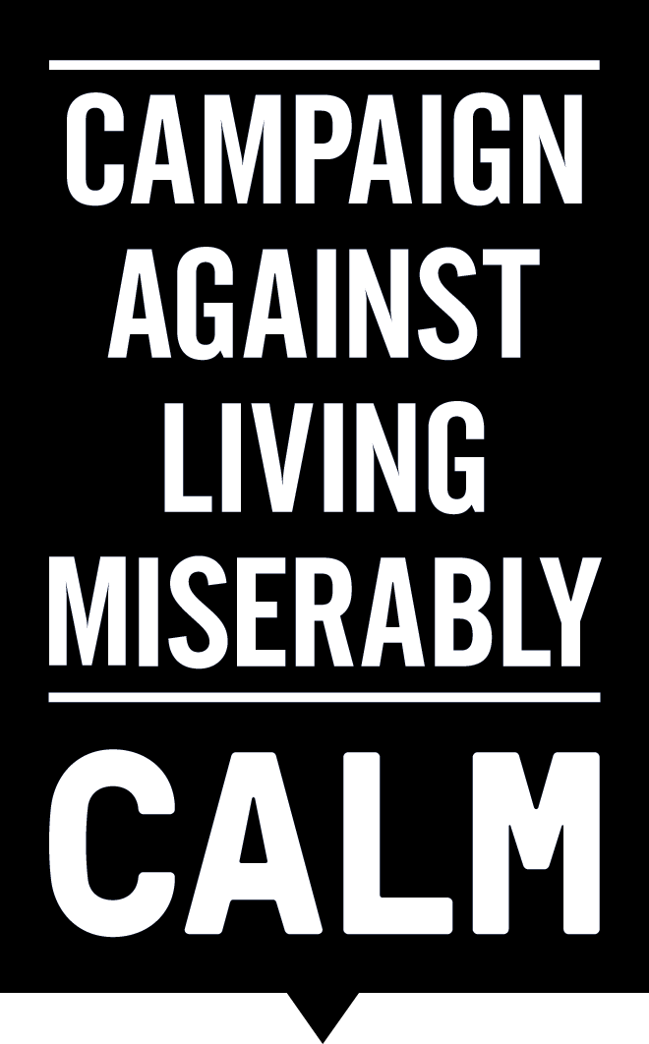
‘BIGGER ISSUES’ CAMPAIGN SEES 45% INCREASE IN AWARENESS OF MALE SUICIDE
21/11/15:
CALM is delighted to announce the success of the #BiggerIssues campaign with male grooming brand, Lynx, in raising awareness that suicide is the biggest single killer of men aged under 45, by a massive 45%.
The campaign, which launched on 2nd November, was backed by MPs, celebrities and suicide prevention charities alike, and culminated in a ‘Thunderclap’ message via social media reaching some 23.4 million people on the morning of International Mens’ Day (19th November) with a debate on men and the issue of male suicide in Parliament that afternoon.
Throughout November, CALM also managed other targeted awareness campaigns, including a partnership with Planet Rock Radio and a London based ‘Mind The Chap’ campaign with TOPMAN and Octopus Investments. This increase is a welcome result for a charity with less than a dozen staff at its London HQ.
CALM commissioned a YouGov poll in October 2015, which showed that awareness of suicide as the biggest single killer of men aged under 45 stood at 20% of UK adults. The poll was repeated on 15-16th December and revealed that awareness across the country rose to twenty nine per cent.
CALM CEO Jane Powell said:

“Too often we hear loved ones saying after a suicide that they weren’t aware of the facts, that they wish they’d known that this is the leading cause of death for young men in the UK. The #BiggerIssues campaign provided a great step forward in terms raising awareness and breaking down the barriers to being able to talk openly about an issue that has too long been swept under the carpet. The more awareness there is, the more we can normalise the conversation around suicide, with the aim of creating an environment in which more men feel able to ask for and can receive help.”

Ends

Notes to editors:

Contact: Jojo Furnival // Communications Manager, CALM // jojo@thecalmzone.net // 0203 697 9331

YouGov Polling:

 | Which ONE, if any, of the following do you think is the single BIGGEST cause of death in men aged under 45 years old in the UK?
 | Dec-15 |  |  | Oct-15
 | Total | Male | Female | Total | Male | Female
Unweighted base | 2091 | 985 | 1106 | 2015 | 977 | 1038
Base: All GB adults aged 16+ | 2091 | 1016 | 1075 | 2015 | 979 | 1036
AIDS | 0% | 1% | - | 0% | 0% | 0%
Knife and gun death | 2% | 2% | 3% | 2% | 1% | 2%
Road accidents | 16% | 16% | 17% | 21% | 20% | 21%
Alcohol poisoning | 5% | 4% | 5% | 6% | 5% | 7%
Suicide | 29% | 29% | 29% | 20% | 18% | 21%
Prostate cancer | 8% | 9% | 8% | 10% | 11% | 9%
Drugs | 7% | 6% | 7% | 9% | 9% | 9%
Heart disease | 15% | 18% | 13% | 17% | 19% | 15%
Testicular cancer | 5% | 5% | 6% | 6% | 6% | 7%
Obesity | 4% | 5% | 4% | 4% | 5% | 3%
None of these | 7% | 6% | 8% | 6% | 5% | 7%

* All figures, unless otherwise stated, are from YouGov Plc. Total sample size was 2091 adults. Fieldwork was undertaken between 15th - 16th December 2015. The survey was carried out online. The figures have been weighted and are representative of all GB adults (aged 16+).
** All figures, unless otherwise stated, are from YouGov Plc. Total sample size was 2,015 adults. Fieldwork was undertaken between 15th-16th October 2015. The survey was carried out online. The figures have been weighted and are representative of all GB adults (aged 18+).

ABOUT CALM:

The Campaign Against Living Miserably, CALM, is an award winning charity dedicated to preventing male suicide in the UK. Founded in 2006 the charity seeks to prevent suicide by providing a service for men who are down or in crisis, and by fomenting cultural change so that any man considering suicide feels able to seek help.

CALM supporters and advocates include the likes of David Baddiel and Professor Green, Dizzee Rascal and Frank Turner, and its offbeat brand and challenging advertising have proven effective in reaching men across the UK. In the past 12 months, CALM has taken over 40,000 callers via its helpline and webchat. CALM’s free, confidential accredited helpline and webchat service are available every day of the week from 5pm to midnight, staffed by professionals, on 0800 585858 (national) 0808 802 5858 (London) and www.thecalmzone.net.

CALM is reg. charity no. 1110621.

There were 6,109 probable suicides in the UK in 2014 of which 76%, or 4,623, were male. Suicide is the biggest single killer of men aged under 45 in the UK (NISRA, GRO, ONS 2014).

