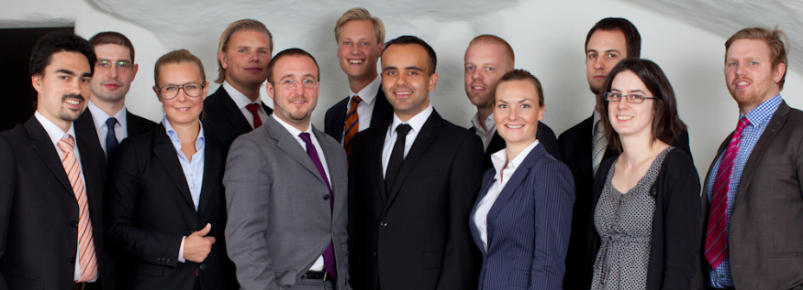

Leading Swedish cloud e-signing company Scrive closes second angel round

Scrive has successfully completed their second angel round and representatives of the investors have taken a board position in the company.

“We think that this company is a really interesting opportunity. It’s an exciting growth market with an estimated market value of about 4bn euro in Sweden alone. The company has managed to outgrow established Swedish competition and match well funded US competition in less than a year on a very tight budget. We chose to invest because we believe that this company is an exceptional player in what is becoming a strongly competitive space.”, says Gunnar Lindberg Årneby, one of the original founders of Spray and appointed board member.

Scrive, based in Stockholm, develops services for online e-signing. The main focus is the B2B sales segment where fast closing times are essential for business. The company has a team of twelve distributed around the globe working from eight different locations such as Buenos Aires, London, Warszaw and Stockholm. The core service has been built using the technology Haskell and the company has a special recruitment strategy.

“We are one of the first companies in the world to base our whole product on Haskell. Today Haskell is mainly used for limited applications such as in algorithms developed by Wall Street banks and for US government top security storage, applications where reliability is key. We chose Haskell because we see quality as a top priority. By choosing Haskell, a mathematical language with a steep learning curve, we were hoping to attract the best technical people from around the globe.”, says Lukas Duczko, CEO and founder of Scrive.

The strategy has paid off. The queue of applicants is long and the company has been able to attract senior developers such as Magnus Carlsson with over 30 years of experience in functional programming.

“We actually have the reversed problem to most tech companies today. We can’t recruit all the talent that is knocking at our door. We posted a short reply on Reddit about using Haskell and got 10 applications instantly.”, says Gracjan Polak, CTO and the second founder of Scrive.

The company looks forward to the challenges facing in 2012. A new team of sales representatives has been set up and sales is growing rapidly.

“In Sweden it’s very difficult to raise seed capital in early stage for a growth business with high capital requirements. Prices are low and few are ready to invest. I think we were able to prove our case when we closed deals of about 200k EUR just one week after closing the investment round.”, says Lukas Duczko.

The focus is now on Sweden but Scrive´s management is looking to the UK for the next European opportunity.

“We are global by definition. We already know how to co-ordinate international operations efficiently and we recently launched our English version. We are testing the UK market with Swedish clients running local UK operations.”

Contact Lukas Duczko, CEO, lukas@scrive.com, +46 70 456 04 04
Gunnar Lindberg Årneby, Board Member, gunnar@bloggverket.se, +46 70 836 69 55
Ashley Tott, Investment Advisor, ashley.tott@nordicvibe.com, +46 70 375 79 14

Visit www.scrive.com

