**Double WTCR Trophy podiums for the Bäckman’s**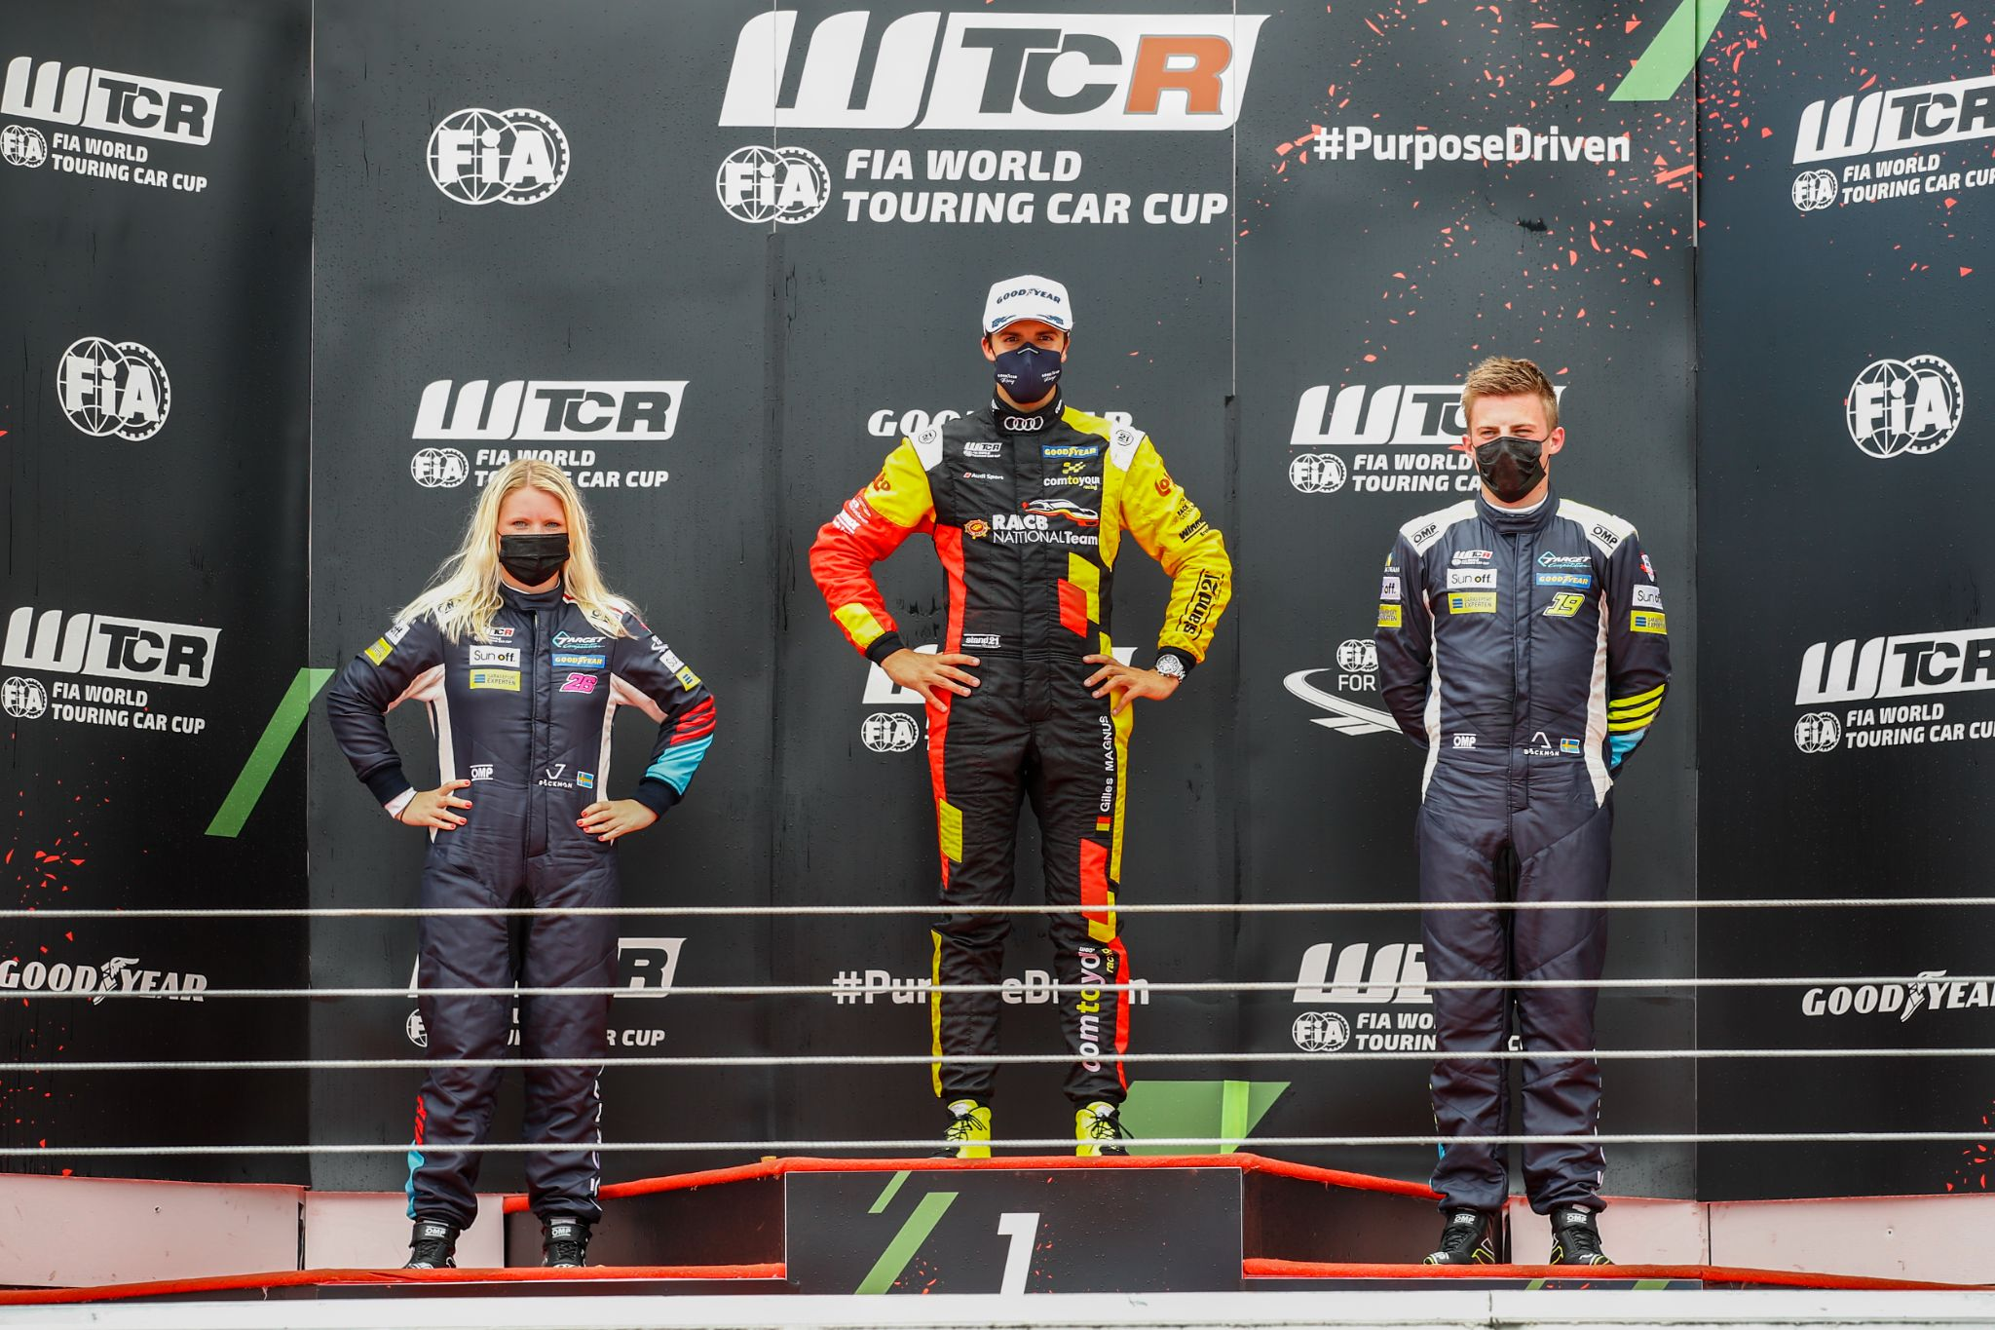Jessica and Andreas Bäckman got double podiums in the WTCR Trophy in Portugal.   
Photo: FIA WTCR (Free rights to use the image)

**The siblings Andreas and Jessica Bäckman competed last weekend in the second round of WTCR - FIA World Touring Car Cup. Andreas scored his first points in the series and both siblings got to step up on the podium for the first time in the series.  
-** **We must look ahead and bring the positives from this weekend with my first point and our WTCR Trophy podiums, Andreas Bäckman says.**

Circuito do Estoril, also known as the Autódromo Fernanda Pires da Silva, is a racetrack located outside Estoril in Portugal and is approximately 30 km from the capital Lisbon. The Portuguese Grand Prix in Formula 1 was run on this track between 1984-1996 and the track length is 4,182 km. Other well-known series such as MotoGP, WTCC and DTM have also run on the track over the years.

Last weekend, June 26th-27th, FIA WTCR was held for the first time at the Portuguese track, and it was time for the world’s top elite drivers to compete for new points. The Swedish National Team drivers Andreas and Jessica Bäckman was on the starting grid, competing for the Italian team Target Competition. The challenging track provided a race weekend with tough races.

**Double podiums for the Bäckman siblings**The Sweden National Team drivers Bäckman got their first podiums in the WTCR Trophy this weekend, which is the series for drivers competing without manufacturer support. Both siblings got to step up on the WTCR Trophy podium in both races, as Andreas with his 15th position in Race 1 was the 2nd best WTCR Trophy driver. Jessica was the 3rd best WTCR Trophy driver in Race 1 and the 3rd best Junior driver. In Race 2, Jessica was the 2nd best WTCR Trophy driver and the 2nd best Junior driver, and Andreas was the 3rd best WTCR Trophy driver.

- Overall, it was a challenging weekend, we are working hard to find the speed in the new cars, but we have not really gotten there yet. Anyway, I am happy with the race’s, we managed to advance some places and we got to step up on the WTCR podium. We are also catching some points in the WTCR Trophy and the Junior series, **Jessica Bäckman** says.

**First WTCR points for Andreas**The siblings had a tough start of the weekend in the free practice, and the qualifying did not go as they had hoped for. On the other hand, the races went a bit better, and they managed to gain positions in both races from their starting positions. Andreas advanced up to 15th position in Race 1 and therefore also scored his first WTCR points.

- It was a tough weekend for the whole team, as we together have not really found the speed in the new cars, which made it difficult to challenge for the top positions. But I am still happy to advance four positions in Race 1 and score my first points. We must look ahead and bring the positives from this weekend with my first point and our WTCR Trophy podiums, **Andreas Bäckman** says.

***Next up is the third round of the WTCR series, July 9th-11th, at the Motorland Aragón track in Spain.***

**Andreas’ results:**Free Practice 1: 21st place  
Free Practice 2: 16th place  
Qualifying: 19th place  
Race 1: 15th place  
Race 2: 17th place

**Jessica’s results:**Free Practice 1: 22nd place  
Free Practice 2: 21st place  
Qualifying: 20th place  
Race 1: 16th place  
Race 2: 16th place

**WTCR Series Standings**

**FIA World Touring Car Cup for Drivers WTCR – Overall (Top 3)**FIA WTCR 2021 (After 2 of 8 race weekends)

1: Jean-Karl Vernay (FRA), 61 p.

2: Attila Tassi (HUN), 56 p.

3: Yvan Muller (FRA), 56 p.

–

**21: Jessica Bäckman (SWE), 2 p.**

**22: Andreas Bäckman (SWE), 1 p.**

[See the full standings here](https://www.fiawtcr.com/standings/)

**WTCR Trophy – Overall (Top 3)**FIA WTCR 2021 (After 2 of 8 race weekends)

1: Gilles Magnus (BEL), 42 p.

2: Tom Coronel (NLD), 22 p.

**3: Andreas Bäckman (SWE), 17 p.**-

**4: Jessica Bäckman (SWE), 17 p.**

[See the full standings here](https://www.fiawtcr.com/standings/)

**FIA World Touring Car Cup for Junior Drivers – Overall (Top 3)**FIA WTCR 2021 (After 2 of 8 race weekends)

1: Gilles Magnus (BEL), 107 p.

2: Luca Engstler (DEU), 80 p.

**3: Jessica Bäckman (SWE), 71 p.**

[See the full standings here](https://www.fiawtcr.com/standings/)

**WTCR – FIA World Touring Car Cup for Teams – Overall (Top 3)**FIA WTCR 2021 (After 2 of 8 race weekends)

1: ALL-INKL.DE Muennich Motorsport, 108 p.

2: Cyan Racing Lynk & Co, 105 p.

3: ALL-INKL.COM Muennich Motorsport, 94 p.

–

**11: Target Competition, 3 p.**

[See the full standings here](https://www.fiawtcr.com/standings/)

***Free rights to use the images.***

***Download press-photos here:***[***http://bit.ly/jabaeckman-photos***](http://bit.ly/jabaeckman-photos)[***https://www.mynewsdesk.com/se/ja-backman/images***](https://www.mynewsdesk.com/se/ja-backman/images)

