News Release MMM DD, 20XX
YANMAR HOLDINGS CO. LTD.

YANMAR Disinfects City for COVID-19

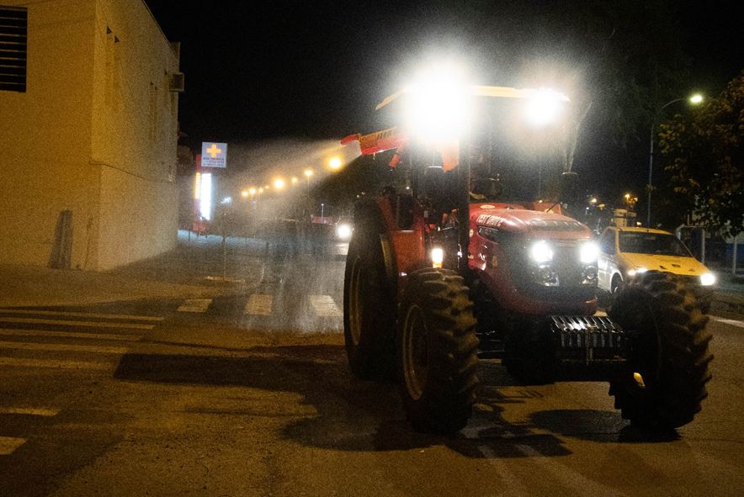
A Solis 90 CV tractor disinfects the streets of Indaiatuba, Brazil.

Indaiatuba, Sao Paulo, Brazil (May 21st, 2020)- Yanmar South America has teamed up with John Deere and the local government of Indaiatuba, an important center of industry in the state of Sao Paulo, in an effort to disinfect the streets of the city of the novel coronavirus, to make them safer for citizens.

The City of Indaiatuba carried out the spraying and disinfection of the city’s streets from April 15th to May 8th with Yanmar contributing a Solis 90 CV tractor to assist in the operation. Working at night, the tractors sprayed a solution of water and sodium hypochlorite, a chlorine-based bleach, prepared and approved by the city’s health department. Yanmar South America employee Odirlei Silva from the agricultural commercial department operated the tractor.
“We have over 60 years of history in Indaiatuba,” said Yanmar South America President Kenji Kitahara. “This city is home to many of our employees and it’s important for the people of the city that we work closely with City Hall in this time of crisis.”

The response of residents was overwhelmingly positive with many taking to social media to express thanks for the disinfection work.
Mr. Nilson Gaspar, Mayor of the City of Indaiatuba agreed with residents: “Nothing is more important to us than the health and wellbeing of our residents. We’re very pleased that the city has been able to come together with Yanmar and John Deere to carry out this important public service.”

Yanmar will consider further action in the future in line with city health guidelines.

About Yanmar
With beginnings in Osaka, Japan in 1912, Yanmar was the first ever to succeed in making a compact diesel engine of a practical size in 1933. Moving on, with industrial diesel engines as the cornerstone of the enterprise, Yanmar has continued to expand its product range, services, and expertise to deliver total solutions as an industrial equipment manufacturer. As a provider of small and large engines, agricultural machinery and facilities, construction equipment, energy systems, marine, machine tools, and components — Yanmar’s global business operations span seven domains.
On land, at sea, and in the city, Yanmar’s Mission of “providing sustainable solutions focused on the challenges customers face, in food production and harnessing power, thereby enriching people’s lives for all our tomorrows,” stands testament to Yanmar’s determination to provide us with “A Sustainable Future”.
For more details, please check out the official website of Yanmar Co., Ltd.
https://www.yanmar.com/global/

＜NOTE＞
The contents of this news release reflect what was mentioned in the press announcement. Please be aware that the contents of this release may differ with new information and developments.

Inquiries
Corporate Communications, Yanmar Global Expert Co., Ltd.
newsroom@yanmar.com

