PRESS RELEASE

**A Divine Medley of Handcrafted Mid-Autumn Delights at Hai Tien Lo**

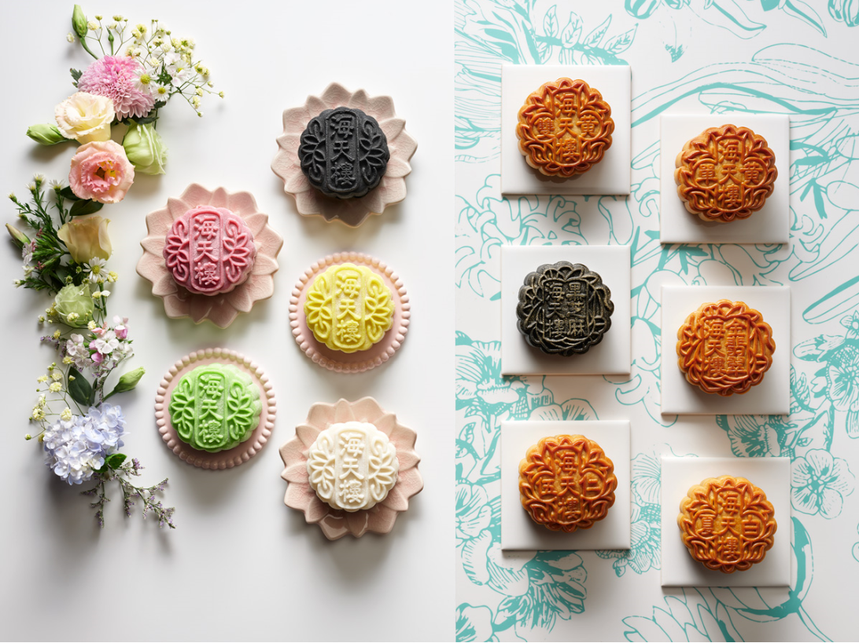*Featuring inventive flavours, a limited edition mooncake gift box and tote bag designed in exclusive collaboration with Pathlight School’s Artists*

*Hai Tien Lo Baked and Snowskin Mooncakes*

**Singapore, 25 June 2019 –** This Mid-Autumn, **Hai Tien Lo (海天楼)** presents a divine medley of **eleven thoughtfully handcrafted baked and snowskin mooncakes** to satisfy all tastes, as well as a splendid **Six-course Mid-Autumn Reunion Set Menu** for joyous celebrations with the loved ones. The Cantonese restaurant has also collaborated with two gifted alumni artists, Selena Seow and Nurul Amirah Binte Zain, from Pathlight School’s Artist Development Programme (ADP), to create the limited edition mooncake gift box, mooncake carrier bag and tote bag. A portion of proceeds from the sales will be donated to Autism Resource Centre (Singapore), the not-for-profit charity that runs Pathlight School. The mooncakes are available from **1 July to 14 September 2019**.

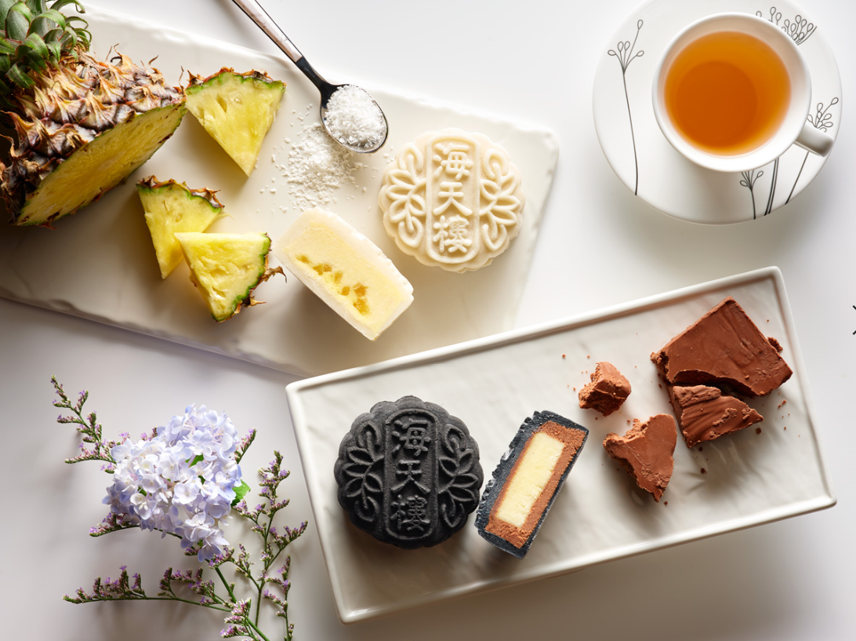 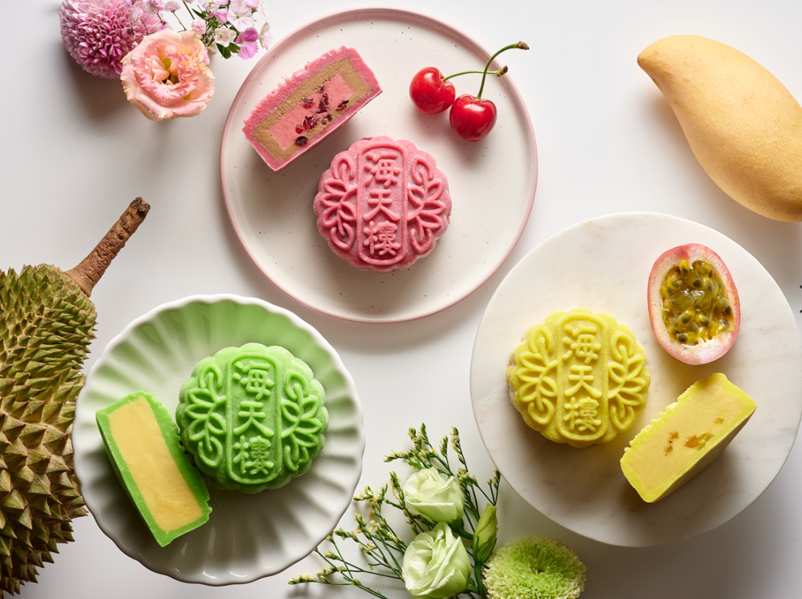

*L-R: Coconut and Pineapple Snowskin, Gianduja and Yuzu Snowskin, Mao Shan Wang Durian Snowskin, Earl Grey and Cherry Snowskin, Passionfruit and Mango Snowskin*

Hai Tien Lo has whipped up five snowskin mooncake flavours this year including four new innovative flavours. Chocolate lovers will enjoy the decadent **Gianduja and Yuzu Snowskin** made with Cacao Barry dark chocolate, hazelnut praline and crunchy hazelnut bits, as well as the aromatic **Earl Grey and Cherry Snowskin** made with Earl Grey tea leaves, dried cranberries, Morello cherry purée and premium dark Araguani and Bahibe milk chocolate. For a refreshing tropical experience,the pina colada-inspired **Coconut and Pineapple Snowskin** and the tangy **Passionfruit and Mango Snowskin** with sweet dried mango bits, will certainly please**.** **Mao Shan Wang Durian Snowskin**, a crowd favourite, is also available this year.

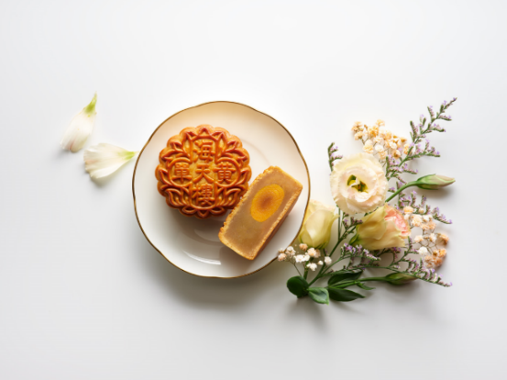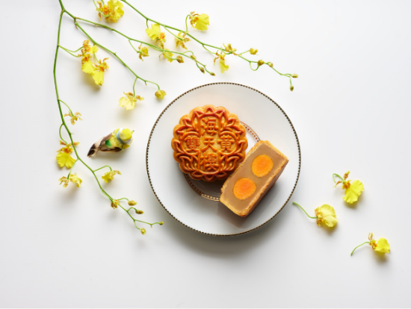

*L-R: White Lotus Seed Paste with Double Yolk, White Lotus Seed Paste with Single Yolk*

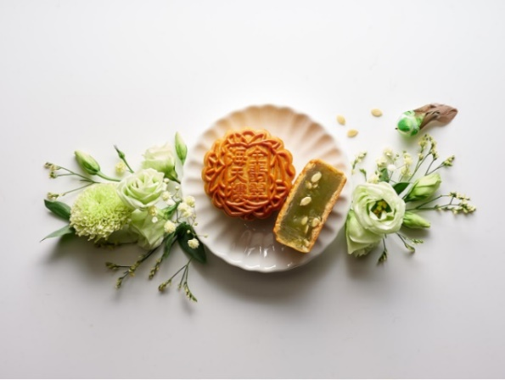

*Jade Paste with Melon Seeds*

Noteworthy baked mooncake flavours this mid-autumn festival include the signature **White Lotus Seed Paste with Single Yolk and Double Yolk**, offering flavourful classic renditions of the confectionary. Diners watching their diet will appreciate the new **Low-sugar Jade Paste with Melon Seeds** for a healthier alternative.

Hai Tien Lo’s well-loved signature baked mooncakes, **Low-sugar White Lotus Seed Paste with Macadamia Nuts**, popular **Charcoal Black Sesame Seed Paste with Melon Seeds** and **Assorted Nuts with Chicken Ham** are making a comeback as well.

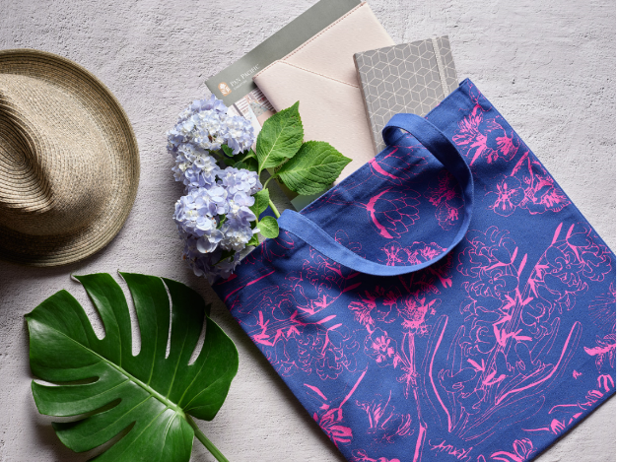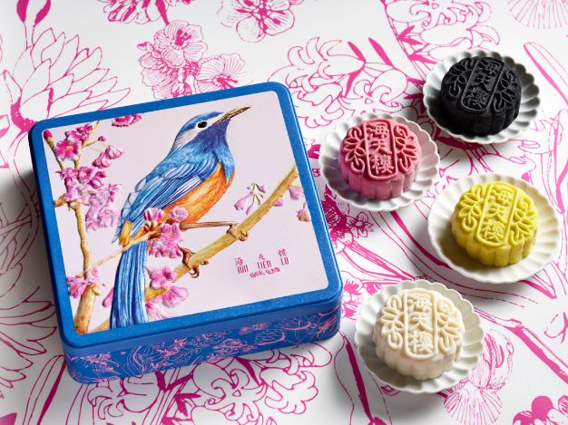

*L-R: Limited Edition Mooncake Gift Box featuring “The Bird and The Blossom” by ADP artist Selena Seow encasing Four Treasures Snowskin Mooncakes (Gianduja and Yuzu, Earl Grey and Cherry, Passionfruit and Mango, Coconut and Pineapple), Limited Edition Tote Bag featuring “Botanical” by ADP artist Nurul Amirah Binte Zain*

**About the Artists**

This year, Hai Tien Lo has exclusively collaborated with **Pathlight School’s Artist Development Programme (ADP)** to present a stunning tin box with sweet hues of pink, blue and orange, that beautifully encases four mooncakes and evokes the joyful vibrancy of the festival. The two visuals are created by **Selena Seow** and **Nurul Amirah Binte Zain**, two talented ADP alumni artists who are on the autism spectrum. Illustrated by Selena, the visual on the box cover, **“The Bird and The Blossom”**, showcases her flair for whimsical illustrations intricately crafted using ink and coloured pencils. **It features the White-eared Sibia from the high-altitude forests in Taiwan, symbolising new opportunities and happiness.** The artwork on the side of the box and mooncake box carrier bag, named **“Botanical”** by Amirah, shows her keen eye for patterns found in nature, expressed through bold lines and vibrant colours. The “Botanical” artwork is also featured on a limited edition tote bag **priced at $15** (Hashtag: totesforARC). **$1 for every mooncake box and $10 for every limited edition tote bag sold will be donated to Autism Resource Centre** **(Singapore),** which runs Pathlight School. Guests can find out more about the ADP artists at its retail platform, [www.theartfaculty.sg](http://www.theartfaculty.sg).

The elegant mooncake box is not only a reflection of Pan Pacific Singapore’s continuous support for local artists, a timeless tin box encapsulates the age-old harvest tradition and serves as a perfect everlasting gift for storage of sentimental items.

The mooncake collection is available between **1 July to 14 September 2019** at Pan Pacific Singapore. Guests placing advanced orders with eligible credit cards between **1 July to 4 August 2019** will enjoy an exclusive early bird deal of **25% savings** on all prepaid orders. And up to 20% savings on all orders placed between **5 August to 14 September 2019**. Snowskin mooncakes are only available for collection from **1 August to 14 September 2019.** Guests may purchase these delightful handcrafted treats and limited edition tote bag from the Level 1 Mooncake Booth at Hai Tien Lo, or by calling **+65 9009 5936**, emailing **mooncake.ppsin@panpacific.com**, or via online orders at **pacificmarketplace.com.sg**.

**FOR COLLECTION** - Mooncake Booth (Level 1, Pan Pacific Singapore)

• **1 July to 25 August 2019, 11:00am to 9:00pm**

• **26 August to 14 September 2019, 10:00am to 9:00pm**

**Mid-Autumn Reunion**

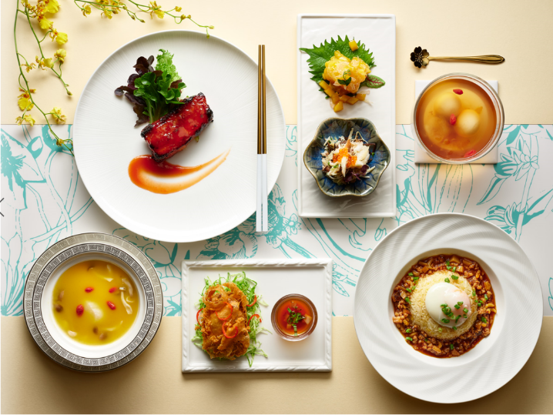

*Six-Course Mid-Autumn Reunion Set Menu*

For a flavourful Mid-Autumn celebratory meal with the loved ones, Executive Chef Ben Zeng has specially curated a sumptuous **Six-Course Mid-Autumn Reunion Set Menu** with a creative twist. Highlights include the **Chilled Crab Meat in Japanese Sake** and **Double-boiled Fragrant Deep-fried Crispy Boneless Duck with Yam Paste**. Every two diners who order the special menu will be entitled to **one complimentary box of Four Treasures Baked Mooncakes**. Priced at SGD128 per person (minimum of two diners required), the Mid-Autumn Reunion Set Menu is available from **1 July to 14 September 2019** for dine-in at Hai Tien Lo.

**About Autism Resource Centre and Pathlight School**

Autism Resource Centre (Singapore) or ARC(S), is a not-for-profit charity dedicated to serving children and adults on the Autism Spectrum Disorder (ASD) to lead meaningful and independent lives in society.

One of the key programmes that it runs is the Pathlight School, the first autism-focused school in Singapore that offers Singapore's mainstream academic curriculum together with life readiness skills.

Pathlight School caters to students on the autism spectrum and related disorders, aged 7 to 18 years, who are cognitively able to access mainstream academic curriculum but require additional support such as smaller class sizes, special accommodations and teaching staff trained in autism. It started operations in January 2004 with just 41 students. Today, it has over 1,400 students and is one of the fastest growing and progressive special schools in Singapore.

**About the Artist Development Programme (ADP)**

ADP is a talent programme started by Pathlight School to uncover and nurture students with artistic talent. Under the ADP, student artists are taught by professional art teachers and given opportunities to exhibit their works and have them developed into high quality products and merchandise. Artists earn royalties from the sale of their artwork and merchandise. They are also given platforms to be involved in public exhibitions and grow as motivated and confident artists.

**Mooncake offerings**

|  |  |
| --- | --- |
| **Box of Four Snowskin and/or Baked Mooncakes** | **Price** |
| *SIGNATURE!* Mao Shan Wang Durian Snowskin純貓山王榴蓮冰皮月餅 | SGD88.80 |
| *NEW!* Coconut and Pineapple Snowskin 椰子鳳梨冰皮月餅 | SGD68.80 |
| *NEW!* Earl Grey and Cherry Snowskin 櫻桃伯爵冰皮月餅 | SGD68.80 |
| *NEW!* Passionfruit and Mango Snowskin百香芒果冰皮月餅 | SGD68.80 |
| *NEW!* Gianduja and Yuzu Snowskin 榛果巧克力柚子冰皮月餅 | SGD68.80 |
| *NEW!* Four Treasures Snowskin Mooncakes 海天樓四喜冰皮月餅  *(Gianduja and Yuzu, Coconut and Pineapple, Earl Grey and Cherry, Passionfruit and Mango)* | SGD68.80 |
| Assorted Nuts with Chicken Ham 鷄肉乾五仁月餅 | SGD73.80 |
| *NEW!* White Lotus Seed Paste with Double Yolk 雙黃白蓮蓉月餅 | SGD73.80 |
| *NEW!* White Lotus Seed Paste with Single Yolk 單黃白蓮蓉月餅 | SGD69.80 |
| *NEW!* Low-sugar Jade Paste and Melon Seeds 翡翠瓜仁月饼 | SGD69.80 |
| Charcoal Black Sesame Seed Paste with Melon Seeds 炭燒瓜子黑芝麻月餅 | SGD69.80 |
| Low-sugar White Lotus Seed Paste with Macadamia Nuts 夏果白蓮蓉月餅 | SGD69.80 |
| Four Treasures Baked Mooncakes 海天樓四喜烘月餅  *(White Lotus Seed Paste with Double Yolk, Charcoal Black Sesame Seed Paste with Melon Seeds,* Low-sugar *Jade Paste with Melon Seeds, Assorted Nuts with Chicken Ham)* | SGD73.80 |

*Prices are subject to prevailing Goods & Services tax.*

|  |
| --- |
| **花好月圆中秋宴 Mid-Autumn Reunion Set Menu (Available exclusively for dine-in)** |
| **Venue:** Hai Tien Lo, Pan Pacific Singapore, Level 3 **Time:** 11:30am to 2:30pm; 6:30pm to 10:30pm **Price:** SGD128 per guest (minimum of two diners) **Every two diners who order the Mid-Autumn Reunion Set Menu will be entitled to one complimentary box of Four Treasures Baked Mooncakes** |
| Menu  清酒蟹肉拼柚子脆虾球  Combination of Chilled Crab Meat in Japanese Sake and Deep-fried Crispy Prawns with Pomelo Sauce  金银贝鲜菌黄鸡汤  Double-boiled Fresh and Dried Scallops with Fresh Mushrooms in Supreme Chicken Stock  香酥芋茸鸭  Fragrant Deep-Fried Crispy Boneless Duck with Yam Paste  紅曲酱烧肉排  Stir-fried Pork Spare Ribs with Fermented Red Yeast Rice Sauce  月滿卤肉飯  Fragrant Rice with Braised Minced Pork and Half Boiled egg  团圓如意不分离(桃胶桂花姜茶汤丸)  Double-boiled Sweet Ginger Tea with Sesame Dumpling, Maltose and Osmanthus |

All prices are subject to 10% service charge and 7% GST, unless otherwise stated.

For dining reservations and enquiries, please speak with us at +65 6826 8240 or email [dining.ppsin@panpacific.com](mailto:dining.ppsin@panpacific.com).

High-resolution Images can be downloaded [here](https://www.dropbox.com/sh/i4g82fzdhs9d84e/AACj58Enlf9eX2bin4bw4NBHa?dl=0).

**Media Contact**

Ms. Gillian Teo

Assistant Director, Marketing Communications  
Pan Pacific Singapore

E-mail: [gillian.teo@panpacific.com](mailto:gillian.teo@panpacific.com)

Tel: +65 6826 8095

Melissa Ng

Senior Marketing Communications Executive

Pan Pacific Singapore

Email: [melissa.ng@panpacific.com](mailto:melissa.ng@panpacific.com)

Tel: +65 6826 8094

*Hotel Facebook:* [*https://www.facebook.com/panpacificsingapore*](https://www.facebook.com/panpacificsingapore)

*Hai Tien Lo Facebook:* [*https://www.facebook.com/HaiTienLo.Singapore*](https://www.facebook.com/HaiTienLo.Singapore)

*Twitter:* [*https://twitter.com/panpacificsgp*](https://twitter.com/panpacificsgp)

*Instagram:* [*http://instagram.com/panpacificsingapore*](http://instagram.com/panpacificsingapore)

**Pan Pacific Hotels and Resorts**

With hotels, resorts and serviced suites across Asia, Oceania and North America, Pan Pacific provides a safe harbour in an ever-changing world. Places with less to worry about because, when you stay with us, rest assured that all will be taken care of. For this is where you will find your balance.

**Pan Pacific Hotels Group**

Pan Pacific Hotels Group is a wholly-owned hotel subsidiary of Singapore-listed UOL Group Limited, one of Asia’s most established hotel and property companies with an outstanding portfolio of investment and development properties.

Based in Singapore, Pan Pacific Hotels Group owns and/or manages 40 hotels, resorts and serviced suites with more than 12,000 rooms including those under development in Asia, Oceania, North America and Europe.

Voted “Best Regional Hotel Chain” by readers in Asia in 2017, Pan Pacific Hotels Group comprises two acclaimed brands: its signature brand, Pan Pacific and its deluxe brand, PARKROYAL.

Sincerity is the hallmark of Pan Pacific Hotels Group. The Group is known to its guests, partners, associates and owners for its sincerity in people and the sense of confidence which alleviates the stresses of today’s complex world.

**About Hai Tien Lo**

Helmed by Executive Chef Ben Zeng, Hai Tien Lo epitomises traditional Cantonese dining with a contemporary twist. Enjoy exquisite dim sum, double boiled soups, Peking duck and classic braised dishes, in addition to modern interpretations like the “Australian Abalone with Japanese Mushrooms and Black Truffles” or “Double-boiled Chicken Soup with Abalone, Dried Scallops, Fresh Prawns and Chinese Mushrooms served in Young Coconut”.