

Media alert

**Starting from today, iotty is compatible with SmartThings app**

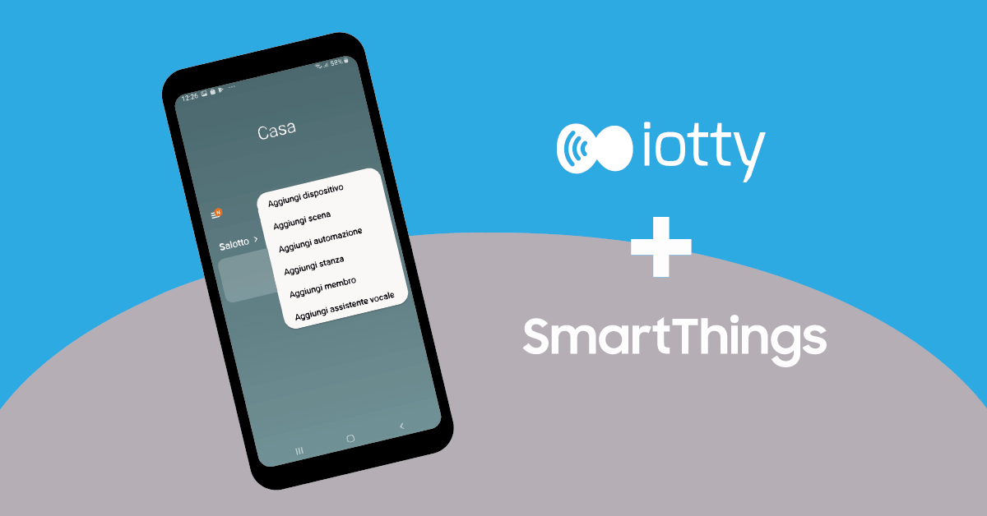

S as “simple”, S as “smart”. These two adjectives are inside the DNA of iotty. They are the concepts at the basis of what iotty offers since its arrival to the market. S stands also for “Step forward”: today iotty makes one and announces the compatibility of its devices with **SmartThings**, the Samsung app for Android and iOS that allows to control smart home devices within a single platform.

Synchronizing the product with the app is easy and immediate. Create an account or just login to SmartThings, select “Add device” and tap on “iotty Smart Devices” in the brand list. Next step is to insert iotty credentials and select the rooms to organise your home. That’s it! Now you can create customized scenes and programs, receive personalized suggestions from the app based on your preferences. Now your home is even smarter. It’s just one click away!

This new integration is another iotty step to increase its influence in the smart home world,

continuing to pursue its goal of playing an increasingly significant role in the future.

**Prices and availability**

E1 and E2 models of the smart switch can be purchased on www.iotty.com individually or in the bundle of 3 and 5 products. The prices start from 74,90 euro. The product is available in while, black, grey, tan and cyan colours.

**About iotty**

iotty was founded in 2017 from two Italian companies with an advanced expertise in the electronics industry, in creation and production of PCB, in IoT field and software development. The business is based on the willingness to offer users smart products with an excellent quality / price ratio, innovative and easy to use, thanks to the compatibility with the main home automation platforms. Today iotty has more than 30 employees and collaborators, and has 4 offices in Italy, USA, branches in Germany and France and an industrial department in Shenzhen, China. The company’s goal is to become a world-class reference for home automation products with Italian design.

**Press contacts:**

Local agency

**iotty**

Maria Elena Loria – Coordinamento Comunicazione [press@iotty.it](mailto:press@iotty.it)