Press Release |  | 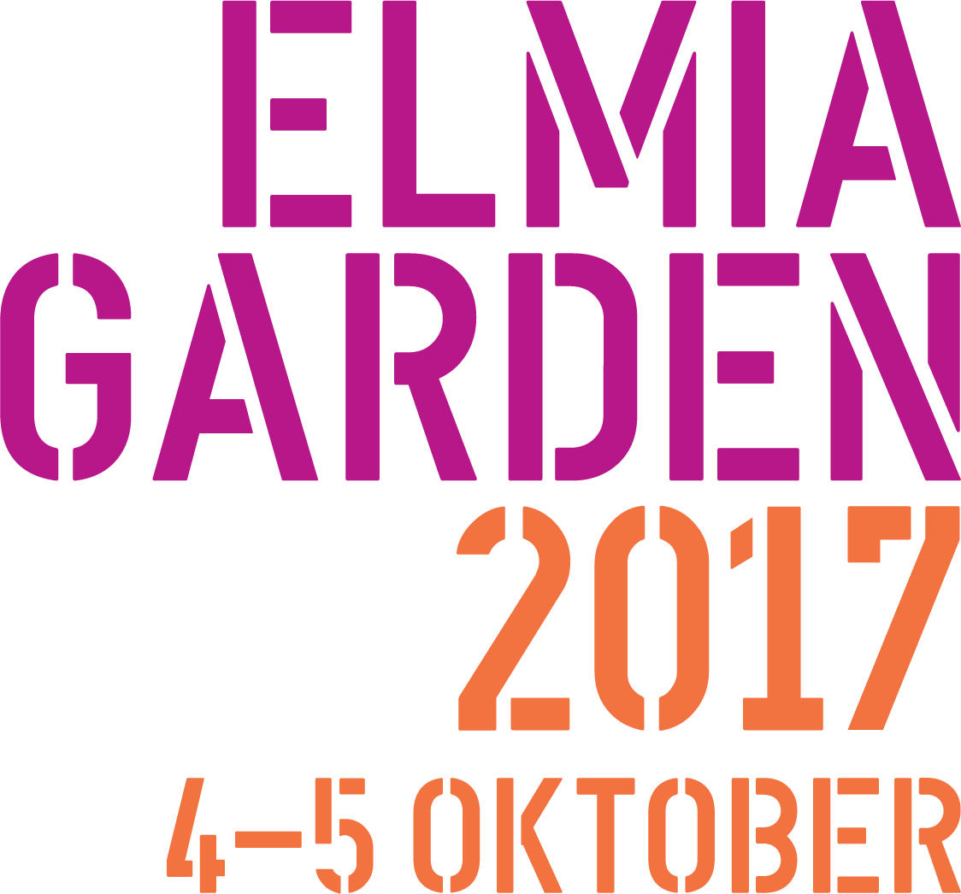
Elmia AB
22 February 2017

New fair manager of Elmia Garden

Elmia Garden is the trade fair that brings together the entire garden industry in Jönköping every autumn. Since the start of this year Kristin Koefoed has taken over from Henrik Landén as manager of the fair. Kristin has worked at Elmia for many years and has been working with Elmia Garden since 2003, partly as the manager of the arena’s experiential and inspirational arrangements.

“The new role feels very exciting and challenging,” Kristin says. “I’m looking forward to working with northern Europe’s leading gardening fair, which is the obvious gathering place for meetings and inspiration. We are a strong team and also have terrific business partners with leading positions in the industry.”

As well as being an important meeting place for the industry, the fair also offers seminars featuring leading industry players and inspirational settings based on the trends for 2018.

“There’s been a desire from the industry to be able to access information and inspiration about current and future gardening trends year round,” Kristin says. “We are therefore now taking the next step in our gardening work and in April we are launching a new inspirational web page called Elmia Garden Trends.”

The fair began at Elmia in 2000 and is now northern Europe’s most important meeting place for the garden industry. Some 3,000 of the industry’s most important players in plant cultivation, wholesale, retail and the florist industry meet every year at Elmia Garden.

“This year’s fair will be larger in terms of floor area and will feature a number of new exhibitors in the categories of garden furniture, technology, lighting and green plant material,” Kristin says. “The seminar programme will be expanded with new themes and inspirational speakers and we are also offering a totally new programme for florists.”

www.elmia.se/garden

For more information contact:
Kristin Koefoed, kristin.koefoed@elmia.se, +46 36 15 22 79, +46 76 458 60 92

