Croatia Debut for JL Audio at the 26th International Zagreb Boat Show
Pavilion 11A, Stand 23
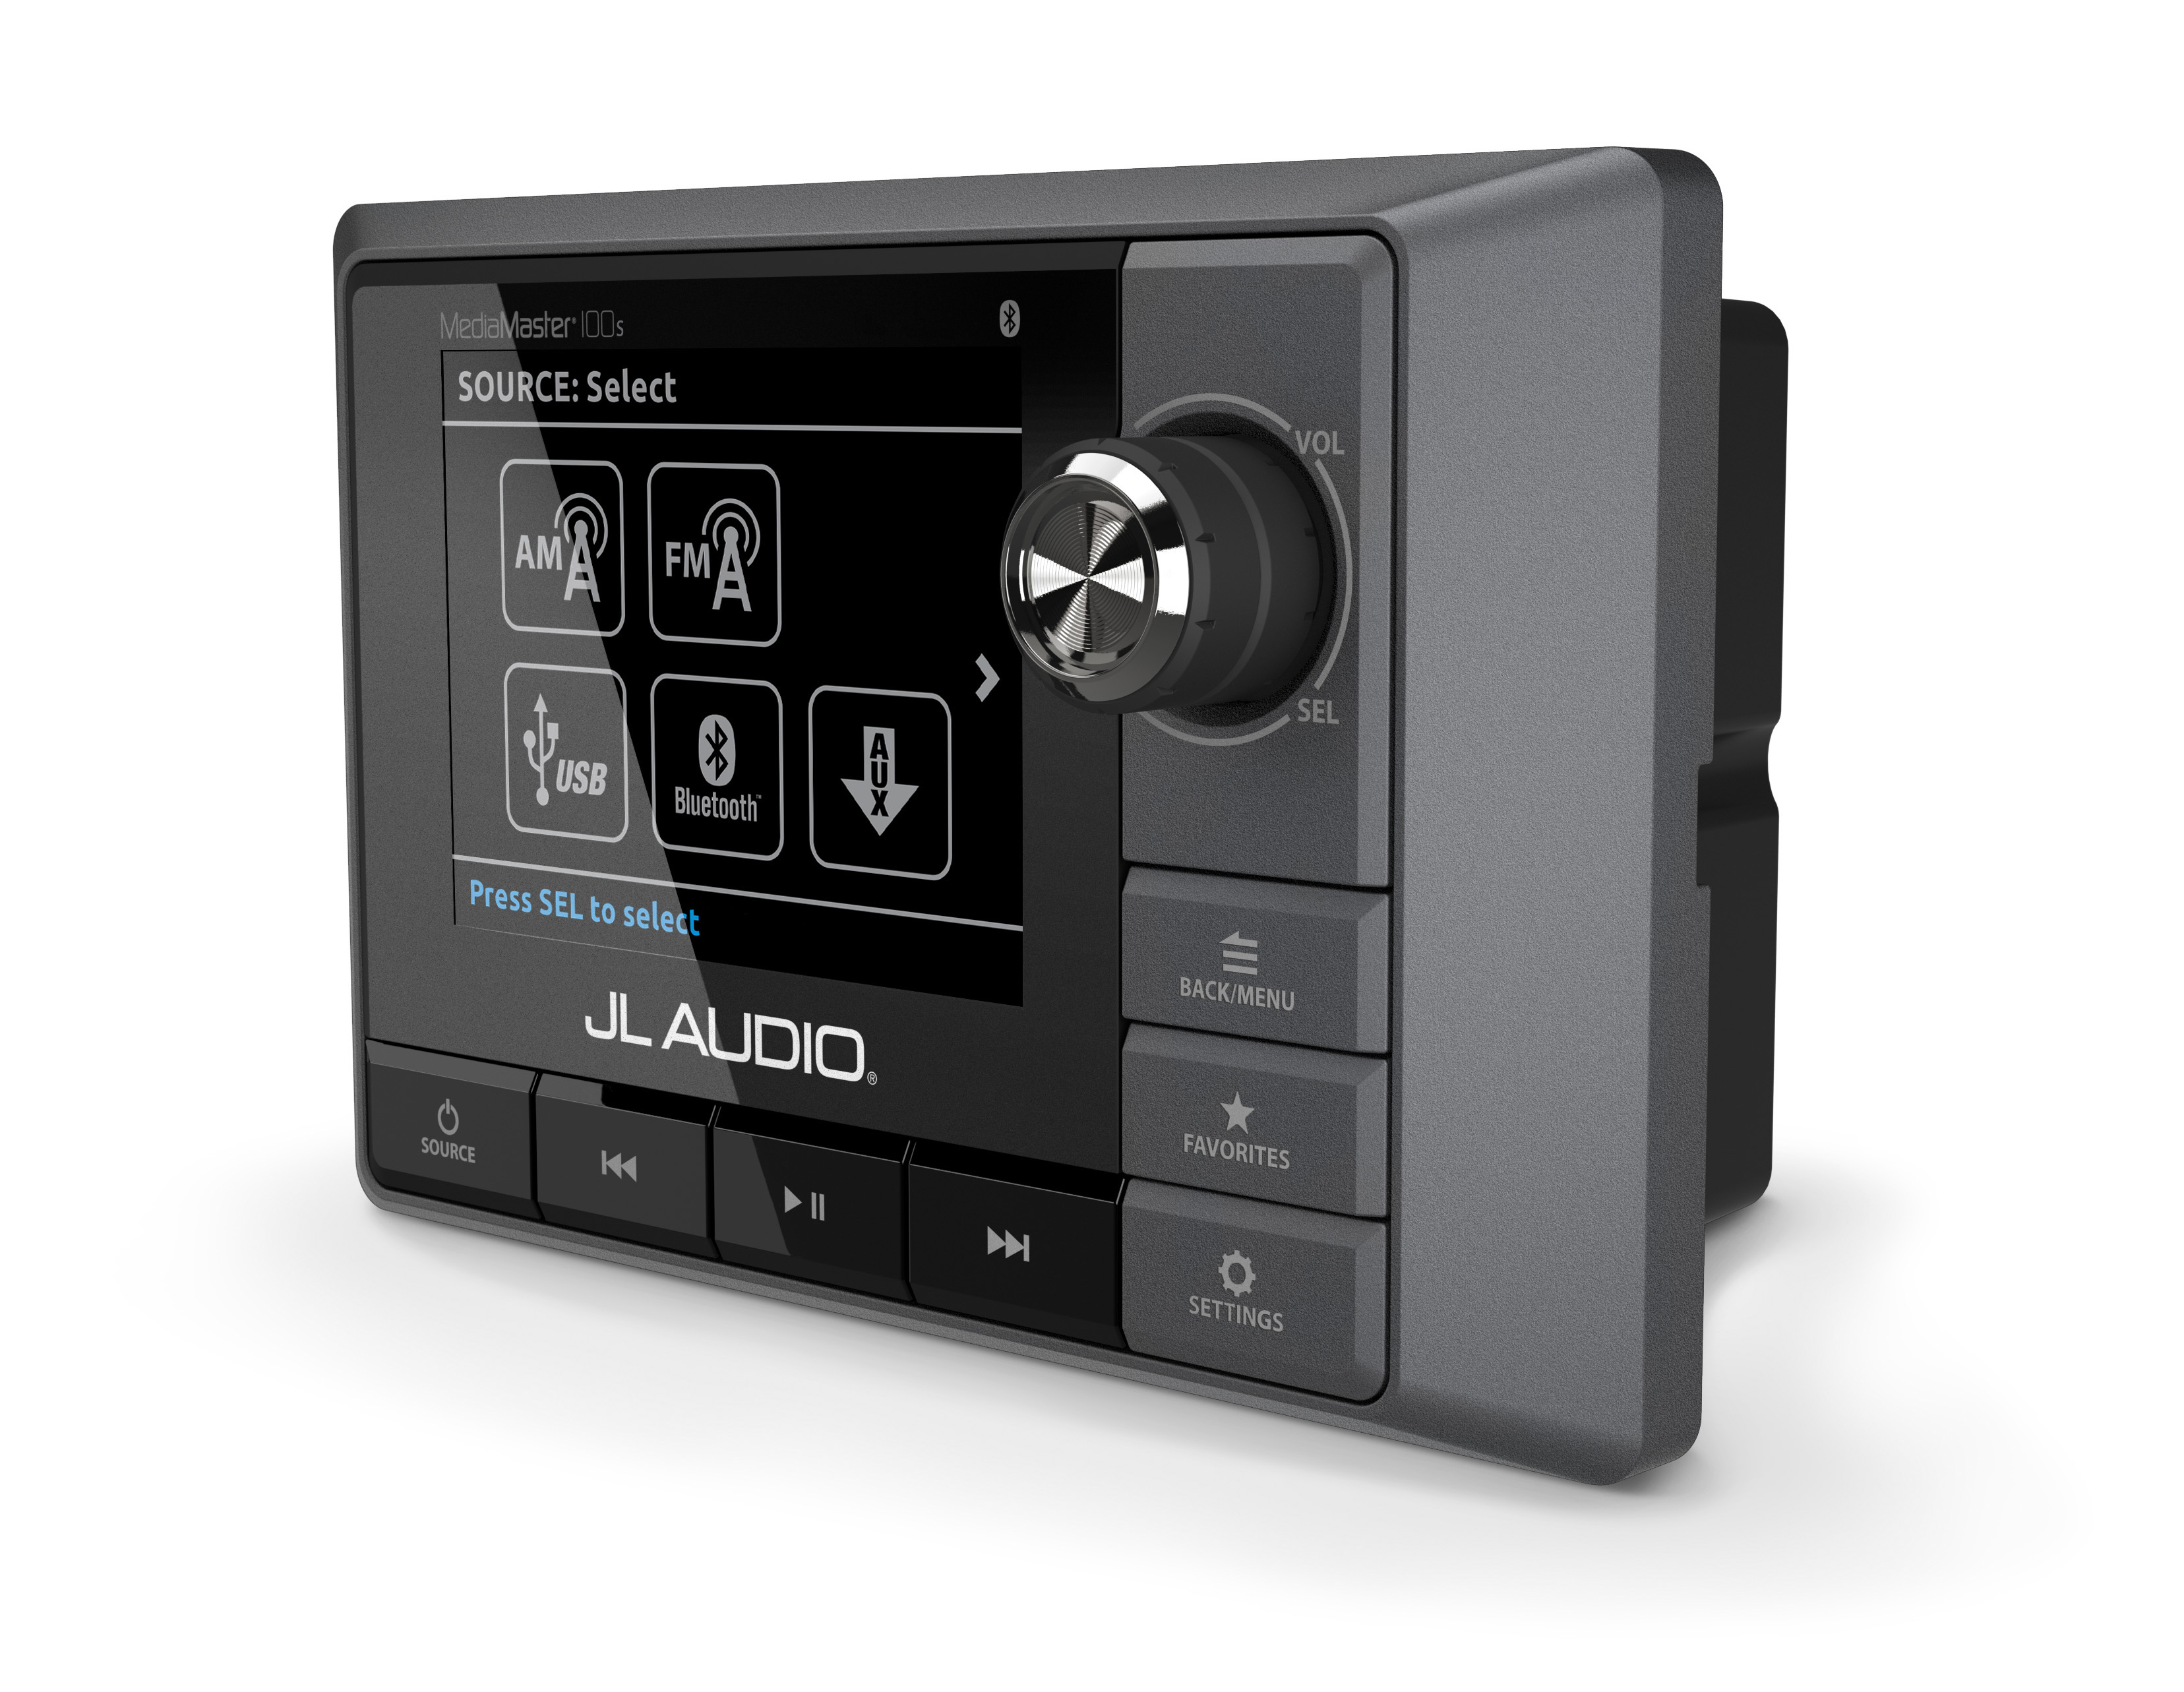
RIZ-ITEA, the Croatian distributor for JL Audio Marine Europe, will be showcasing an extensive range of JL Audio’s premium audio systems for the first time at this year’s Zagreb Boat Show. The Zadar based marine electronics specialist will demonstrate the crystal clear sound of JL Audio’s speakers and sub-woofers and smart functionality of its source unit and blue tooth receivers on an interactive demonstration unit from its stand during the show, which runs from 22nd – 26th February.

JL Audio’s new marine audio source unit, the MediaMaster 100s will be on display alongside a range of JL Audio’s speakers, subwoofers, amplifiers and Bluetooth wireless receivers. Offering superb audio performance, excellent ergonomics and advanced audio features, the MediaMaster®100s completes an extensive line-up of high quality, marine audio products offering an integrated marine audio solution to boat builders and customers.

Vedran Ivosic from RIZ-ITEA explains why Croatia is such a key market for JL Audio, “Croatia is one of Europe’s leaders in nautical tourism and boasts the world’s biggest charter market. Its coastline of 1,777km in addition to 718 islands and 467 islets and reefs, makes it a magnet for motorboat, sailing boat and catamaran owners. We also have a growing and well-respected boat building industry so there is definitely a demand for more high end products such as JL Audio. “

As Croatia’s only continental boat show, Zagreb is an important event in the industry’s international boat show calendar attracting over one hundred leading international boat brands and a huge range of engines and marine equipment each year. Last year’s event attracted over 25,500 visitors and this year’s event is set to be even bigger with six pavilions playing host to some big name exhibitors.

For more information about JL Audio’s range of premium audio systems, contact RIZ-ITEA on Tel: +385 (0) 23 305 777; E-mail info@rizitea.com or www.jlaudiomarine.eu.

ENDS
For further information, please contact:

Paul Baker or Karen Bartlett
JL Audio Marine Europe Saltwater Stone
Tel: +44 (0)1202 664 390 Tel: +44 (0)1202 669244
paul.baker@jlaudiomarine.eu k.bartlett@saltwater-stone.com
www.jlaudiomarine.eu www.saltwater-stone.com
Notes to Editors:
About JL Audio
JL Audio is America’s leading luxury car and marine audio manufacturer. The company prides itself on exceptional durability and consistency created with extensive testing. Its marine division provides speaker systems designed and built for the testing environment of the ocean. The marine range brings high end, home audio quality to the leisure, luxury yacht and sports boat market.

About JL Audio Marine Europe
JL Audio UK is responsible for marketing and distributing JL Audio’s car and marine audio systems throughout Europe.

