Global Focus with NOA
NOA Relax & Focus, a low calorie beverage with natural herbs that help coping with stress and maintain focus, is rapidly growing across the globe. NOA is now available in 15 countries and the aim is to be able to provide people in 30 countries with this delicious beverage.
There is a clear shift in the way we consume beverages. We want drinks that are good for us and not full of sugar. According to Joel Goldstein, president of Mr Checkout Distributors; more and more consumers continue to adopt a healthier lifestyle, retailers must expand their product offering and meet consumer demand. Over the last few years, consumers have paid closer attention to the food they eat, analyzing every ingredient and worrying more than ever about how it was processed. Now, that focus will turn to the beverage world, creating many of these new trends. One of the effects of the growing health trend is the consumer demand for beverages that do more than just quench thirst. These drinks are referred to as functional drinks, and they will continue to grow within the next year. These drinks will continue to make their way into the market and replace “refreshing” beverages such as carbonated sodas and sugary sports drinks. - See more at: http://www.progressivegrocer.com/departments/beverages/top-trends-beverage-category-2016?cc=12#sthash.9nS9MXiM.dpuf
As a result of this trend we see growing demand for NOA Relax & Focus that contains natural active ingredients, no preservatives and is low in sugar. NOA is now available throughout most of Europe, Hongkong, China, Korea and Mexico. A launch in the US is getting close, so stay tuned for more news about this.
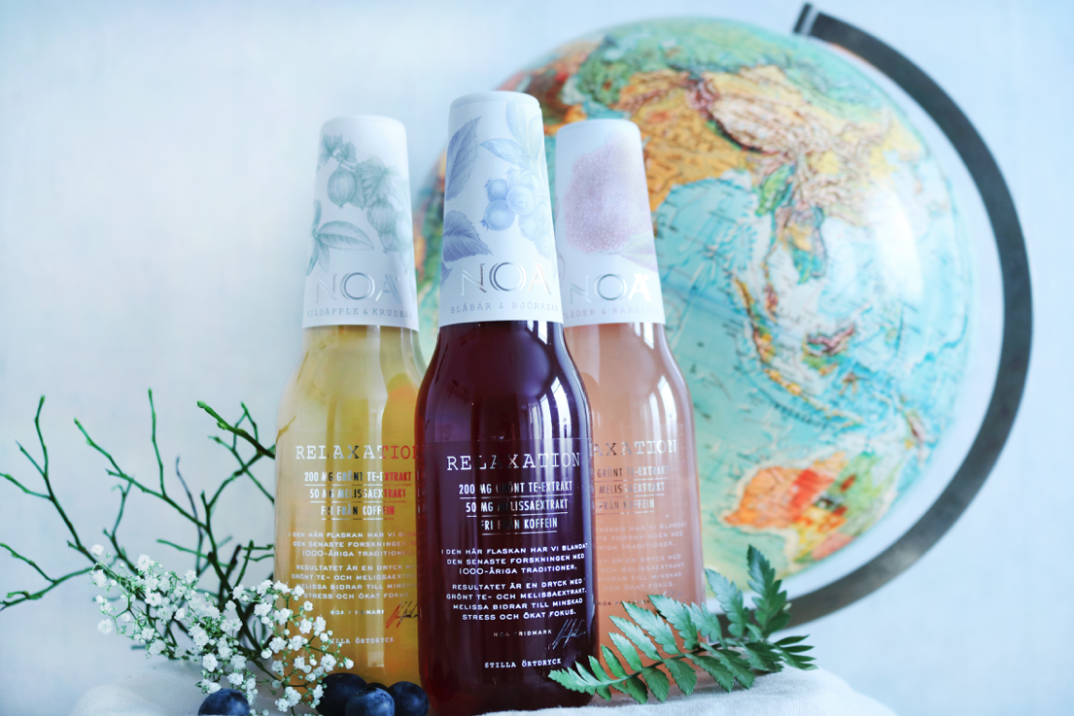

NOA Relax & Focus is an award-winning beverage with natural herbs that contributes to reduced stress and increased focus (Green tea extract with L-theanine, Lemon balm). NOA Relax & Focus is the result of the latest research and millennia-old traditions. The company was founded by Mr Noa Fridmark in late 2013, with the product launching in Sweden and Norway in late 2014. Since then, NOA Relax & Focus has won a number of international awards, including ”Best Premium Beverage” in November 2014 at WBIA – the world’s largest beverage awards. An international panel of industry experts deemed the complete branding concept and packaging to be the best in the world. NOA Relax & Focus has attracted strong international media attention, with 100+ newspaper articles and more than 300 bloggers writing about the company and its products.
For more information and images please contact: (Nina Gillsvik, CMO, NOA Relax & Focus, nina.gillsvik@noapotions.se, +46705587293

