SIKA ENSURES A WATERTIGHT FUTURE FOR LUXURY HOUSEBOAT

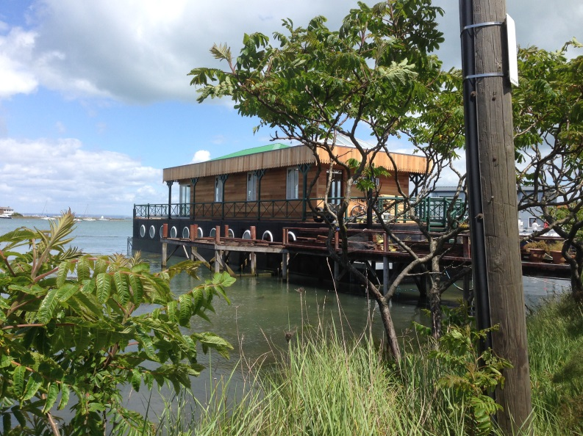

Sika is synonymous with sealing and bonding in boat building circles however not many in the industry may be aware that the company also makes a highly effective waterproof concrete system that is used in the construction of concrete hulls. A recent project involving a highly technical and unusual application for a luxury houseboat reveals just how effective the Sika® Watertight Concrete system is.

Sika’s waterproof concrete system, incorporating a waterproofing solution, was chosen for the construction of a rectangular concrete hull for the twenty-five metre long, seven metre wide luxury houseboat, to ensure the boat would not only be watertight and offer long term performance but also help create a floating foundation that would stand the test of time.

Built by H & J Construction at Hythe Shipyard, the houseboat required a concrete hull so that it would benefit from good resistance to impact, fatigue and cracks propagation resulting in less long term maintenance. With a heritage that goes back to before WWI, the use of concrete in boatbuilding is not new and as it requires no expensive molds such as in glass-reinforced plastic boat construction, it can produce an inherently strong and rigid hull at a relatively lower cost.

To meet the requirements, the specification included 64m³ of Sika® Watertight Concrete to deliver outstanding levels of water-tightness to the heavily reinforced concrete box frame of the boat. Extensive reinforcement was required to prevent any flex in the base of the hull
should the boat be subjected to any freak waves at its mooring.

Typically specified for below ground and basement construction, Sika® Watertight Concrete is a high quality solution that prevents water from migrating through the concrete. State-of-the-art Sika admixtures work within the concrete, firstly to reduce the water/cement ratio, thus increasing the density of the mix and minimising the size, volume and continuity of the concrete's pores, and secondly, fill the remaining pores.

Luke Eastman of H & J Construction commented: “The Sika® Watertight Concrete system was ideal for this unusual application as it was vital that the concrete created a watertight hull with a crack free and permanent seal.”

With the luxury houseboat fitted out and now moored at Bembridge in the Isle of Wight, the successful application of Sika’s watertight solution has played a crucial part in the longevity of this vessel and ensured it remains waterproof for the long term.

For further information contact Sika Waterproofing at waterproofing@uk.sika.com or visit www.sikawaterproofing.co.uk.

Ends

For further media information, please contact:

Karen Bartlett
Saltwater Communications
Telephone: +44 (0) 01202 669244
Email: karen.bartlett@saltwatercoms.com

Notes to Editors:

Sika Limited is a wholly owned subsidiary of Sika AG, a specialty chemicals company with a leading position in the development and production of systems and products for bonding, sealing, damping, reinforcing and protection in the building sector and automotive industry. Sika has subsidiaries in 97 countries around the world and manufactures in over 170 factories. Its more than 17,000 employees generated annual sales of CHF 5.49 billion in 2015.
In the UK, Sika provides market-leading solutions for flooring, sealing and bonding applications, waterproofing, roofing, structural sealing and strengthening and many other construction applications.

Sika UK’s head office is based in Welwyn Garden City at Watchmead, Welwyn Garden City, Hertfordshire, AL7 1BQ. Call 01707 363866, or visit www.sika.co.uk.

