FRIDAY 6TH FEBRUARY 2026 / 1500 GMT

ROBYN ANNOUNCES THE SEXISTENTIAL TOUR

2026 ARENA TOUR WILL TAKE PLACE IN EUROPE, NORTH AMERICA AND AUSTRALIA

SIGN UP FOR PRE-SALE HERE

ROBYN'S NINTH STUDIO ALBUM SEXISTENTIAL RELEASED 27TH MARCH

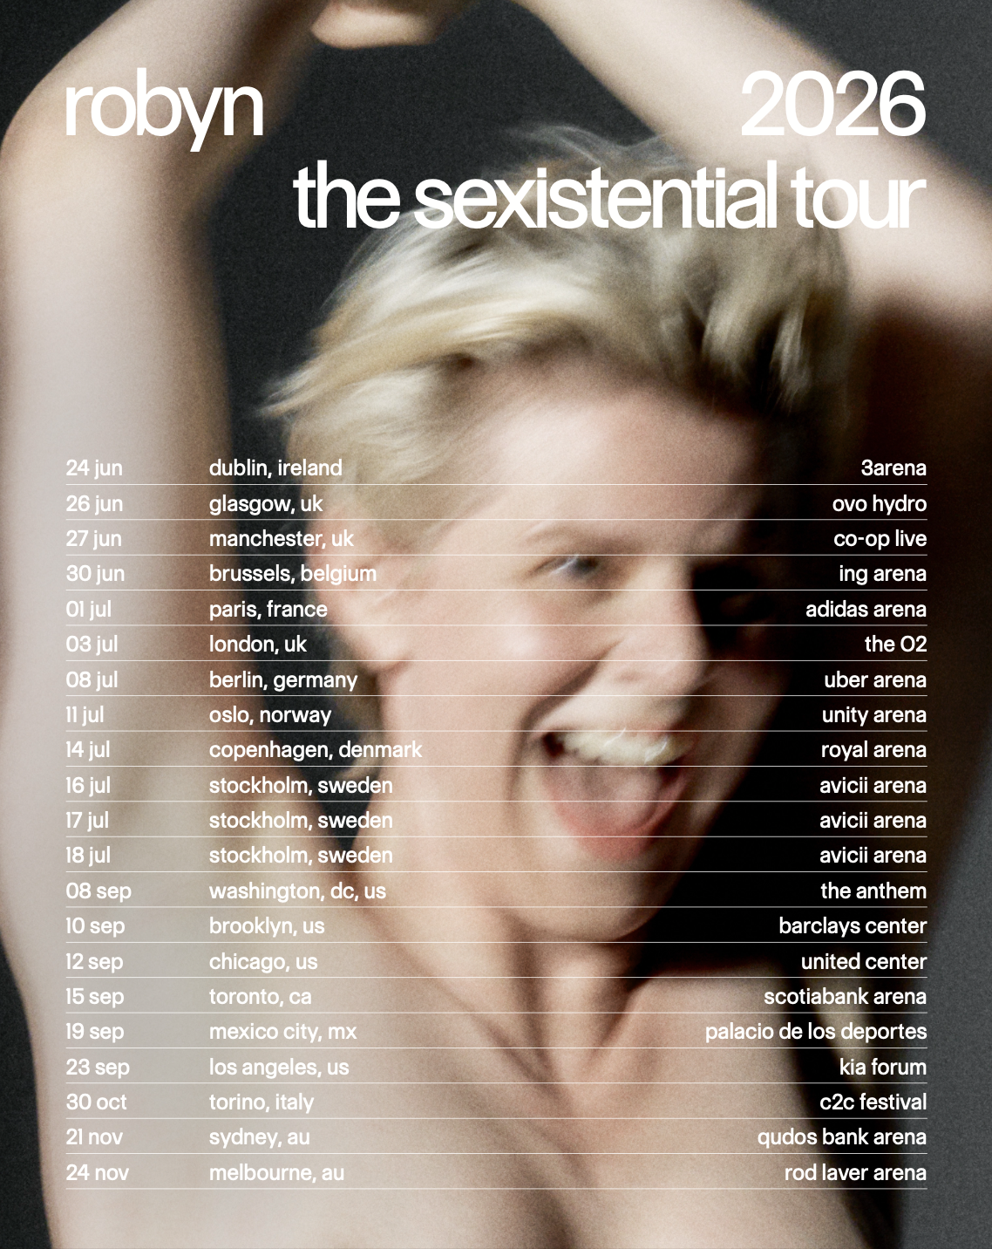
(high res tour art)

Generational pop icon Robyn today announces a 2026 arena tour. The Sexistential Tour - which takes place in Europe, North America, and Australia across 20 dates - is Robyn’s first major tour since 2019 and will feature her biggest ever headline shows, including London's 20,000 capacity O2 Arena and three consecutive hometown nights at Stockholm's Avicii Arena. Fans should head to robyn.com/tour to sign up for presale access by Wednesday 11th February at 10am local (9am local in Australia) with tickets then going on general sale Friday 13th February.

Robyn’s upcoming global tour will feature an exciting lineup of special guest openers across the UK, Europe, and North America dates. The list includes Erika de Casier (Dublin, Paris), Smerz (Glasgow, Brussels, Stockholm), 808 State (Manchester), Saya Gray (London), Mechatok (Berlin), Romy (Copenhagen, Oslo, New York), Zhala (Manchester, Berlin, Stockholm) and Becky and the Birds in Stockholm. In North America, dates will also spotlight Nourished By Time (DC), Peaches (Chicago), Grace Ives (Toronto), Lykke Li (Mexico City), and horsegiirL (Los Angeles), bringing together a mix of boundary-pushing artists who are both friends of Robyn and among the voices that inspire her.

Robyn is currently in the eye of one of the year’s most celebrated musical returns. Having provided some of the biggest moments in pop culture over the last three decades, 2026 has seen her announce Sexistential - her ninth studio album and first since 2018’s Honey. Produced with longtime production collaborator Klas Åhlund, and reuniting her with Max Martin for their first co-writes since 2010, it’s the most ecstatic record Robyn has ever made - the sound of one of contemporary music’s most influential artists coming home.

Robyn’s live performances are equally celebratory, and a run of recent public appearances have created huge anticipation and speculation around Sexistential. Whether performing with David Byrne to celebrate Saturday Night Live's fiftieth anniversary, appearing on CNN’s New Year’s Eve broadcast with Anderson Cooper and Andy Cohen, delivering a standout performance on The Late Show with Stephen Colbert, headlining her own New Year’s Eve shows in NYC, making show-stopping live appearances with the likes of Charli xcx and Gracie Abrams, collaborating with Yung Lean and Charli for a version of Brat’s “360,” soundtracking Acne Studio's 2025 Paris show or - most recently - being announced to support Harry Styles at eight stadium shows in Amsterdam, Robyn continues to shape and influence popular culture in truly unique ways.

THE SEXISTENTIAL TOUR 2026

PRE-SALE SIGNUP

Wed 24 Jun - 3Arena, Dublin, Ireland
Fri 26 Jun - OVO Hydro, Glasgow, United Kingdom
Sat 27 Jun - Co-op Live, Manchester, United Kingdom
Tue 30 Jun - ING Arena, Brussels, Belgium

Wed 1 Jul - Adidas Arena, Paris, France
Fri 3 Jul - The O2, London, United Kingdom
Wed 8 Jul - Uber Arena, Berlin, Germany
Sat 11 Jul - Unity Arena, Oslo, Norway
Tue 14 Jul - Royal Arena, Copenhagen, Denmark
Thu 16 Jul - Avicii Arena, Stockholm, Sweden
Fri 17 Jul - Avicii Arena, Stockholm, Sweden
Sat 18 Jul - Avicii Arena, Stockholm, Sweden

Tue 8 Sep - The Anthem, Washington, DC, USA
Thu 10 Sep - Barclays Center, Brooklyn, NY, USA
Sat 12 Sep - United Center, Chicago, IL, USA
Tue 15 Sep - Scotiabank Arena, Toronto, ON, Canada
Sat 19 Sep - Palacio de los Deportes, Mexico City, MX, Mexico
Wed 23 Sep - Kia Forum, Los Angeles, CA, USA

Fri 30 Oct - C2C Festival, Torino, Italy

Sat 21 Nov - Qudos Bank Arena, Sydney, Australia
Tue 24 Nov - Rod Laver Arena, Melbourne, Australia

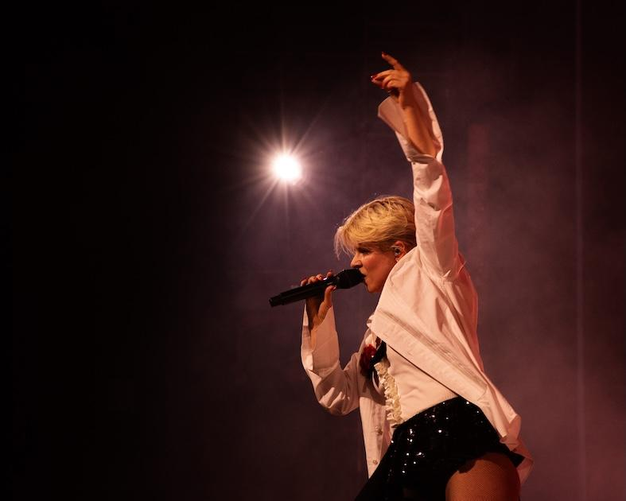
Robyn at Brooklyn Paramount shot by Danica Robinson. High res

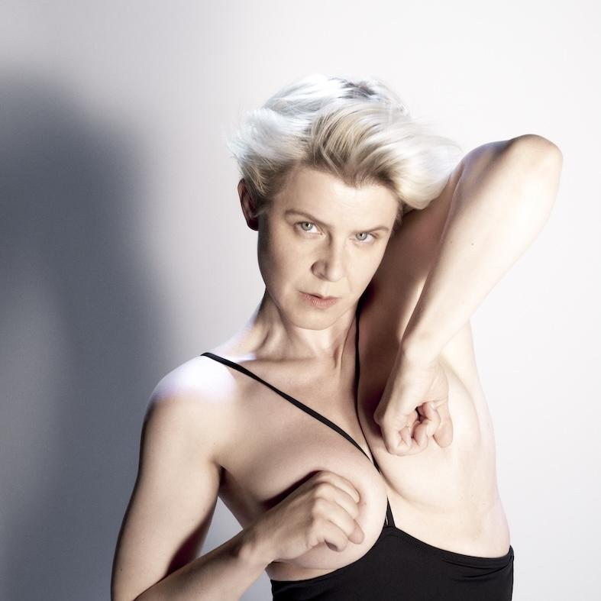
(Robyn by Marili Andre. High res)

Sexistential will be released on LP, Deluxe LP, CD, limited cassette and digitally, including magenta, white and alternate art LP formats across various retailers. All are available to pre-order now.

PRE-ORDER SEXISTENTIAL HERE

DOWNLOAD ASSETS HERE:
PRESS SHOT | LIVE PHOTO | TOUR ADMAT

Follow Robyn:
Official / Instagram / TikTok / Facebook / YouTube



