Press release
Düsseldorf, 29/08/2024
Exceeding expectations: AMRC and Surplex successfully auction machinery
The Advanced Manufacturing Research Centre (AMRC) at the University of Sheffield is a leading research institution in manufacturing engineering and material sciences. In February, 32 select, high-quality machines from the machine park were auctioned off by the industrial auction house Surplex. Phil Bell, Commissioning Engineer at AMRC, and Antony Reed, UK Country Manager for Surplex, take stock.
The Advanced Manufacturing Research Centre (AMRC) at the University of Sheffield is a global leader in machining technology, manufacturing engineering, and material sciences. Special emphasis is placed on aerospace, but also on other demanding manufacturing sectors such as the automotive industry, construction, the food industry, and medicine.
The outstanding research performance is based on excellent equipment with high-quality and well-maintained machines. To stay technologically up-to-date, AMRC regularly renews its equipment and sells older, high-quality machines. This promotes sustainability and allows other companies access to powerful equipment while AMRC efficiently manages its budget.
Strategic decisions in the sales process
Earlier this year, Antony Reed, UK Country Manager for Surplex, and Phil Bell, Commissioning Engineer at AMRC, met to discuss the sale of surplus machines. As a specialised auction house, Surplex first conducted an appraisal and presented various sales solutions. They decided on a so-called marketing deal. Antony Reed explains, “This means that the AMRC machines were only auctioned on the 18-language platform Surplex.com and not bought by Surplex. Generally, Surplex also buys machines and adds them to its stock to auction them independently.”
Another decision point in the marketing process is the type of distribution: auction or direct sale. They opted for an auction and against a direct sale, although the latter is often preferred for high-quality and expensive machines. Antony Reed states, “This decision was the subject of intense discussions within our team. But an auction offers potential for higher revenues through a broad market presence and stronger competition among bidders. For the quality machines from AMRC, it’s the best solution.” The team working alongside Antony Reed included Leigh McCarron, Project and Acquisition Manager, who was responsible for on-site tasks such as registering the machines; Marie Vinet, Sales Assistant, who organised the auction and was the point of contact for all buyers; and George Pratt, Consultant, who provided strategic support and expertise.
Outstanding results and customer-oriented processes
Surplex compiled a list of the machines and detailed descriptions on Surplex.com, followed by extensive global marketing activities. The auction took place on 22 February. By the end of the follow-up sale, all machines were successfully sold. Phil Bell emphasised, “Surplex sold every piece resulting in a higher than expected value.”
The auction itself attracted more than 11,000 visitors to the website – a remarkable number given the 32 machines offered. Buyers from various countries including the UK, France, the United Arab Emirates, the Czech Republic, Poland, and Austria were successful. Phil Bell: “Payments were made accurately, on time and as promised.”
After payment, the machines were transported. Surplex also handles this, as its strength lies not only in global trade but also in the comprehensive service offering for buyers and sellers. This includes not only the advice and appraisal of machines for the sellers but also practical support with logistical challenges such as transport and customs formalities for the new owners. This is precisely why AMRC relied on Surplex. Phil Bell: “The decommissioning and removal process was also handled by Surplex who conducted it to suit our requirements and procedures, across several sites. This allowed me to carry out my day-to-day duties with the peace of mind that everything was in secure hands.”
Foundation for further cooperation
The successful completion of this auction has not only brought short-term benefits but also opened the door for future cooperation. “I would not hesitate to sell equipment through Surplex in the future,” Phil Bell concludes. Antony Reed adds, “This auction was something special. We were dealing with really high-quality machines that do not come on the market every day.”

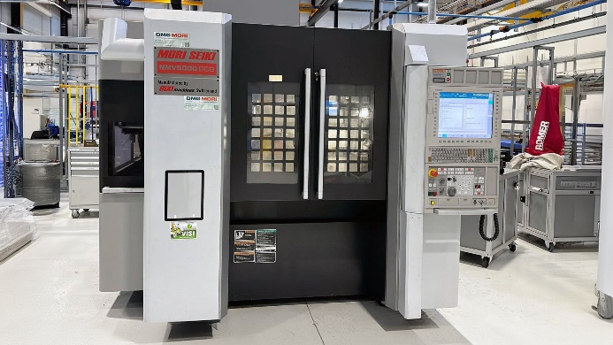 | Photo 1  The most expensive item at the auction was the DMG MORI SEIKI NMV 5000 DCG vertical machining centre.  (© Surplex).
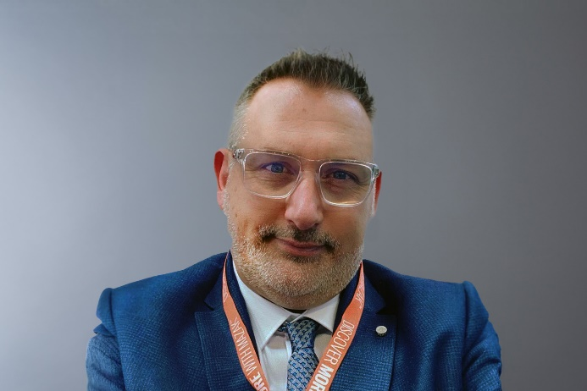 | Photo 2  Antony Reed, UK Country Manager for Surplex, is the contact for England, Wales, Scotland, and Northern Ireland.  (© Surplex).

