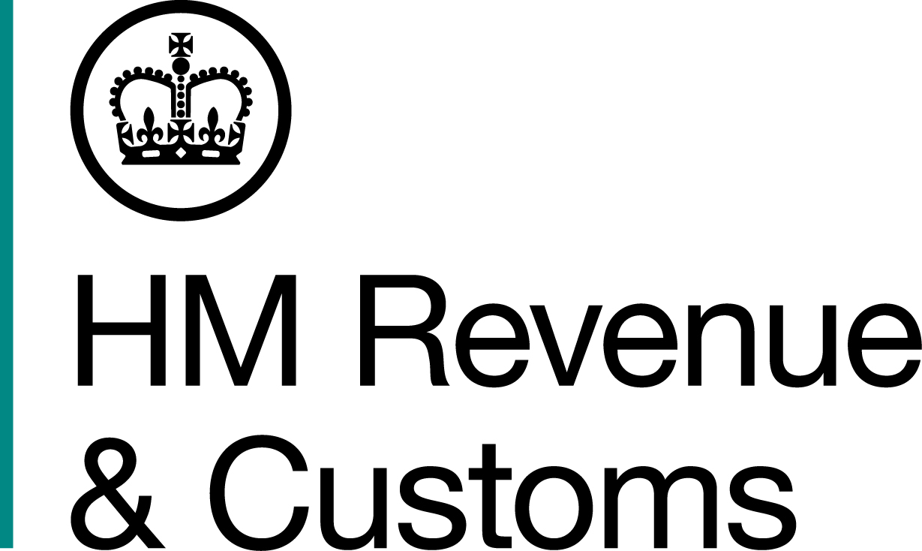
News Release

 | For the attention of News Desks |  | No of pages: 3
 | Date: | 15 March 2018 | Ref: | NW 01 18

Tobacco tax fraudster ordered to repay £478K

The jailed ringleader of an illegal cigarette network in Blackburn has been ordered to pay back £478,693.

Former postmaster Iqbal Haji, of Whalley Street, Blackburn, was ordered to repay the money within three months, or face a further four years behind bars and still owe the money.

The 52-year-old was jailed for six years in May 2016 for Excise Duty evasion and money laundering offences, following an investigation by HM Revenue and Customs (HMRC).

Haji kept meticulous sales records in two ‘dealer’ books at his Blackburn home. The details have, so far, led to seven of Haji’s customers being convicted and sentenced to a total of more than 14 years.

Debbie Porter, Assistant Director, Fraud Investigation Service, HMRC, said:

“We will not allow criminals like Haji to profit from crime and will do all we can to recover their ill-gotten gains. Haji kept detailed records, which helped us dismantle this criminal network and assisted our investigation.

“Disrupting criminal trade is at the heart of our strategy to clampdown on the illicit tobacco market, which steals from the taxpayer and undermines legitimate traders. Anyone with information about the trade in smuggled or counterfeit tobacco can report it to us online or contact our Fraud Hotline on 0800 788 887.”

When HMRC officers searched Haji’s home in September 2014, they seized illegal cigarettes, hand rolling tobacco and criminal cash. They also discovered meticulous records he kept of his illegal trade, dating back to 2010. They revealed the network evaded more than £16million of duty. The books revealed three of his main customers were Keith Allen, 68, James Willmott, 56, both of Accrington and Wayne Brown, 53, of Darwen. A further four men have also been convicted with all seven customers jailed for a total of 14 years.

Allen and Willmott have repaid more than £100,000. Brown has paid back £60,000 and HMRC are still pursuing him for the remainder of the £67,616.16 he was ordered to hand back in October 2017. Further confiscation court hearings are due to take place for other convicted members of the network.

Haji was ordered to pay the money back at Preston Crown Court this week. His assets were found to include two houses in Blackburn, a BMW F80 M3 car worth £61,000, savings in bank accounts and hidden assets totalling £41,000.

Information about any type of tax fraud can also be reported to HMRC online at www.gov.uk/report-an-unregistered-trader-or-business.

Notes for Editors

- Iqbal Haji, DOB 28/10/65, of Whalley Street, Blackburn, Lancashire, was sentenced to six years jail for Excise Duty evasion and two years jail for money laundering, to run concurrently, on May 16, 2016. On March 12, 2018, he was ordered to pay back £478,693 or face a further four years in jail.

- The two dealer books found at Haji’s home address contained sales of illegal tobacco and cigarettes dating back to 2010. Each book contained the name of customers, quantities, price and profit from each transaction. The first dealer book from the 1 May 2014 showed Haji had sold 5,915.35 kilos of illegal HRT and 7,321,400 illegal cigarettes, worth over £2,769,306 in evaded UK Excise Duty and VAT. The second dealer book, dated from 2010, listed sales of 32,794.80 kilos of illegal HRT and 37,463,420 illegal cigarettes. The second book sales amounted to over £13,391,578 in evaded UK Excise Duty and VAT. In total, over the four years Haji was responsible for the onward sale of 38,710.15 kilos of HRT and 44,784,820 cigarettes. The total stolen tax amounted to £16,160,885.

- HMRC’s flickr site www.flickr.com/hmrcgovuk

- Follow HMRC’s press office on Twitter @HMRCpressoffice

Issued by HM Revenue & Customs Press Office

Press enquiries only please contact:

Nick McCarthy
Tel: 03000 589 546
Email: nick.mccarthy@hmrc.gsi.gov.uk

Out of hours
Tel: 07860 359544
Website: www.gov.uk/hmrc

