Press release
Düsseldorf, 08/08/2024
Surplex and TBAuctions join forces to expand the Continental European market
TBAuctions, Europe’s leading B2B multi-brand digital auction platform, is excited to announce the acquisition of Surplex. The transaction closed on 7th August 2024. This strategic move accelerates TBAuctions’ growth into seven new countries including Poland, Portugal, Romania, Czech Republic, Hungary, and Serbia. It also bolsters TBAuctions’ presence in Germany, Spain, France, and Italy, while adding deep industry vertical expertise in metal and woodworking. By becoming part of the TBAuctions family, Surplex clients will now have access to source sellers from 20 countries, sell over 1.6 million assets receiving bids from 750k bidders from over 175 countries, generate hammersales of more than €1.6 billion.
The sale of used business equipment and digital auctions as a channel for the trade of these assets are growing very rapidly in Europe. This is driven by advancements in technology, increased digital adoption, and a shift towards sustainability. Online auctions make it possible to reach out to buyers outside once own area and give potential buyers a wider choice. Surplex joining forces with TBAuctions would be able to further benefit from these trends, enhance service offering to buyers, and enable entrepreneurs to sell their used business goods to 750k bidders across Europe. This move aligns with TBAuctions’ strategy to achieve sustained growth through technology.
Founded in 1999 in Düsseldorf, Germany, Surplex has built a strong reputation across Europe with offices in 16 countries, specializing in installed industrial machinery for metal and woodworking for worldwide commercial buyers. This complements well with TBAuctions’ position in the Nordics and Benelux focused more on mobile equipment.
Michael Werker, Managing Owner of Surplex, said: “It makes a lot of sense for Surplex to come together with TBAuctions. We share similar values, commitment to excellent customer service, and a passion to drive the circular economy.” Uli Stalter, Managing Owner of Surplex, summarises saying: “The combination of skills and geographic footprint between Surplex and the family of TBAuctions brands creates a comprehensive digital auction experience across Europe.”
Tom Christenson, CEO of TBAuctions, shared: “Surplex has a great team of people, excellent customers, and a strong brand across Europe. Together with TBAuctions’ best in class tech platform, we see great opportunities through our complementary services, values, and people to drive exponential growth. This marks a major milestone for us to serve customers in all countries of Europe on our journey to revolutionise digital auctioning and promote sustainable trade.”
About Surplex
Surplex has been one of Europe’s leading industrial auction houses for 25 years and trades worldwide in used machines and factory equipment. The 18-language auction platform Surplex.com has over 125,000 registered customers. Around 1,000 online auctions are held annually, with more than 400,000 industrial products sold to date. The company is based in Düsseldorf and has offices in 16 European countries. More than 220 employees from 27 different nations provide a full service.
About TBAuctions
TBAuctions is a leading multi-brand (Troostwijk Auctions, Klaravik, Auksjonen, PS Auctions, British Medical Auctions, Vavato, and Auktionshuset dab), digital auction platform for B2B used goods in Europe with 1,000+ team members across the Nordics, Benelux+UK, and Continental Europe. We believe that “Everything Has Value” and we make auctioning more effective and efficient by using technology, automation, and economies of scale. TBAuctions’ proprietary platform hosts intelligent online auctions, connecting bidders from various storefronts into a single, unified auction experience TBA brings sustainable trade to a higher level. Sourcing locally and selling globally, millions of products are auctioned every year. Funds managed by Castik Capital are the majority owners of TBAuctions, with Summa Equity as the minority shareholder.

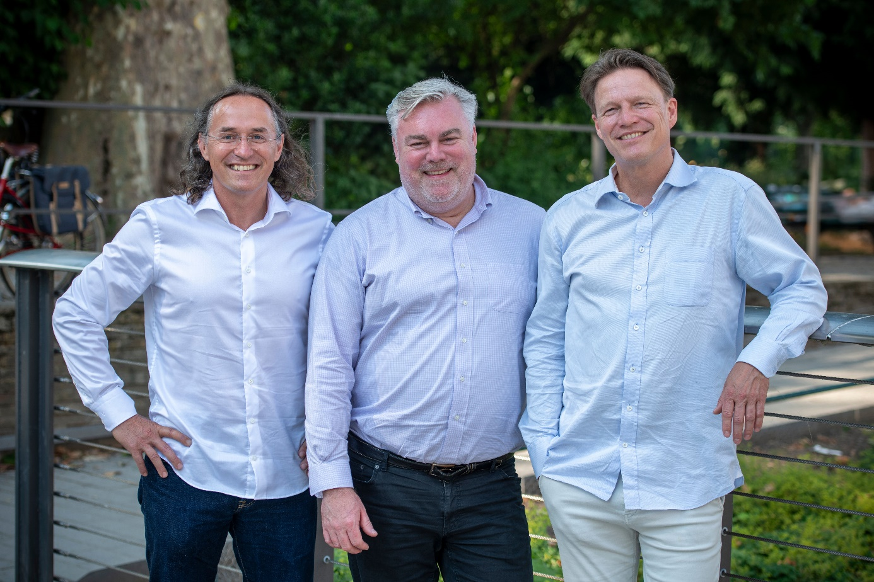Photo
From left to right: Uli Stalter, Managing Director of Surplex; Tom Christenson, CEO of TBAuctions; Michael Werker, Managing Director of Surplex.
(© TBAuctions)

