Publication immediately
Consecutive No, Short Title 10-2018, Leica MC1 software and MCP80 control unit announced
Leica Geosystems simplifies heavy construction with all-in-one machine control platform
Leica MC1 software, MCP80 interchangeable control unit support multiple machines for heavy construction

(Heerbrugg, Switzerland 14 June 2018) – Leica Geosystems, part of Hexagon, industry leader of measurement technology, announced today the launch of the new all-in-one machine control platform consisting of a panel and docking station combined with a new application software that supports multiple machines for heavy construction.
With the new all-in-one machine control platform, Leica Geosystems delivers an intelligent and intuitive hardware and software combination for the heavy construction industry. The MCP80 panel displays information about the work in process and automatically positions the tools, such as bucket, blade or drill bit to dig, grade or drill.

“I really appreciate the larger screen on the panel – it makes my work easier. The panel and cradle have a robust design and the lock function secures the panel in place. The new common software platform, with similar menus and workflows across machines, is an advantage for operators like me working on different machines,” said Michael Madsen, machine operator at Entreprenørfirmaet Ollerup, Denmark, a construction company with competences in soil, sewerage, coating and supply.

Simplified workflow for heavy construction
The new platform for heavy construction offers a unified hardware platform with common software interface across Leica Geosystems’ 3D Machine Control portfolio. Interchangeable between several heavy construction machines, the MCP80 control unit integrates into the common software platform, Leica MC1. Machine specific data, such as calibration values and hydraulic parameters, are stored in the Leica MDS docking station. Users can now switch from one machine to another and build complex designs with simpler workflows and less down time.

One platform to digitise and connect machines on site
Leica Geosystems’ new all-in-one machine control platform allows users to automate their fleet, so work can be done more productively and with less rework. The MCP80 interchangeable, cable-free control unit, delivers a robust housing and connectors as well as a 20-centimetre touchscreen with 3D and 2D simultaneous views. The new solution automatically guides the operator to position the machine, achieving the required design with the highest quality and accuracy.

“Our motivation to create a machine control solution is to make our customers’ lives easier, and increase their productivity and profitability. With one panel and one software for all 3D applications, as well as common data formats, users can guide their machines on site in an intuitive way with seamless data transfer from project start to finish,” said Sten Kristensen, product management director of Leica Geosystems Machine Control Division.
For more information about Leica MC1 software and MCP80 control unit, please visit: https://leica-geosystems.com/products/machine-control-systems
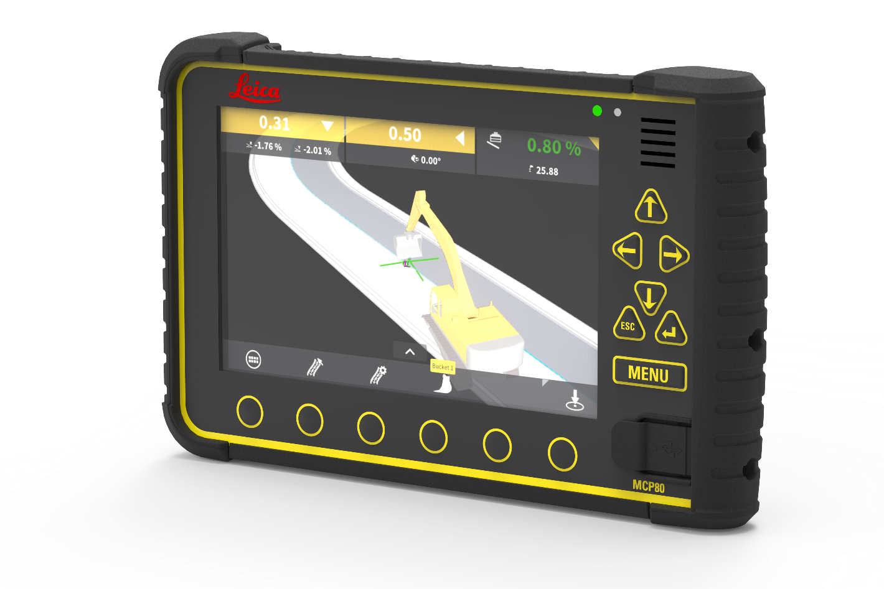
The MCP80 control unit is a cable free, interchangeable 20 cm touchscreen interface supported by MC1, one common software to automatically guide and control most heavy construction machines.
Leica Geosystems – when it has to be right
Revolutionising the world of measurement and survey for nearly 200 years, Leica Geosystems, part of Hexagon, creates complete solutions for professionals across the planet. Known for premium products and innovative solution development, professionals in a diverse mix of industries, such as aerospace and defence, safety and security, construction, and manufacturing, trust Leica Geosystems for all their geospatial needs. With precise and accurate instruments, sophisticated software, and trusted services, Leica Geosystems delivers value every day to those shaping the future of our world.
Hexagon is a global leader in digital solutions that create Autonomous Connected Ecosystems (ACE). Hexagon (Nasdaq Stockholm: HEXA B) has approximately 18,000 employees in 50 countries and net sales of approximately 3.5bn EUR. Learn more at hexagon.com and follow us @HexagonAB.
For further information please contact:
Leica Geosystems AG
Penny Boviatsou
Phone: +41 41 727 8960
Fax: +41 (0)71/726-5511
penny.boviatsou@leica-geosystems.com
www.leica-geosystems.com

