Press Release
February 2, 2015

‘’Monster carpet’’ and new Swedish design at Svenskt Tenn

A carpet and a textile print designed by Josef Frank around 1940 are now reintroduced by Svenskt Tenn, alongside a tray and two lampshades by the contemporary Swedish designers Daniel Carlsten and Oscar Lind Modin.

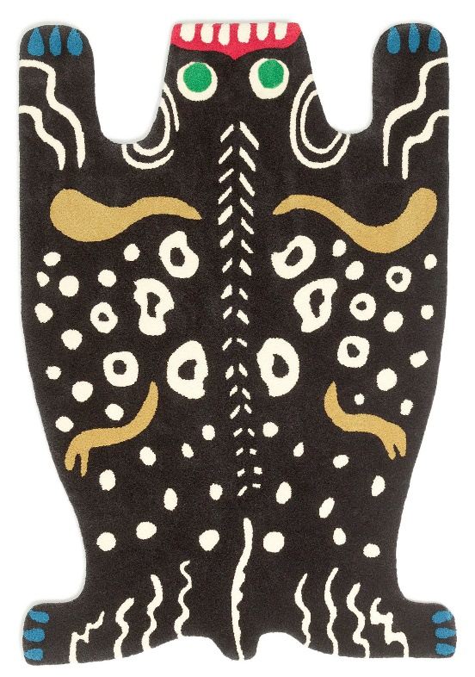
As a child Daniel Carlsten used to dream of becoming a magician, and often practised card tricks in front of the mirror. In an old box containing his collection of cards, he found inspiration to the tray ‘’Ace of Spades’’, named after the most beautiful card in the deck. Price: SEK 900.

For Oscar Lind Modin, the inspiration to design his two lampshades came from Loie Fuller’s “Serpentine Dance”, first performed in 1892, and a ruff from Budapest. The shades are made of 300 metres of cotton ribbon on a handmade metal stand. Price: SEK 11,000.

The textile print Dehli and the carpet No 19, also known as the ‘’Monster carpet’’ are sourced from Svenskt Tenn’s archives. Josef Frank was no fan of game hunting and he designed several carpets with the purpose of substituting real animal skins. This wool carpet was designed in 1939. Price: SEK 29,000.

The Dehli print was designed during Josef Frank’s New York period in 1943-45. It was last available during the 1980’s. It is now reintroduced in two qualities, 100 g/m² linen, made for airy, almost transparent curtains; and 315 g/m² linen, also used for curtains, and well suited for pillows and home furniture that are not exposed to heavy use. Prices: SEK 1,100/m and 1,450/m respectively.

For further information, please contact:

Vicky Nordh, Marketing Assistant: +46 8-670 16 23 or vicky.nordh@svenskttenn.se

Thommy Bindefeld, Marketing Director: +46 8 670 16 02 or thommy.bindefeld@svenskttenn.se

Image bank: www.svenskttennpress.se User name: Press Password: Tenn

Svenskt Tenn is an interior design company with retail stores at Strandvägen in Stockholm and online. Since 1975, Svenskt Tenn is owned by the Kjell and Märta Beijer Foundation, which provides research grants within ecology, medicine and the preservation of Swedish interior design tradition.

