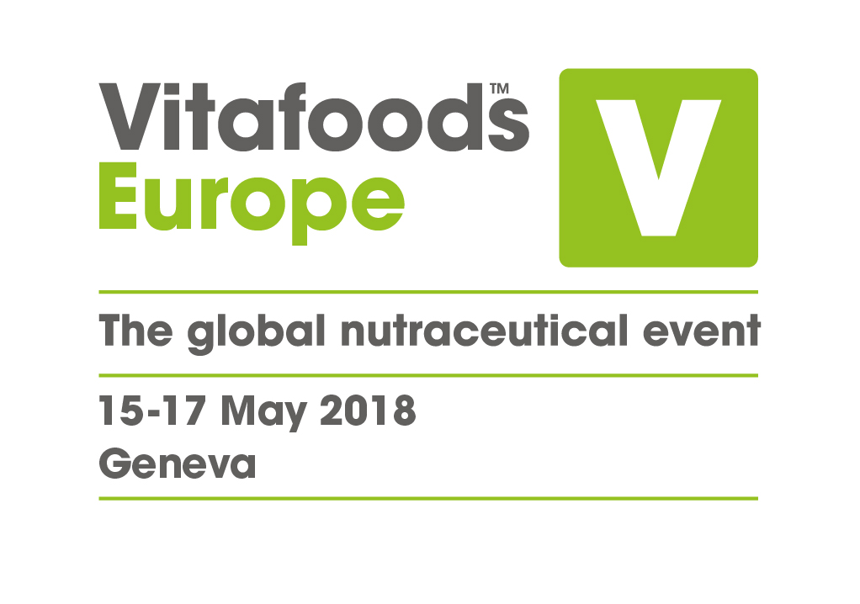
1

19 December 2017

PRESS RELEASE

Nutrition industry gives its verdict on new rules for novel foods

Many people working in the nutrition industry feel positive about the EU’s new process for the approval of novel foods, new research by the organisers of Vitafoods Europe shows. However, experts are warning that there could be adverse implications for some companies’ intellectual property portfolios.

The new regulations on novel foods, defined as anything without a significant history of consumption in the EU before 15 May 1997, come into force on 1 January 2018. For the first time, the approval system will be centralised, with applications submitted to the European Commission rather than individual member states.

There appears to be a degree of optimism about the new regime. A fifth (20%) of industry professionals surveyed by the organisers of Vitafoods Europe* said they thought the new rules would have a positive impact. This was double the number who expected them to have a negative impact (10%).

More than a quarter of respondents (27%) said they had already taken action to prepare for the new rules, while 17% said they were now more likely to apply for novel foods status, compared with 12% who said they were less likely to do so.

A quicker process?

Reforming the novel foods regulation is intended to streamline and speed up the application process. “The biggest problem with the old system was time” said Liza Van Den Eede, Regulatory Affairs Director at Pen & Tec Consulting, who is presenting an update on the new process at Vitafoods Europe 2018. “It took an average of three and a half years to get a novel food approval and in some cases it was five or even six. The better defined deadlines in the new process, as well as the guidance from EFSA, should hopefully mean faster approvals. However, there are probably many companies that are pessimistic about the timescales based on past experience with EFSA, since unforeseen supplementary information requests can slow down the process considerably.”

Patrick Coppens, Director of Scientific & Regulatory Affairs at Food Supplements Europe, added: “On paper this is a very nice process. It’s more streamlined, it’s clearer and it should be faster. But like all legislation, the proof of the pudding is in the eating.”

Intellectual property concerns

Another key change is that authorisations will be generic. This means that once a novel food is approved it will in most cases be authorised for anyone to market. “Of course, that’s not an incentive for companies to invest in a lot of safety investigations for the product,” said Patrick Coppens. “It will really depend on what companies can do to protect their intellectual property. If the return on investment is not certain, there will be some companies who don’t invest.”

Dr Steffi Dudek, Senior Scientific Consultant at analyze & realize, also expressed concerns. “The new regulations certainly represent progress for traditional foods from third countries or for relatively simple products – exotic berries for example. But manufacturers of innovative synthetic or fermented ingredients who got authorisation under the old regulation after investing heavily in research will be disappointed that their proprietary data is not respected in the way we had hoped. I’m also concerned that some products that should be subject to their own authorisation might enter the EU market under a generic authorisation. It remains to be seen how companies will take the responsibility to assess the status of their products.”

More applications in 2018?

So could we see an increase in number of applications for novel foods approval in 2018?

“It’s possible that a lot of companies have waited for the new regulations to kick in before submitting their applications,” said Steffi Dudek. “The definitions are clearer and progress never stops. It’s hard to predict, but I suspect the number of applications will increase.”

* Notes to Editors

Vitafoods Europe commissioned a survey of 208 nutrition industry representatives between 14 November and 4 December 2017.

ENDS

About Vitafoods Europe
Vitafoods Europe is the global nutraceutical event, featuring exhibitors from all over the world in four key market areas: ingredients & raw materials; branded finished products; contract manufacturing & private label; and services & equipment. The event offers a range of visitor attractions, including an industry-leading education programme.

Vitafoods Europe is part of Informa Exhibitions’ Global Health & Nutrition Network (GHNN), which brings together a portfolio of events, digital media and publishing for marketers, manufacturers and formulators of nutrition and dietary supplements, healthy foods/beverages and personal care products. GHNN’s events include Vitafoods Europe, Vitafoods Asia, SupplySide West and Ingredient Marketplace.

Natural Products INSIDER is the global media brand covering healthy ingredients and finished applications. Vitafoods Insights offers online content and a series of topic-specific digital magazines that bring highlights of the Vitafoods events to a global audience. SupplySide West & Vitafoods Global Storefronts offers a new online environment where ingredient buyers and product developers can find and connect with the suppliers and solutions they need, all year long. For more information, visit www.informaglobalhealth.com.

Informa’s Global Exhibitions Division organises transaction-oriented exhibitions and trade shows, which provide buyers and sellers across different industries and communities with a powerful platform to meet face-to-face, build relationships and conduct business. Informa has a portfolio of more than 150 exhibitions, serving a number of core verticals, including Health & Nutrition, Beauty, Property & Construction and Pop Culture.

