Pressinformation
New Classic Product Portfolio for Bath and Kitchen
AXOR Montreux: Authenticity in Perfection
Stockholm, April 2018. Drawing from an era of increasing prosperity and dynamic modernization, AXOR and the Stuttgart-based Phoenix Design Studio have created a bath and kitchen collection in the style of the first industrially manufactured fittings. With authentic forms and defining design features of the early 20th century, AXOR Montreux is an iconic collection that stylistically reflects on a time of scientific and cultural change. Functionally, it delivers the highest qualitative standards and acknowledges the technological advancements of the age. The products have the Swedish Type Approval.
„The style and industrial production methods of the early 20th century still hold value today. We have re-interpreted these features with great precision and workmanship to offer our customers the best in design and functionality – in the bathroom and, for the first time, in the kitchen“, Göran Svedebäck, sales manager of Hansgrohe Sweden, comments on the market launch.
The Evolution of Industrial Design
Reminiscent of the archetypical design of the first industrially manufactured bath and kitchen fixtures, AXOR Montreux is characterized by additive forms and charming stylistic detailing. Industrial design elements, such as pipes and valves, were not only combined with classical details (e.g. delicate cross handles and ceramic inlays), but also with contemporary lever handles. A unique reminiscence of this time also includes a bridge variant of the three-hole washbasin mixer.
Technologically Advanced
Functionally speaking, AXOR Montreux stands for technological advancement: state-of-the-art technology and engineering turn taps, shower pipes and accessories into charming and innovative re-interpretations of the 20th century without compromising comfort. The first classical kitchen taps from AXOR allow for maximum operability around the sink with swivel and pull-out spouts. In the bathroom, taps with lower and higher spouts now accommodate different comfort zones. Ease-of-use is also evident in the new AXOR Montreux Showerpipe: operating elements for overhead and hand shower are separated with ergonomic lever handles.
Authentic, precise design and state-of-the-art industrial manufacturing processes characterize the new bath and kitchen taps; the latter is evident in the distinctive finishes that the bathroom products are available in: chrome and nickel. Nickel is applied using the highly intricate PVD (physical vapor deposition) technology, by which a coating is applied in a vacuum using steam. This leaves the fixtures extremely scratch and abrasion resistant.
AXOR utvecklar, konstruerar och producerar kranar, duschar och tillbehör till lyxiga badrum och kök – till perfektion. Speciella avantgardeprodukter och kollektioner skapas på högsta estetiska och tekniska nivå. Några av dem ses idag som klassiker innanför badrumsdesign. Gemensamt för dem alla är att de följer tanken ”Form follows Perfection”: Produktutvecklingen är först färdig när intet mer kan tillfogas eller tas bort. Genom mer än 20 år har tongivande designobjekt blivit utvecklade efter detta recept i samarbete med några av världens största designers, bl.a. Philippe Starck, Antonio Citterio, Jean-Marie Massaud och Patricia Urquiola. AXOR är ett märke inom Hansgrohe Group.
Läs mer om märket AXOR på:
www.facebook.com/axor.design
www.twitter.com/Hansgrohe_PR
www.instagram.com/_u/axordesign

#AXOR
#FORMFOLLOWSPERFECTION

Sanitetsbranchens designfrämste
I den aktuella Rankingen från det Internationale Forum Design (iF) av de bästa verksamheter i världen när det handlar om design, ligger Hansgrohe SE på en 6:e plats av ca 2000 verksamheter. Med 1040 poäng mer än andra verksamheter är armatur- och duschspecialisten från Schiltach före verksamheter som Audi, BMW och Apple och toppar ännu en gång design-hitlistan för sanitetsbranschen.
www.hansgrohe.se/design

Ytterligare information: | Hansgrohe AB  Tlf. 031-21 66 00  info@hansgrohe.se  www.hansgrohe.se  www.axor-design.com
Images Overview
AXOR Montreux
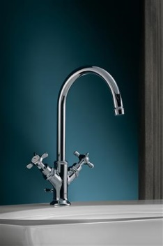 | 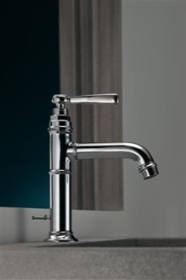 | 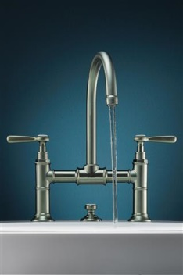 | 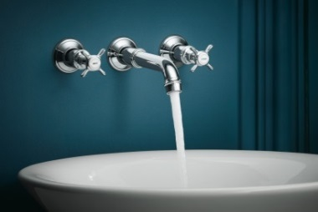
AXOR_Montreux_Washbasin_Cross_Handles | AXOR_Montreux_Washbasin_Lever_Handles | AXOR_Montreux_Washbasin_3HoleBridge | AXOR_Montreux_Washbasin_3HoleCrossHandles
Copyright: Kuhnle & Knoedler for AXOR/ Hansgrohe SE
Reminiscent of the archetypical design of the first industrially manufactured bath and kitchen fixtures, AXOR Montreux is characterized by additive forms and charming stylistic detailing. Industrial design elements, such as pipes and valves, were not only combined with classical details (e.g. delicate cross handles and ceramic inlays), but also with contemporary lever handles. |  | A unique reminiscence of this time also includes a bridge variant of the three-hole washbasin mixer. With cross handles and authentically labeled ceramic inlays it is a genuine reminder of the first industrially manufactured fittings.

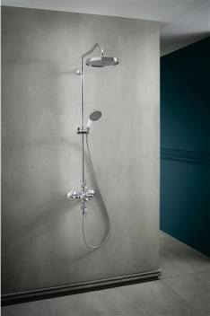 | 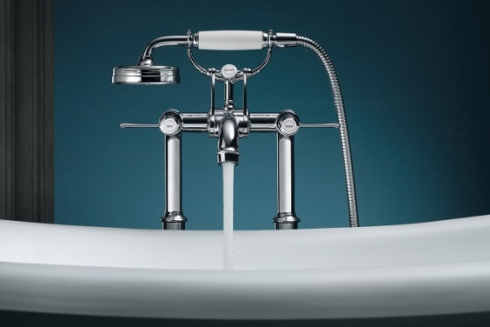
AXOR_Montreux_Showerpipe | AXOR_Montreux_Bathtub_Lever_Handles_Water
Copyright: Kuhnle & Knoedler for AXOR/ Hansgrohe SE
Functionally speaking, AXOR Montreux stands for technological advancement: state-of-the-art technology and engineering turn taps, shower pipes and accessories into charming and innovative re-interpretations of the 20th century without compromising comfort. The new AXOR Montreux Showerpipe, for example, separates the operating elements for overhead and hand shower with an ergonomic lever handle. | Just how elegant the interplay between precision and ease-of-use can be, is evident in the AXOR Montreux bathtub fitting: a clearly labeled converter allows an easy switch between hand shower and bathtub filler.

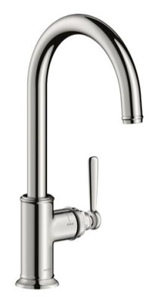 | 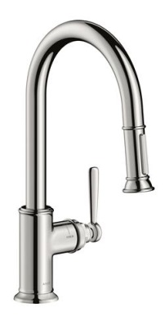 | 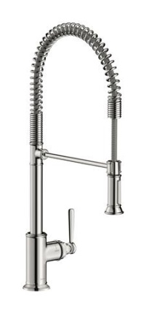
AXOR_Montreux_Single_Lever_Kitchen_Mixer | AXOR_Montreux_Single_Leverl_Kitchen_Mixer_PullOutSpot | AXOR_Montreux_Single_Lever_Mixer_Semi_Pro
Copyright: Kuhnle & Knoedler for AXOR/ Hansgrohe SE
The first AXOR kitchen mixers with classic design allow for easy operation in the kitchen with a swivel or pull-out spout. AXOR Montreux also introduces a semi-pro kitchen mixer that is rotatable up to 360° and features two spray types.

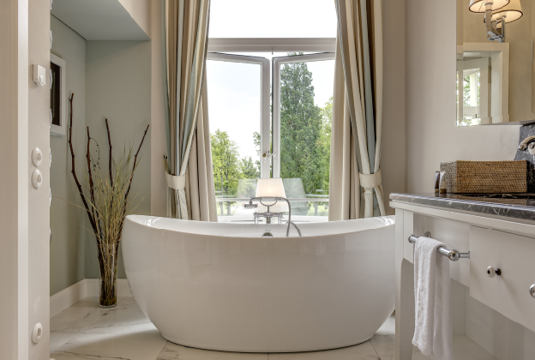 | 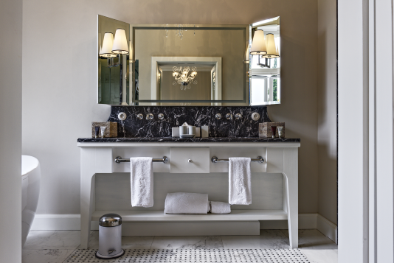
Schloss_Weissenhaus_Bathtub | Schloss_Weissenhaus_Washbasin
Copyright: Soenne Fotodesign | Copyright: Soenne Fotodesign
The Weissenhaus Grand Village Resort & Spa, one of Europe’s most beautiful beach hotels, is located only about 100 kilometers northeast of Hamburg. The bathrooms of this exclusive retreat are equipped with fittings from the AXOR Montreux collection. The playful elegance of the mixers and showers and their classic design fit seamlessly into the historical ambience of Schloss Weissenhaus. Elegant flow and attention to detail – a bathtub with an AXOR Montreux floor-standing two-handle bath mixer (left). A three-hole washbasin mixer harmonizes seamlessly with the marble surface of the washstand (right).

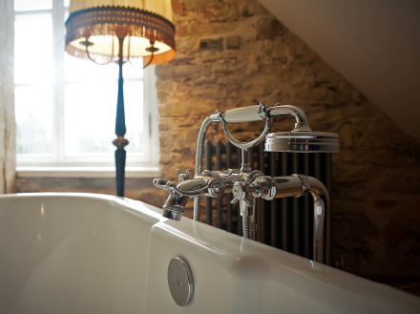 | 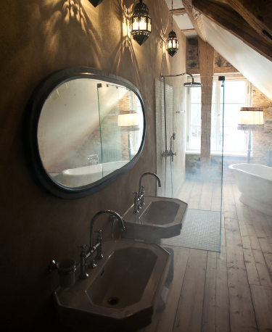
Kau_Manor_Bathroom_2 | Kau_Manor_Bathroom_1
Copyright: Heiki Leis
American film-maker and artist Mary Jordan turned Kau Manor in Estland into an exclusive boutique hotel. With the utmost care, she chose antique furniture and original, exquisite works of art. Classic AXOR bathroom fittings, showers and accessories. With a sure feel for the history and architecture of the manor, which dates back to the 13th century. Classical and comfortable. In 2016 the hotel received the World Boutique Hotel Award in London as the World's Most Inspired Design Hotel.

Images for downloading: http://www.mynewsdesk.com/se/hansgrohe
Copyright: We must draw your attention to the fact that we have only limited usage rights for the images provided, all further rights however belong to the respective photographers. These images may therefore only be published free of charge if they clearly and expressly serve to portray or advertise the performances, products or projects of Hansgrohe SE and/or its brands (AXOR, hansgrohe). Any other form of publication requires the approval of the respective copyright owner and remuneration must be made in agreement with said copyright owner.

