New solution from DENTSPLY Implants:

Simplicity without compromise with the new
ASTRA TECH Implant System EV

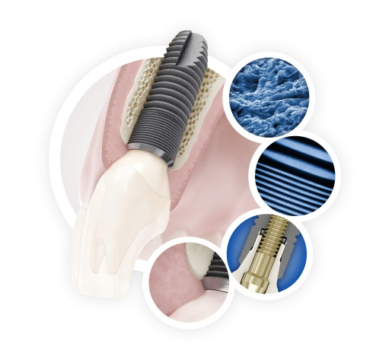
September 2014—DENTSPLY Implants’ next step in the continuous EVolution of the
ASTRA TECH Implant System continues. The ASTRA TECH Implant System EV is designed with a site-specific, crown-down approach based on the natural dentition for increased surgical simplicity and flexibility and restorative ease—without compromising the unique Astra Tech
Implant System BioManagement Complex.

The foundation of this evolutionary step is the unique
Astra Tech Implant System BioManagement Complex, well documented for its long-term marginal bone maintenance and esthetic results provided by the combination of the key features: the OsseoSpeed surface, MicroThread, Conical Seal Design and Connective Contour.

The main objective of the new system is to further improve system logic, robustness and user friendliness. Simplicity without compromise has permeated the evolution of the Astra Tech Implant System EV and the new system is a result of the collaborative input and insights from dental professionals throughout the global dental industry.

SIMPLANT with ASTRA TECH Implant System EV
At the European Association of Osseointegration (EAO) Annual Meeting in Rome, Italy, September 25-27, DENTSPLY Implants presents SIMPLANT computer guided implant treatment with
Astra Tech Implant System EV.

SIMPLANT is a comprehensive system based
on 3D imaging, allowing for precise implant planning and predictable restorative results. Using SIMPLANT with Astra Tech Implant System EV unlocks the potential of digital driven crown-down planning and enhances the treatment outcomes for the benefit of the patients. Furthermore, working with a complete digital workflow allows for
even greater simplicity and efficiency in the treatment process.

ASTRA TECH Implant System EV highlights
- Versatile implant assortment
- Flexible drilling protocol that allows for preferred primary stability
- User-friendly surgical tray with three interchangeable overlay options
- Color-coded assortment
- Unique interface with one-position-only placement of
ATLANTIS patient-specific abutments
- Self-guiding impression components
- One system—one torque

For more information and highlights of the new ASTRA TECH Implant System EV, please visit the campaign site:

www.jointheev.com

About DENTSPLY Implants
DENTSPLY Implants offers comprehensive solutions for all phases of implant therapy, including ANKYLOS®, ASTRA TECH Implant System™ and XiVE® implant lines, digital technologies, such as ATLANTIS™ patient-specific CAD/CAM solutions and SIMPLANT® guided surgery, SYMBIOS® regenerative solutions, and professional development programs. DENTSPLY Implants creates value for dental professionals and allows for predictable and lasting implant treatment outcomes, resulting in enhanced quality of life for patients.

About DENTSPLY International
DENTSPLY International Inc. is a leading manufacturer and distributor of dental and other healthcare products. For over 110 years, DENTSPLY’s commitment to innovation and professional collaboration has enhanced its portfolio of branded consumables and small equipment. Headquartered in the United States, the Company has global operations with sales in more than 120 countries.

For further information, please contact:
Kerstin Wettby – Senior Manager, Global Marketing | PR & Communication, DENTSPLY Implants, Sweden
Cell phone +46 705 16 32 02 | kerstin.wettby@dentsply.com | www.dentsplyimplants.com

You can also visit our News & Press Room at:
www.dentsplyimplants.com/en/Resources/News-and-Press

###

