Norwegian Seafood Research Fund supports additional functionality for K-Sim Fishery simulator solution to prevent loss of fish

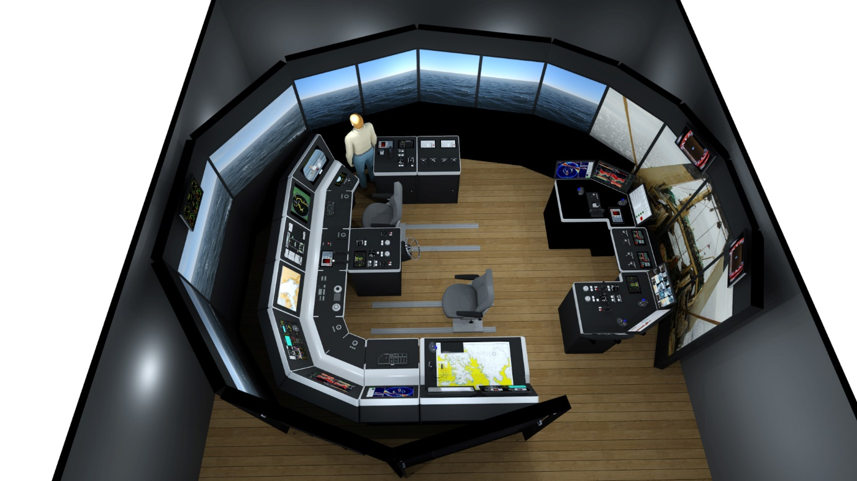

*Illustration of a full mission K-Sim Fishery simulator with new purse seine functionality for studies and training*

**Asker, November 1st, 2019** – Kongsberg Digital (KDI) has signed a new contract with FHF (the Norwegian Seafood Research Fund) to initiate a new phase of development on its ground-breaking K-Sim Fishery simulator system. One of the goals is to enable research and training on release in purse seine operations to prevent loss and death rate of fish.

Launched in 2018, K-Sim Fishery is a top-modern fishery simulator, which introduces a whole new level of detail, authenticity and applicable content for crew training in the techniques and processes of trawl fishing. The new project will include development of additional purse seine capabilities for research purposes, with the aim of improving safety and efficiency in operations and enhancing the fishing gear and methods as well as the catch and storage procedures needed to improve the fish quality and reduce the environmental impact. The new simulator system will in addition be ideal for education and training in purse seine fishery.

The project, which is scheduled to begin this year, will be handled by Kongsberg Digital in partnership with Hordaland Vocational School, Mørenot Austevoll AS, Austevoll Seafood ASA and Sørheim Holding AS. In addition to sharing indispensable advice and industry knowledge, these partners will provide data input and assist with system testing and verification.

Following completion of the project, the K-Sim Fishery simulator will be installed in several educational establishments. Trainees using the K-Sim Fishery simulator will build competence and benefit from the realistic and immersive exercises of purse seine fishing. Advanced hydrodynamic modelling of the vessel and purse seine will, for example, precisely replicate the effects of waves and tidal currents affecting the execution of their tasks. The consequent honing of skills among crew members will further improve overall safety, efficiency and economy in these types of fishery operations.

*“The simulator allows crews to train on all phases of purse seine operations without exposing them to risk or the equipment to damage. It is important to have the possibility to practice, to avoid bursting of the purse seine, huge death rate and subsequent loss of fish.”* adds Roar Pedersen, Manager, Vessel Technology, FHF.

*“It’s vital to provide modern fishing crews with the thorough training they require to carry out their work as safely and efficiently as possible,”* says Jan Ståle Kauserud, Vice President Products, Maritime Simulation, Kongsberg Digital,“*We are proud that we can contribute to this, and will continue to develop the K-Sim Fishery simulator to meet demands direct from the industry.”*

Ends

For further information, please contact:

Anne Voith

**Kongsberg Digital**

Maritime Simulation

Tel: +47 48084640

Email: anne.voith@kdi.kongsberg.com

Anne.voith@kdi.kongsberg.com

**About Kongsberg Digital**

Kongsberg Digital is a provider of next-generation software and digital solutions to customers within maritime, oil and gas, and renewables and utilities. The company consists of more than 500 software experts with leading competence within the internet of things, smart data, artificial intelligence, maritime simulation, automation and autonomous operations.

Kongsberg Digital is subsidiary of KONGSBERG (OSE-ticker: KOG), an international, knowledge-based group delivering high-technology systems and solutions to clients within the oil and gas industry, subsea, merchant marine, defence and aerospace. KONGSBERG has 11.000 employees located in more than 40 countries.

[*www.kongsberg.com/en/kongsberg-digital/*](http://www.kongsberg.com/en/kongsberg-digital/)

[*www.kongsberg.com*](http://www.kongsberg.com)