Higher performance and extra functionality for surveyors as KONGSBERG release new features on the
EM 2040 MKII multibeam echosounder
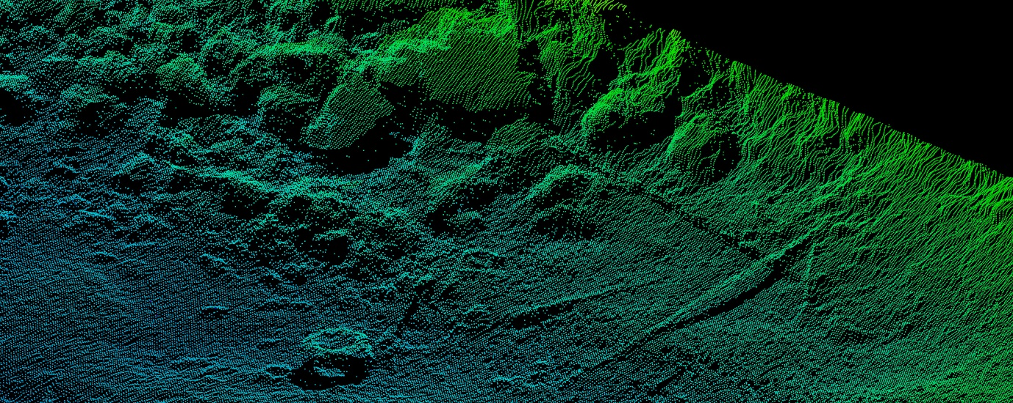
Above: A 600kHz, 100-degree scan from the EM2040. Below: A 300kHz scan using the same hardware
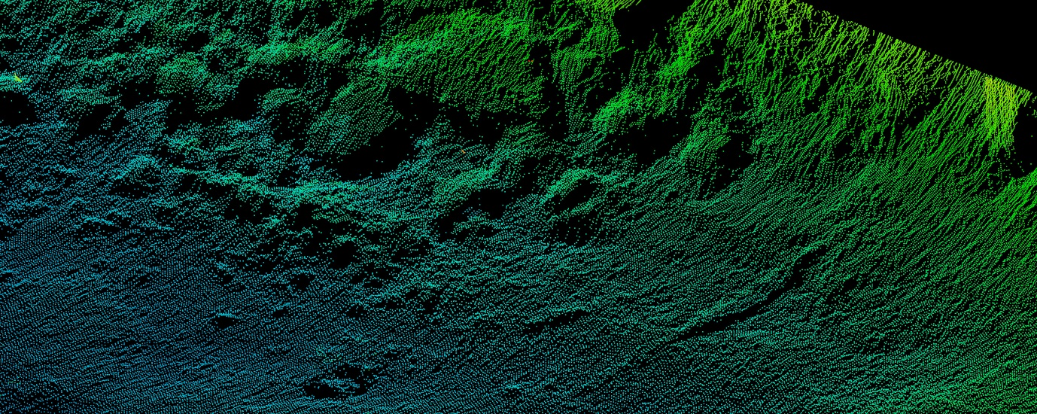

Kongsberg, Norway, 20 March 2020 – Kongsberg Maritime has released two new state-of-the-art features on its market-leading EM 2040 MKII multibeam echosounder. The first enables the use of dual high frequencies to survey wide swaths of the seabed at much higher resolutions than before, while the second facilitates simultaneous collection of backscatter data using multiple frequencies. These cutting-edge functionalities constitute a significant upgrade to the current system, which already offers outstanding range and resolution.
The EM 2040 MKII is a broadband multibeam echosounder system, which uses frequencies from 200kHz to 400kHz to yield a wide swath of up to 170 degrees. With the new high frequency feature, the EM 2040 MK II will additionally employ 600kHz and 700kHz frequencies to give enhanced detail over a swath of up to 120 degrees. This will enable the user to carry out bathymetric survey, inspection and wreck mapping at the highest resolution possible today. Seabed classification will also be more accurate due to the added ability to simultaneously collect backscatter data at multiple frequencies – an enhancement of the single-frequency facility standard to all EM systems.
As part of a new EM technology platform designed for future challenges, the EM 2040 is compatible with a new KONGSBERG-developed datagram format, which supports several new features such as extended backscatter calibration, with more features already in development. The new format is supported by Kognifai, KONGSBERG’s open digital ecosystem which brings opportunities to transform survey operations through digitalisation.
“The EM 2040 provides state-of-the-art survey vessel operators with the highest performance, most accurate mapping capability available on the market today. For existing EM 2040 MKI systems an upgrade path will be offered, while for EM 2040 MKII users the new features will be offered just as a software upgrade,” says Helge Uhlen, Vice President Kongsberg Maritime Sales. “The unparalleled performance of the EM 2040 has resulted in a record number of shallow water systems being delivered for operations around the world, so we are pleased to introduce these new features, which enable our customers to survey with much higher resolutions and higher performance.”
The EM 2040 is a mapping system that takes advantage of features and benefits achieved in the development of the EM family of multibeam echosounders: EM 712, EM 304 and EM 124. It joins Kongsberg Maritime’s unmatched range of leading Multibeam Echo Sounder Systems, from very shallow water to full ocean depth, all with proven superior performance and reliability.
Ends
For further information, please contact:

Gunvor Hatling Midtbø, VP Communication
Kongsberg Maritime
Tel: +47 9921 4209
gunvor.hatling.midtbo@km.kongsberg.com
David Pugh
Saltwater Stone
Tel: +44 (0)1202 669244
d.pugh@saltwater-stone.com

About Kongsberg Maritime
Kongsberg Maritime is a global marine technology company providing innovative and reliable ‘Full Picture’ technology solutions for all marine industry sectors including merchant, offshore, cruise, subsea and naval. Headquartered in Kongsberg, Norway, Kongsberg Maritime has manufacturing, sales and service facilities in 34 countries.
Kongsberg Maritime solutions cover all aspects of marine automation, safety, manoeuvring, navigation, and dynamic positioning as well as energy management, deck handling and propulsion systems, and ship design services. Subsea solutions include single and multibeam echo sounders, sonars, AUV and USV, underwater navigation and communication systems.
Training courses at locations globally, LNG solutions, information management, position reference systems and technology for seismic and drilling operations are also part of the company’s diverse technology portfolio. Additionally, Kongsberg Maritime provides services within EIT (Electro, Instrument & Telecom) engineering and system integration, on an EPC (Engineering, Procurement & Construction) basis.
Kongsberg Maritime is part of Kongsberg Gruppen (KONGSBERG), an international, knowledge-based group that celebrated 200 years in business during 2014. KONGSBERG supplies high-technology systems and solutions to customers in the oil and gas industry, the merchant marine, and the defence and aerospace industries.
Web: Kongsberg Gruppen | Kongsberg Maritime
Social media: LinkedIn | Twitter | Facebook

