KONGSBERG to supply ‘Full Picture’ hybrid upgrade   
for Tidewater Marine Offshore Supply Vessel

* *Milestone contract sees KONGSBERG providing energy-efficient solution   
  that meets industry requirements to reduce CO2, NOx and SOx emissions*

**Kongsberg, Norway, 12th September 2019** – KONGSBERG is pleased to announce that it has been contracted to provide a ‘Full Picture’ upgrade for the Tidewater Marine Offshore Supply Vessel (OSV), *Bailey Tide*.

As a single supplier under the terms of the contract, KONGSBERG will deliver and install a state-of-the-art hybrid power solution including K-Pos DP (Dynamic Positioning), K-Chief 700 IAS (Integrated Automation System) and AGS (Advanced Generator Supervisor) upgrades designed to significantly improve energy efficiency, optimise power management and enhance vessel positioning maneuvers. As well as advancing onboard safety and energy storage, the hybrid solution will substantially cut operational costs by helping to reduce the vessel’s fuel consumption.

The hybrid upgrade will be accompanied with the installation of a KONGSBERG Information Management System (K-IMS), an interactive and collaborative web-based platform which will give Tidewater Marine and its sub-suppliers continuous data access, both on board and on shore. Work on *Bailey Tide*’s upgrade has already started, and is expected to be completed before May 2020.

“*We are hugely looking forward to collaborating with Tidewater on this project*,” says Deepak Thomas, Sales Manager from Kongsberg Maritime Singapore, “*continuing to deliver the best energy solutions in the maritime sector while simultaneously respecting all environmental requirements. Our AGS software functionality has also proved its worth across the Tidewater fleet in mitigating blackouts and increasing the reliability and safety of the Power Management System, and we’re keen to assist the company in progressing ever further in the pursuit of environmentally-responsible, cost-effective energy efficiency*.”

“*KONGSBERG’s comprehensive hybrid upgrade positions us as a pioneer in the OSV sector*,” adds Jeff Gorski, Chief Operating Officer for Tidewater Marine, “*in helping our clients to meet strict environmental regulations, due to be introduced in 2020, for decreasing CO2, NOx and SOx emissions. It manifests our leadership approach towards reducing the carbon footprint on the global maritime map*.”

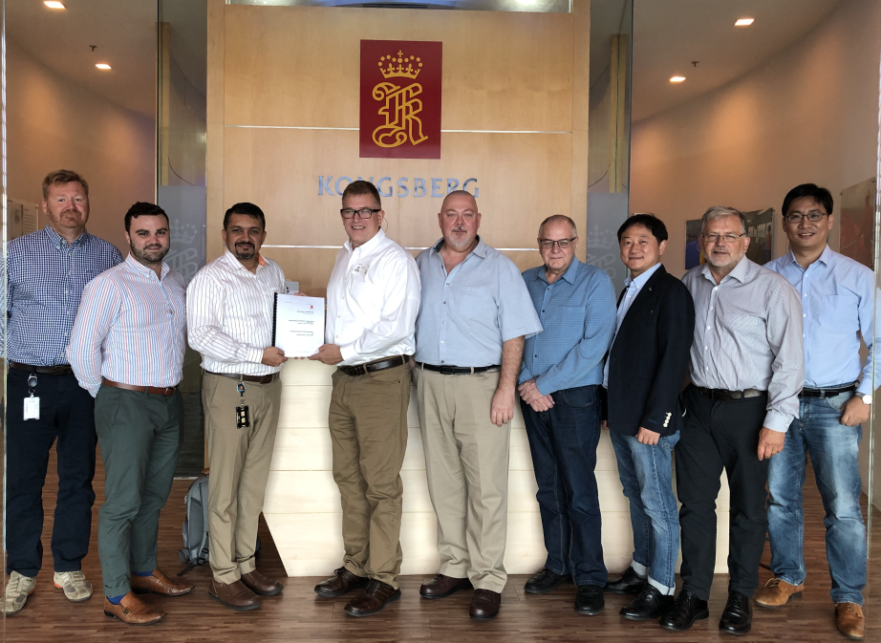

*The KONGSBERG and Tidewater Marine Project Team celebrate the signing of their landmark contract at Kongsberg Maritime’s Singapore headquarters.*

Ends

For further information, please contact:

Gunvor Hatling Midtbø, VP Communication

Kongsberg Maritime

Tel: +47 9921 4209

gunvor.hatling.midtbo@km.kongsberg.com

Saul Trewern

Saltwater Stone

Tel: +44 (0)1202 669244

s.trewern@saltwater-stone.com

**About Kongsberg Maritime**

Kongsberg Maritime is a global marine technology company providing innovative and reliable ‘Full Picture’ technology solutions for all marine industry sectors including merchant, offshore, cruise, subsea and naval. Headquartered in Kongsberg, Norway, Kongsberg Maritime has manufacturing, sales and service facilities in 34 countries.

Kongsberg Maritime solutions cover all aspects of marine automation, safety, manoeuvring, navigation, and dynamic positioning as well as energy management, deck handling and propulsion systems, and ship design services. Subsea solutions include single and multibeam echo sounders, sonars, AUV and USV, underwater navigation and communication systems.

Training courses at locations globally, LNG solutions, information management, position reference systems and technology for seismic and drilling operations are also part of the company’s diverse technology portfolio. Additionally, Kongsberg Maritime provides services within EIT (Electro, Instrument & Telecom) engineering and system integration, on an EPC (Engineering, Procurement & Construction) basis.

Kongsberg Maritime is part of Kongsberg Gruppen (KONGSBERG), an international, knowledge-based group that celebrated 200 years in business during 2014. KONGSBERG supplies high-technology systems and solutions to customers in the oil and gas industry, the merchant marine, and the defence and aerospace industries.

Web: [Kongsberg Gruppen](https://kongsberg.com/) | [Kongsberg Maritime](https://www.km.kongsberg.com)

Social media: [LinkedIn](https://www.linkedin.com/company/kongsberg/) | [Twitter](https://twitter.com/kogmaritime?lang=en) | [Facebook](https://www.facebook.com/KongsbergGruppen/)