**The Bäckman’s ready for their WTCR debut at the Green Hell**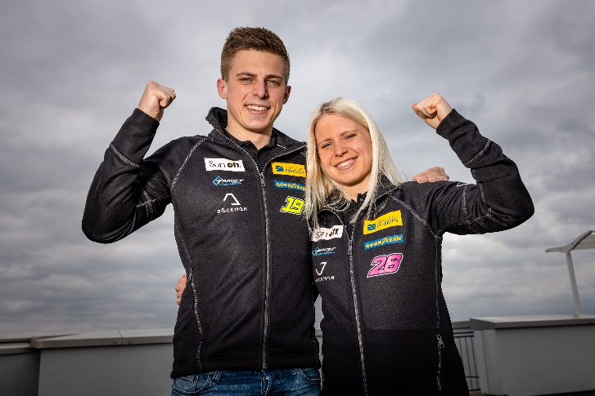Andreas and Jessica Bäckman are ready for the WTCR season opener at Nürburgring this weekend.  
Photo: FIA WTCR (Free rights to use the images)

**The Sweden National Team drivers Andreas and Jessica Bäckman are ready and excited for their debut in WTCR - FIA World Touring Car Cup. The first round is held this weekend at the one of the world’s toughest tracks, Nürburgring Nordschleife, a 25 km long track with over 150 corners.**

**- It will be a tough start to the season as we have not driven much in the new cars yet, Jessica Bäckman says.**

This weekend, June 3-5, the season opener of the FIA WTCR series will take place on the classic Nürburgring Nordschleife track in Germany. It will be the siblings' debut in the prestigious series and the debut in their new Hyundai Elantra N TCR cars.

- It feels really exciting that the season is finally starting now. It will be tough to start the season on one of the most challenging tracks on the calendar. But I look forward to the weekend and I feel ready to take on the challenge, **Andreas Bäckman** says.

**The structure of the WTCR series**The 2021 season will consist of five competitions in Europe and it ends with three competitions in Asia. The start of the season will take place on one of the world's toughest tracks, the Nürburgring Nordschleife, an approximately 25 km long track with over 150 corners and ending on the well-known Macau track, located near Hong Kong. Each event is built on two practice sessions, one timed qualifying and two races. Points are awarded to the top 5 in the timed qualifying and the top 15 in each race. The driver with the most points after the last race in Asia will take home the driver title "FIA Drivers Title" in the WTCR series.En bild som visar text, utomhus, bil, väg
Jessica Bäckman in her new Hyundai Elantra N TCR.  
Photo: Private (Free rights to use the images)

**Nürburgring - The Green Hell**The Nürburgring Nordschleife, also known as "The Green Hell", is one of the toughest tracks in the world. Formula 1 raced on this 25 km long track from 1927 until 1976 when the world champion Niki Lauda was involved in a serious accident. Nowadays, Formula 1 runs on the Nürburgring GP track, which is about 4 km long. Since 2018, the WTCR has raced on this famous track the same weekend as the Nürburgring 24-hour race. It usually has, before Covid-19, a big audience with up to 200,000 spectators. June 3rd-5th, it is now time again when the WTCR is held at the same time as the Nürburgring 24-hour race, and the Bäckman siblings are ready.

- After the long break, I look forward to my debut in WTCR. It will be a tough start not least that we compete against the world's best drivers, but also that we compete with a completely new car model that we have not driven that much yet. It will be very exciting, and I feel ready for the challenge, **Jessica Bäckman** says.

**WTCR is broadcasted LIVE on Eurosport**Throughout this season, all competitions will be broadcasted LIVE on both Eurosport 1 on TV and can also be streamed via Eurosport Player. The two free practice sessions are also broadcasted LIVE on WTCR's [Facebook](https://www.facebook.com/WorldTouringCarCup)- and [YouTube](https://www.youtube.com/FIAWTCR) pages.

**Timetable for this weekend (WTCR Round 1):**(all times are in CET/Swedish time)

**Thursday June 3rd:**14:30 Free Practice 1 (Broadcasted LIVE on Eurosport Player & on FIA WTCR on [Facebook](https://www.facebook.com/WorldTouringCarCup) and [YouTube](https://www.youtube.com/FIAWTCR))  
19:00 Free Practice 2 (Broadcasted LIVE on Eurosport Player & on FIA WTCR on [Facebook](https://www.facebook.com/WorldTouringCarCup) and [YouTube](https://www.youtube.com/FIAWTCR))

**Friday June 4th:**14:05 Qualifying (Broadcasted LIVE on Eurosport Player)

**Saturday June 5th:**8:30 Replay of the Qualifying (Broadcasted on Eurosport 1)  
9:00 Race 1 (Broadcasted LIVE on Eurosport 1 & Eurosport Player)  
10:20 Race 2 (Broadcasted LIVE on Eurosport 1 & Eurosport Player)

**The FIA WTCR app**In the FIA WTCR app, you can follow the competitions with live timing, and there is also more information such as results and the championship standings. Here you will also find the latest news and photos. The FIA WTCR app is available on both [App Store](https://apps.apple.com/se/app/fia-wtcr/id358795125) and [Google Play](https://play.google.com/store/apps/details?id=com.eurosport.events.wtcc&hl=sv&gl=US).

**About the track:**

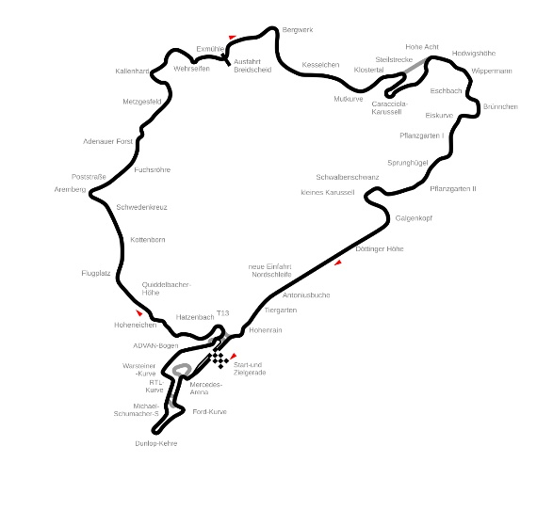

**Location:** Nürburgring Nordschleife, Germany

**Length:** 25,378 km

**Corners:** 154

**Race length:** 3 laps (76,134 km)

**Track record (TCR):** 8:51.802 / average speed 171.7 kph, Nestor Girolami (Honda Civic Type R TCR) 2020

​***Free rights to use the images.***