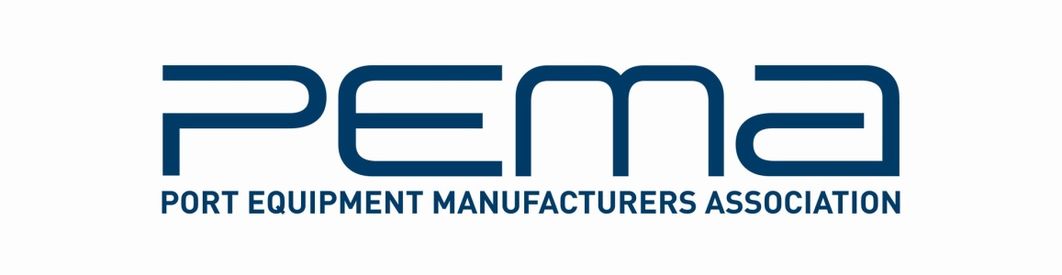

Media Release

Kranunion, Paceco Corp and Römer Fördertechnik confirmed as latest members of PEMA

Leading crane and safety technology manufacturers join global industry trade body for port equipment and technology

London, 13.04.15 – The Port Equipment Manufacturers Association (PEMA), the global industry body for port equipment and technology, has announced three new member companies: Paceco Corp, Kranunion GmbH & Co and Römer Fördertechnik GmbH.

Headquartered in Hayward, California, Paceco Corp is one of the world's leading manufacturers of container handling machinery for cargo ports. Nearly 40% of the container quay cranes in the world carry the Paceco Corp brand. Paceco Corp also develops and manufactures custom software and electronic hardware for advanced automation in marine terminals, including driver display systems, optical character recognition (OCR) systems, and various equipment safety systems using sonar and laser technology

Kranunion is a global association of crane manufacturers Kirow, Kocks and Ardelt which specialise in cranes and transportation units for ports, shipyards, steel mills and railways. Leipzig-based Kirow, founded in 1887, is manufacturer of railway cranes and slag pot carriers. Kocks is an established maker of Goliath cranes and ship-to-shore cranes, while Ardelt specialises in double jib level luffing cranes.

Römer Fördertechnik GmbH, based in Wetter, Germany, specialises in brake and safety technology for port, mining and conveyor operations and material handling. Its product range includes hydraulic buffers, dampers, brakes, couplings, storm brakes and guide rollers.

“We are delighted to welcome these three industry leaders as our latest members,” said PEMA’s President Ottonel Popesco, President of PEMA. “PEMA is a trusted industry body representing all facets of port equipment and technology, and the expertise of Paceco Corp, Kranunion and Römer Fördertechnik will be a vital addition to our global network of 80 member companies.”

** ENDS **

Information for the media
For more information on this media release, please contact Rachael White, PEMA Secretary General at: Tel +44 20 8279 9403 | rachael.white@pema.org

About PEMA
Founded in 2004, PEMA provides a forum and public voice for the global port equipment and technology sectors. The Association has seen strong growth in recent years, and now has nearly 80 member companies representing all facets of the industry, including crane, equipment and component manufacturers; automation, software and technology providers; consultants and other experts.

www.pema.org

