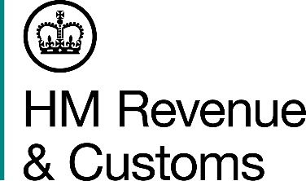
News Release

 | For the attention of News Desks |  | No. of pages: 2
 | Date: | 28 May 2015 | Ref: | NI 10/15

Five arrested in Co Tyrone tobacco raids

Five men have been arrested, and more than four million suspected illicit cigarettes seized, as part of a joint investigation by HM Revenue and Customs (HMRC), the Police Service of Northern Ireland (PSNI) and the Revenue Commissioners.

HMRC and PSNI officers searched a farm and a private address in Co Tyrone this morning where the cigarettes, worth an estimated £1.3 million in lost duty and taxes, were found.

Mike Parkinson, Assistant Director, Criminal Investigation, HMRC, said:

“Tobacco fraud is a highly organised global crime, which costs the UK £2 billion a year in lost taxes. Co-operation with our partners across the UK, Ireland and overseas is essential if we are to tackle this problem effectively.

“Anyone with information on tobacco fraud can contact the Customs hotline on 0800 59 5000.”

A suspected mobile laundering plant was also seized during the operation. The five men are being questioned by HMRC and investigations into the seizures are continuing.

Notes for editors

- A 34 year-old man from Armagh, two men aged 37 and 22 from Co Monaghan and two men aged 39 and 38 from Co Tyrone, were arrested.

- Follow HMRC’s Press Office on Twitter @HMRCpressoffice

- HMRC’s Flickr channel: www.flickr/hmrcgovuk

Issued by HM Revenue & Customs Press Office

Press enquiries only please contact:
Stephen Cassidy
Tel: 03000 511 593
E-mail: stephen.cassidy@hmrc.gsi.gov.uk
Or
Greg Black
Tel: 03000 546 374
E-mail: greg.black@hmrc.gsi.gov.uk
Out of hours
Tel: 07699 750728
Website www.gov.uk/hmrc

