LIZZY MCALPINE CONFIRMS
“THE OVER COUNTRY TOUR”
EXTENSIVE HEADLINE SHOWS ACROSS NORTH AMERICA, THE U.K., EUROPE, AUSTRALIA AND NEW ZEALAND

Press photo, credit Keith Oshiro
September 24, 2026—Much-lauded songwriter, vocalist and producer Lizzy McAlpine today confirms “The Over Country Tour,” an extensive run of headline shows across North America, the U.K., Europe, Australia and New Zealand. Kicking off in Adelaide, Australia in February, the tour includes dates at New York City’s Madison Square Garden, Los Angeles’ Kia Forum, Paris’ L'Olympia, London’s O2 Academy Brixton and more.
“We’re going over country!!! I am so excited to play these songs live for you. See you so soon,” McAlpine says.
TICKET INFO: Fans can sign up for the artist presale now at lizzymcalpine.com/tour. See specific timings for each territory below.
- Australia and New Zealand: Artist Presale starts on Tuesday, September 29 at 10 A.M. local time. Tickets go on sale to the public Wednesday, September 30 at 12 P.M. local time
- Europe and U.K.: Artist Presale starts on Wednesday, September 30 at 10 A.M. local time. Tickets go on sale to the public Friday, October 2 at 10 A.M. local time
- North America: In order to help real fans get tickets, the Artist Presale for North American shows will be split into two waves. Wave 1 starts on Wednesday, September 30 at 10 A.M. and Wave 2 will start the same day at 2 P.M. local time. Tickets go on sale to the public Friday, October 2 at 10 A.M. local time.
Lizzy will be joined across the tour with support from Mila Bea, Worthitpurchase, Flyte, SRCHR, Sydney Ross Mitchell, Searows and Post Animal. Support will vary per market. See below for full tour routing and visit lizzymcalpine.com/tour for more information.
The tour announcement arrives following the release of McAlpine’s fourth album, Angel, via Indigo Blue/RCA Records last week—listen here. The album has already earned praise from NYLON, Consequence and more, with NPR’s All Songs Considered calling the record “gorgeous” and Rolling Stone hailing Angel as “magnificent.”
Recorded and produced with longtime collaborators Mason Stoops (Miley Cyrus, ROLE MODEL, Mumford & Sons) and Taylor Mackall (ROLE MODEL, Tiny Habits) in and around Los Angeles over nearly two years, Angel marks a clear sonic expansion for McAlpine—a rich tapestry of classic and contemporary influences, from ‘70s Laurel Canyon folk to 21st-century indie. Written during a period of profound self-discovery, the album chronicles McAlpine’s return to self through the themes of love, heartbreak, and the endurance of community and friendship.
Angel and “The Over Country Tour” follow the success of McAlpine’s 2024 album Older, which received widespread critical acclaim and saw her sell out an extensive international tour, performing sold-out nights at Radio City Music Hall, Los Angeles’ Greek Theatre and venues across the U.K., Australia and Europe. The deluxe edition, Older (and Wiser), featured Platinum-Certified "Spring Into Summer," Platinum-Certified "Pushing It Down and Praying" and Gold-Certified “Staying.”
Born outside Philadelphia, Lizzy gained early recognition for her original songs and covers online before releasing her debut album, Give Me A Minute, in 2020. Solidifying herself as a rising force and amassing thousands of devoted fans, Lizzy’s widely successful second studio album, five seconds flat, was released to critical acclaim in the spring of 2022 and featured Platinum-Certified track “ceilings.” More from Lizzy is imminent.
LIZZY MCALPINE LIVE
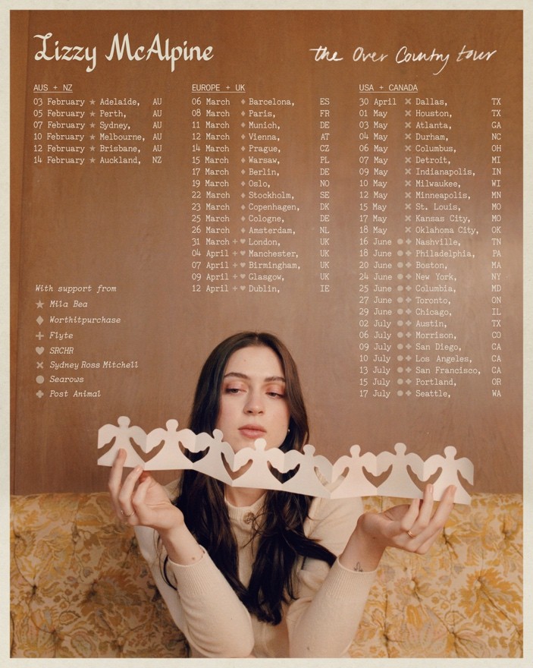
February 3––Thebarton Theatre––Adelaide, AU*
February 5––Red Hill Auditorium––Perth, AU*
February 7––TikTok Entertainment Centre––Sydney, AU*
February 10––Sidney Myer Music Bowl––Melbourne, AU*
February 12––Riverstage––Brisbane, AU*
February 14––Te Paepae Theatre, NZICC––Auckland, NZ*
March 6––Sala Apolo––Barcelona, ES†
March 8––L'Olympia––Paris, FR†
March 11––TonHalle––Munich, DE†
March 12––Gasometer––Vienna, AT†
March 14––SaSaZu––Prague, CZ†
March 15––Stodola––Warsaw, PL†
March 17––Columbiahalle––Berlin, DE†
March 19––Sentrum Scene––Oslo, NO†
March 22––Cirkus––Stockholm, SE†
March 23––Poolen––Copenhagen, DK†
March 25––Palladium––Cologne, DE†
March 26––AFAS Live––Amsterdam, NL†
March 31––O2 Academy Brixton––London, UK‡§
April 4––Aviva Studios––Manchester, UK‡§
April 7––O2 Academy Birmingham––Birmingham, UK‡§
April 9––O2 Academy Glasgow––Glasgow, UK‡§
April 12––3Arena––Dublin, IE‡§
April 30––The Bomb Factory––Dallas, TX||
May 1––713 Music Hall––Houston, TX||
May 3––The Fox Theatre––Atlanta, GA||
May 4––DPAC––Durham, NC||
May 6––Palace Theatre––Columbus, OH||
May 7––Fox Theatre––Detroit, MI||
May 9––Clowes Memorial Hall––Indianapolis, IN||
May 10––The Riverside Theater––Milwaukee, WI||
May 12––State Theatre––Minneapolis, MN||
May 15––Stifel Theatre––St. Louis, MO||
May 17––The Midland Theatre––Kansas City, MO||
May 18––Civic Center Music Hall––Oklahoma City, OK||
June 16––Bridgestone Arena––Nashville, TN#^
June 18––Xfinity Mobile Arena––Philadelphia, PA#^
June 20––Agganis Arena––Boston, MA#^
June 24––Madison Square Garden––New York, NY#^
June 25––Merriweather Post Pavilion––Columbia, MD#^
June 27––Scotiabank Arena––Toronto, ON#^
June 29––United Center––Chicago, IL#^
July 2––Moody Center––Austin, TX#^
July 6––Red Rocks Amphitheatre––Morrison, CO#^
July 9––The Rady Shell at Jacobs Park––San Diego, CA#^
July 10––Kia Forum––Los Angeles, CA#^
July 13––Chase Center––San Francisco, CA#^
July 15––Theater Of The Clouds––Portland, OR#^
July 17––Climate Pledge Arena––Seattle, WA#^
*with Mila Bea
†with Worthitpurchase
‡with Flyte
§with SRCHR
|| with Sydney Ross Mitchell
# with Searows
^ with Post Animal
www.lizzymcalpine.com
For more information, please contact
Reid Kutrow or Carla Sacks at Sacks & Co., 212.741.1000,
reid.kutrow@sacksco.com or carla@sacksco.com.

