Press Release
Stockholm, November 13, 2015

Svenskt Tenn welcomes Christmas with classic and new designs

Christmas arrives at Svenskt Tenn today, with many new designs for beautiful home decoration and ideal gifts to put under the Christmas tree.

Upstairs in the tea room, there is an ample scent of Svenskt Tenn’s own Christmas tea blend and soft gingerbread. Christmas decorations are fronted in the store and in the large gallery room, the company’s decorators have staged a welcoming home environment inspired by traditional Christmas celebration.

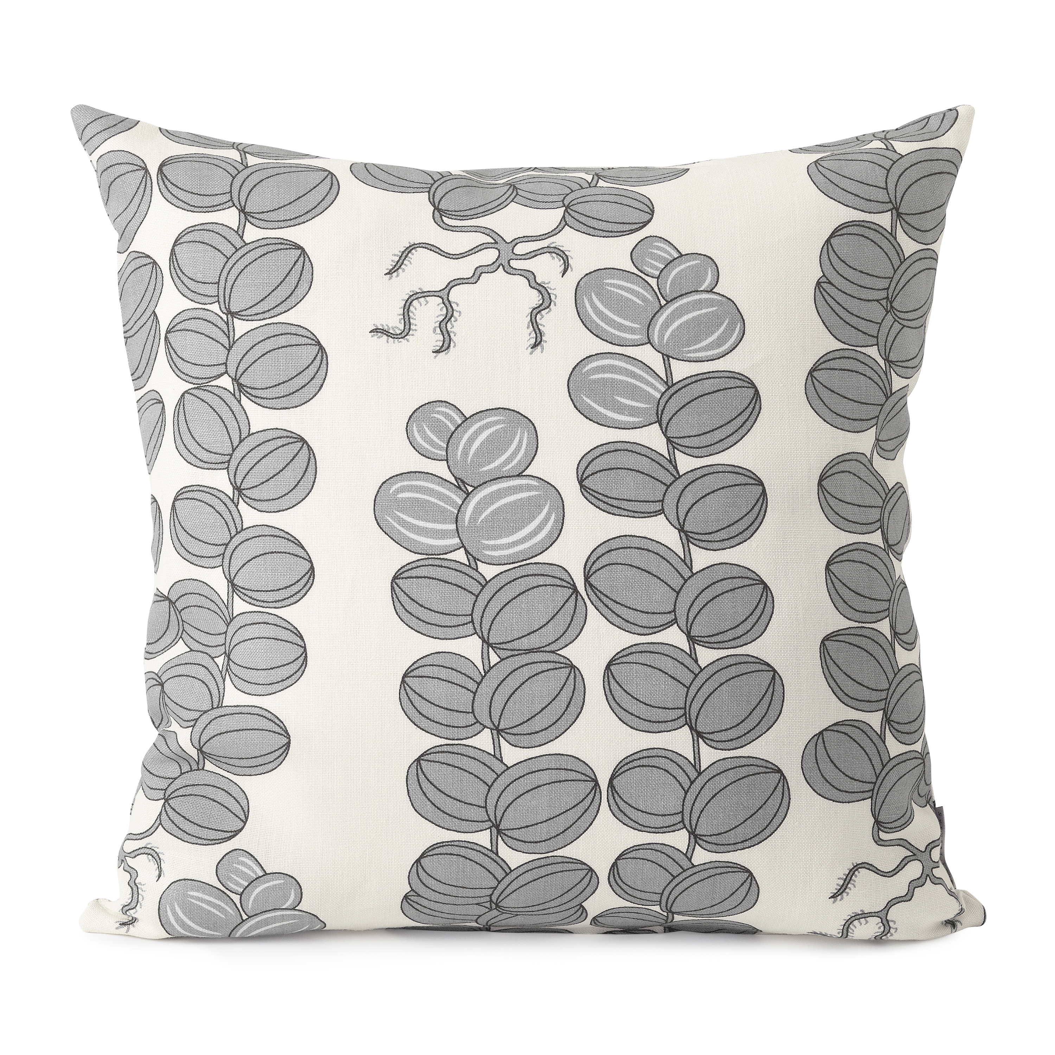
The dinner table is set with the textile Celotocaulis in a light gray on a white colourway, a Josef Frank design in a colour which was last produced in the 1980s – and new ornaments are hanging from the Christmas tree. Designers Erika Pekkari, Carina Seth Andersson and Birgitta Löwendahl have contributed with new decorations for this year’s season.

More contemporary design is presented by John Astbury and Karin Wallenbeck, whose tray made of stainless steel and brass is sold exclusively by Svenskt Tenn.

In addition, a box designed by Andreas Beijer as part of a student project at the Carl Malmsten Furniture Studies, is now available in a limited edition of 10. The box, shown in an exhibition at Svenskt Tenn in 2014, consists of several layers of veneer with a brass container. The lid is a glass sphere, or actually a crystal ball, as the content inside is revealed by a closer look. Andreas Beijer was inspired by a photograph taken by Lennart Nilsson, where Svenskt Tenn founder Estrid Ericson holds a crystal ball reflecting the image of Josef Frank.

Prices: decorations from SEK 40, tray SEK 2,900 and box SEK 14,500.

For further information, please contact:

Vicky Nordh, Marketing Assistant: +46 8-670 16 23 or vicky.nordh@svenskttenn.se

Thommy Bindefeld, Marketing Director: +46 8 670 16 02 or thommy.bindefeld@svenskttenn.se

Svenskt Tenn is an interior design company with retail stores at Strandvägen in Stockholm and online. Since 1975, Svenskt Tenn is owned by the Kjell and Märta Beijer Foundation, which provides research grants within ecology, medicine and the preservation of Swedish interior design tradition.

